STORES

EBS store: In ebs store if you stop the instance its not deleted after the terminated it will be deleted

Insance store: in instance store stopping the instance it will be deleted

S3 is a scalable storage in the cloud

Create a bucket and give permissions for object and bucket otherwise its private one if you give permissionsit becomes public

Creation of buckets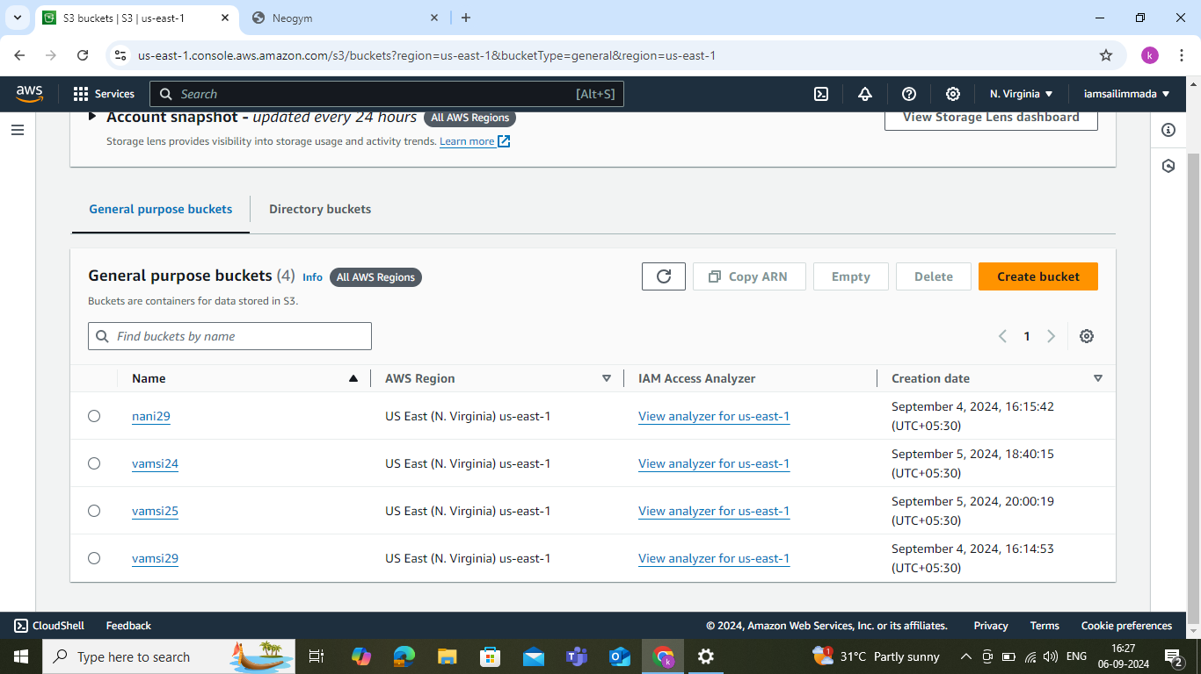

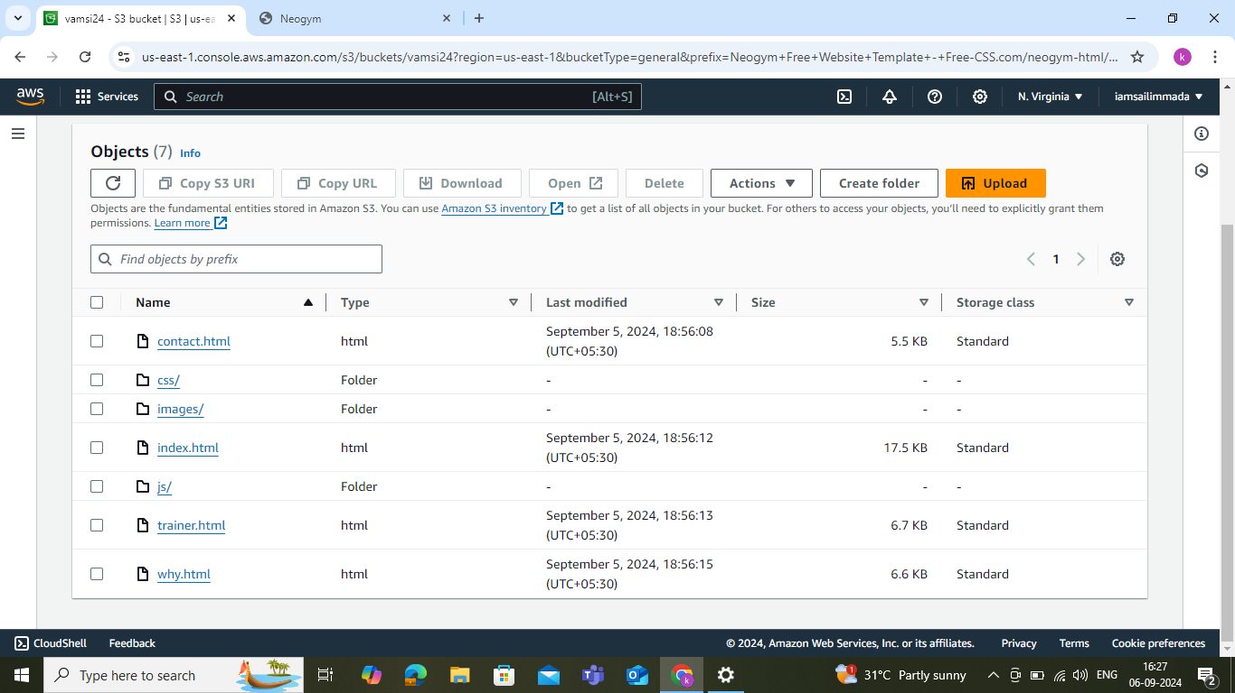Bucket policy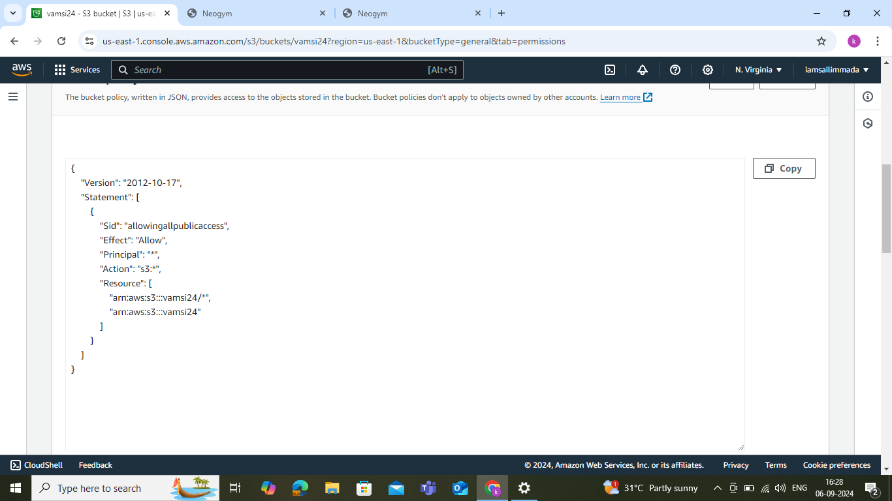output