15. Demonstrate Infrastructure as a Service (IaaS) by establishing the remote
connection, launching the created VM image and run in your desktop.
Aim: To Demonstrate the Infrastructure as a service by Creating a resource Groupo using a public cloud service provier (azure)
PROCEDURE:
STEP 1: Open The Microsoft Azure
STEP 2: Go to Resources and Click Add resouces
STEP 3: searh for virtual Meachine and open it and name it
STEP 4: After that Set the username and password for it
STEP 5: After Creating all you will go main page
STEP 6: Make further changes to the Azure
STEP 7: Then Set the Image and run it
STEP 7:Then you will get Your Deployment is Complete

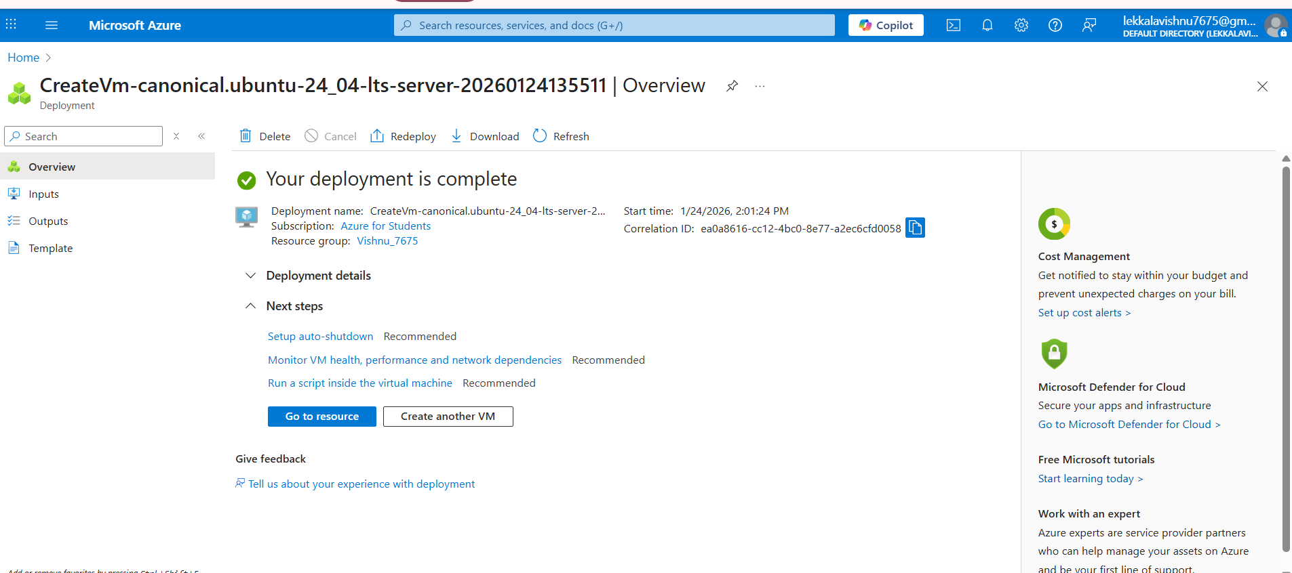

After That generate the image


