program that can perform a letter frequency attack on any monoalphabetic substitution cipher without human intervention. Your software should produce possible plaintexts in rough order of likelihood. It would be good if your user interface allowed the user to specify “give me the top 10 possible plaintexts.”

import random, math

from collections import Counter

EN_FREQ = {'E':12.7,'T':9.1,'A':8.2,'O':7.5,'I':7.0,'N':6.7,'S':6.3,'H':6.1,'R':6.0,'D':4.3,'L':4.0,'C':2.8,'U':2.8,'M':2.4,'W':2.3,'F':2.2,'G':2.0,'Y':2.0,'P':1.9,'B':1.5,'V':1.0,'K':0.8,'J':0.2,'X':0.2,'Q':0.1,'Z':0.1}

COMMON = ["the","and","to","of","a","in","that","is","was","he","for","it","as","with","his","on","be","at"]

def clean(s): return ''.join(c for c in s.upper() if c.isalpha() or c==' ')

def apply_key(txt, key): return ''.join(key.get(c,c) for c in txt.upper())

def freq_score(txt):

c=Counter(c for c in txt if c.isalpha()); n=sum(c.values()); sc=0

for k,v in c.items():

e=EN_FREQ.get(k,0)/100*n

sc -= (v-e)**2/(e+1)

return sc

def word_bonus(txt):

s=txt.lower(); b=0

for w in COMMON: b+=s.count(w)*len(w)

return b

def fitness(t): return freq_score(t)+3*word_bonus(t)

def rand_key():

a=list("ABCDEFGHIJKLMNOPQRSTUVWXYZ"); b=a.copy(); random.shuffle(b)

return dict(zip(a,b))

def swap_key(k):

k=k.copy(); a,b=random.sample(list(k.keys()),2)

k[a],k[b]=k[b],k[a]; return k

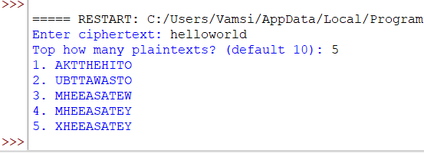

def attack(cipher, top=10, loops=5000):

key=rand_key(); best=apply_key(cipher,key); bests=f=fitness(best)

out=[(f,best)]

for _ in range(loops):

k2=swap_key(key); p2=apply_key(cipher,k2); f2=fitness(p2)

if f2>f or random.random()<math.exp((f2-f)/max(1,loops*0.001)):

key,f,best=k2,f2,p2

if f2>bests:

bests=f2; out.append((f2,best))

out.sort(reverse=True); seen=set(); res=[]

for s,t in out:

if t not in seen:

seen.add(t); res.append(t)

if len(res)>=top: break

return res

cipher=input("Enter ciphertext: ")

top_n=int(input("Top how many plaintexts? (default 10): ") or 10)

results=attack(cipher,top_n)

for i,r in enumerate(results,1):

print(f"{i}. {r}")]}")eview}")