**Experient-3**

**Design and Configuration of BUS Topologies using Packet Tracer.**

3 hubs and 6 PCs

Assign IP address for each PCs

IP address for PC0:192.168.1.1

IP address for PC1: 192.168.1.2

IP address for PC2: 192.168.1.3

IP address for PC3: 192.168.1.4

IP address for PC4: 192.168.1.5

IP address for PC5: 192.168.1.6

allocate the message

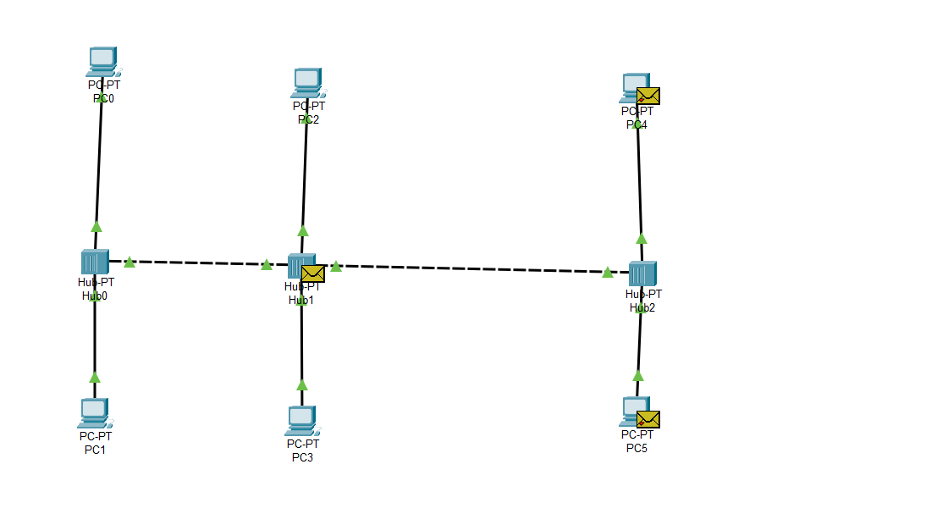

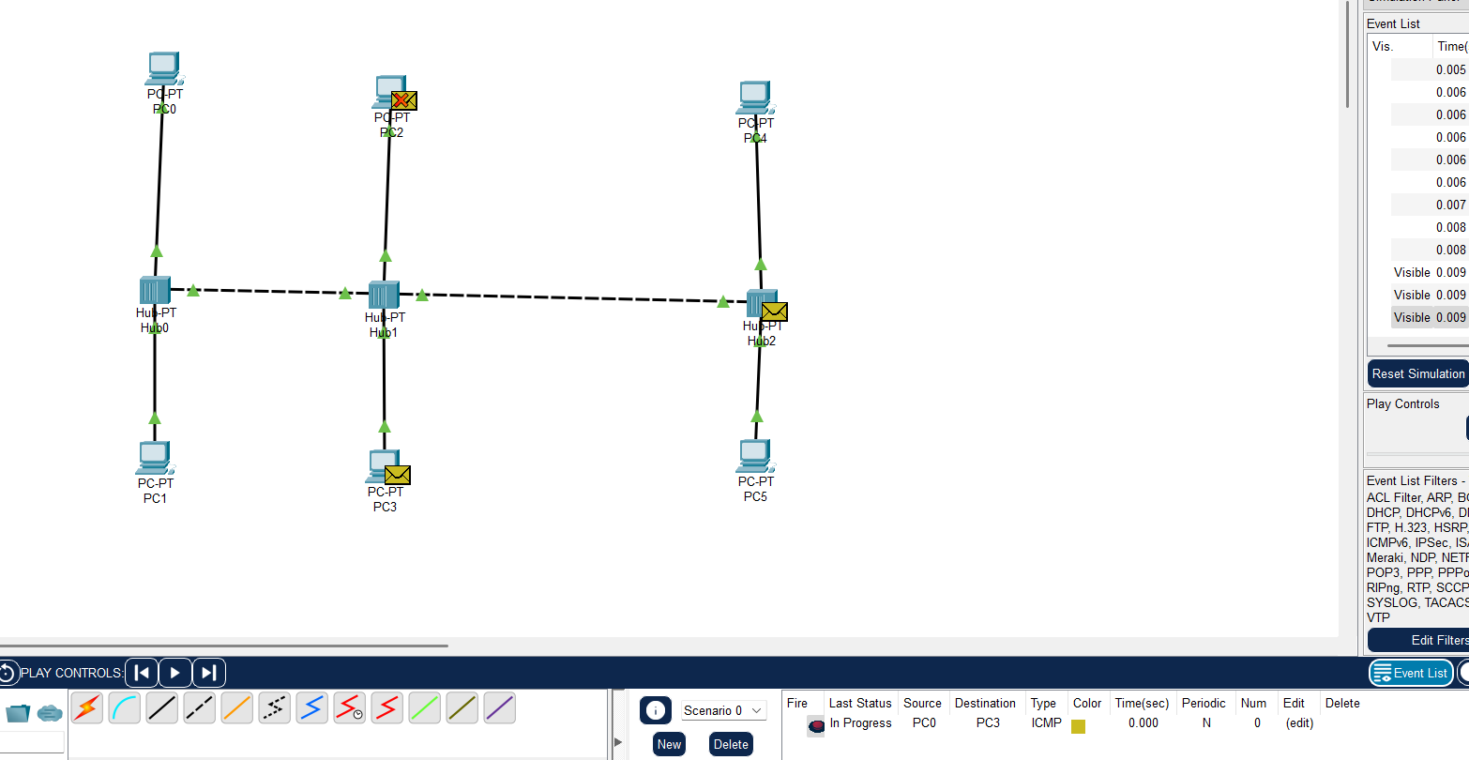

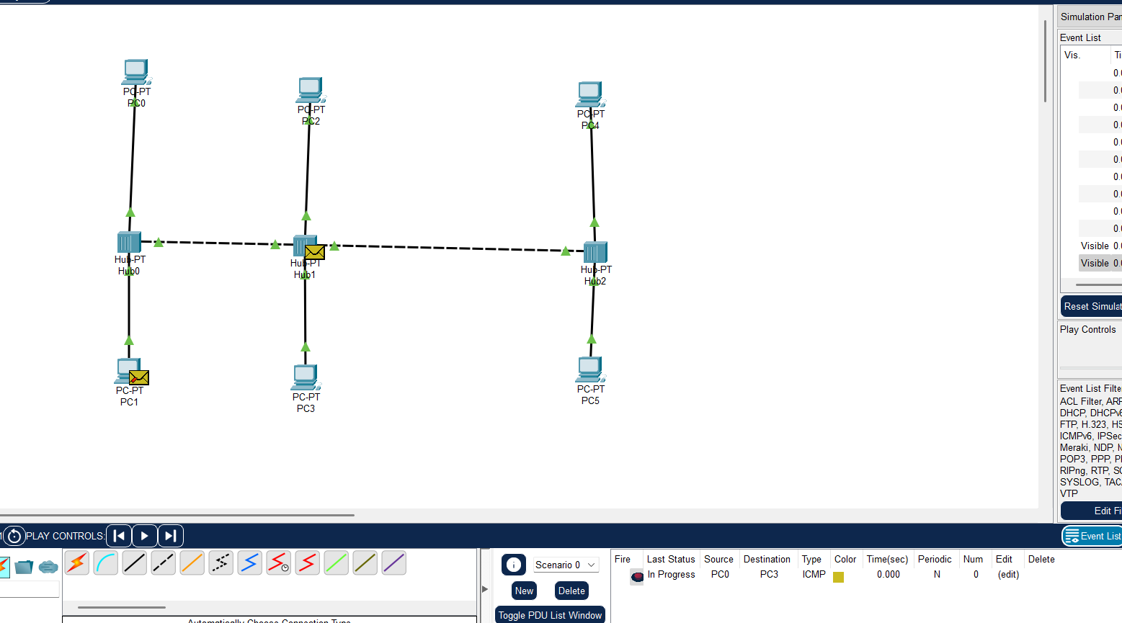

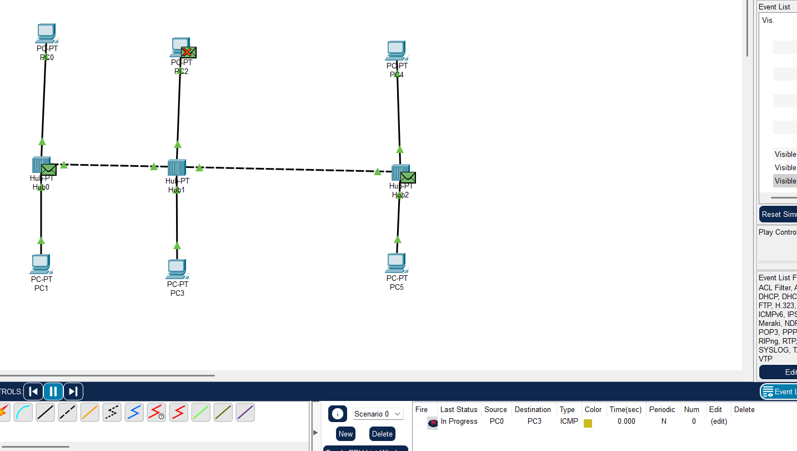

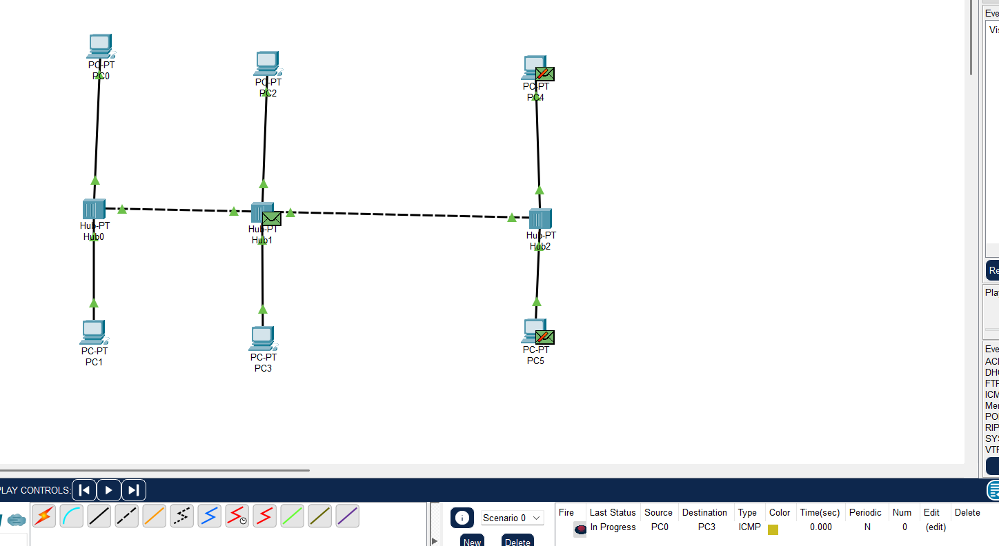

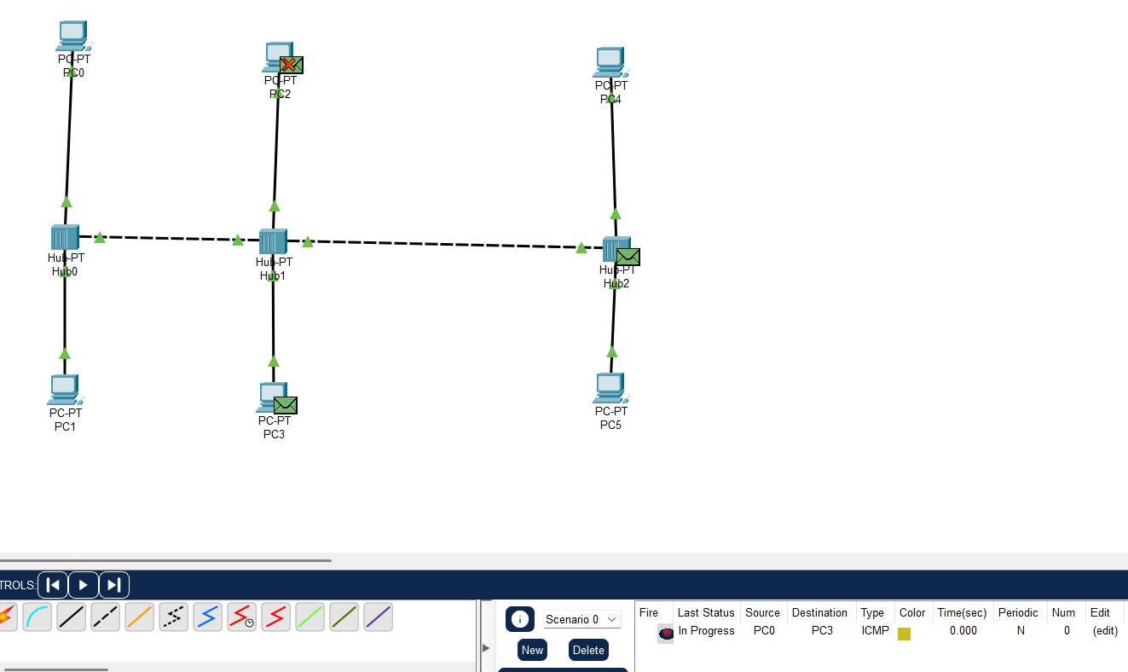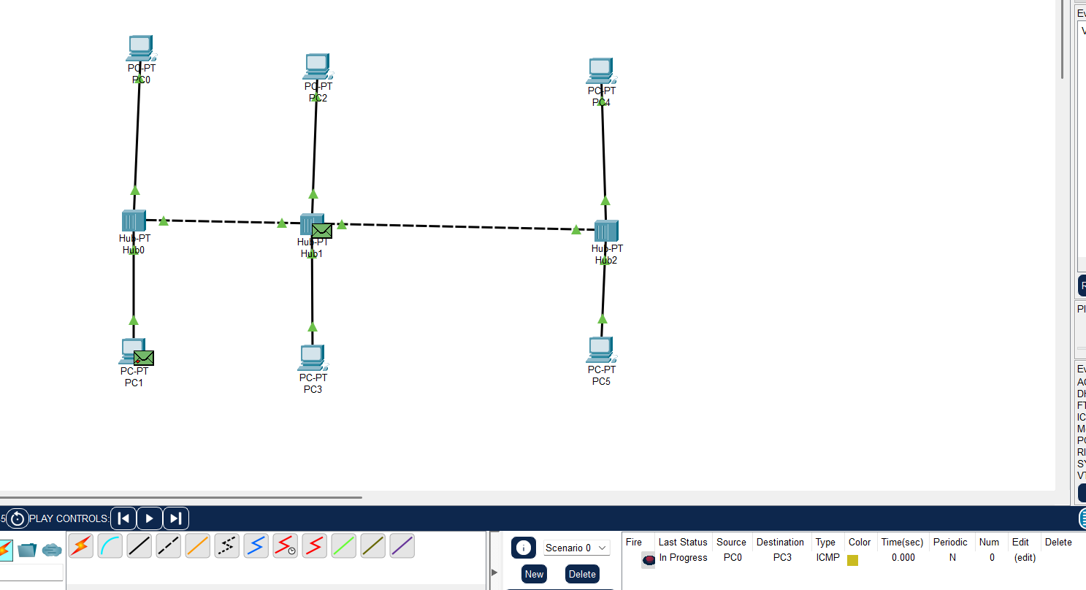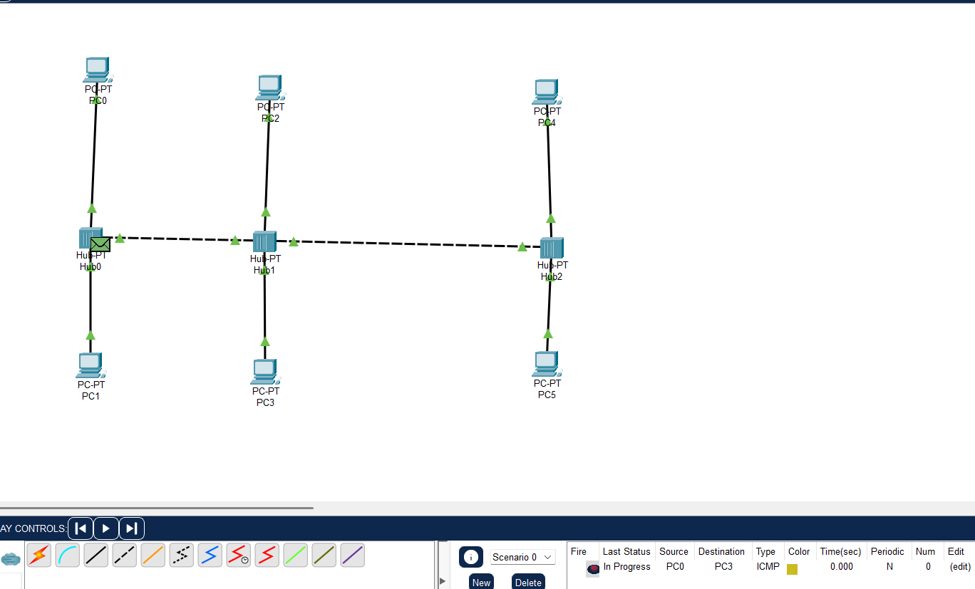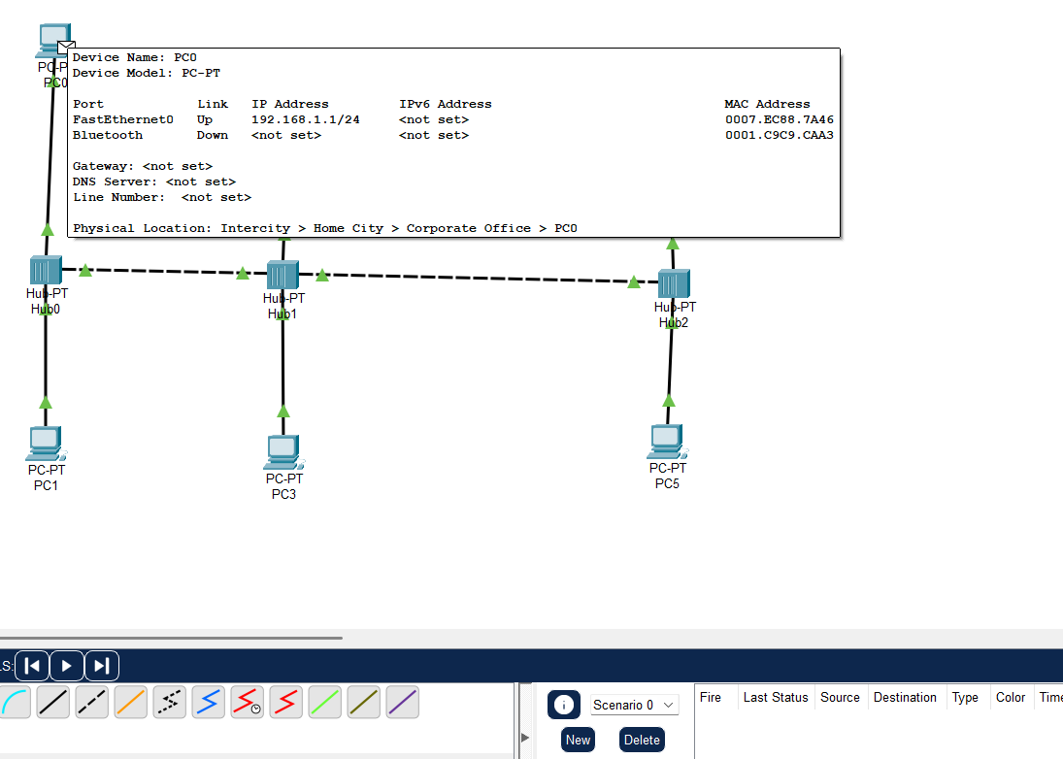

Output:

