**Experiment-11**

**Designing two different network with Static Routing techniques using Packet Tracer.**

**Step1:** 2 Routers, 2 Switches and 4 PCs

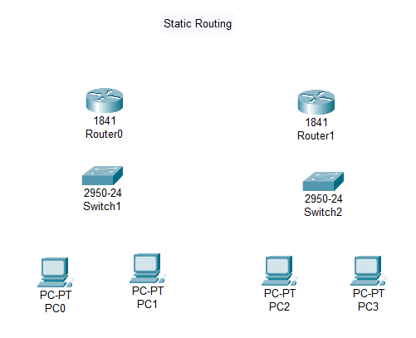

**Step2:** Connect fast ethernets from Router to Router, Router to Switch and PCs

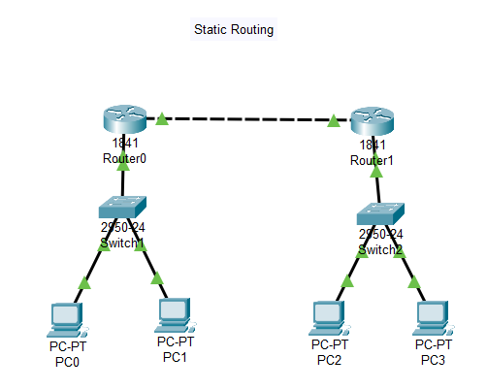

**Step3:** Assign IP address for each PCs

IP address for PC0:192.168.0.1

IP address for PC1: 192.168.0.2

IP address for PC2: 192.168.0.3

IP address for PC3: 192.168.0.4

**Step4:** allocate the message

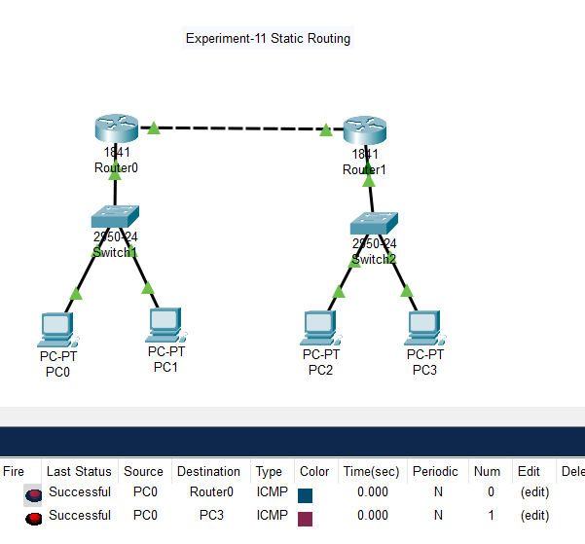

**Result:** message sent successfully from PC0-Router0 and PC0-PC3