**Experiment-12**

**Design the Functionalities and Exploration of TCP using Packet Tracer.**

**Step1:** 1 Server, 1 Switch and 4 PCs

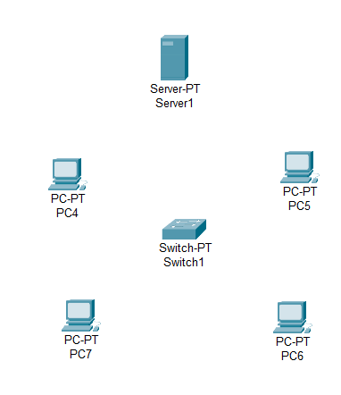

**Step2:** connect fast ethernets from Hub to PCs

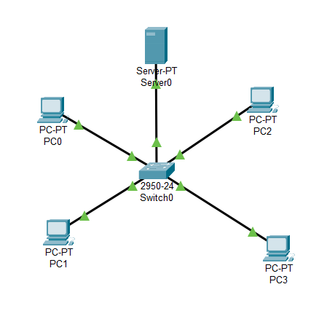

**Step3:** Assign IP address for each PCs

IP address for PC0:192.168.0.1

IP address for PC1: 192.168.0.2

IP address for PC2: 192.168.0.3

IP address for PC3: 192.168.0.4

**Step4:** Simulation

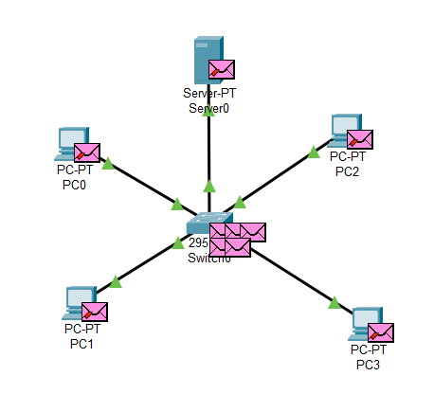

**Result:** Message Forwarding successfully