**Experiment-13**

**Design the network model for Subnetting – Class C Addressing using Packet Tracer.**

**Step1:** 1 Router, 2 Switches and 4 PCs

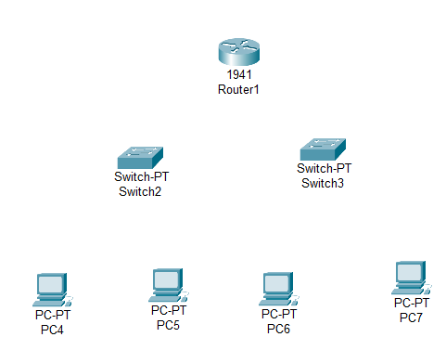

**Step2:** connect fast ethernets from Router to Switch and Switch to PCs

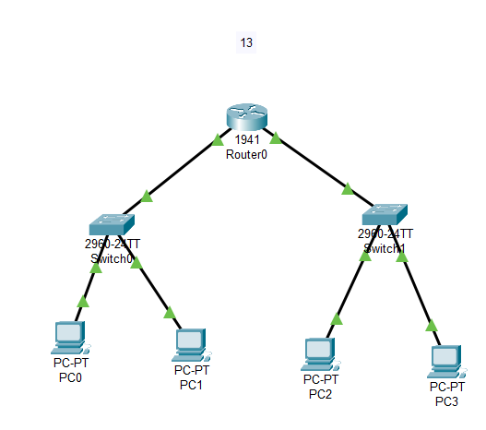

**Step3:** Assign IP address for each PCs

IP address for PC0:192.168.0.1

IP address for PC1: 192.168.0.2

IP address for PC2: 192.168.0.3

IP address for PC3: 192.168.0.4

**Step4:** allocate the message

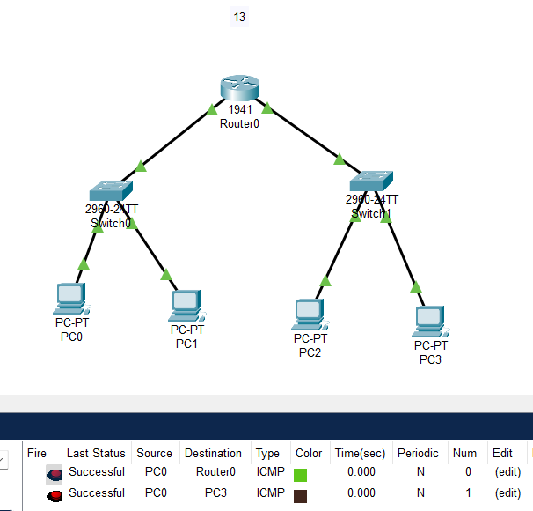

**Result:** message sent successfully from PC0-Router and pc0 – pc3