**Experiment-14**

**Simulating X, Y, Z Company Network Design and simulate using Packet Tracer.**

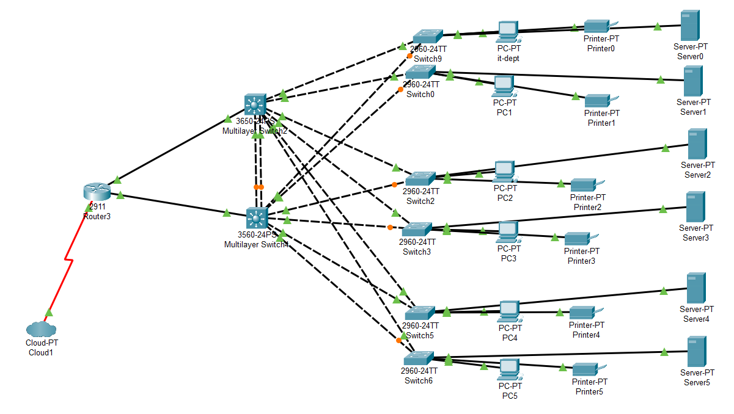

**Step4:** allocate the message

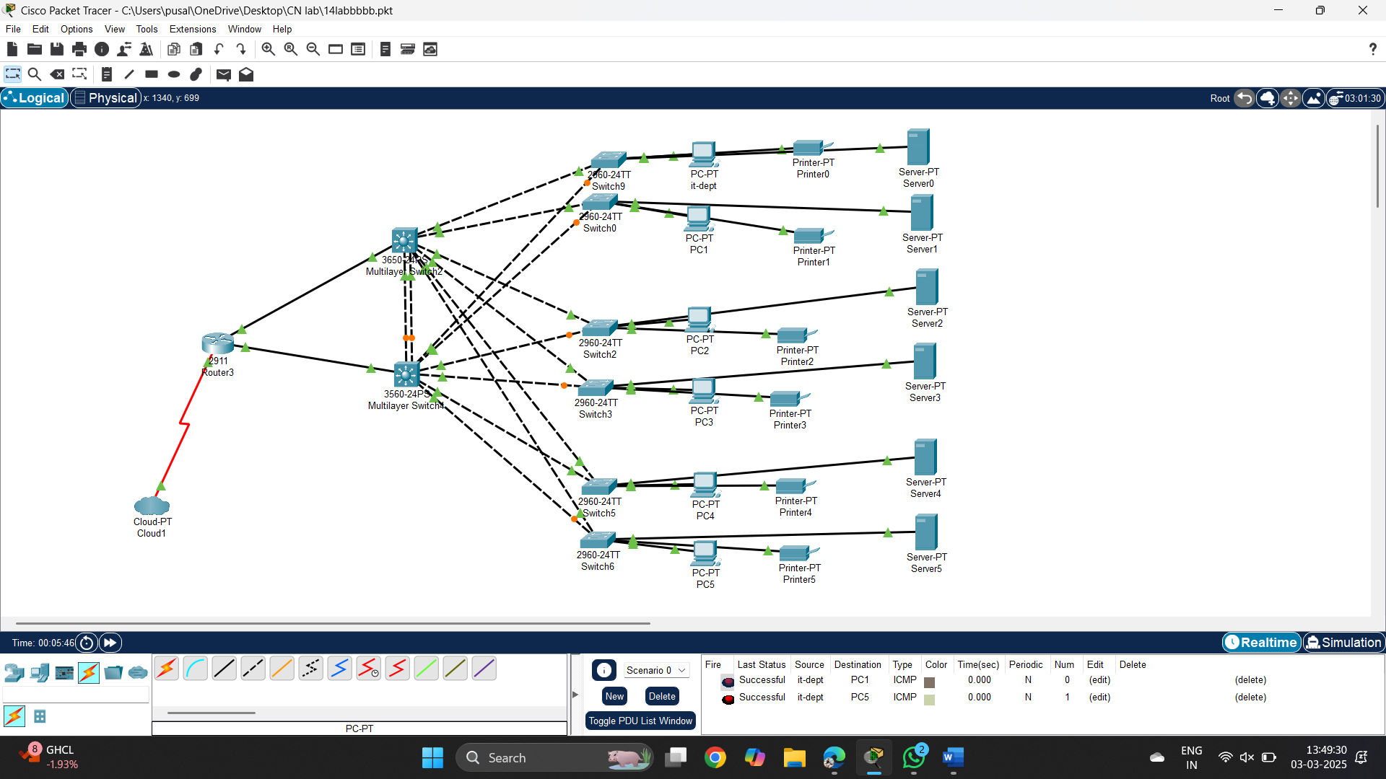

**Result:** message sent successfully from it-dept-PC1