**Experiment-16**

**Configuration of firewall in packet tracer.**

**Step1:** 1 Router, Switch and 2 PCs

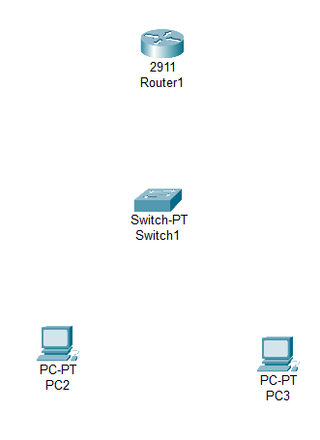

**Step2:** connect fast ethernets from Hub to PCs

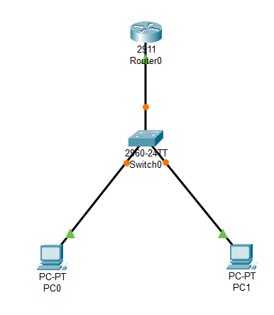

**Step3:** Assign IP address for each PCs

IP address for PC0:192.168.0.1

IP address for PC1: 192.168.0.2

**Step4:** allocate the message

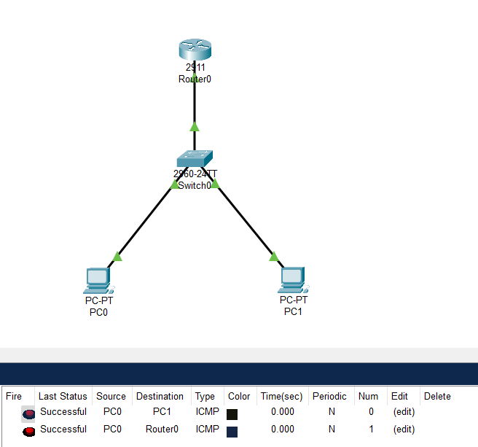

**Result:** message sent successfully from PC0-PC1