**Experiment-17**

**Make a Computer Lab to transfer a message from one node to another to design and simulate using Cisco Packet Tracer.**

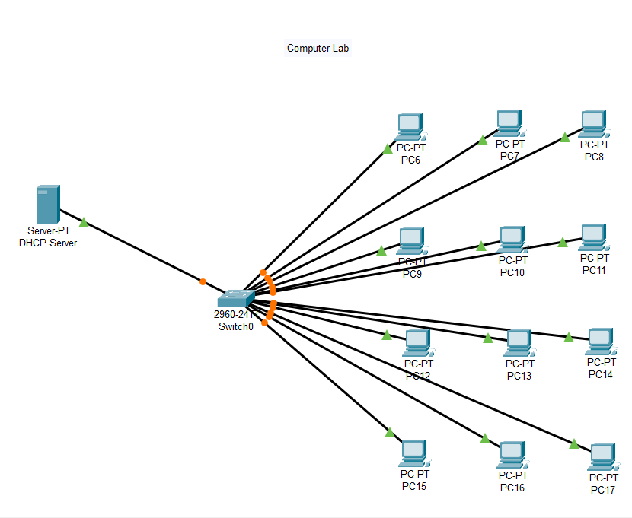

**Allocate message**:

