**SET1**

**Roll number:cb.en.u4cse22527**

Q1)

isVal :: [[a]] -> Bool

isVal [] = True

isVal matrix = isValid && checkDimensions matrix (head matrix)

where

isValid = all (\row -> length row == length (head matrix)) matrix

checkDimensions m firstRow =

case (length m, length firstRow) of

(3, 3) -> True -- Triple matrix

(4, 4) -> True -- Quad matrix

_ -> True

main :: IO ()

main = do

print $ isVal [[1,2], [3,4], [5,6]]

print $ isVal [[1,2,3], [4,5,6], [7,8,9]]

print $ isVal [[1,2,3,4], [5,6,7,8], [9,10,11,12], [13,14,15,16]]

print $ isVal [[1,2,3], [4,5], [6,7,8]]

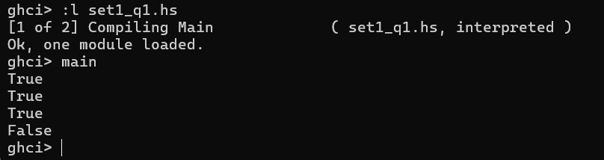

Q2)

partitionList :: (a -> Bool) -> [a] -> ([a], [a])

partitionList p lst = foldr (\x (yes, no) -> if p x then (x:yes, no) else (yes, x:no)) ([], []) lst

main :: IO ()

main = do

print $ partitionList even [1, 2, 3, 4, 5, 6]

print $ partitionList (> 10) [5, 10, 15, 20]

print $ partitionList (`elem` "aeiou") "haskell"

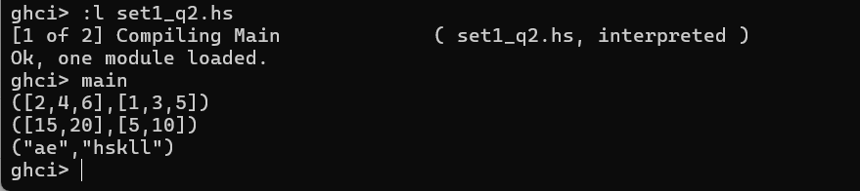

4. lst ::(Eq a, Num a) => [a] -> a -> a -> [a]

lst [] _ _= []

lst (x:xs) a n

| (a == 0) = n : lst xs a (n-1)

| otherwise = x : lst xs (a-1) n

Non-recursive: 4 – i and 5 – i+1

(take 4 [3,5,1,6,8,14]) ++ [15] ++ (drop 5 [3,5,1,6,8,14])

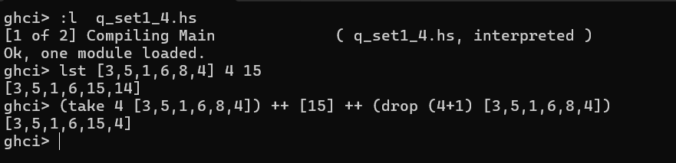

5. addFive :: Int -> Int

addFive x = x + 5

square_it :: Int -> Int

square_it x = x^2

main :: IO()

main = do

print( (\x -> square_it . addFive $ x) 3)

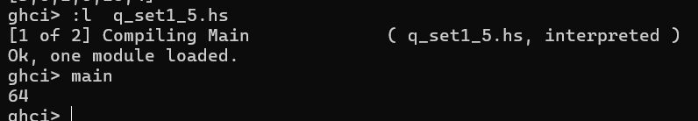

6. myfilter ::(Int->Bool) -> (Int->Bool) -> [Int] -> [Int]

myfilter p1 p2 [] = []

myfilter p1 p2 (x:xs)

| even x = if p2 x then x : myfilter p1 p2 xs else myfilter p1 p2 xs

| otherwise = if p1 x then x : myfilter p1 p2 xs else myfilter p1 p2 xs

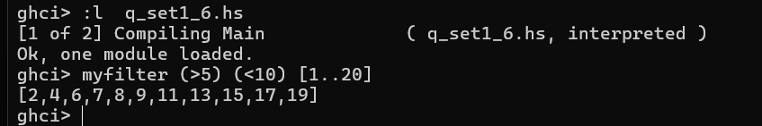

7. rem_vo :: [String] -> [String]

rem_vo [] = []

rem_vo (xs:xxs) = helper xs : rem_vo xxs

helper :: String -> String

helper [] = []

helper (x:xs)

| x elem "aeiouAEIOU" = helper xs

| otherwise = x : helper xs

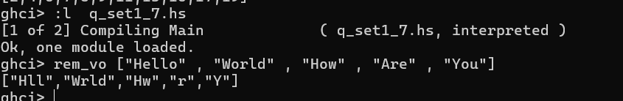

8. rotate :: [a] -> Int -> [a]

rotate xs n

| n >= 0 = (drop n xs) ++ (take n xs)

| n < 0 = (drop len xs) ++ (take len xs)

where len = n + length xs

