PENETRATION TESTING REPORT
FOOTPRINTING & NETWORK SCANNING PHASES
W2-PM-FINAL | CYBERSECURITY | NETWORKWALKS

Pentester Name  (Cybersecurity Professional) | Gopisetti Vamsi Manohar
Program/Batch | B083-Networkwalks
Date | 17 September 2026
Modules completed | W2-PM1 (Multiple Kali Tools)  W2-PM5 (Zenmap Scanning)
Client/Target | 1. Networkwalks (secured written permission already)  2. My own local LAN Network
Permission secured from client? | Yes
Phases covered | Phase 1: Reconnaissance & Footprinting  Phase 2: Scanning & Network Discovery  Phase 3-5: In Progress

1. Liability Disclaimer
I have performed these activities only on the systems & devices where I had secured written permission or the devices/systems that I own myself. All these materials are for education and research purpose only. Do not use anything from here to break the law. The instructor, the authors and Networkwalks are not responsible for what you do with this knowledge. Every action you take is your own responsibility. Misuse can lead to criminal charges, heavy fines, loss of your job and a permanent record. In most countries unauthorised access is a crime even when nothing is damaged.

2. Introduction
This report covers footprinting the networkwalks.com domain using multiple Kali Linux tools (W2-PM1) and scanning my own local network with Zenmap (W2-PM5). One module covers the footprinting phase and the other covers the scanning phase, so together they show how an attacker moves from gathering public information to mapping live hosts on a network. It is the Week 2 part of my ongoing internship program at Networkwalks.
All commands were run in Kali Linux (footprinting) and on a Windows PC with Zenmap installed (scanning). Every step below includes the exact command used, the result I observed, a screenshot as evidence, and a short note on why the finding matters from an attacker's point of view.

3. Tools Used
The table below lists each tool used in this report and its purpose.
Tool | Purpose
Kali Linux & Windows | Operating systems used for reconnaissance activities
WHOIS | Find domain registration details (owner, dates, name servers).
whatweb | Fingerprint web technologies (server, CMS, plugins, IP).
nslookup | Resolve the domain name to its IP address using DNS.
curl -I | Read the HTTP response headers of the website.
wafw00f | Detect whether a Web Application Firewall protects the site.
dnsrecon | Enumerate all DNS records (NS, MX, SPF, TXT, SRV).
Zenmap (Nmap GUI) | Scan the local subnet to find live hosts, IPs and MAC addresses.

4. Activities Performed

4.1 Footprinting & Reconnaissance

I performed reconnaissance against the networkwalks.com domain using six Kali Linux tools: WHOIS, WhatWeb, Nslookup, Curl, Wafw00f and DNSRecon. Each tool was used to collect a different type of information about the target.
First, I used WHOIS to obtain publicly available domain registration information and identify the domain’s name servers. The results provided information about the domain registration and hosting infrastructure.
I then used WhatWeb to identify technologies used by the website. The results identified WordPress 7.1 and WP Download Manager 3.3.58, along with other information exposed by the website.
Using Nslookup, I resolved the domain name to its IP address. The provided result identified 192.232.216.135.
I used Curl with the -I option to inspect the HTTP response headers. This provided additional information about the web application and exposed the WordPress REST API endpoint /wp-json/.
Next, I used Wafw00f to determine whether a Web Application Firewall was protecting the website. The result identified ModSecurity (SpiderLabs).
Finally, I used DNSRecon to enumerate DNS records. The results provided information relating to name servers, mail servers, SPF/TXT records, service records and DNS software information.

4.2 Network Scanning with Zenmap
For the second activity, I used Zenmap to perform network discovery on my local network. The practical required me to identify my local IP address and subnet, discover live hosts, identify their IP and MAC addresses, and generate a network topology.
I first used the Windows ipconfig command to identify my local IP address and LAN subnet. I then entered the subnet into Zenmap and selected Ping Scan to identify active hosts.
The example results provided in the practical identified four live hosts:
- 10.0.0.1
- 10.0.0.2
The example results also included four MAC addresses.
After completing the scan, I opened the Topology section in Zenmap, enabled the legend and saved the network topology in PDF format as required by the practical task.

5. Risk Analysis / Impact
Based on the information collected during the footprinting and network scanning activities, I identified the following potential risks.
# | Risk / Finding | Evidence / Observation | Potential Impact | Risk Level
1 | Web technology information exposed | WhatWeb identified Apache and WordPress-related technologies, including WordPress Download Manager information. | Exposed technology information can help an attacker fingerprint the web application and identify components that may require further security review. | ● Medium
2 | Server IP address identifiable | Nslookup resolved networkwalks.com to 192.232.216.135. | The IP address provides information about the network location of the web service and can assist infrastructure profiling. | ● Low
3 | HTTP technical information exposed | curl -I returned HTTP response information, including HTTP/2 200, Apache/WordPress-related headers and a /wp-json/ REST API link. | This information may assist technology fingerprinting and further authorized enumeration of the web application. | ● Low
4 | WAF detection result inconclusive | The Wafw00f test encountered a temporary DNS NameResolutionError in the lab environment. A successful curl request later confirmed that the website was reachable. | The result does not confirm whether a WAF is present or absent. A repeat test under stable DNS conditions would be required for confirmation. | ● Low
5 | DNS infrastructure information exposed | DNSRecon identified HostGator name servers, SPF/TXT information, Google site-verification information and DNS-related records. DNSSEC was recorded as not configured. | DNS information can help build a broader profile of the target's external infrastructure and may identify areas for DNS-security review. | ● Medium
6 | Multiple live hosts visible on local network | Zenmap/Nmap identified three live hosts in the scanned /24 local network. | Unexpected or unauthorized devices on an internal network could increase the network's attack surface and should be inventoried and verified. | ● Medium
Risk level key: ● Critical ● Medium ● Low
The risks above are observations from the footprinting and scanning exercises, not confirmed vulnerabilities.
The practical exercises primarily involved information gathering, host discovery and service identification. No exploitation or vulnerability validation was performed as part of these two modules.
Therefore, the presence of information such as a software technology, IP address, DNS record or open port does not by itself prove that the system is vulnerable. Further authorized security testing would be required to validate any vulnerability.

6. Recommendations
Based on the actual observations documented in my Week 2 project, I recommend the following security improvements:
- Review publicly exposed technology information
Organizations should regularly review information exposed by their web servers, CMS platforms, plugins and other technologies. Unnecessary technical details should be minimized where practical.
- Keep web technologies updated
Apache, WordPress, plugins and other web components should be regularly updated and reviewed against current security advisories.
- Review HTTP response headers
HTTP response headers should be reviewed to determine whether unnecessary technical information is being exposed. Appropriate security headers should also be configured.
- Review DNS configuration regularly
DNS records should be checked periodically to ensure that only required information and services are publicly exposed. DNS-security controls such as DNSSEC can also be evaluated where appropriate.
- Verify WAF protection under stable conditions
The Wafw00f result in this project was inconclusive because of a DNS resolution error. The test should be repeated under stable network/DNS conditions before making any conclusion about WAF protection.
- Perform regular internal network discovery
Organizations should periodically perform authorized network discovery to identify active devices, services and changes within their networks.
- Investigate unknown devices
Any unexpected host discovered during network scanning should be identified, verified and associated with an authorized user, system or business purpose.
- Maintain network documentation
Network topology, IP ranges, devices, services and authorized systems should be documented and updated regularly.
- Protect sensitive evidence when publishing reports
IP addresses, MAC addresses, cookies, verification tokens and other sensitive information should be masked or redacted before publishing project evidence publicly.
- Perform security testing with authorization
Reconnaissance, scanning and penetration-testing activities should only be performed against systems and networks where appropriate authorization has been provided.

7. Conclusion
The Week 2 penetration testing activities successfully covered the Footprinting and Network Scanning phases using authorized and controlled testing. During the footprinting phase, multiple Kali Linux tools were used to gather information about networkwalks.com, including domain registration details, DNS records, server information, web technologies, HTTP response headers, and the available REST API endpoint.

The network scanning phase using Zenmap/Nmap provided visibility into the local network by identifying live hosts and exposed services.

The assessment also showed that some results require further validation. In particular, the Wafwoof scan was inconclusive because of a temporary DNS resolution error, so no definite conclusion about WAF protection was made.

Overall, this project provided practical experience in reconnaissance, DNS enumeration, web technology identification, network discovery, and service enumeration. The findings can be used to improve security visibility and guide further authorized vulnerability assessment and hardening activities.

8. Evidences Collected

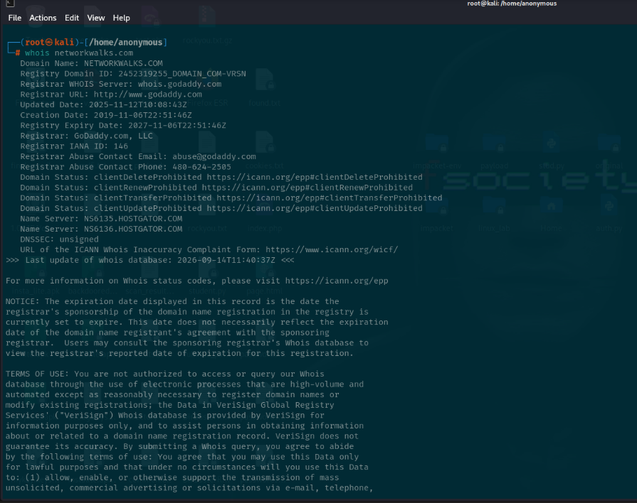

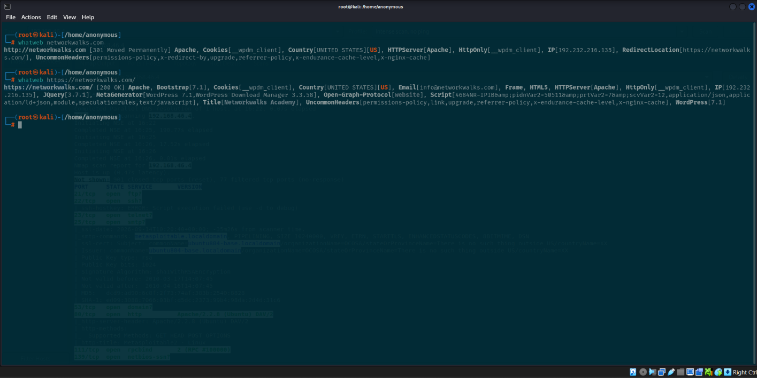

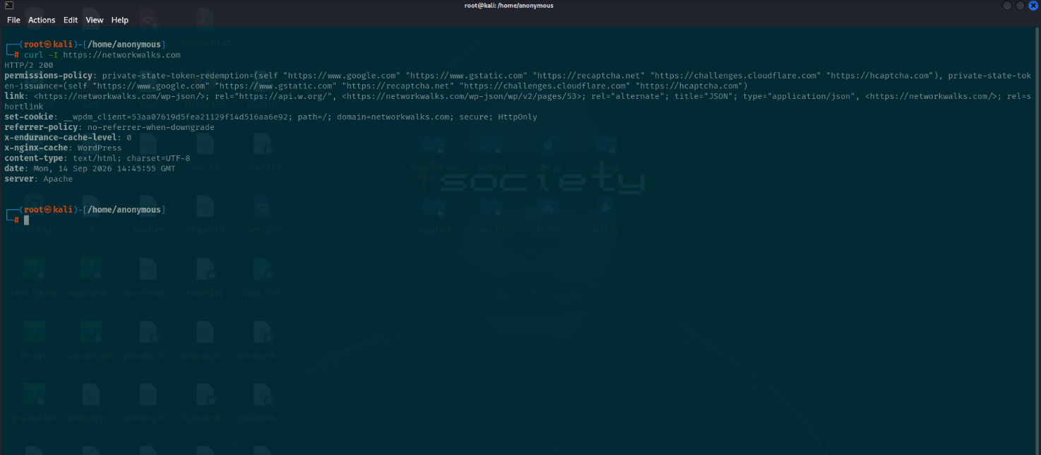

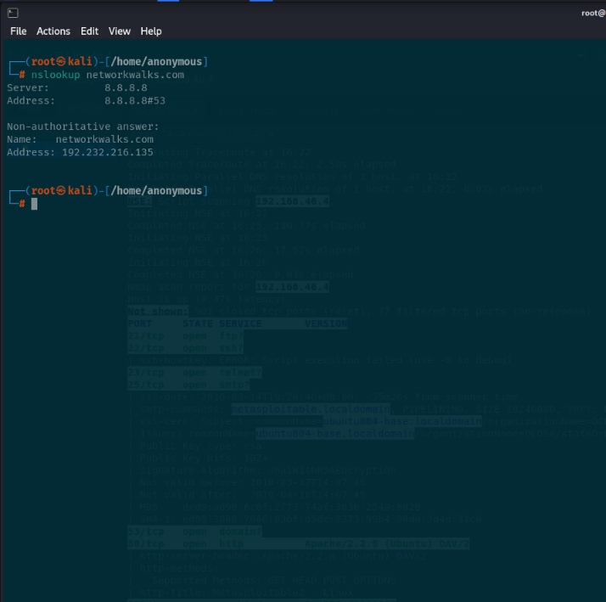
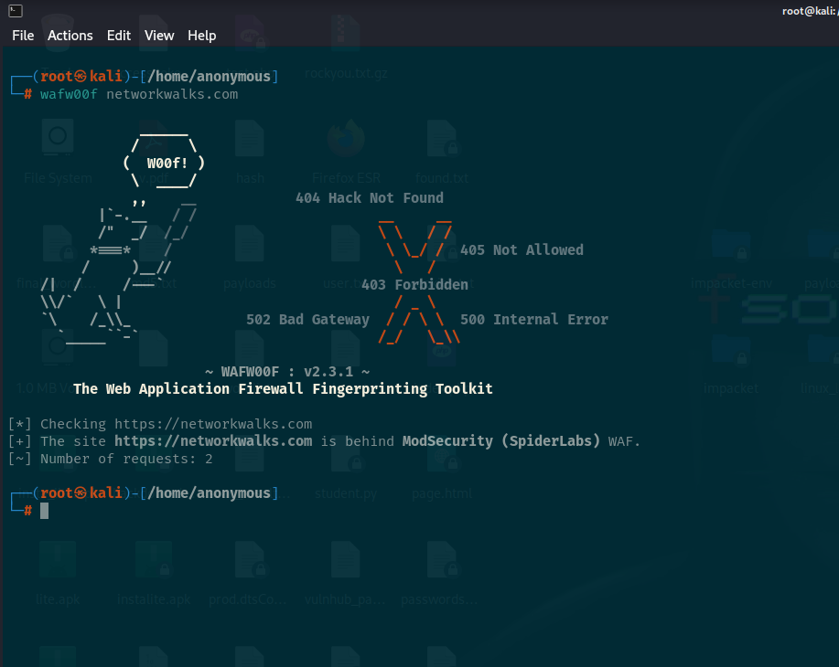

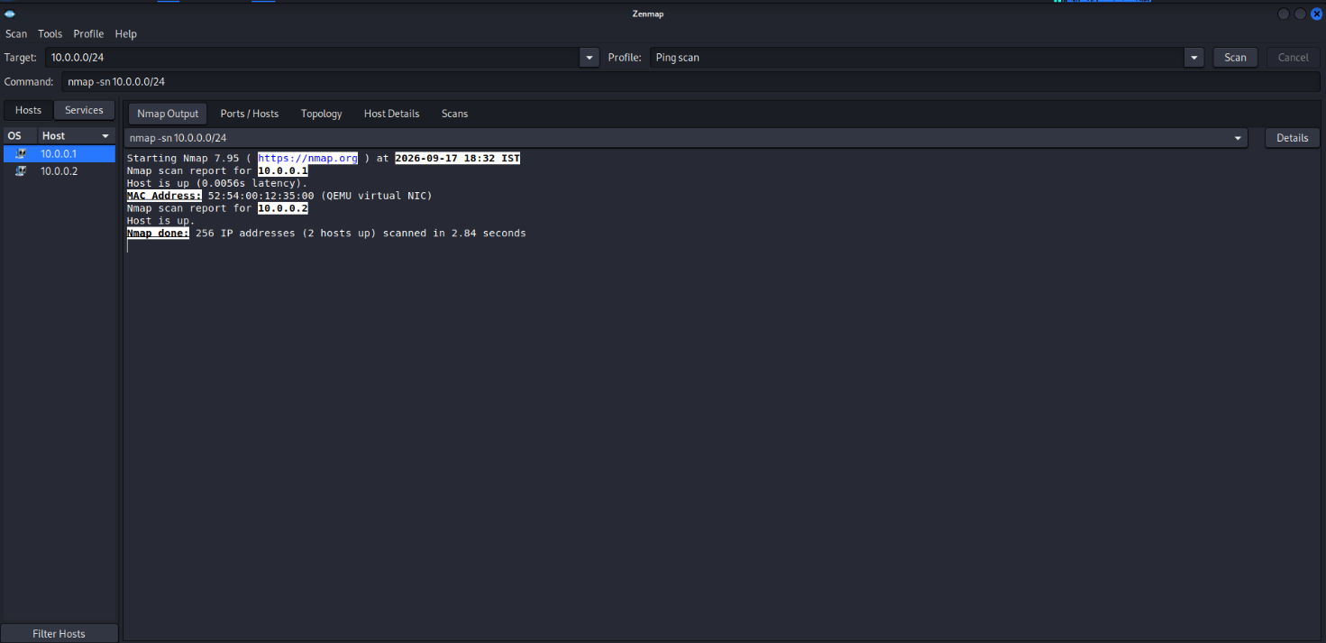
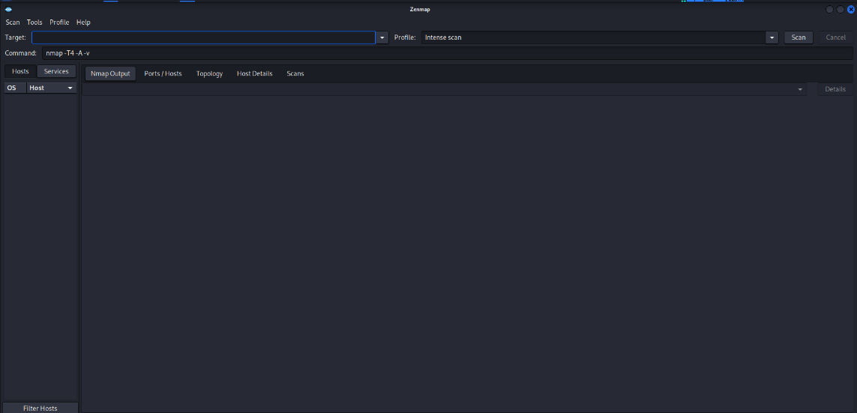
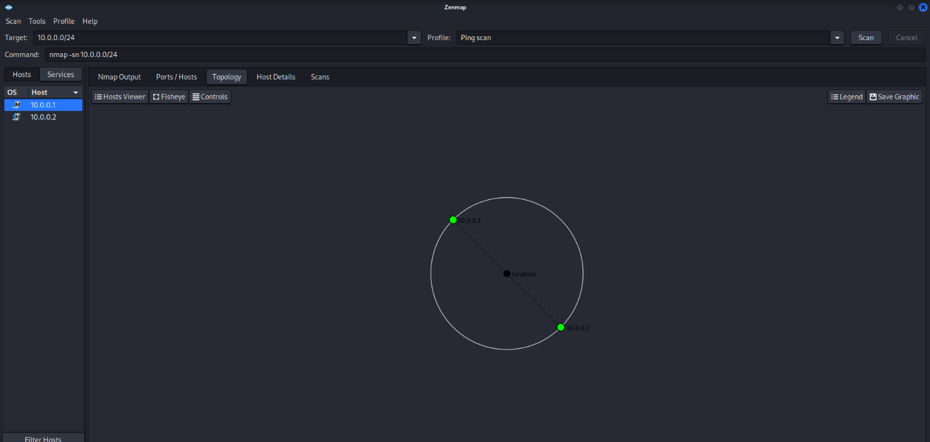

-End-

👤 Author
Gopisetti Vamsi Manohar
Cybersecurity Professional B083
LinkedIn: https://www.linkedin.com/in/vamsi-manohar

📌 Project Information
Program Name: Cybersecurity program at Networkwalks | Week: 02 | Repository: https://github.com/Vamsimanohar0/NETWORKWALKS-B083-WK2

