PENETRATION TESTING REPORT
Mediroza General Hospital
Networkwalks B083 | Week 4
Black-Box Web Application Penetration Test
Target: https://medirozahospital.com
Assessment status: Completed

1. Executive Summary
This report documents the authorized black-box penetration test of Mediroza General Hospital's web infrastructure. The engagement was conducted within the scope defined by the Networkwalks B083 Week 4 project brief: testing was restricted to the target domain, with no social engineering or denial-of-service testing.
The assessment demonstrated an attack chain beginning with information disclosure through robots.txt, followed by exposure of a legacy SQL database backup under the /old/ path. Testing of the patient authentication function identified SQL injection that allowed authentication bypass and access to three locked patient PDF reports. The recovered project evidence also established that the exposed database backup contains staff salary records and shareholder records.
For PDF 1, the supplied PDF hash was identified by the recovery service used during the exercise as PDF R3 / 128-bit, and the password candidate 123456 was returned. Local John the Ripper parsing did not accept the supplied hash, so local cryptographic verification was not demonstrated in the available evidence. This distinction is retained in the report rather than presenting the online recovery result as independently verified.

2. Engagement Scope and Authorization
Client | Mediroza General Hospital
Assessment type | Penetration Testing & Vulnerability Assessment
Testing model | Black-box
Target | https://medirozahospital.com
Duration | 5 days (per project brief)
Authorization | Written authorization granted
In scope | Target domain / web infrastructure
Explicit exclusions | Social engineering and denial of service
The project brief states that the assessment was conducted in a controlled educational environment and that the target was authorized for security testing.

3. Objectives and Methodology
The assessment followed the four milestones defined by the project brief:
- M1 – Initial Access: identify an exposed entry point and retrieve three confidential patient PDF lab reports.
- M2 – Data Extraction: analyze and recover the contents/passwords of the three encrypted PDF files.
- M3 – Critical Data Exposure: identify exposure of hospital employee salary data and shareholder details.
- M4 – Reporting: document findings, evidence, risk, and remediation.
Observed techniques included web reconnaissance, review of robots.txt, directory enumeration, inspection of exposed files, analysis of authentication behavior, SQL injection testing, PDF hash extraction, and password-recovery testing. Testing remained focused on the authorized target.

4. Findings Summary
ID | Finding | Severity | Affected Area
F-01 | SQL Injection / Authentication Bypass | Critical | /patient/ authentication
F-02 | Publicly Accessible Legacy Database Backup | Critical | /old/
F-03 | Sensitive Patient PDF Exposure | Critical | Patient restricted area / PDF files
F-04 | Weak PDF Password / Password Recovery | High | Patient report 1
Severity ratings are based on demonstrated confidentiality impact and attack-chain consequences in the controlled exercise. The ratings are assessment judgments rather than ratings supplied by the project brief.

5. Detailed Findings

F-01 — SQL Injection in Patient Authentication
Severity: Critical
Affected component: Patient login at /patient/

Description
The patient authentication mechanism accepted a SQL injection payload in the username field. The test payload used during the exercise was:
admin' --
An arbitrary password was supplied. The application subsequently granted access to the restricted patient area, demonstrating authentication bypass.

Impact
An attacker able to reach the patient login could bypass intended authentication controls and access restricted

Evidence
- Patient login endpoint was identified during reconnaissance.
- SQL injection payload was accepted in the username field.
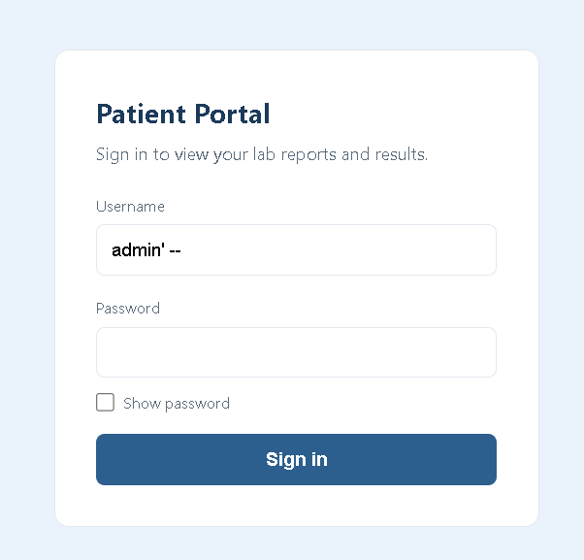
- Authentication succeeded despite use of an arbitrary password.
- Three locked patient PDF files became accessible after the bypass.
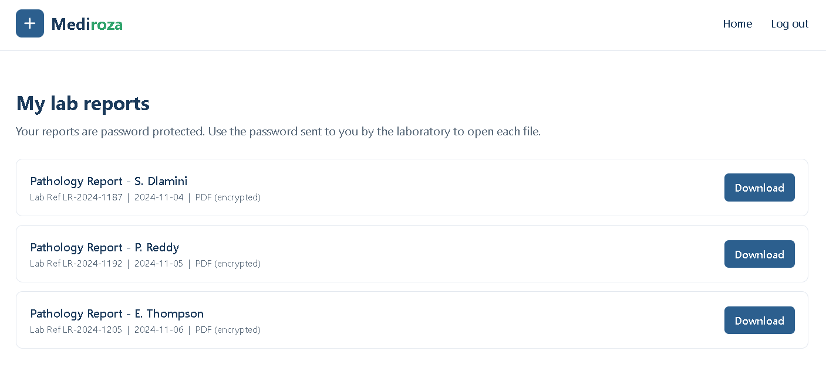

Remediation
- Replace dynamically constructed SQL statements with parameterized queries/prepared statements.
- Apply strict server-side input handling and avoid concatenating user-controlled values into SQL.
- Use a well-tested authentication framework and centralized authentication logic.
- Return generic authentication errors and avoid database error disclosure.
- Add automated SQL injection tests to the application's security regression suite.

F-02 — Publicly Accessible Legacy Database Backup
Severity: Critical
Affected component: /old/mediroza_db_backup_2019.sql

Description
Directory enumeration identified /old/ through robots.txt. The /old/ location exposed a downloadable SQL backup named mediroza_db_backup_2019.sql. The backup identifies itself as an internal Mediroza CMS 1.4.2 backup for the mediroza_hr database and warns that it contains confidential staff and shareholder records.

Impact
The backup discloses structured confidential business and personnel information, including employee names, job titles, departments, email addresses, phone numbers, national IDs, monthly salaries, joining dates, and shareholder names, ownership percentages, share counts, and share classes.

Evidence
The supplied SQL dump contains a staff table with 30 employee records and a shareholders table with 10 records. The backup metadata states a backup date of 2019-08-27 02:14:03.
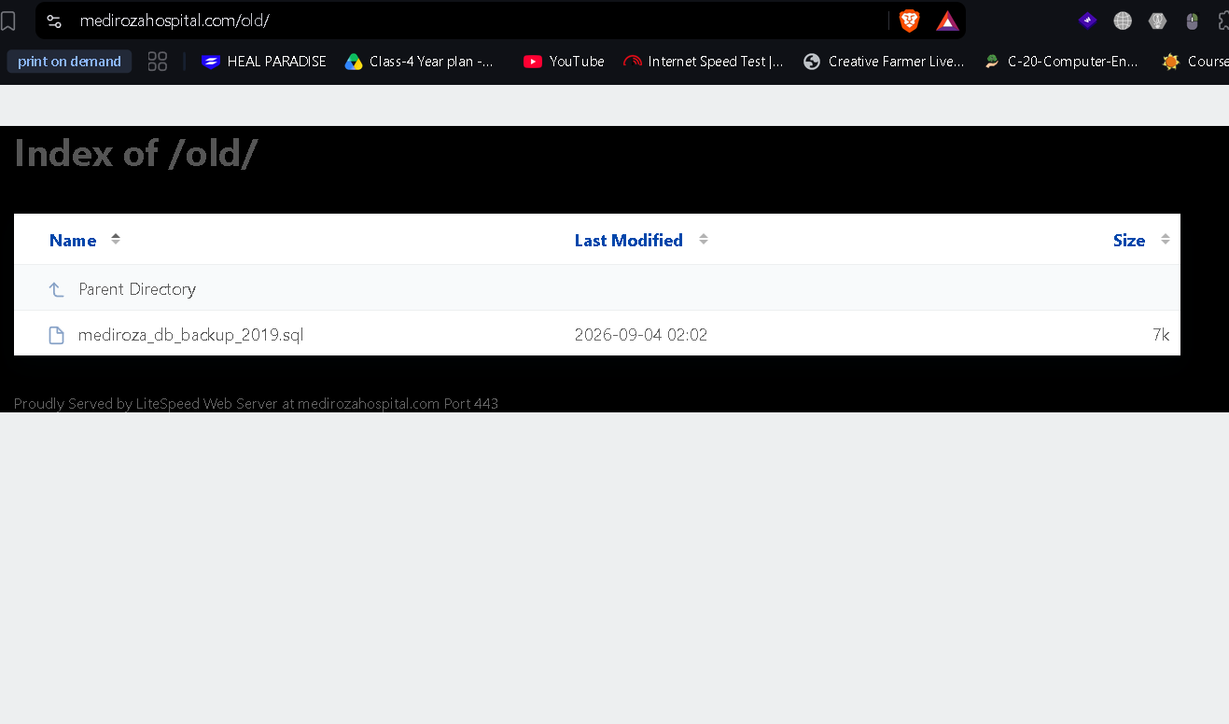
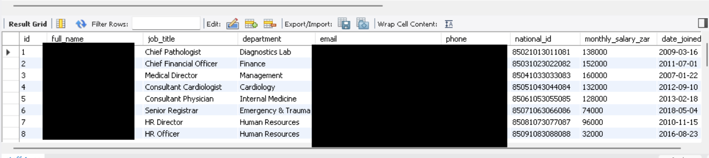
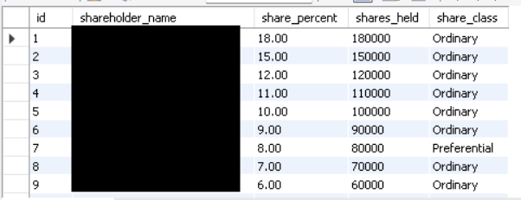

Remediation
- Remove database backups, source archives, and other sensitive artifacts from web-accessible directories.
- Store backups outside the web document root and restrict access through appropriate administrative controls.
- Implement deployment checks that detect .sql, .bak, archive, and configuration files in public directories.
- Review historical/legacy directories and remove obsolete application versions and backup modules.
- Rotate or invalidate any credentials, tokens, or secrets that may have been present in exposed backups.

F-03 — Confidential Patient Report Exposure
Severity: Critical
Affected component: Patient restricted area and three locked PDF lab reports

Description
Following authentication bypass, the assessment reached the restricted patient area and identified three locked PDF lab reports. This satisfied the project's M1 objective of demonstrating access to three confidential patient reports.

Impact
The exposure creates a direct confidentiality risk because patient laboratory reports are sensitive medical records. The demonstrated authentication bypass provides the enabling condition for unauthorized access.

Remediation
- Fix the underlying authentication SQL injection described in F-01.
- Enforce authorization checks for every patient document request, not merely at the portal level.
- Use unpredictable, access-controlled document identifiers and prevent direct object access without authorization.
- Log and monitor access to patient documents and alert on anomalous authentication/access patterns.
- Review the three exposed reports and any related document endpoints for broader unauthorized access.

F-04 — Weak Password Protection on Patient PDF
Severity: High
Affected components: patient_report_1.pdf, patient_report_2.pdf, patient_report_3.pdf

Description
The PDF hash extracted for patient_report_1.pdf was represented in $pdf$ format with parameters corresponding to PDF R3 / 128-bit encryption. An online recovery tool used during the exercise returned 123456 as a matching password. However, the same hash was not accepted by the local John the Ripper installation during the documented attempts. Accordingly, 123456 should be treated as a recovered candidate from the online tool rather than independently verified local decryption in this report.
PDF | HASH | PASSWORD
patient_report_1.pdf | $pdf$2*3*128*4294967292*1*32*3361663365326235643333353531613238303137316238333238373763353339*32*ef16c52ab8efce2c18c79e9d28895b5928bf4e5e4e758a4164004e56fffa0108*32*c431fab9cc5ef7b59c244b61b745f71ac5ba427b1b9102da468e77127f1e69d6 | 123456
patient_report_2.pdf | $pdf$2*3*128*4294967292*1*32*3166346338373236356437626464363834663737303265633666363264616463*32*39f4e6b0aedf12344c340ffb39f8905528bf4e5e4e758a4164004e56fffa0108*32*408b37bcf12da873d7f2840f3c1b917a023961ded4c8164d38e46e9655e66775 | password
patient_report_3.pdf | $pdf$2*3*128*4294967292*1*32*3261393066326130336634386337323631306164373264323130316137616538*32*5090fa0a5dba99cb97c9d140cd23119428bf4e5e4e758a4164004e56fffa0108*32*58e03d692cf37b50b0b5eaa189fcbd372260a949c8992ad7b44fd13e2b40c1f8 | !@#$%^&

Impact
A weak document password reduces the protection provided by PDF encryption if an attacker obtains the encrypted file. Combined with the patient-area access vulnerability, weak document passwords increase the potential impact of document disclosure.

Evidence
The supplied images are cracked PDF’s
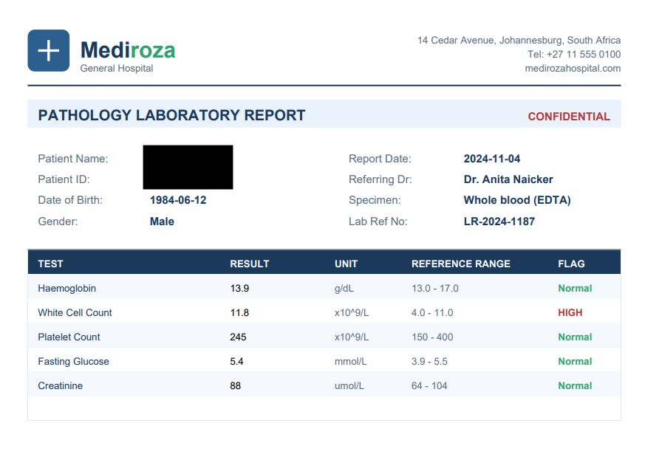
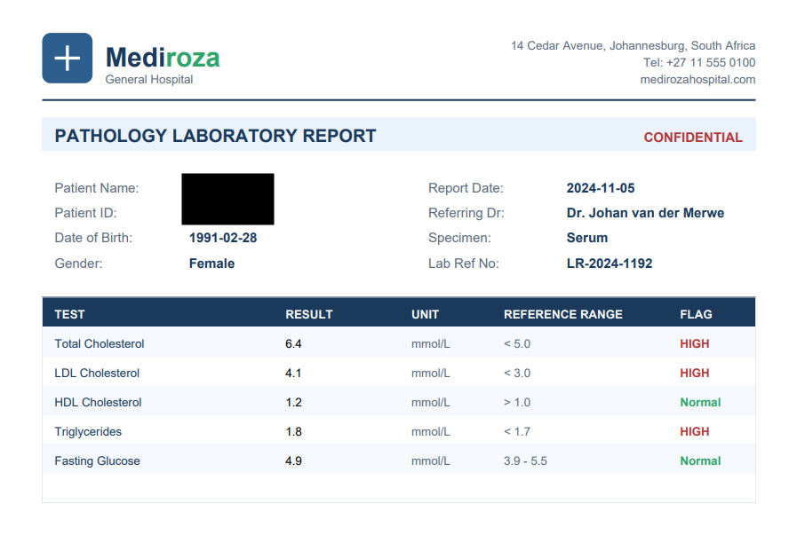
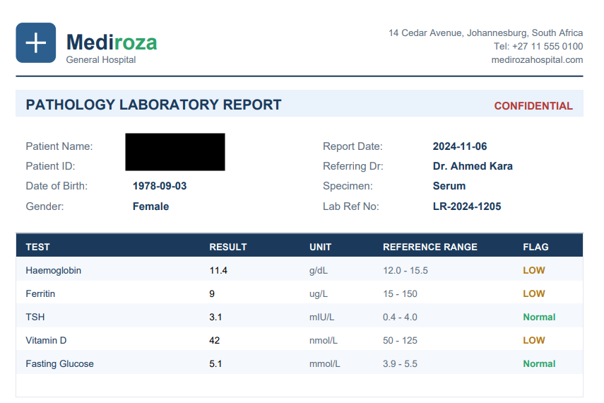

Remediation
- Do not rely on short/common passwords for sensitive patient documents.
- Prefer access-control enforcement at the application layer over distributing sensitive documents protected only by passwords.
- If document-level encryption is required, use strong, randomly generated secrets managed through an appropriate key-management process.
- Review existing patient PDFs for weak or reused passwords and reissue them with appropriate protection.

6. Milestone Results
Milestone | Status | Result
M1 | Completed | robots.txt disclosed restricted paths; SQL injection in patient authentication bypassed login; three locked patient PDFs were reached.
M2 | Substantially completed | PDF 1 was identified as PDF R3/128-bit and an online recovery tool returned 123456. Local John parsing did not accept the supplied hash, so local decryption evidence was not independently verified in this record.
M3 | Completed | The exposed SQL backup contained staff salary and shareholder tables, directly satisfying the stated M3 objectives.
M4 | Completed | This report documents scope, methodology, findings, evidence, risk, and remediation.

7. Attack Chain
- Reconnaissance identified robots.txt.
- robots.txt disclosed /patient/, /staff/, and /old/ paths.
- /old/ exposed a legacy SQL database backup.
- The patient portal's authentication function was tested.
- SQL injection in the username field bypassed authentication.
- The restricted patient area exposed three locked PDF reports.
- PDF’s was converted to a $pdf$ hash and tested for password recovery.
- The SQL backup disclosed employee salary and shareholder information.

8. Overall Risk and Business Impact
The demonstrated vulnerabilities form a high-impact confidentiality attack chain. Authentication bypass allows access to restricted patient resources, while the publicly accessible SQL backup independently exposes confidential personnel and ownership records. The combination indicates that sensitive information is not being adequately protected at multiple application and deployment layers.
The most urgent remediation priorities are to eliminate the SQL injection, remove public access to database backups and legacy directories, and review authorization controls around patient documents.

9. Remediation Priority Plan
- Immediate: Disable public access to /old/ and remove the exposed SQL backup.
- Immediate: Correct the patient login SQL injection using parameterized queries.
- Immediate: Review patient-document authorization and invalidate unauthorized sessions.
- High: Audit the web root for additional backups, source files, archives, and legacy application content.
- High: Review and strengthen document encryption/password practices.
- Medium: Add secure deployment checks, vulnerability scanning, and SQL injection regression tests.
- Medium: Implement centralized logging and monitoring for authentication and patient-document access.

10. Evidence and Limitations
Evidence available for this report includes the project brief, the observed robots.txt content, the exposed SQL backup contents supplied during the exercise, the SQL injection payload and observed authentication bypass, and the PDF hash/password-recovery output described during the exercise.
Patient medical contents, personal identifiers, and other sensitive records are intentionally not reproduced in this report. They are unnecessary to establish the vulnerabilities and should be handled according to the client's evidence-handling requirements.
The project brief itself does not provide a CVSS scoring methodology, and no independent CVSS calculation was performed. The Critical/High labels in this report are qualitative assessment ratings based on demonstrated impact.
The report does not claim independent local verification of PDF 1 decryption because the available evidence shows that the online recovery tool returned 123456 while the local John the Ripper installation rejected the hash. This limitation should be resolved before treating the PDF password as fully verified.

11. Conclusion
The authorized assessment demonstrated multiple security weaknesses across the web application and its deployed content. The primary attack path was SQL injection leading to patient-portal authentication bypass and access to three confidential patient reports. Separately, a legacy database backup was publicly accessible and exposed employee salary and shareholder records. These findings provide clear remediation targets for application, deployment, access-control, and document-protection improvements.

Appendix A — Reproduction Evidence to Attach
- Screenshot of robots.txt showing /patient/, /staff/, and /old/.
- Screenshot/HTTP evidence of the exposed SQL backup URL.
- Redacted screenshot of the patient login and the SQL injection test.
- Redacted screenshot demonstrating successful authentication bypass.
- Screenshot showing the three locked PDF reports, with patient identifiers obscured.
- PDF hash output for each report.
- Password-recovery output for each report, with sensitive document contents omitted.
- Relevant file hashes and timestamps for collected evidence.

