**Course:** Big Data Development

**Mentor:** Mufaddal

**Answers:**

**Assignment 1:**

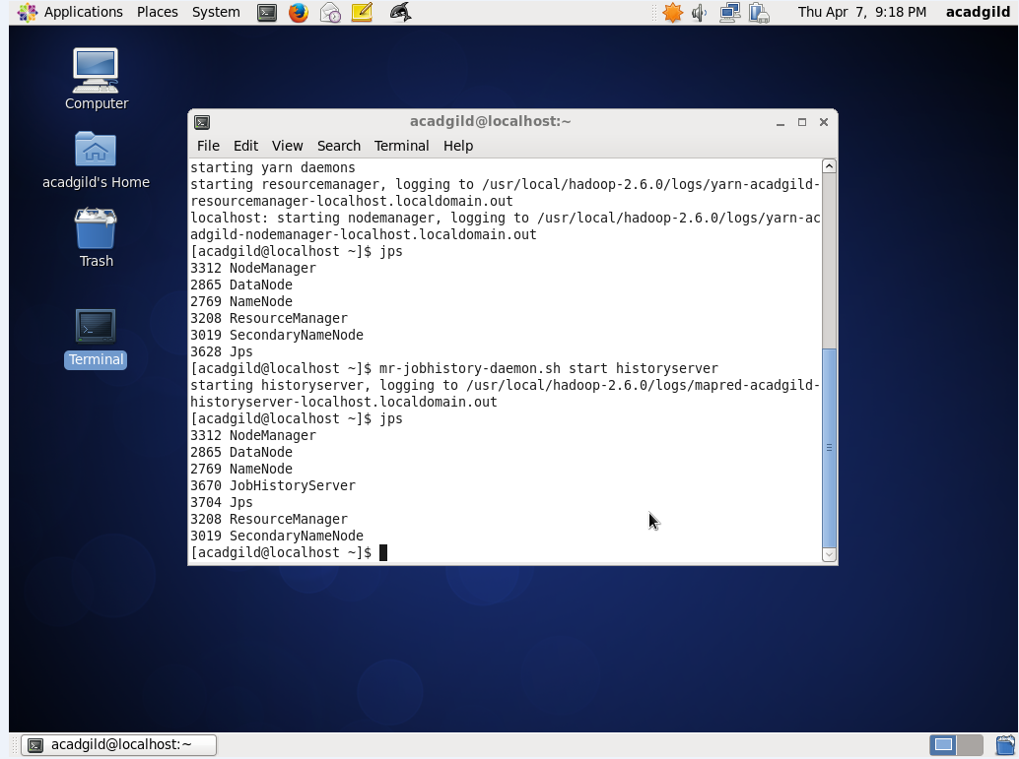

**Assignment 2:**

1. D
2. A
3. A
4. C
5. D
6. A
7. C
8. A
9. C
10. C
11. B
12. D
13. B
14. A
15. D