Section 1: Resume Information Extraction
import re
def extract_resume_info(resume_text):
data = {}
name_match = re.search(r'(?:Name\s*:\s*|^)([A-Z][a-z]+(?:\s+[A-Z][a-z]+)+)', resume_text, re.MULTILINE)
data['Name'] = name_match.group(1).strip() if name_match else "Unknown"
email_match = re.search(r'[a-zA-Z0-9._%+-]+@[a-zA-Z0-9.-]+\.[a-zA-Z]{2,}', resume_text)
data['Email'] = email_match.group(0) if email_match else "Not found"
phone_match = re.search(r'(?:\+?\d{1,3}[-.\s]?)?[6-9]\d{9}', resume_text)
data['Phone'] = phone_match.group(0) if phone_match else "Not found"
skills_list = ['Python', 'Java', 'SQL', 'Machine Learning', 'NLP']
found_skills = []
for skill in skills_list:
if re.search(rf'\b{re.escape(skill)}\b', resume_text, re.IGNORECASE):
found_skills.append(skill)
data['Skills'] = found_skills
exp_match = re.search(r'(\d+(?:\.\d+)?)\+?\s*(?:years?|yrs?)(?:\s+of)?\s+experience', resume_text, re.IGNORECASE)
data['Experience'] = float(exp_match.group(1)) if exp_match else 0.0
return data
def process_resumes(resumes):
print("=" * 60)
print("RESUME PROCESSING & SHORTLISTING SYSTEM")
print("=" * 60)
shortlisted = []
for idx, text in enumerate(resumes, 1):
info = extract_resume_info(text)
print(f"\n--- Candidate Profile #{idx} ---")
for k, v in info.items():
print(f"{k}: {v}")
is_eligible = info['Experience'] >= 2.0 and any(s.lower() == 'python' for s in info['Skills'])
if is_eligible:
shortlisted.append(info['Name'])
print("Status: SHORTLISTED")
else:
print("Status: NOT SHORTLISTED")
print("\n" + "=" * 60)
print("SHORTLISTED CANDIDATES (>= 2 years exp & Python):")
for name in shortlisted:
print(f" - {name}")
print("=" * 60)
sample_resumes = [
"""John Doe
Email: john.doe@example.com | Phone: +91 9876543210
Summary: Data Scientist with 3.5 years of experience.
Proficient in Python, SQL, and Machine Learning.
""",
"""Jane Smith
Contact: jane.smith@domain.org, 9123456789
Experience: 1 year of experience in software development.
Skills include Java, Python, and SQL.
""",
"""Alex Brown
Email: alex.b@tech.com | Phone: 8765432109
Professional with 4 years of experience specializing in Java, NLP, and SQL.
"""
]process_resumes(sample_resumes)
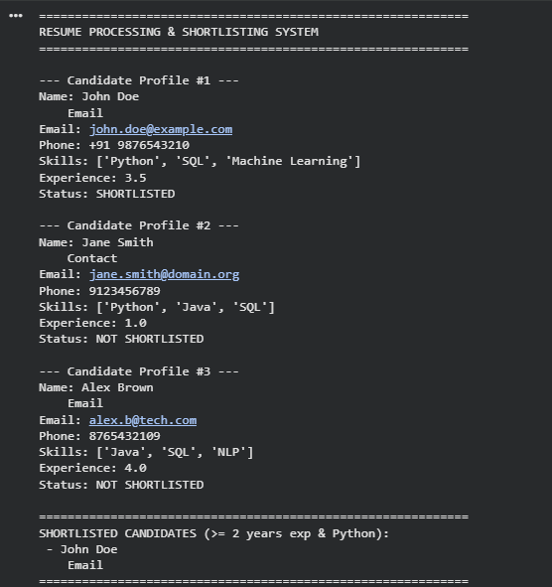

Section 2: Product Search System
import re
class ProductSearchEngine:
def __init__(self, catalog):
self.catalog = catalog
def search(self, pattern, search_type="Search"):
regex = re.compile(pattern, re.IGNORECASE)
results = [product for product in self.catalog if regex.search(product)
print(f"\n--- {search_type} (Pattern: '{pattern}') ---")
if results:
print(f"Found {len(results)} match(es):")
for prod in results:
print(f" • {prod}")
else:
print("No matching products found.")
return results
def exact_match(self, keyword):
return self.search(rf'^{re.escape(keyword)}$', "Exact Keyword Match")
def prefix_match(self, prefix):
return self.search(rf'^{re.escape(prefix)}', "Prefix Match")
def suffix_match(self, suffix):
return self.search(rf'{re.escape(suffix)}$', "Suffix Match")
def partial_match(self, keyword):
return self.search(rf'{re.escape(keyword)}', "Partial Match")
catalog = [
"Apple iPhone 15 Pro",
"Apple iPad Air",
"Apple Watch Series 9",
"Samsung Galaxy S24",
"Samsung Galaxy Watch",
"Sony WH-1000XM5 Headphones",
"Wireless Bluetooth Headphones",
"Smart Watch"
]
engine = ProductSearchEngine(catalog)
engine.exact_match("Smart Watch")
engine.prefix_match("Apple")
engine.suffix_match("Headphones")
engine.partial_match("Watch")
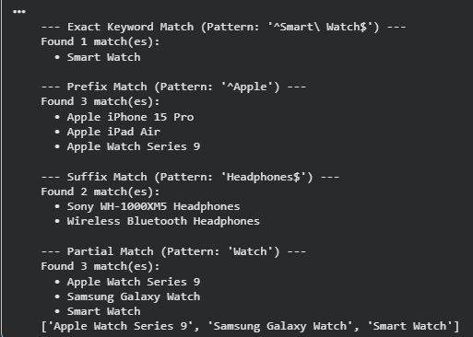

Section 3: University Registration System
import re
def validate_student_registration(student):
errors = []
reg_no_pattern = r'^\d{2}[A-Z]{3}\d{4}$'
if not re.match(reg_no_pattern, student.get('register_number', '')):
errors.append("Invalid Register Number (Expected format: YYDEPTNNNN, e.g., 23CSE1001).")
email_pattern = r'^[a-zA-Z0-9._%+-]+@[a-zA-Z0-9.-]+\.(?:edu|ac\.in)$'
if not re.match(email_pattern, student.get('email', '')):
errors.append("Invalid Institutional Email (Must belong to an .edu or .ac.in domain).")
course_pattern = r'^[A-Z]{2,4}\d{3,4}$'
if not re.match(course_pattern, student.get('course_code', '')):
errors.append("Invalid Course Code (Expected format: 2-4 uppercase letters followed by 3-4 numbers, e.g., CSE201).")
sem_pattern = r'^(?:(?:Sem(?:ester)?\s*)?[1-8])$'
if not re.match(sem_pattern, str(student.get('semester', '')).strip(), re.IGNORECASE):
errors.append("Invalid Semester (Must be between 1 and 8).")

phone_pattern = r'^[6-9]\d{9}$'
if not re.match(phone_pattern, student.get('mobile', '')):
errors.append("Invalid Mobile Number (Must be a 10-digit number starting with 6-9).")
print("\n" + "=" * 50)
print(f"REGISTRATION REPORT: {student.get('name', 'Student')}")
print("=" * 50)
if not errors:
print("Registration Status: SUCCESSFUL")
print("All submitted fields passed validation checks.")
else:
print("Registration Status: FAILED")
print("Reason(s):")
for err in errors:
print(f" - {err}")
print("=" * 50)
valid_student = {
'name': 'Rahul Sharma',
'register_number': '23CSE1045',
'email': 'rahul.s@university.edu',
'course_code': 'CSE301',
'semester': '5',
'mobile': '9876543210'
}
invalid_student = {
'name': 'Ananya Roy',
'register_number': 'CS1001', # Invalid format
'email': 'ananya@gmail.com', # Personal email domain
'course_code': 'CS-101', # Contains hyphen
'semester': '9', # Exceeds standard semester range
'mobile': '1234567890' # Does not start with 6-9
}
validate_student_registration(valid_student)
validate_student_registration(invalid_student)
