# Installing Docker on Windows OS:

1. Go to Bios settings (Press **F2** on startup) and enable Virtualization.
2. Download the Installer:
3. [Docker Toolbox](https://www.docker.com/products/docker-toolbox) (Recommended)
4. [Native Windows Installer](https://docs.docker.com/docker-for-windows/install/#download-docker-for-windows): Experimental and not yet matured so you may face some issues with this if Docker Toolbox or Oracle Virtualbox is already installed.
5. Follow the instructions of the installation page for installation.
6. On first run Docker tool creates a Virtual Private Network so it requires Administrative permissions.

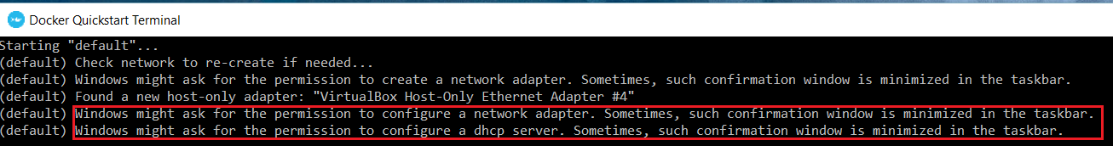

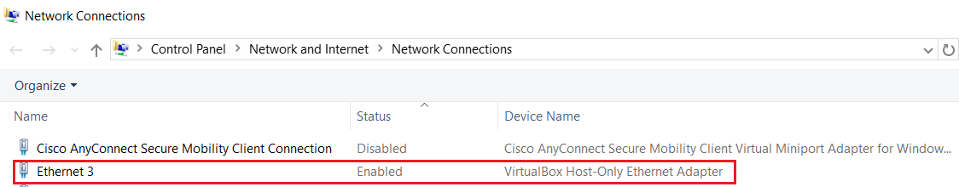

1. Please ignore this INFO message as this was introduced in 1.13 version and would be removed in next stable release.

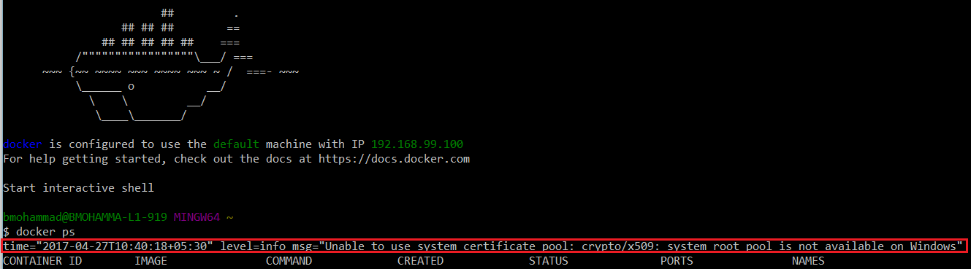

# Create DockerHub Account:

To upload docker images to DockerHub one should have account here are the instructions

1. Go to [DockerHub](https://hub.docker.com/)
2. Provide the required information, make sure to provide valid email id since this will be used for account activation.

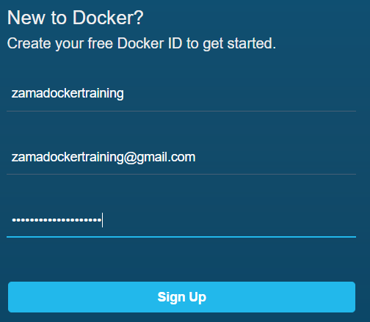



1. Activate your account:

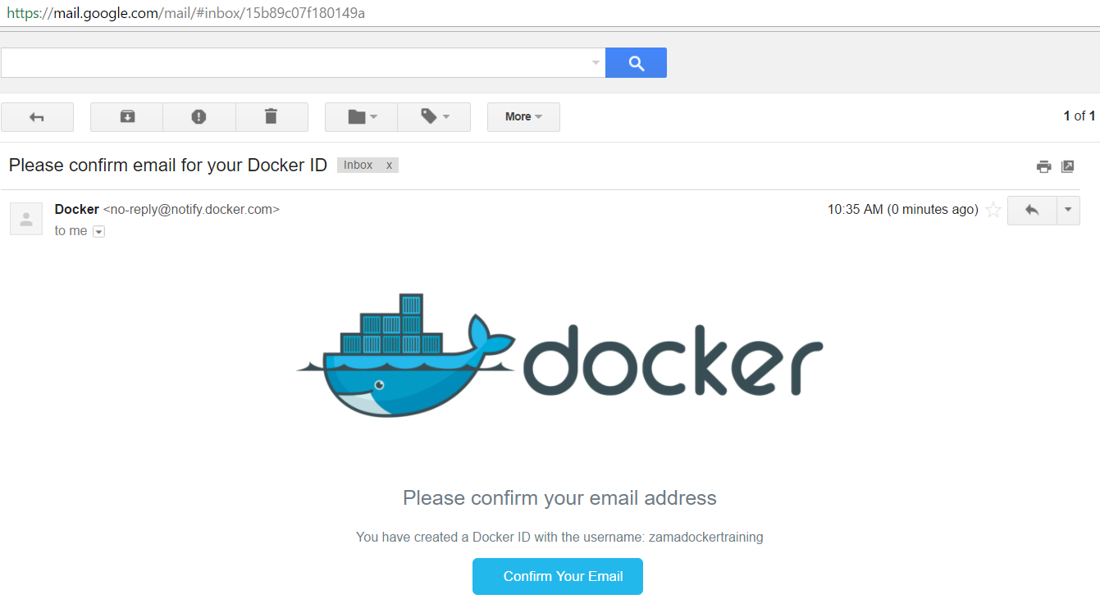

# Create Repository in DockerHub:

To upload Docker image we need to setup Docker repository, here are the instructions:

1. Click on Create Repository

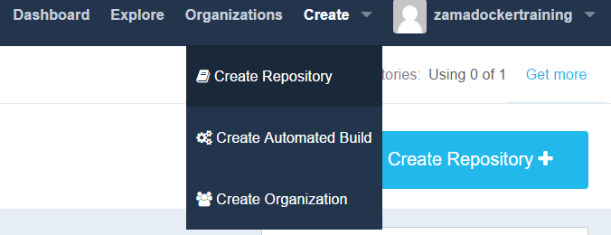

1. Provide the required information

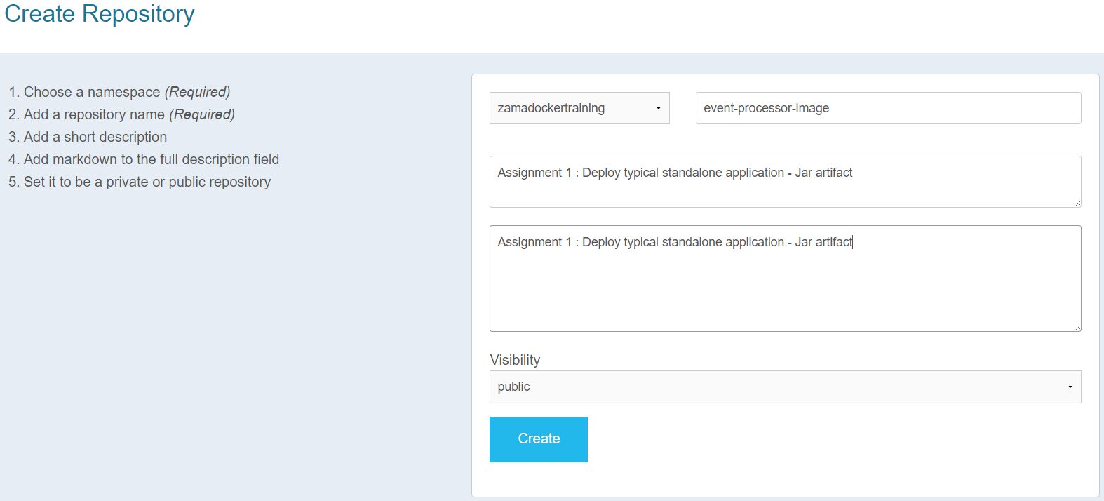

1. Verify your repository

