

Angular With ASP.NET Core Web API
Training Assignments

Document Code | 25e-BM/HR/HDCV/FSOFT
Version | 1.1
Effective Date | 20/11/2012

Hanoi, 06/2024
RECORD OF CHANGES
No | Effective Date | Change Description | Reason | Reviewer | Approver
 | 01/Jun/2024 | Create a newly issued | Create new | ToanHK2  DieuNT1 | VinhNV

Contents
TypeScript Basic: Quiz Application 4
Objectives: 4
Prerequisites: 4
Problem Requirements: 4
Mark Scale: 7

CODE: ANG.M.A001.Opt1
TYPE: MEDIUM
LOC: 190
DURATION: 180 MINUTES

TypeScript Basic: Quiz Application

Objectives:
- Gain a solid understanding of TypeScript syntax, including basic types, interfaces, enums, arrays, objects, and classes.
- Learn how to develop a simple application using TypeScript, applying fundamental programming concepts to manage data and functionality.
- Practice defining and using data models to structure and organize data within an application.
- Understand the concept of services and interfaces in TypeScript to encapsulate and manage application logic and data operations.
- Explore asynchronous programming using promises to handle data retrieval and manipulation operations.
- Develop skills in testing and debugging TypeScript code, including proper error handling and logging techniques.
- Learn how to organize code into modules and classes to promote modularity, reusability, and maintainability.
- Apply fundamental programming concepts to build a basic quiz application, mimicking real-world scenarios encountered in software development.
- Practice structuring a TypeScript project, including organizing code into separate files and adding comments for clarity and documentation
- Enhance problem-solving skills by implementing proper error handling strategies to manage potential exceptions and issues.
- Learn and apply coding best practices, adhering to conventions, and writing clean, readable, and maintainable TypeScript code.

Prerequisites:
- Working environment: Visual Studio Code/Visual Studio 2013 or higher.
- Delivery: Source code packaged in a compress archive.

Problem Requirements:
This assignment challenges you to explore the fundamentals of TypeScript by building a basic quiz application. You'll practice using basic syntax, data types, arrays, objects, classes, interfaces, and modules to manage quiz data and functionality.
Function Requirements:
- Data Model:
Quiz:
  - id: number
  - title: string
  - description: string (optional)
  - duration: number
  - questions: Array<Question> (array of Question objects)

Question:
  - id: number
  - content: string (question content)
  - questionType: enum (MultipleChoice,SingleChoice,TrueFalse, FillInTheBlanks, ShortAnswer, LongAnswer,)
  - answers: Array<Answer> (array of Answer objects)
Answer:
  - id: number
  - text: string (answer text)
  - isCorrect: boolean
- Service class and interface:
IQuizService:
  - getQuizzes(): Promise<Quiz[]> (returns a promise that resolves to an array of all quizzes)
  - getQuizById(id: number): Promise<Quiz | null> (returns a promise that resolves to a specific quiz by ID or null if not found)
  - addQuiz(quiz: Quiz): Promise<void> (adds a new quiz to the system)
  - updateQuiz(quiz: Quiz): Promise<void> (updates an existing quiz)
  - deleteQuiz(id: number): Promise<void> (deletes a quiz by ID)
QuizService:
  - Implement IQuizService
  - Implement in-memory storage for quizzes using an array initially (consider using a more persistent storage solution in a real application)
- Main.ts:
  - Serves as the entry point for testing the functionalities of the QuizService. Imports the QuizService class.
  - Creates an instance of the QuizService.
  - Calls the service methods (addQuiz, getQuizzes, updateQuiz, deleteQuiz, etc.) to test their functionality.
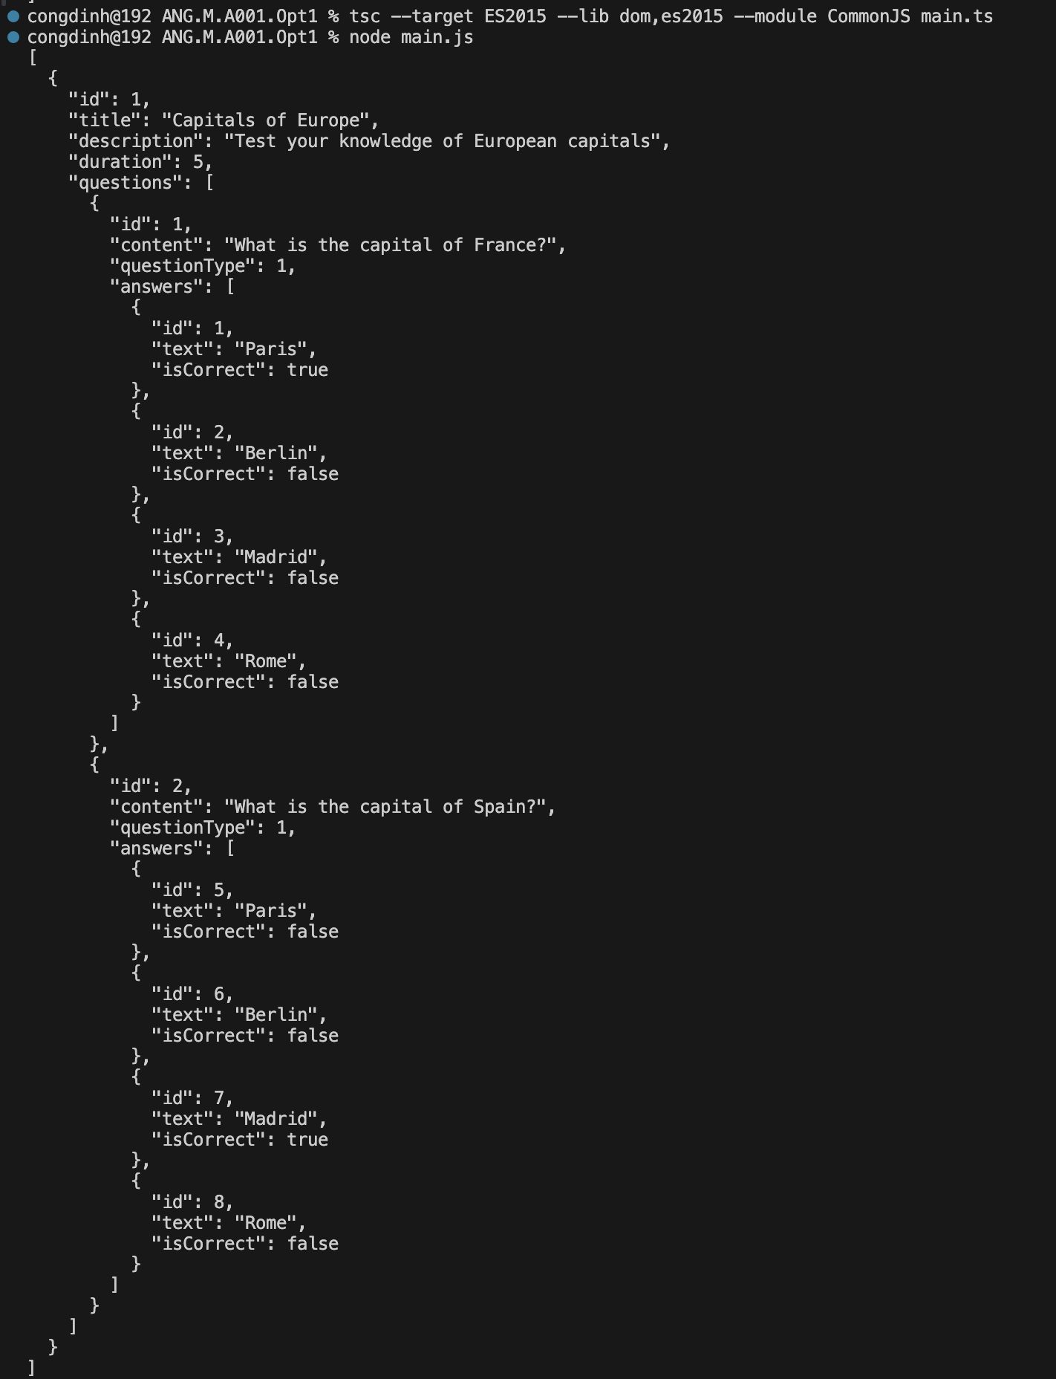
Hints:
- Utilize appropriate data types for each property in the classes.
- Leverage interfaces to define contracts for the QuizService methods.
- Implement methods within the QuizService class to handle data access and manipulation.
- Consider using helper functions for common tasks like finding a quiz by ID within the service.
- Remember to handle potential errors during data access operations (e.g., quiz not found).
- Ensure that error handling is properly implemented within each method call to manage potential exceptions or promise rejections.
- Use console.log and console.error statements to output relevant information and error messages during testing.
- Using the following code to use specific target, libraries and module:
tsc --target ES2015 --lib dom, es2015 --module CommonJS main.ts
Business Rules:
- Ensure data consistency by maintaining the relationship between quizzes, questions, and answers.
- Implement proper error handling to gracefully handle situations like missing quizzes or invalid data.
- The QuizService should encapsulate the logic for managing quiz data, promoting modularity and reusability.
Evaluation Criteria:
- The submission should be a complete TypeScript program with well-defined classes, interfaces, and a service implementation.
- The code should demonstrate a clear understanding of basic TypeScript concepts.
- Correct usage of data types, arrays, objects, classes, interfaces, and modules will be evaluated.
- Functionality of the QuizService methods for managing quiz data will be assessed.
- Adherence to coding conventions and proper error handling will be considered.
- Organize the code into a structured project or individual files.
- Include comments to explain each code segment and its purpose.
Submission file:
- Zip solution folder to a zip file
- File: FullName_ANG_M_A01_v1.0.zip
Estimated Time: 180 minutes.

Mark Scale:
OOP design | 10% | Function requirements | 60%
Business rules | 15% | Main function | 15%

-- THE END --

