

Angular With ASP.NET Core Web API
Training Assignments

Document Code | 25e-BM/HR/HDCV/FSOFT
Version | 1.1
Effective Date | 20/11/2012

Hanoi, 06/2024
RECORD OF CHANGES

No | Effective Date | Change Description | Reason | Reviewer | Approver
 | 01/Jun/2024 | Create a newly issued | Create new | ToanHK2  DieuNT1 | VinhNV

Contents
Angular with ASP.NET Core Web API: Quiz Application 4
Objectives: 4
Prerequisites: 4
Problem Requirements: 4
Task 1: Angular Fundamentals 4
Task 2: User Interaction and Navigation 7
Task 3: Data Management and Integration 10
Task 4: Security and Advanced Concepts 16
Task 5: Integration and Deployment 18
Bonus: 22
Mark Scale: 23

CODE: ANG.P.L001
TYPE: MEDIUM
LOC: 190
DURATION: 900 MINUTES

Angular with ASP.NET Core Web API: Quiz Application

Objectives:
- Master Angular Fundamentals: Gain a solid understanding of core Angular concepts like components, templates, data binding (one-way and two-way), and built-in pipes (e.g., DatePipe) for data formatting.
- Component Development Expertise: Develop reusable and maintainable components encompassing UI logic and layout elements (common header, footer, subject list, individual quiz display, etc.).
- User Interaction and Navigation: Implement user interaction using directives (ngIf, ngFor) and navigate between different application sections (quizzes list, quiz detail) using Angular Router.
- Form Creation and Management: Create forms for login, register, subject/quiz creation/editing, and question creation (including answer options) utilizing FormsModule or ReactiveFormsModule based on complexity.
- Data Management and API Integration: Develop services using HttpClient to communicate with the ASP.NET Core Web API backend. These services will handle fetching data (quizzes, subjects), submitting answers, and potentially caching frequently accessed data.
- Dependency Injection: Understand and leverage dependency injection to promote loose coupling between components and services, improving testability and maintainability.
- Security Awareness: Implement security best practices like input validation and sanitization to mitigate potential vulnerabilities and protect user data.
- Advanced Concepts Exploration: Explore different rendering strategies like Client-side Rendering (CSR), Server-side Rendering (SSR), and Static Site Generation (SSG) to choose the appropriate one based on performance, SEO, and user experience considerations.
- Unit Testing Expertise: Write unit tests for components, services, and other application logic using a testing framework like Jasmine and Karma to ensure core functionalities and data behavior work as expected.
- Deployment Readiness: Learn how to build the Angular application for production using the Angular CLI and understand different deployment options (static hosting, cloud platforms) based on project requirements.

Prerequisites:
- Working environment: Visual Studio Code/Visual Studio 2013 or higher.
- Delivery: Source code packaged in a compress archive.

Problem Requirements:
This assignment outlines the development of an Angular frontend application to complement the ASP.NET Core Web API Quiz Application you've built.
Design file: ANG.P.L001.Opt1_design.zip

Task 1: Angular Fundamentals
Description:
This task focuses on building a foundational understanding of Angular concepts, including components, templates, data binding, and pipes.

Function Requirements:
- Project Setup:
  - Create a new Angular project using the Angular CLI (ng new quiz-app).
  - Install Bootstrap/Tailwind, Font-Awesome packages
- Components:
  - Create common component to reuse in other components
    - Header
    - Footer (Year in footer should use Date Pipe)
    - Quiz Card
  - Generate page components:
    - Home
    - About
  - Create reusable components to display quizzes in HomeComponent (using fake data for quizzes, we integrate with real data from API in Task 03).
    - Home Page (task01_home.png):
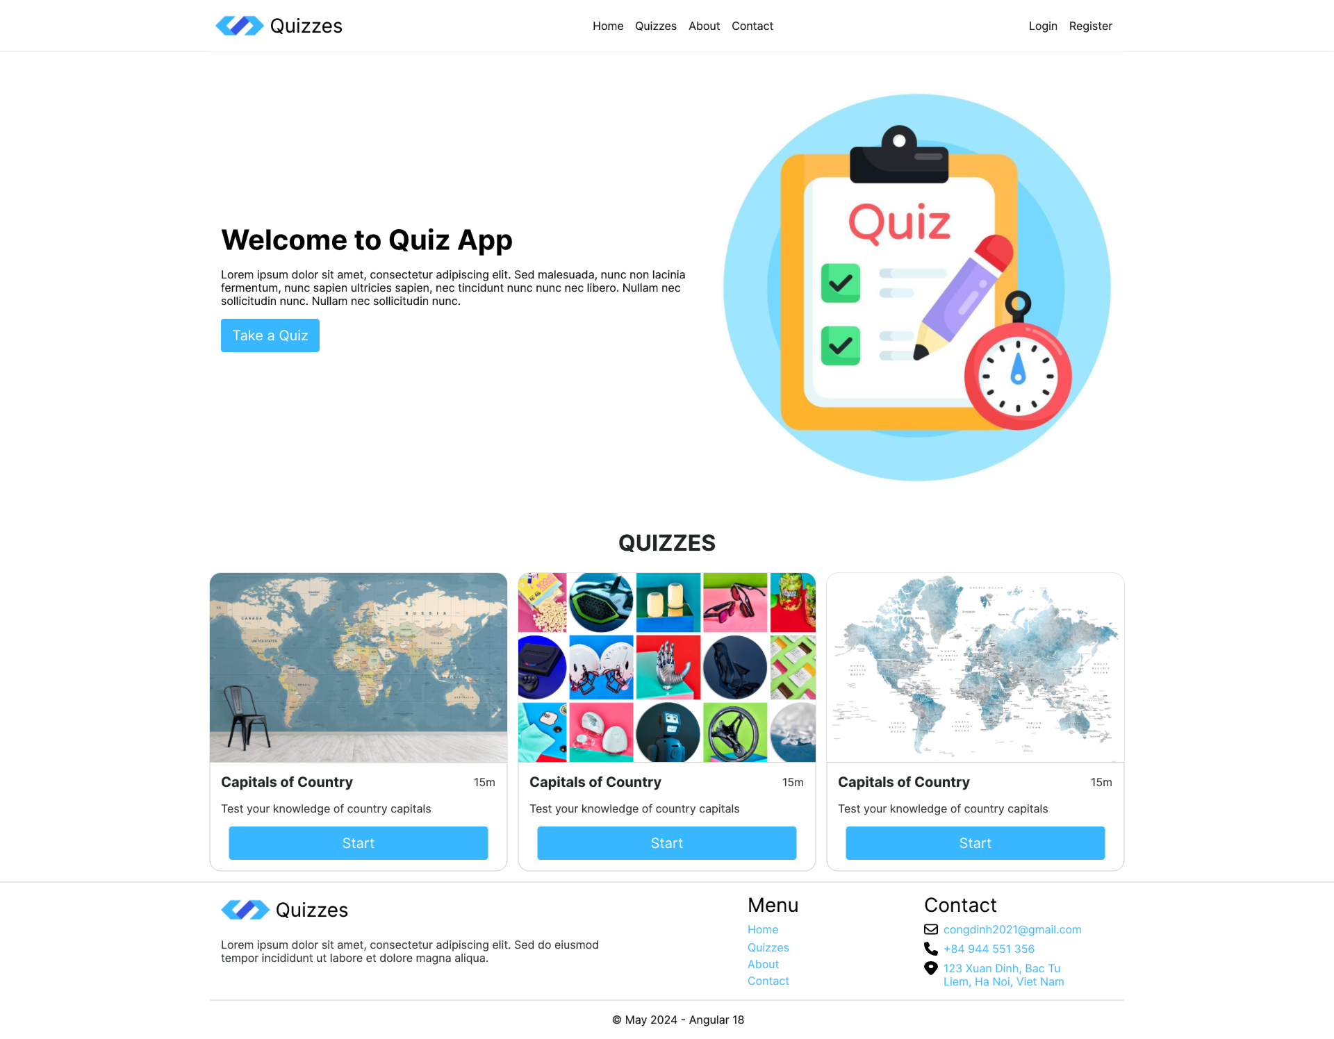
    - About Page (task01_about.png): Our team using fake data

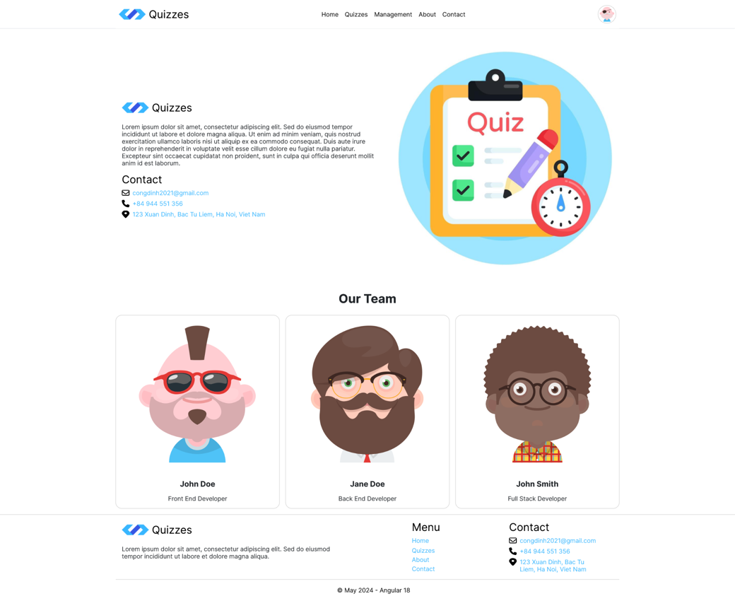
  - Utilize the @Component decorator to define component metadata (selector, template, styles).
- Templates:
  - Write HTML templates for components using Angular directives and expressions.
- Data Binding and Pipes:
  - Implement data binding (one-way, two-way) to display application data in templates.
  - Utilize built-in pipes (e.g., DatePipe, UpperCasePipe) to format data for display.
Date format to display:
    - dd MM YYYY – 16 May 2024
    - MMM YYYY – May 2024
    - YYYY – 2024
  - Create a custom DurationFormatPipe to format duration(minutes)
Duration format to display:
    - 15 – 15m
    - 60 – 1h
    - 75 – 1h15m
Hints:
- Use Angular CLI commands for project creation and component/module generation (ng generate component/module).
- Refer to Angular documentation for detailed information on components, templates, and data binding.
- Design file in folder: task01
Business Rules:
- Components should be self-contained units responsible for UI and logic.
- Templates should be clear, concise, and utilize Angular directives for interactivity.
- Data binding should provide a seamless connection between component data and the view.
Evaluation Criteria:
- Functional components displaying quiz data and user interfaces.
- Correct utilization of templates with data binding and pipes for data presentation.
- Adherence to Angular best practices for component structure and template design.
Submission file:
- Zip solution folder to a zip file
- File: FullName_ANG_QuizApp_Task_01_v1.0.zip
Estimated Time: 180 minutes.

Task 2: User Interaction and Navigation
Description:
This task focuses on implementing user interactions and routing within the Angular application.
Function Requirements:
- Directives:
  - Implement built-in directives like ngIf, ngFor to conditionally render content and iterate over data.
  - Consider using custom directives for complex UI behaviors.
- Components:
  - Create layout components for use by different page and user roles:
    - AuthenticationLayout: Login or Register page.
    - CustomerLayout: Home, Quizzes, About, Contact.
    - ManagerLayout: Quiz, Question, User and Role Management.
  - Generate management pages (Only generate components to configure routing, detailed design will be done in the next task):
    - Quiz Management: quiz-list, quiz-details
    - Question Management: question-list, question-details
    - User Management: user-list, user-details
    - Role Management: role-list, role-details
  - Generate sidebar component to display menu of management page.
    - Sidebar Design (task02_sidebar.png):
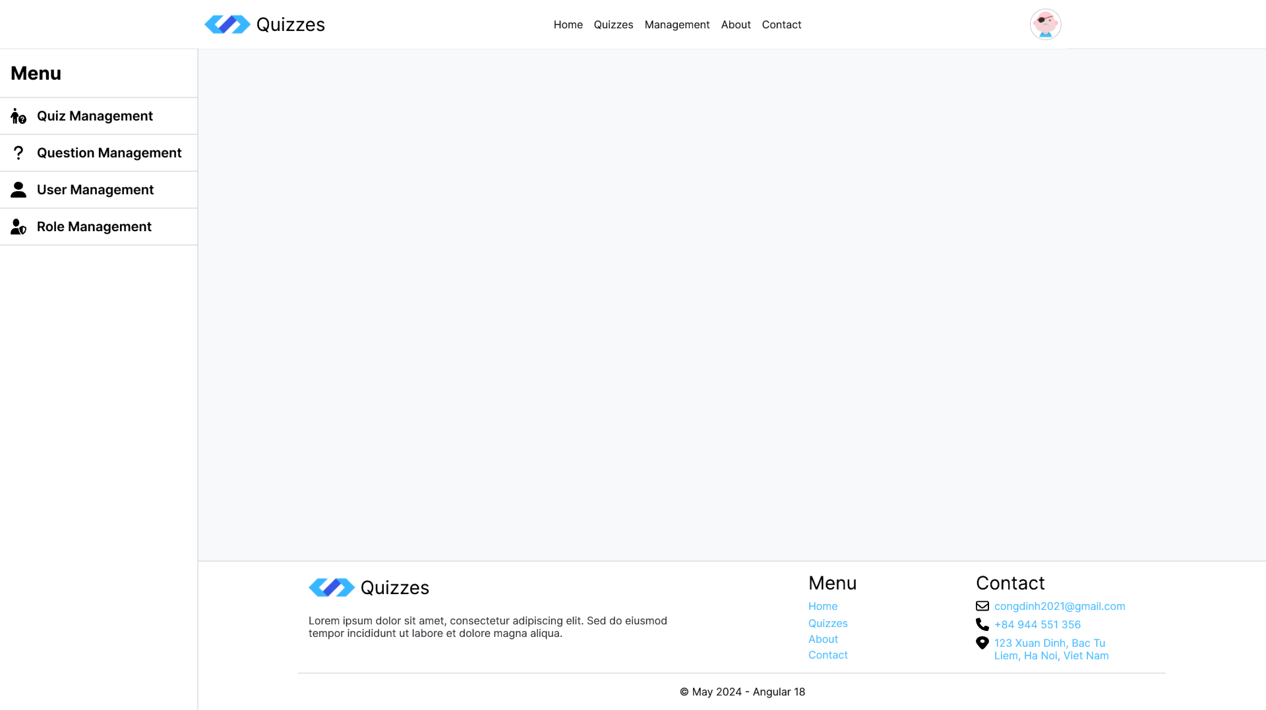
- Routing:
  - Configure routing using RouterModule to define routes for different views:
    - Home: http://localhost:4200
    - Quizzes: http://localhost:4200/quizzes
    - Management:
Quiz: http://localhost:4200/manager/quiz
Question: http://localhost:4200/manager/question
User: http://localhost:4200/manager/user
Role: http://localhost:4200/manager/role
    - About: http://localhost:4200/about
    - Contact: http://localhost:4200/contact
    - Authentication:
Login: http://localhost:4200/auth/login
Register: http://localhost:4200/auth/register
  - Utilize navigation components (router-link) to link between routes and enable user navigation.
- Forms:
  - Create Login and Register Form UI for Authentication module. (When the user submits the form, display the form data on the console. We will integrate with API in the next task)
    - Login Page Design (task02_login.png):
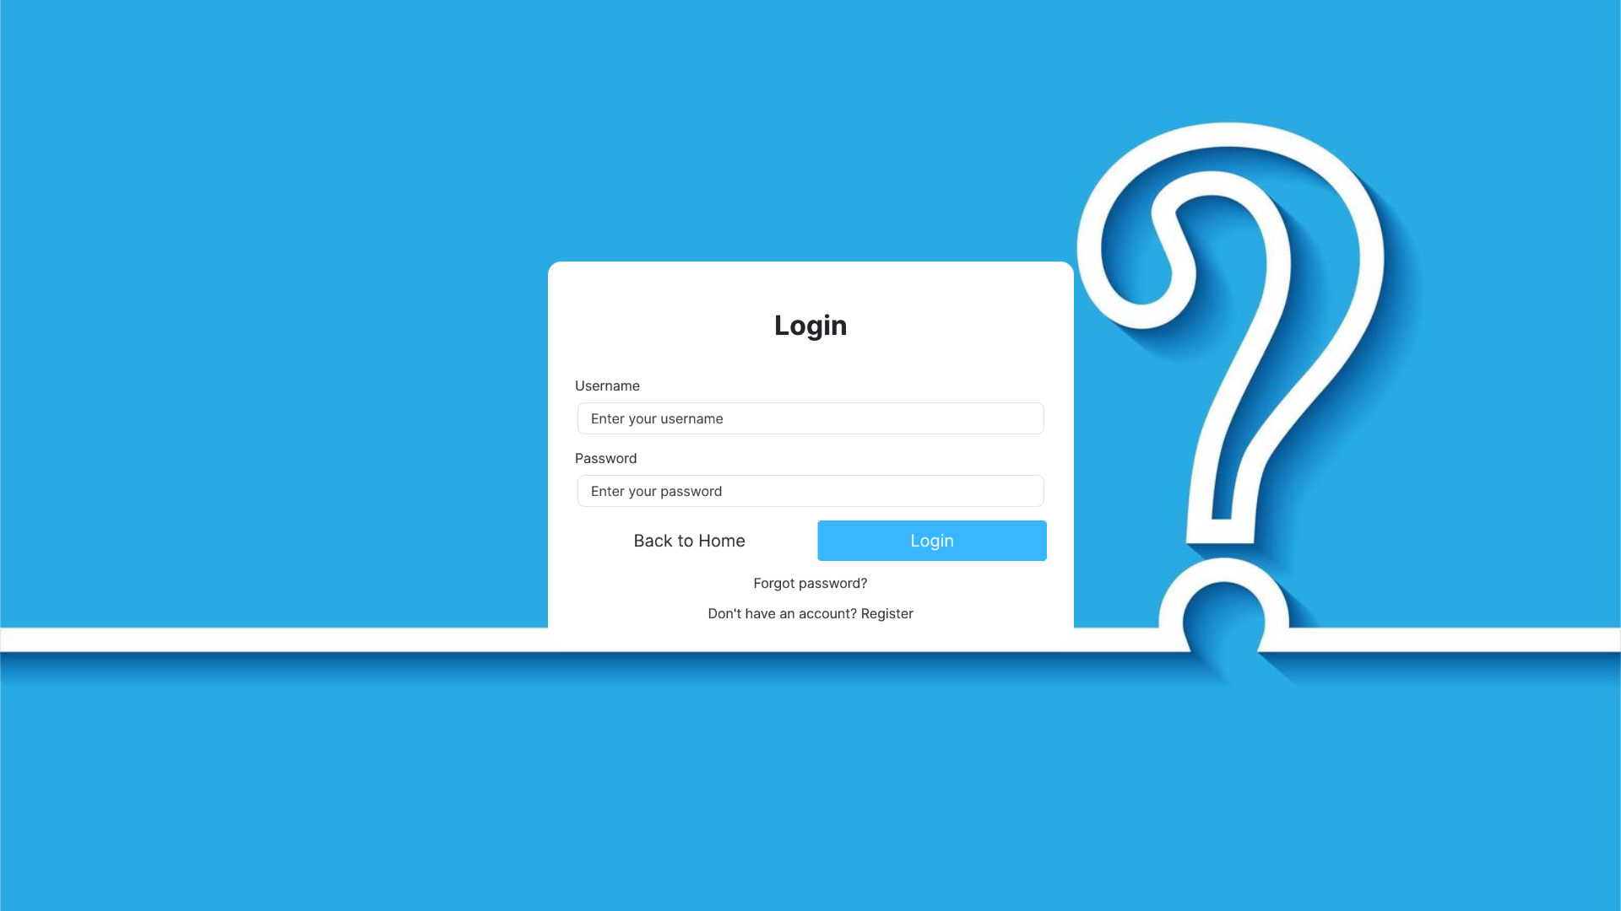
    - Register page design (task02_register.png):
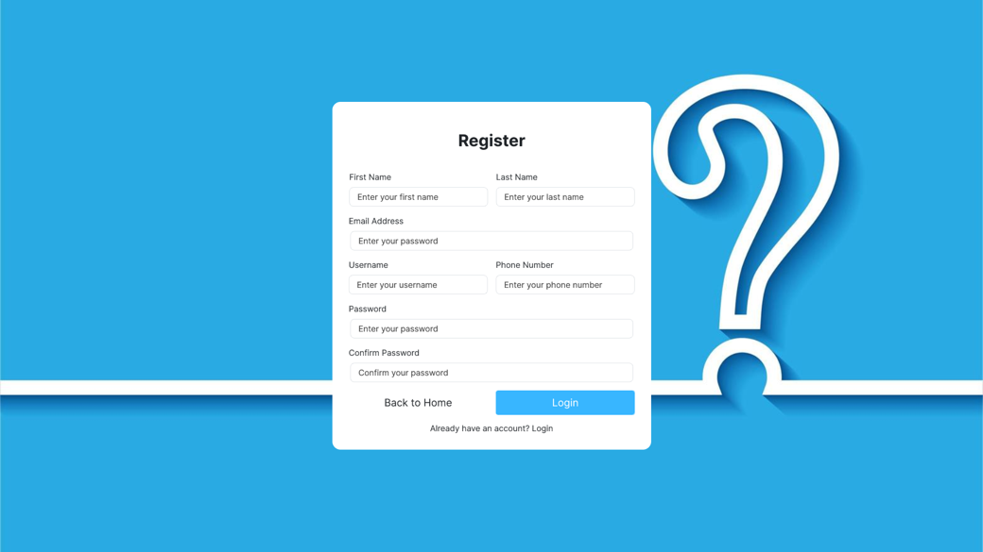
  - Create Feedback Form in Contact page component. (When the user submits the form, display the form data on the console).
    - Contact Page Design (task02_contact.png).
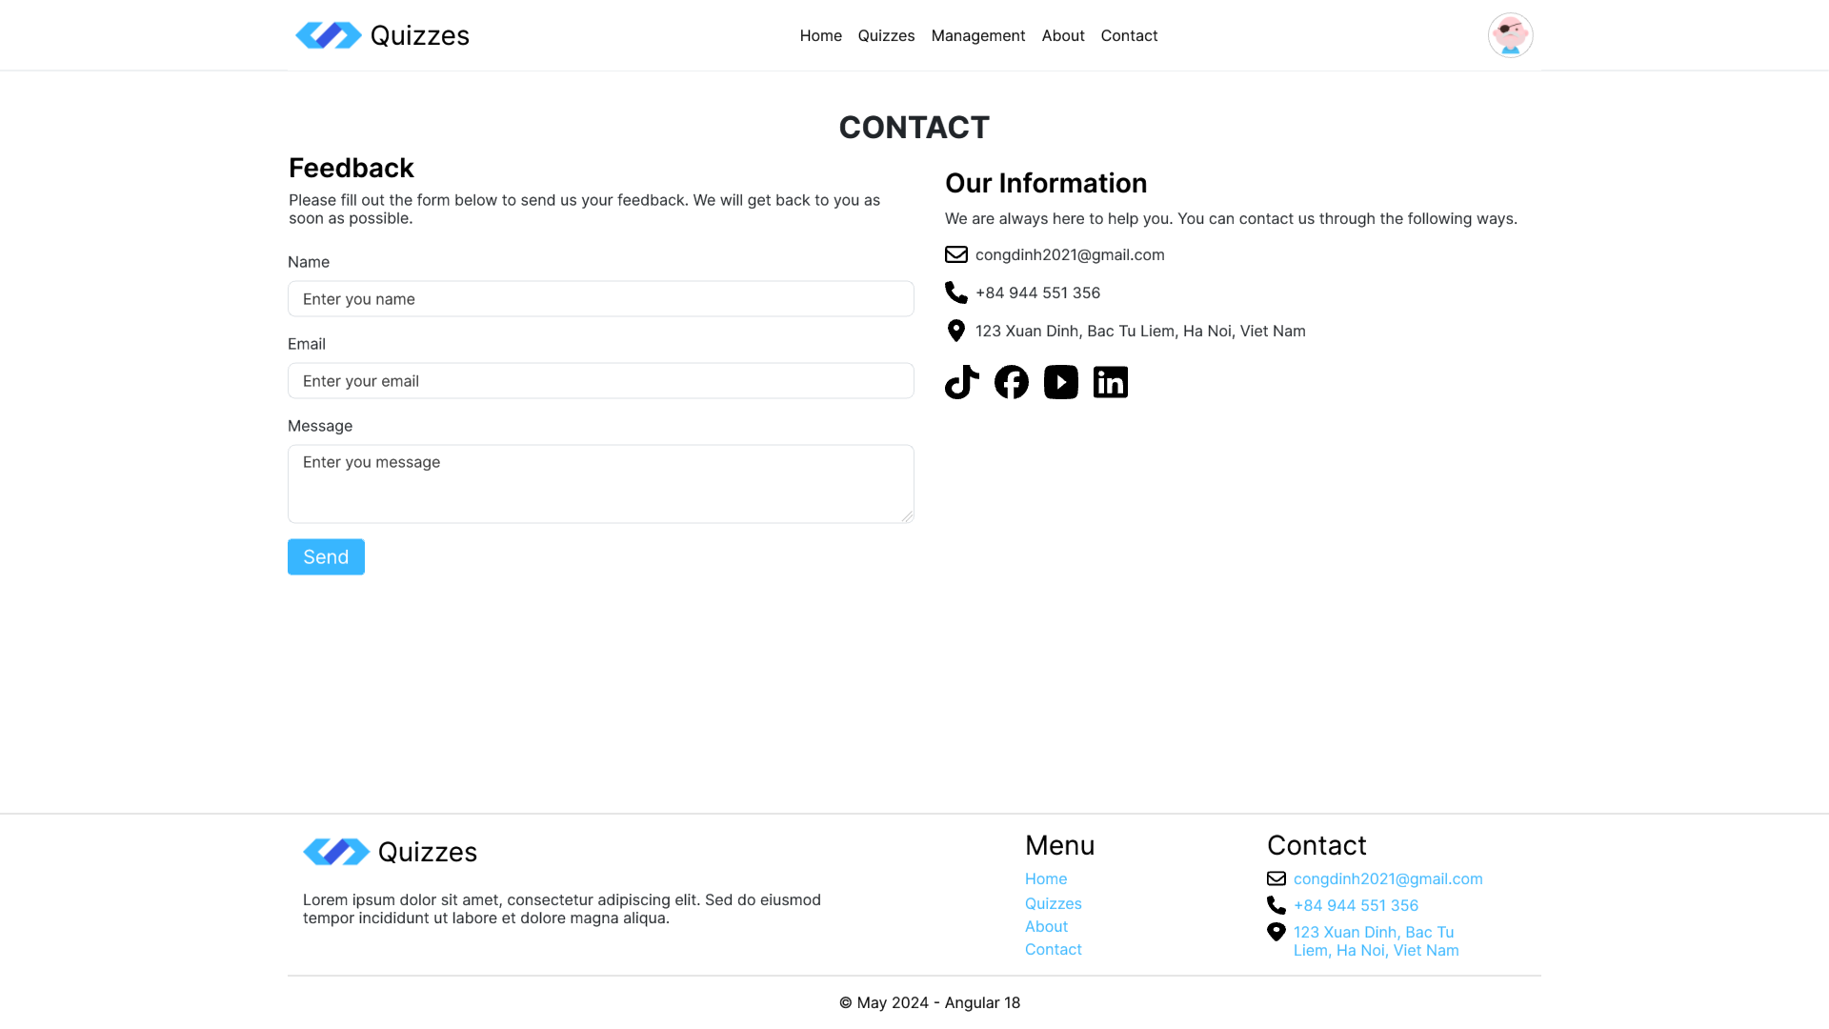
  - Create Take a Quiz Form in Quizzes page component. (When the user submits the form, display the form data on the console. Using fake data for quizzes, we integrate with real data from API in Task 03).
    - Quizzes Page Design (task02_quizzes.png):
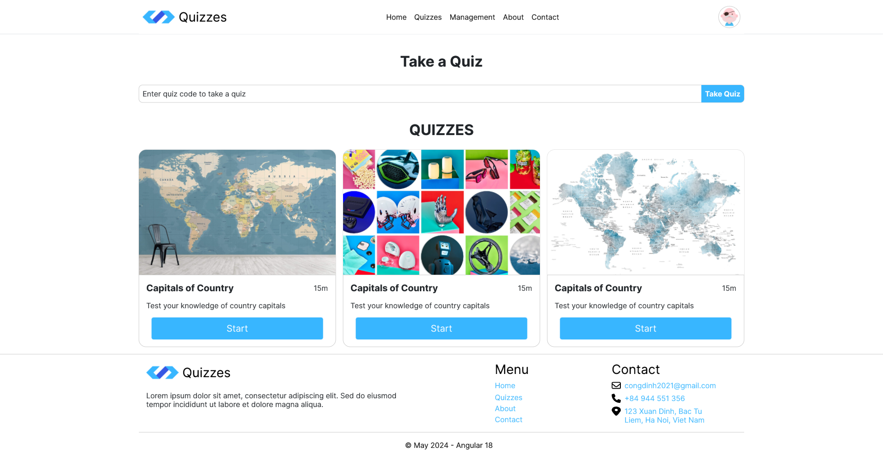
  - Leverage FormsModule for basic forms or explore ReactiveFormsModule for more complex scenarios..
Hints:
- Use Angular Router documentation to understand route configuration and navigation.
- Explore the available directives and built-in form modules for functionalities.
- Design file in folder: task02
Business Rules:
- Directives should enhance the interactivity and behavior of components.
- Routing should enable seamless navigation between different application sections.
- Forms should provide a user-friendly interface for interaction and data submission.
Evaluation Criteria:
- Implementation of directives to control content display and user interaction.
- Defined routes and navigation components for user flow within the application.
- Functional forms for user input and data manipulation.
Submission file:
- Zip solution folder to a zip file
- File: FullName_ANG_QuizApp_Task_02_v1.0.zip
Estimated Time: 180 minutes.

Task 3: Data Management and Integration
Description:
This task focuses on managing application data and integrating with the ASP.NET Core Web API backend.
Function Requirements:
- Services:
  - Create services to communicate with the ASP.NET Core Web API. Utilize HttpClient to make HTTP requests to API endpoints (e.g., fetch quizzes, submit answers).
  - Using interfaces for services makes code cleaner, easier to maintain, more scalabletype safety, easy to dependency injection and testing (loose coupling, design consistency, better documentation).
IQuizService:
  - getAll(): Observable<QuizViewModel[]>;
- QuizViewMode: id, title, description, duration, isActive
  - getById(id: string): Observable<QuizViewModel>;
  - create(obj: QuizCreateViewModel): Observable<boolean>;
- QuizCreateViewModel: title, description, duration, isActive
  - update(obj: QuizEditViewModel): Observable<boolean>;
- QuizEditViewModel: id, title, description, duration, isActive
  - delete(id: string): Observable<boolean>;
  - deleteQuestionFromQuiz(selectedId: string, selectedQuizQuestionId: string): Observable<boolean>;
  - addQuestionToQuiz(obj: QuizQuestionCreateViewModel): Observable<boolean>;
- QuizQuestionCreateViewModel: quizId, questionId
  - prepareQuiz(data: PrepareQuizViewModel): Observable<QuizPrepareInfoViewModel>;
- PrepareQuizViewModel: userId, quizId, quizCode
- QuizPrepareInfoViewModel: id, title, description, duration, thumbnailUrl, quizCode, user (UserViewModel)
  - takeQuiz(takeQuizViewModel: TakeQuizViewModel): Observable<QuizForTestViewModel>;
- TakeQuizViewModel: userId, quizId, quizCode
- QuizForTestViewModel: id, title, description, duration, quizCode, startTime, question(UserViewModel)
- QuestionForTestViewModel: id, content, questionType, answers(AnswerForTestViewModel)
- AnswerForTestViewModel: id, content
  - submitQuiz(quizSubmissionViewModel: QuizSubmissionViewModel): Observable<boolean>;
- QuizSubmissionViewModel: quizId, userId, quizCode, answers(UserAnswerSubmissionViewModel)
- UserAnswerSubmissionViewModel: questionId, answerId
IQuestionService:
  - getAll(): Observable<QuestionViewModel[]>;
- QuestionViewModel: id, content, questionType, isActive
  - getQuestionsByQuizId(id: string): Observable<QuestionViewModel[]>;
  - getAnswersByQuestionId(selectedId: string): Observable<AnswerViewModel>;
- AnswerViewModel: id, content, isCorrect, isActive, questionId
  - getAnswerById(selectedId: string): Observable<AnswerViewModel>;
  - getById(id: string): Observable<QuestionViewModel>;
  - create(obj: QuestionCreateViewModel): Observable<boolean>;
- QuestionCreateViewModel: content, questionType, isActive
  - addAnswerToQuestion(obj: AnswerCreateViewModel): Observable<boolean>;
- AnswerCreateViewModel: content, isCorrect, isActive, questionId
  - updateAnswerToQuestion(obj: AnswerEditViewModel): Observable<boolean>;
- AnswerEditViewModel: id, content, isCorrect, isActive, questionId
  - update(obj: QuestionEditViewModel): Observable<boolean>;
- QuestionEditViewModel: id, content, questionType, isActive
  - delete(id: string): Observable<boolean>;
  - deleteAnswer(answerId: string, questionId: string): Observable<boolean>;
IUserService:
  - getAll(): Observable<UserViewModel[]>;
- UserViewModel: id, firstName, lastName, displayName, email, userName, phoneNumber, dateOfBirth, avatar, isActive, roles.
  - getById(id: string): Observable<UserViewModel>;
  - create(obj: UserCreateViewModel): Observable<boolean>;
- UserCreateViewModel: firstName, lastName, email, userName, phoneNumber, dateOfBirth, password, confirmPassword, isActive.
  - update(obj: UserEditViewModel): Observable<boolean>;
- UserEditViewModel: id, firstName, lastName, email, userName, phoneNumber, dateOfBirth, password, confirmPassword, isActive.
  - delete(id: string): Observable<any>;
IRoleService:
  - getAll(): Observable<RoleViewModel[]>;
- RoleViewModel: id, name, description, isActive
  - getById(id: string): Observable<RoleViewModel>;
  - create(obj: RoleCreateViewModel): Observable<boolean>;
- RoleCreateViewModel: name, description, isActive
  - update(obj: RoleEditViewModel): Observable<boolean>;
- RoleEditViewModel: id, name, description, isActive
  - delete(id: string): Observable<any>;
IAuthService:
  - login(returnUrl: string, model: LoginViewModel): Promise<LoginResponseViewModel | undefined>;
- LoginViewModel: userName, password
- LoginResponseViewModel: userInformation, token, expires
  - register(userCreateViewModel: UserCreateViewModel): Promise<LoginResponseViewModel | undefined>;
  - isAuthenticated(): boolean;
  - getAccessToken(): string;
  - logout(): boolean;
  - getCurrentUser(): UserViewModel | undefined;
  - isManager(): boolean;
- Dependency Injection:
  - Inject services into components using the @Inject decorator.
  - Understand the concept of dependency injection for managing dependencies within the application.
- API Integration:
  - Implement services to interact with the Quiz API endpoints (GET, POST, PUT, DELETE).
  - Handle API responses, parse data, and update the application state accordingly.
- Components:
  - Implement List UI for Quiz, Question, User and Role Management.
    - Quiz List Design (task03_quizlist.png):
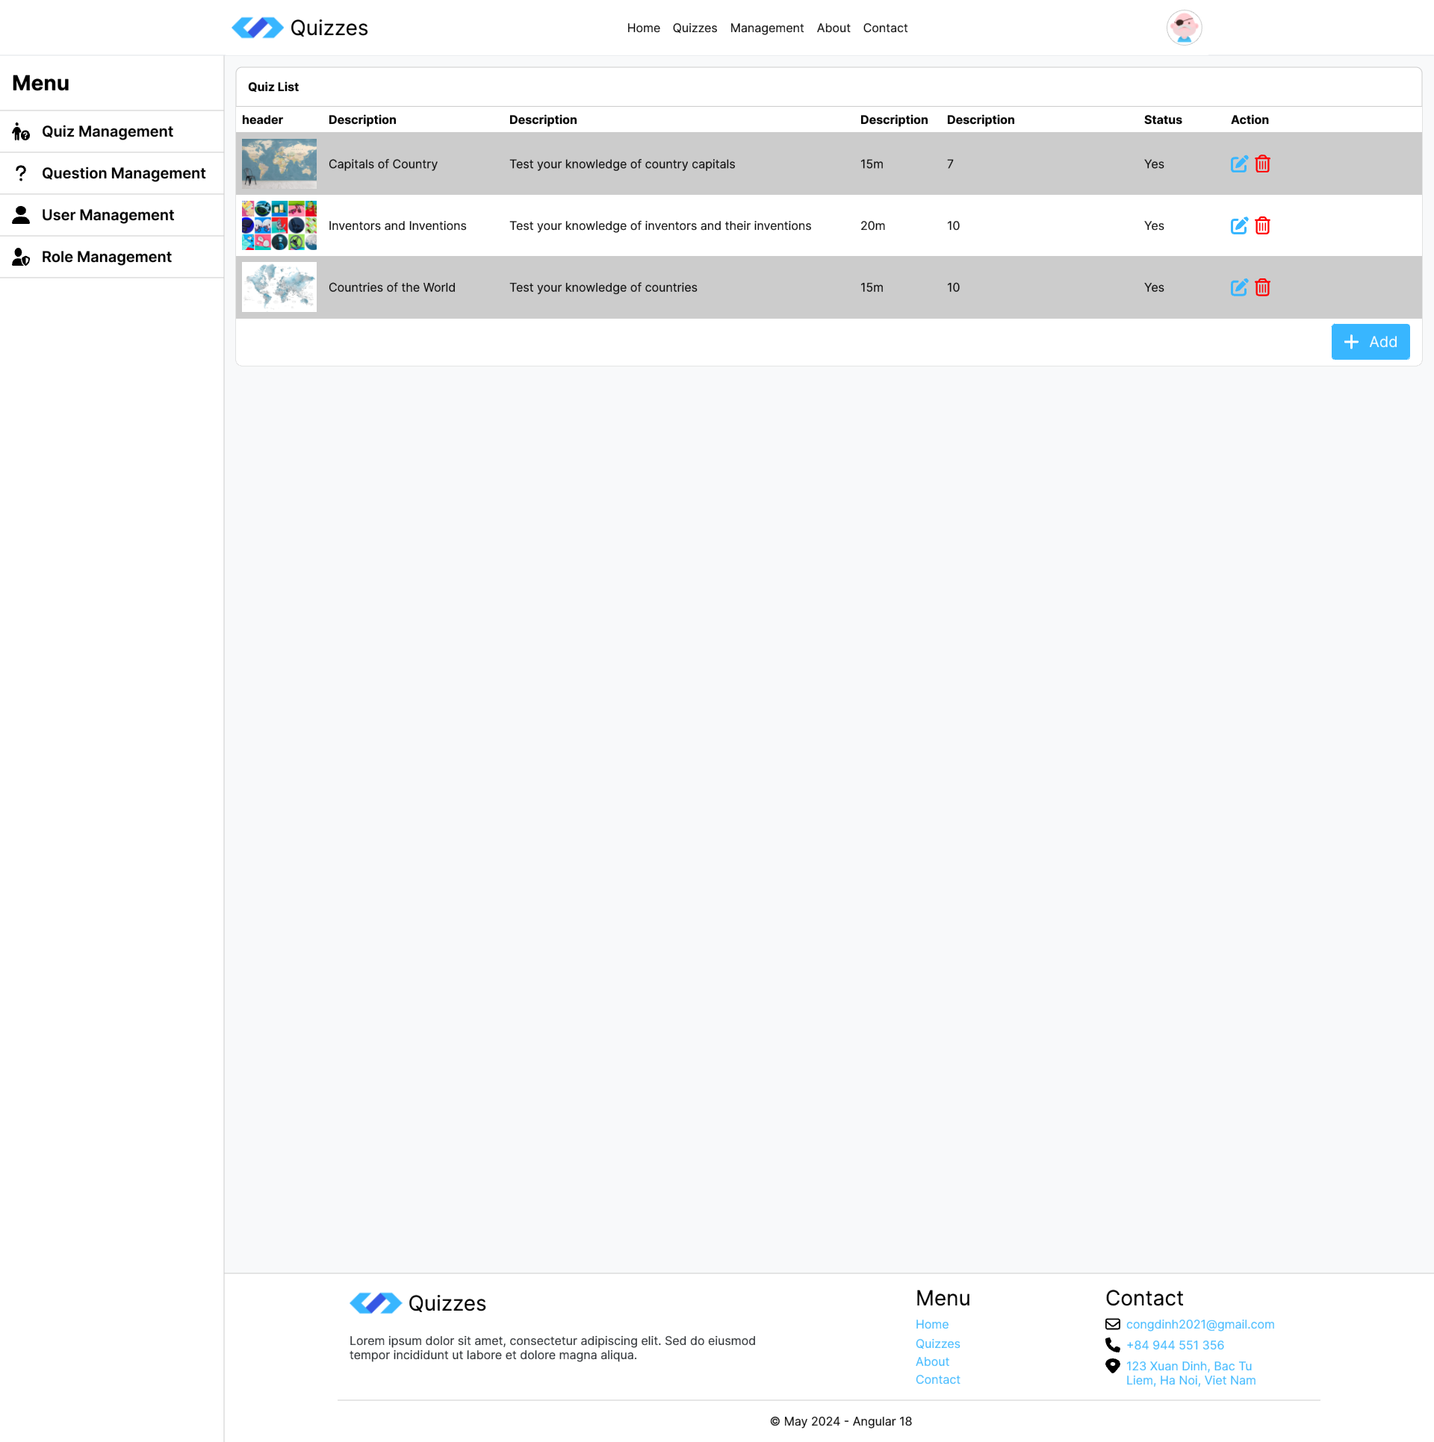

    - Question List Design (task03_questionlist.png):
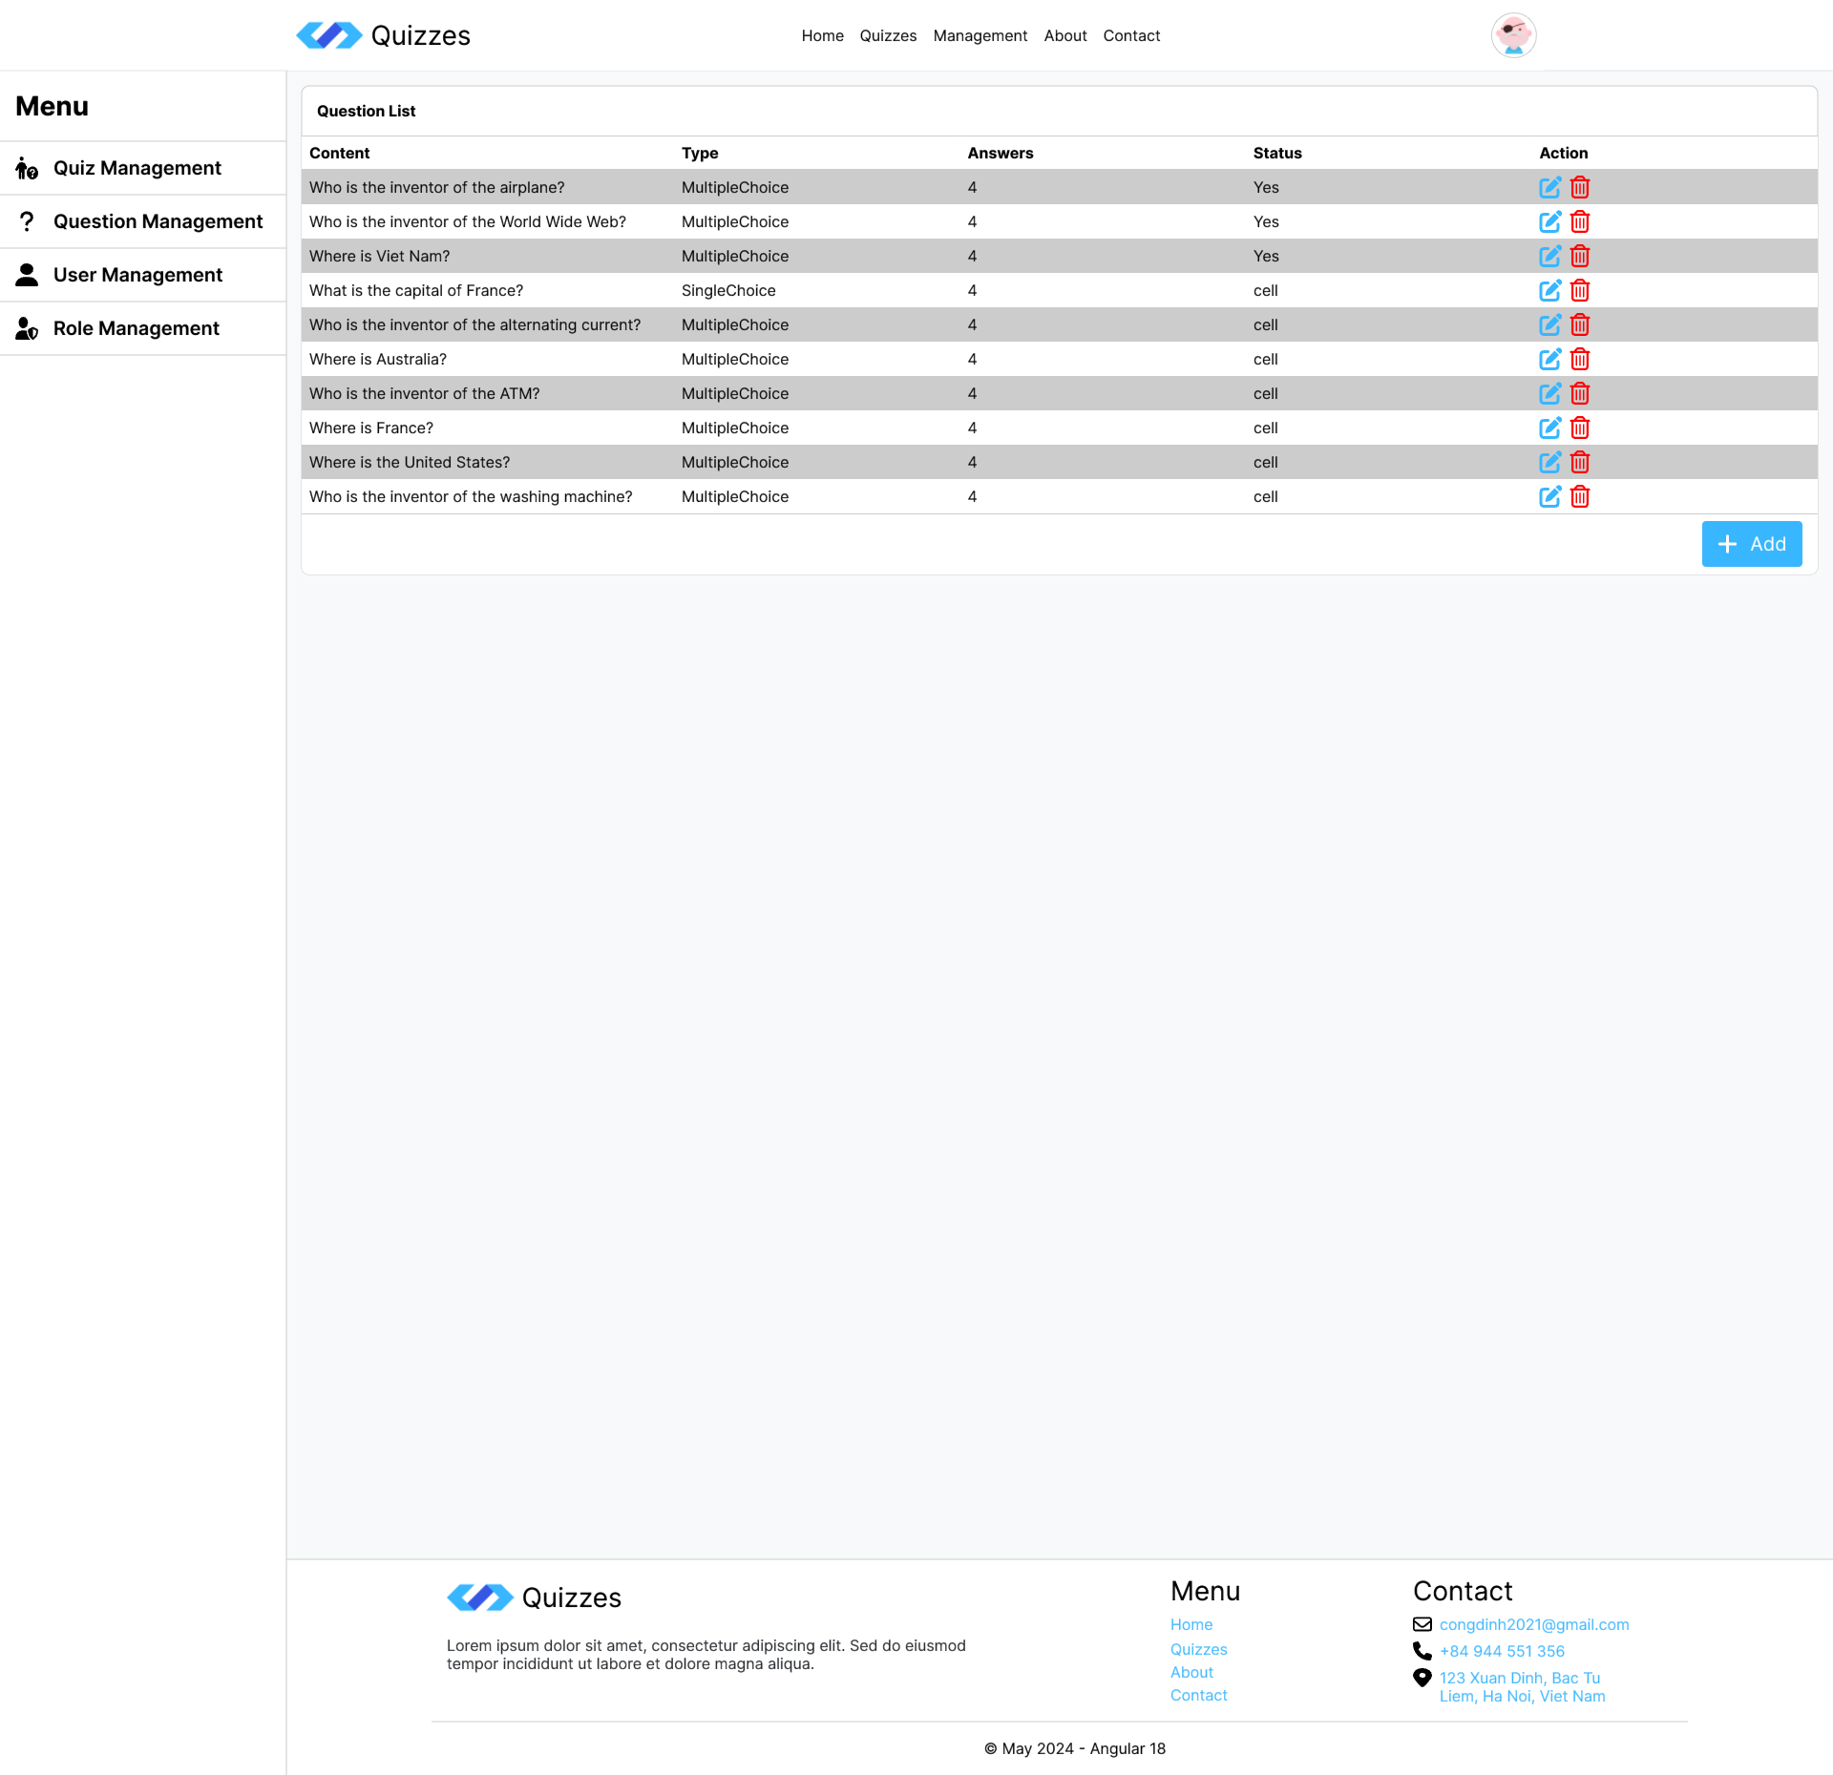
    - User List Design (task03_userlist.png):
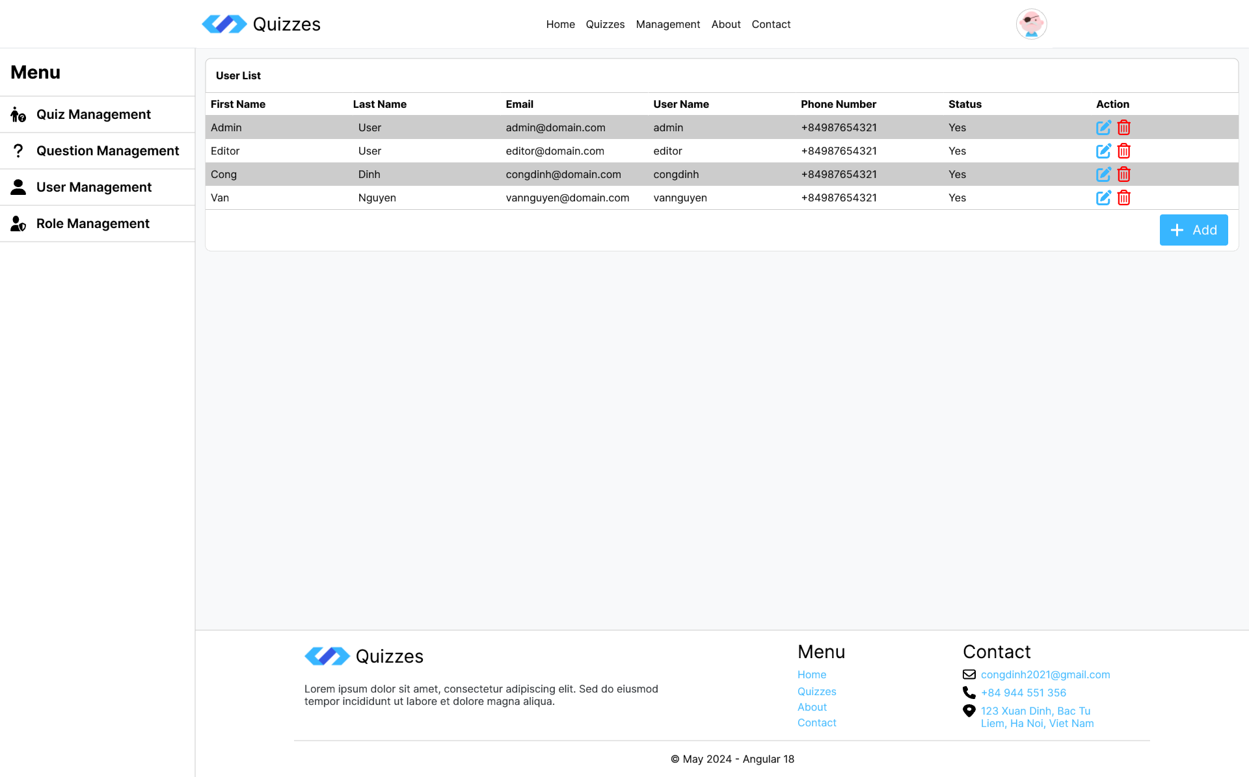

    - Role List Design (task03_rolelist.png):
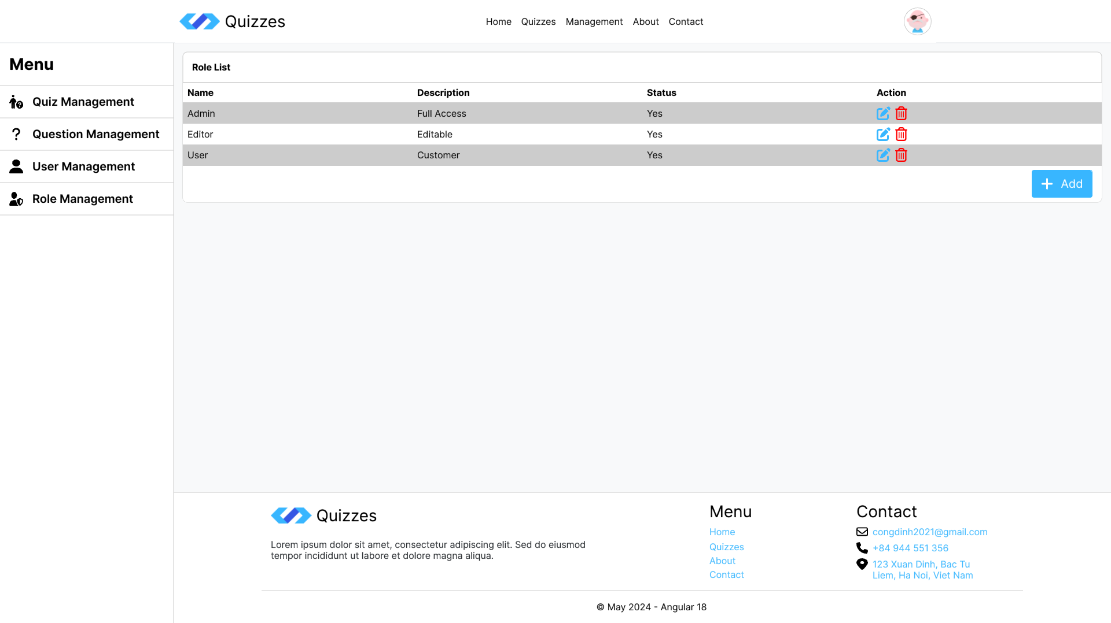
  - Using service to get and display quizzes in home and quizzes page:
Home Page (task03_homepage.png):
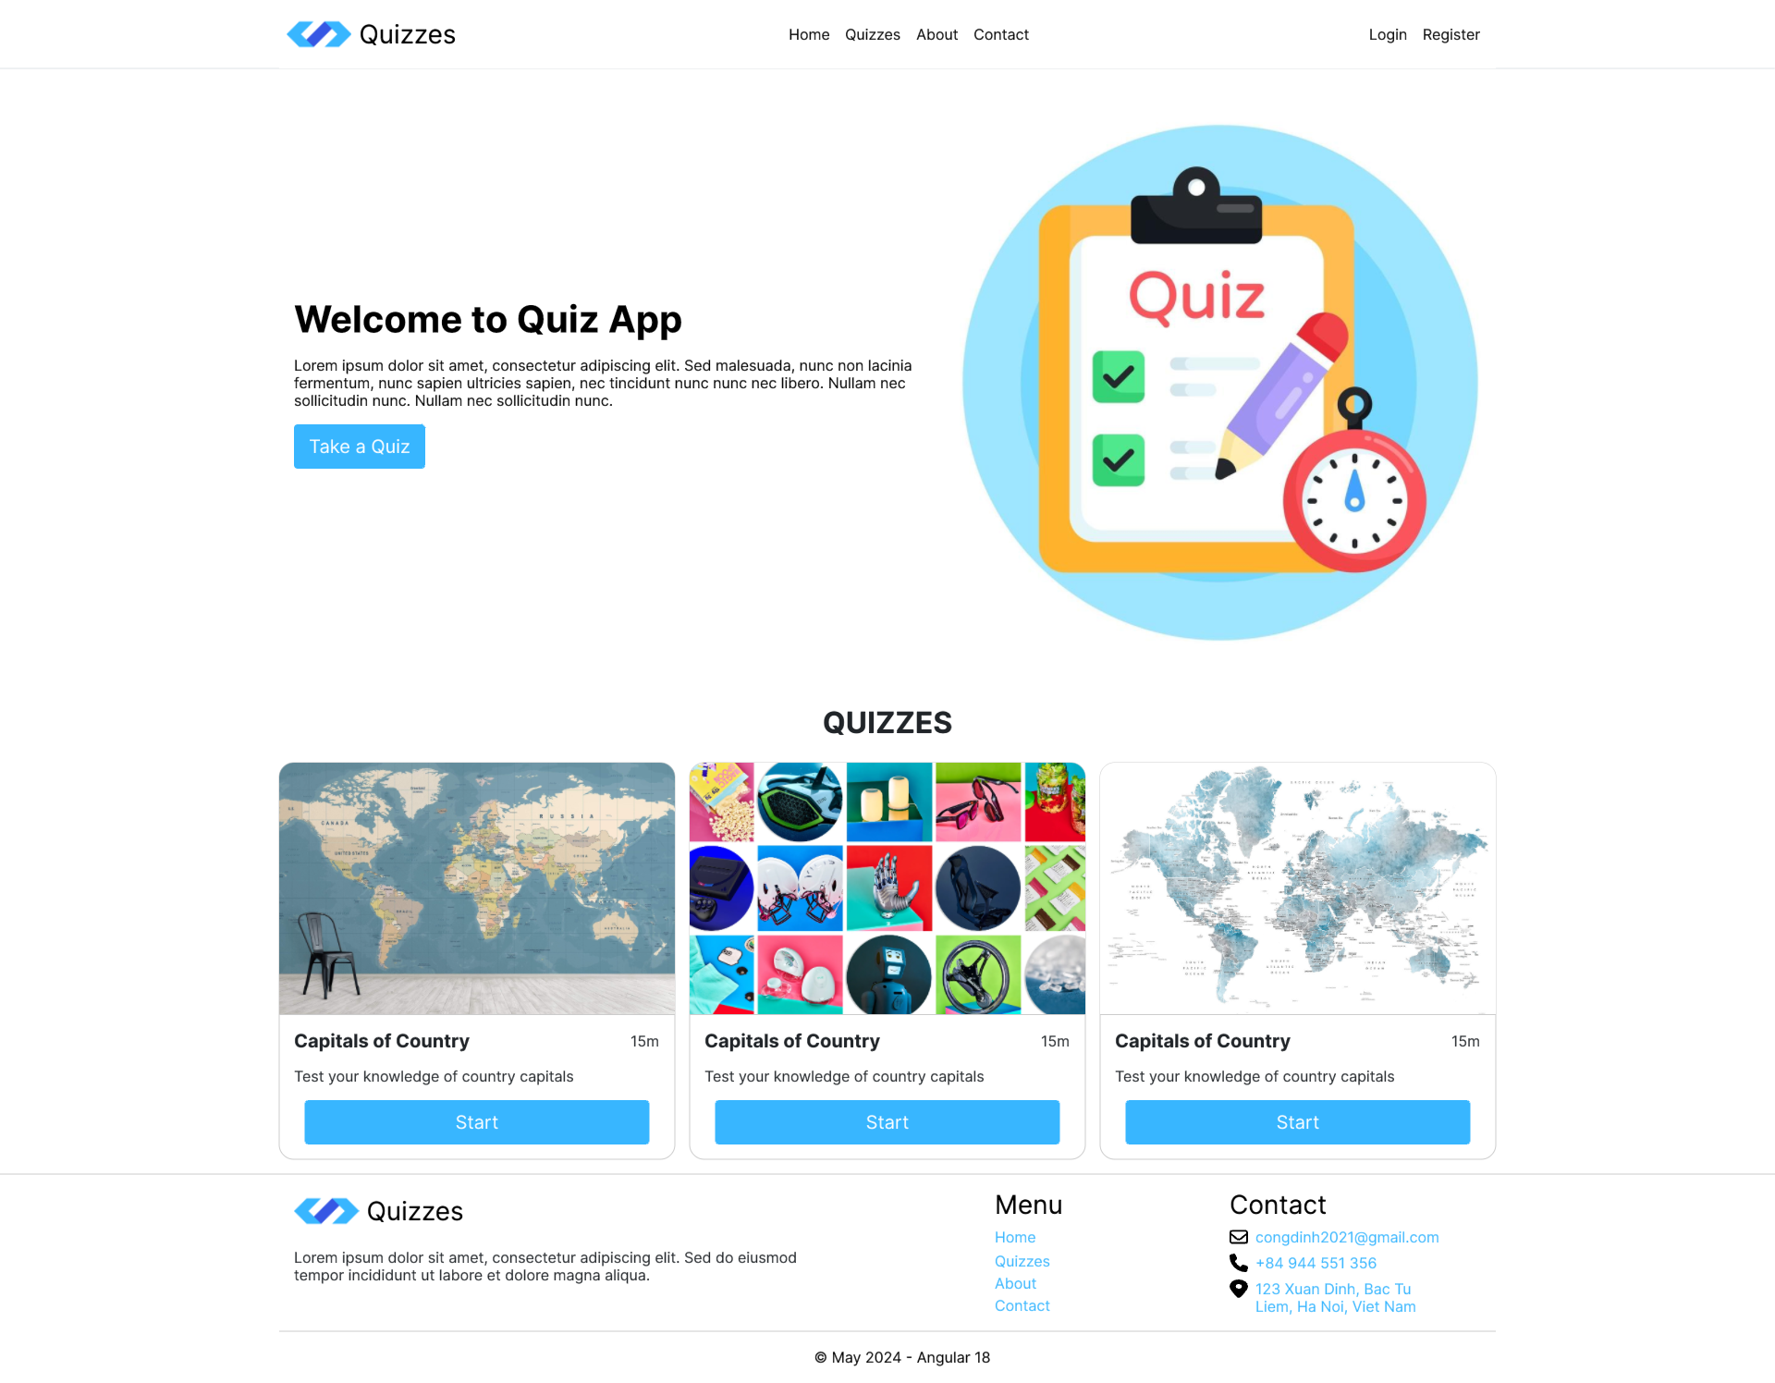

Quizzes Page (task03_quizzespage.png):
Hints:
- Refer to Angular documentation on HTTP services and dependency injection.
- Use libraries like rxjs for asynchronous data handling and observable patterns.
- Design file in folder: task03
Business Rules:
- Services should encapsulate data access logic and communication with the API.
- Dependency injection should promote loose coupling and testability of components.
- API calls should be handled appropriately, including error handling and data processing.
Evaluation Criteria:
- Development of services to manage data communication and interaction with the API.
- Correct implementation of dependency injection for service consumption within components.
- Successful integration with the Quiz API for data retrieval and manipulation.
Submission file:
- Zip solution folder to a zip file
- File: FullName_ANG_QuizApp_Task_03_v1.0.zip
Estimated Time: 180 minutes.

Task 4: Security and Advanced Concepts
Description:
This task delves into security considerations and explores advanced Angular features.
Function Requirements:
- Authentication/Authorization:
  - Integrate with the ASP.NET Core Web API's authentication mechanisms (JWT).
  - Store tokens securely and use them for authorized API calls in Angular services.
  - Using IauthService to complete the Login and Register Form. Displays a dialog message if there was an error while processing the form.
    - After logging in, display the profile dropdown menu with name and logout button
    - Home Page (task04_homeauthenticated.png)
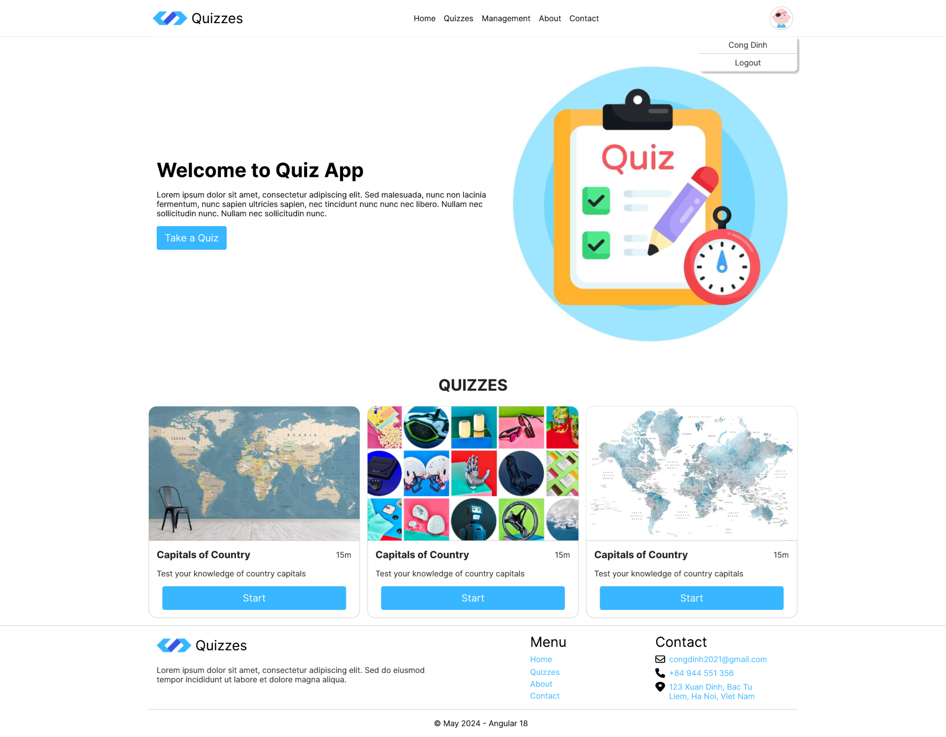
  - Create an authentication interceptor to integrate the token into the header of requests to API endpoints.
  - Create an authentication guard to ensures that only authenticated users can access certain routes, enhancing security and user experience.
    - Only admin/editor users can access Management pages. Redirect to 403 page if user don’t have permission to access a specific page.
    - Only authenticated users can take a quiz. Redirect to login page if user unauthenticated
    - 403 Page (task04_403.png):
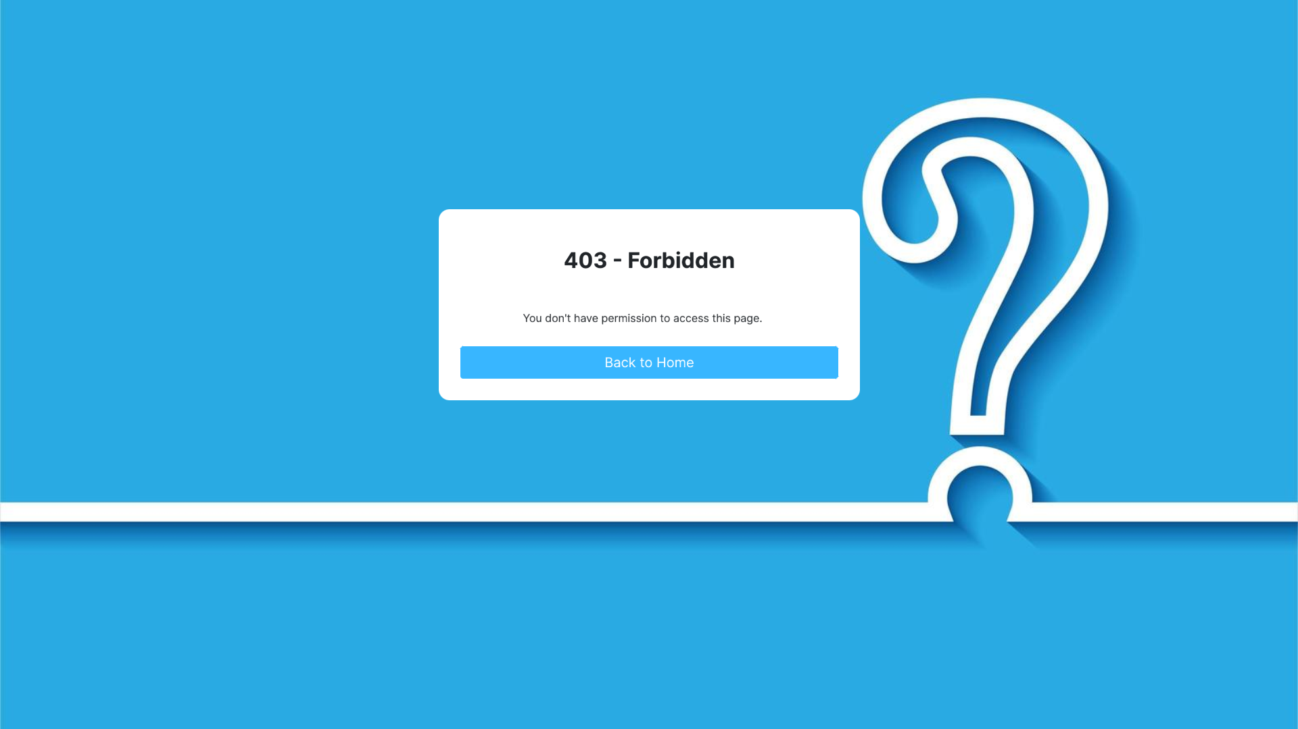
- Security:
  - Implement best practices for secure application development (e.g., input validation, sanitization).
  - Consider security vulnerabilities and implement strategies to mitigate risks.
- SSR, CSR, SSG (Optional):
  - Learn about Angular's SSR, CSR, SSG operating mechanism
  - Implement SSR for Home and About Page
- Unit Testing:
  - Write unit tests for QuizServices(All methods), AuthService(Login, Register method) and Home Page components using a testing framework (e.g., Jest, Jasmine, Karma).
  - Ensure core functionalities and data behavior are tested effectively.
Hints:
- Research best practices for secure coding and data handling in Angular applications.
- Explore Angular Universal for SSR and SSG capabilities.
- Utilize testing frameworks and tools for writing unit tests.
- Design file in folder: task04
Business Rules:
- Authentication and authorization should restrict access to protected resources and functionalities.
- Security measures should safeguard user data and prevent vulnerabilities.
- Rendering strategy should balance performance, SEO, and user experience.
- Unit tests should provide a safety net for application logic and maintain code quality.
Evaluation Criteria:
- Implementation of authentication and authorization using JWT tokens.
- Adherence to security best practices to minimize application risks.
- Understanding and consideration of different rendering strategies for Angular applications.
- Writing unit tests to ensure component and service functionality.
Submission file:
- Zip solution folder to a zip file
- File: FullName_ANG_QuizApp_Task_04_v1.0.zip
Estimated Time: 180 minutes.

Task 5: Integration and Deployment
Description:
This task focuses on deploying the Angular application and integrating it with the ASP.NET Core Web API backend.
Function Requirements:
- Integration with ASP.NET Core Web API:
  - Configure base URL for API calls in Angular services to point to the deployed backend API.
  - Ensure seamless communication and data exchange between frontend and backend.
- Complete Customer pages: Allows users to click the Start button on Quiz or Enter quiz code in Quizzes page to prepare to take a quiz.
Prepare quiz page design (task05_preparequiz.jpeg):
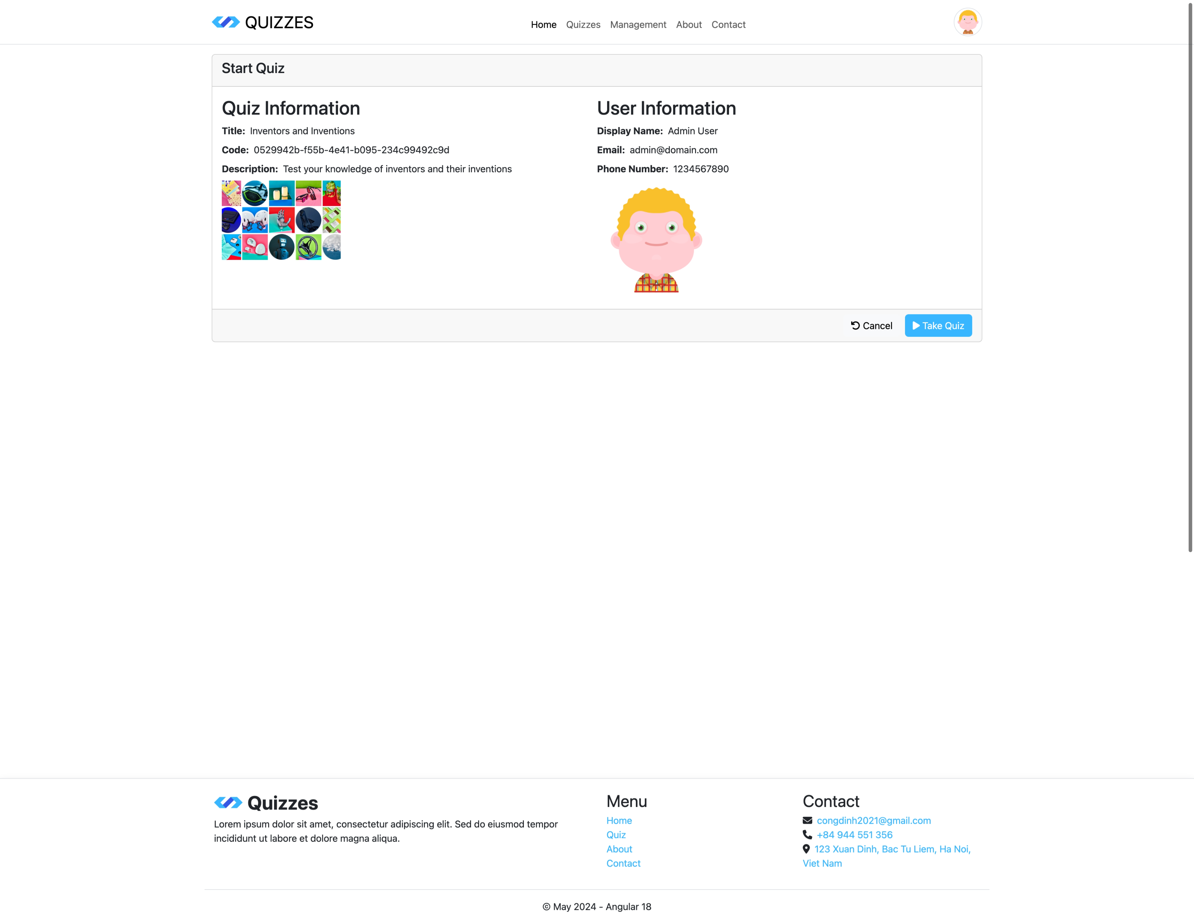
Submit Quiz page design (task05_submitquiz.jpeg):
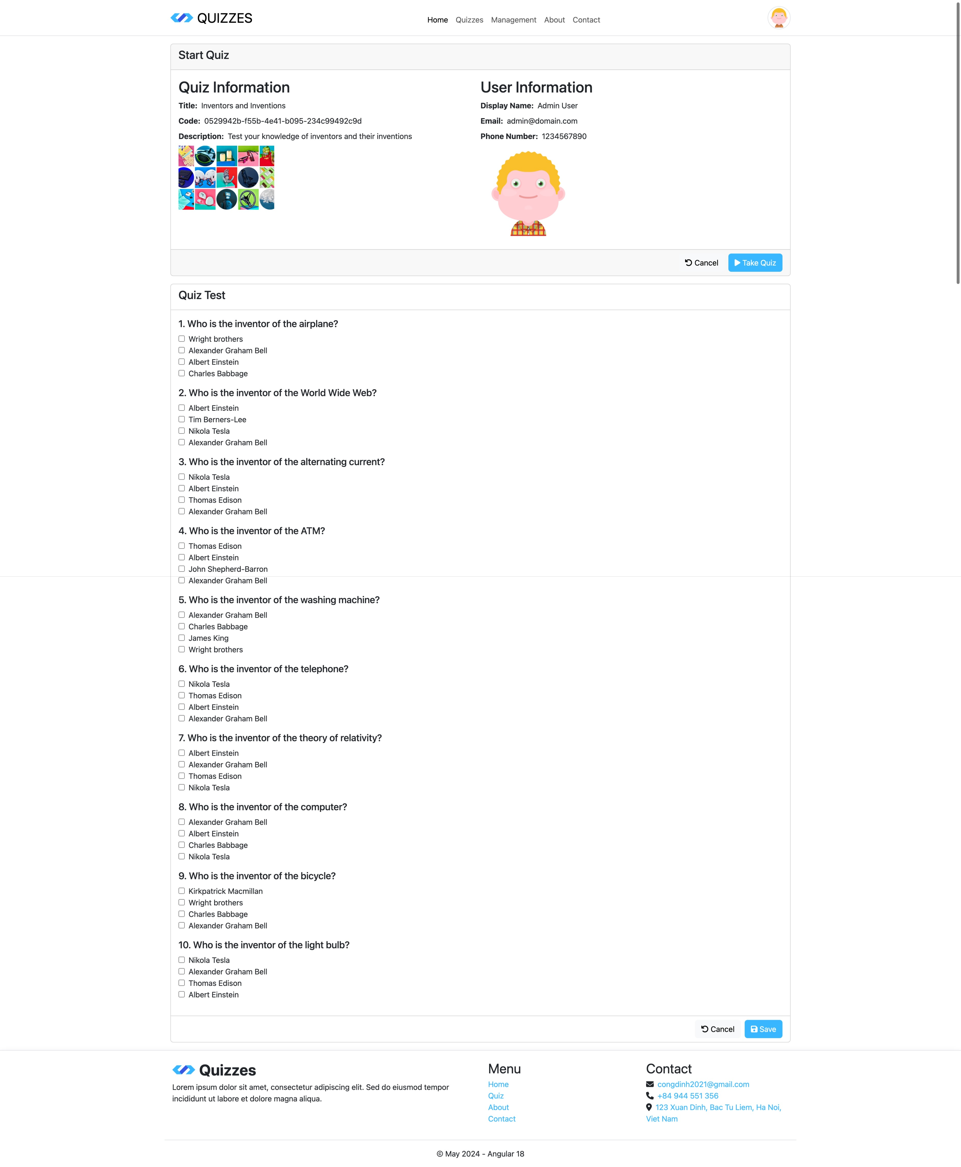
- Complete Management pages:
Add/Edit Quiz and add Question to Quiz (task05_quiz.png): Display Show Question button when user edit a quiz, not show in Add form.
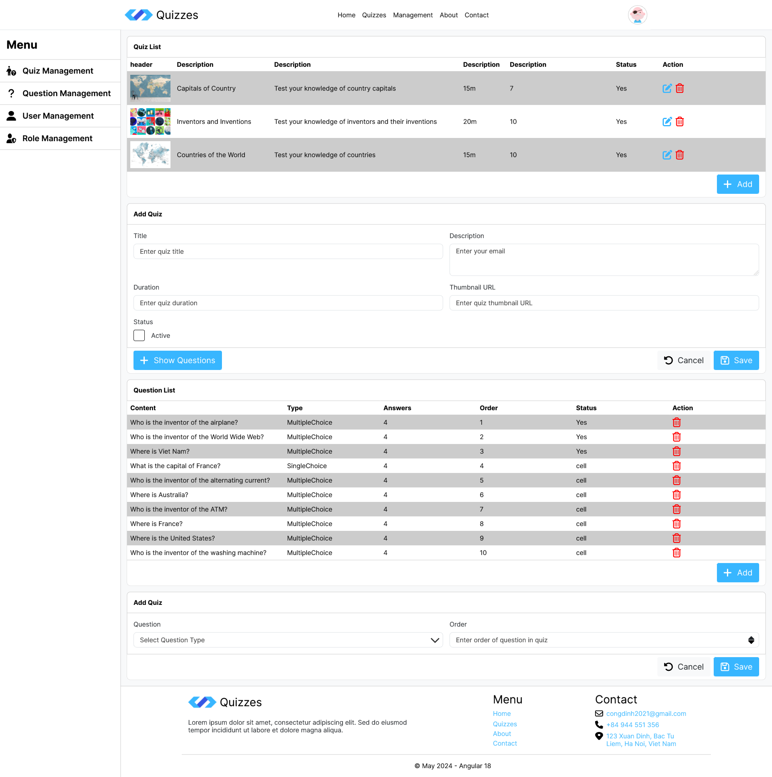

Add/Edit Question and Add/Edit Answer of Question (task05_question.png): Display Show Answer button when user edit a question, not show in Add form
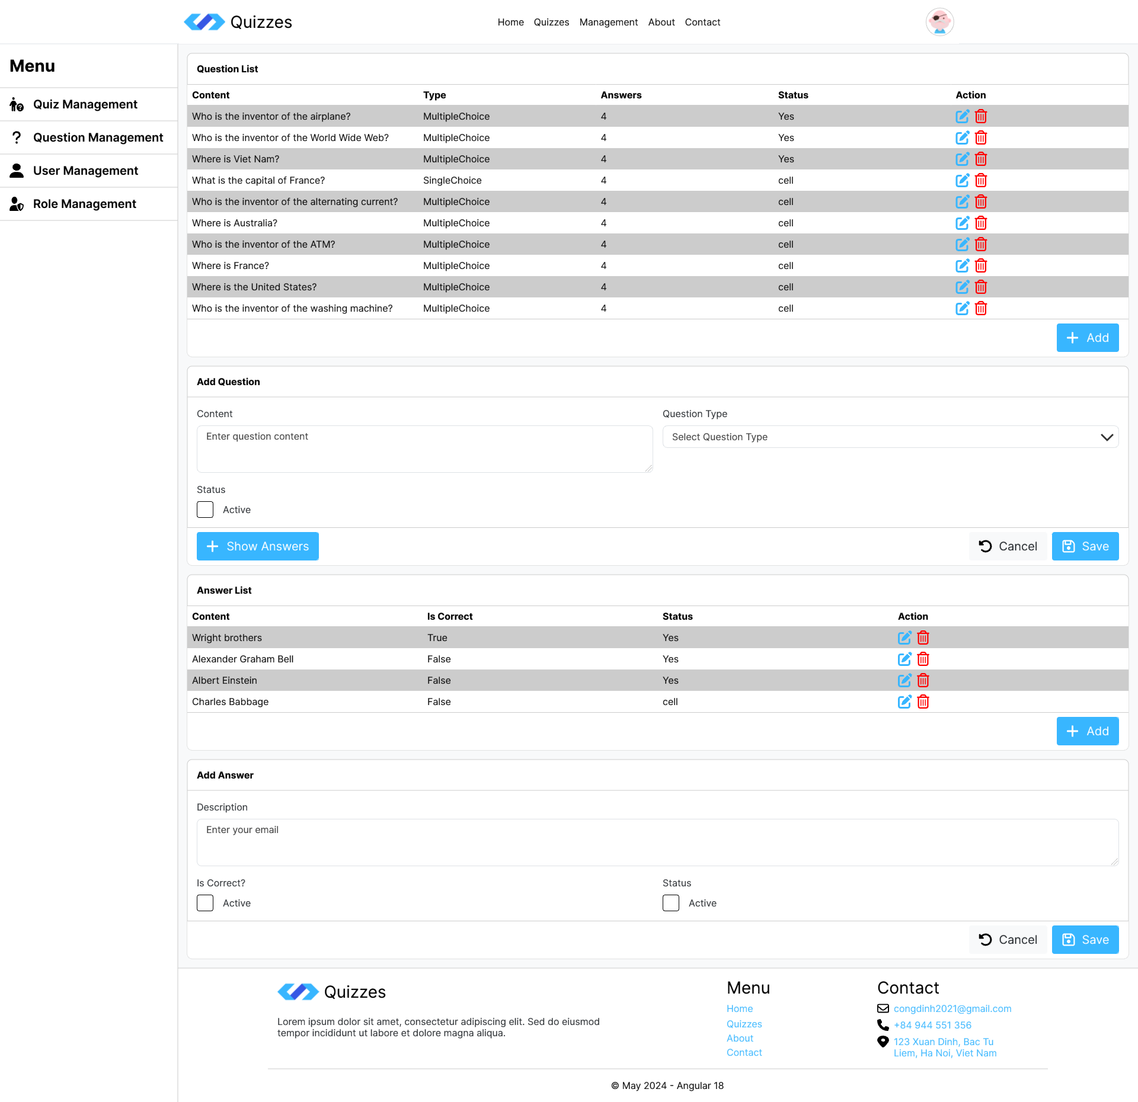
Add/Edit User (task05_user.png): User cannot edit password
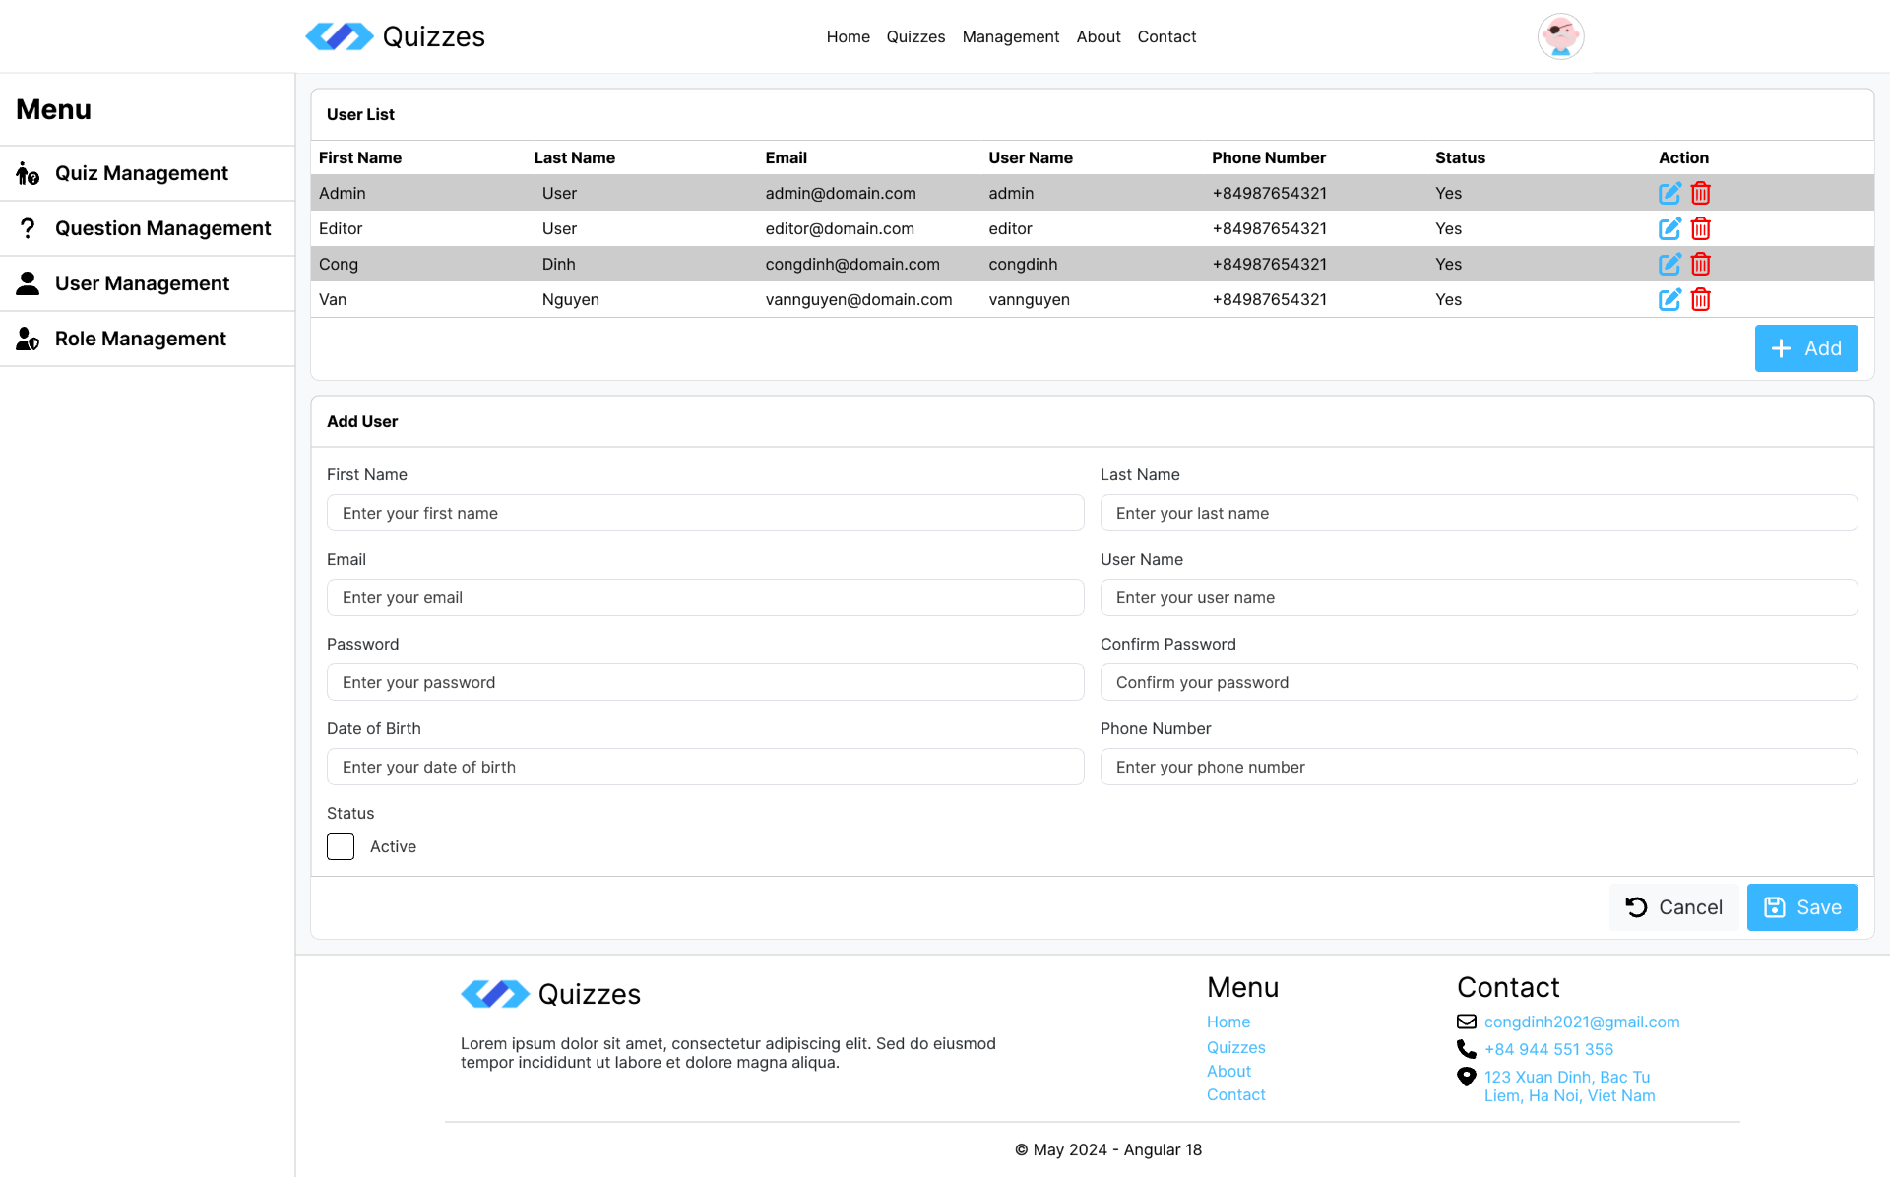

Add/Edit Role (task05_role.png):
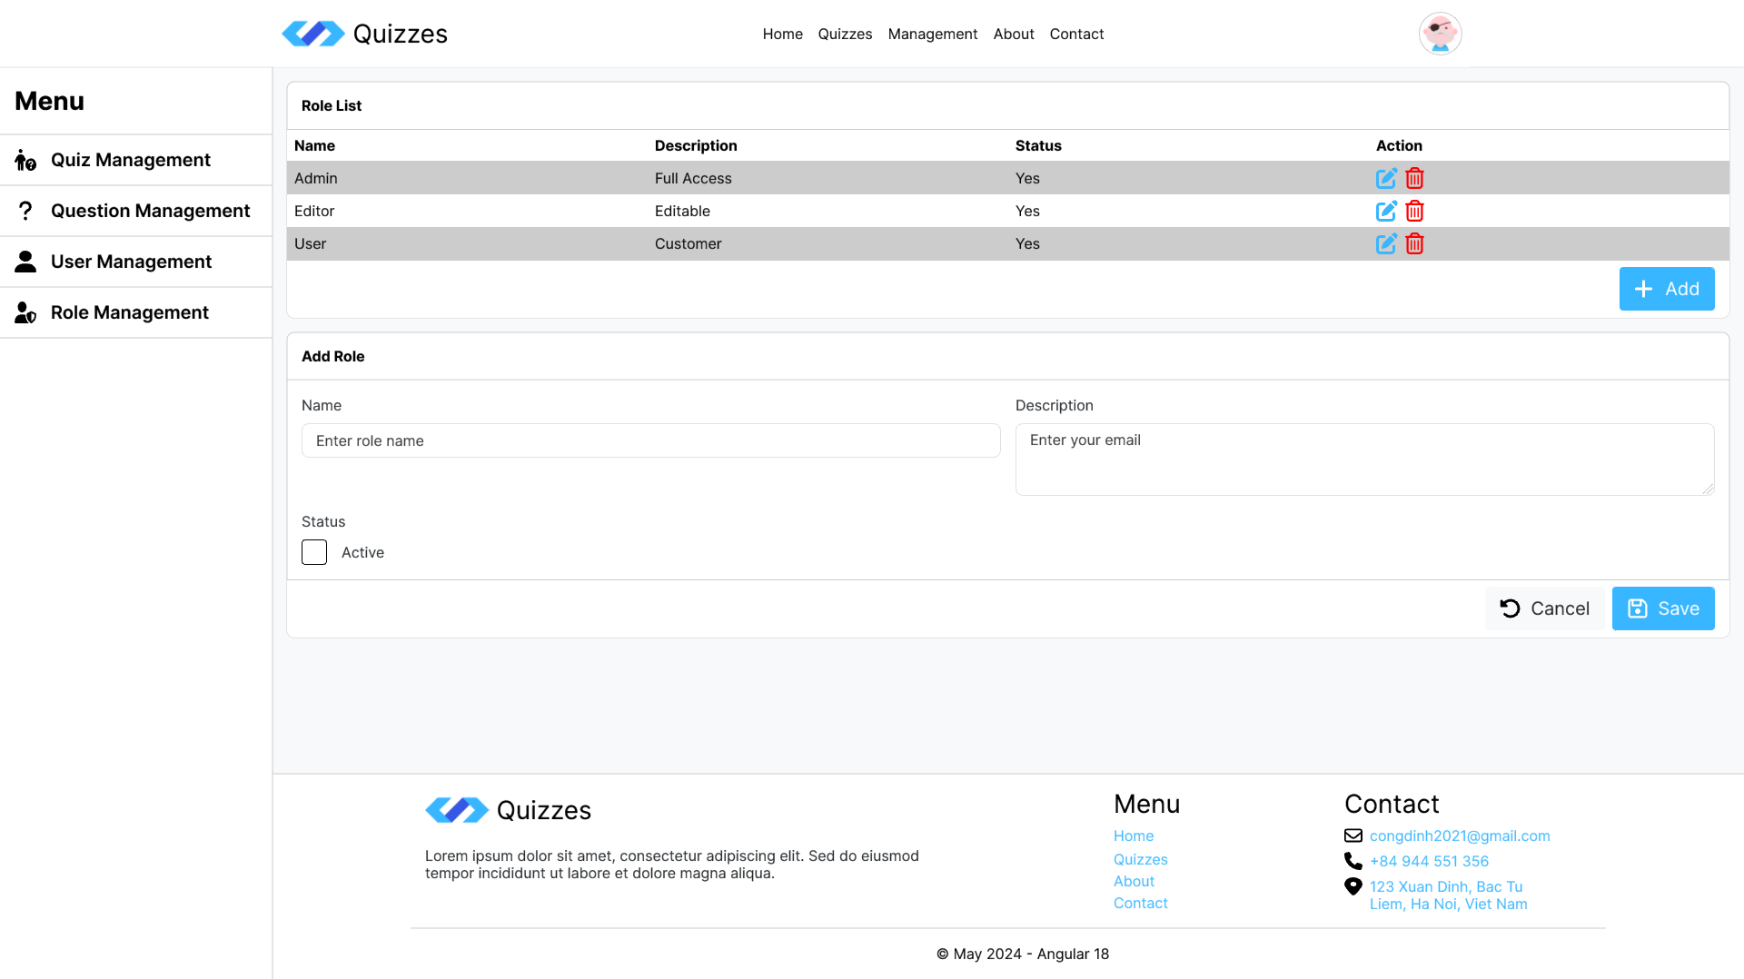
- Deployment:
  - Utilize tools like Angular CLI (ng build) to build the Angular application for production.
  - Consider deployment options (static hosting, cloud platforms) based on project requirements.
Hints:
- Configure environment variables for different deployment environments (development, production).
- Research deployment strategies and tools relevant to your chosen hosting platform.
- Design file in folder: task05
Business Rules:
- The frontend and backend should communicate effectively for successful application operation.
- Deployment should be efficient and result in a functional, accessible application.
Evaluation Criteria:
- Successful integration with the deployed ASP.NET Core Web API backend.
- Building and deployment of the Angular application for production environment.
- Understanding of different deployment strategies and considerations.
Submission file:
- Zip solution folder to a zip file
- File: FullName_ANG_QuizApp_Task_05_v1.0.zip
Estimated Time: 180 minutes.

Bonus:
Expanded the following features:
- Assign permissions to users.
- View quiz scores after taking the test.
- Manage user profiles, Change password, Update user avatar
- Paging, searching, sorting.
- Generate quiz codes in bulk for a list of users.
- Manage quiz by user

Mark Scale:
OOP design | 10% | Function requirements | 60%
Business rules | 15% | Main function | 15%

-- THE END --

