

SOFTWARE REQUIREMENT SPECIFICATION

Lớp: | HN26_FR_OU_KS_01
Học viên: | Lê Văn Chuyền – ChuyenLV1  Lê Văn Anh – AnhLV48  Nguyễn Thế Anh – AnhNT578

HaNoi – 2026
Table of Contents
I. Record of Changes 4
II. Software Requirement Specification 5
1. Overall Requirements 5
1.1. Context Diagram 5
1.2. Main Business Processes 5
1.4. System Functionalities 11
1.5. Entity Relationship Diagram 11
2. Use Case Specifications 12
2.1. View Home Page 12
2.2. View Quiz List 12
2.3. View Quiz Detail 13
2.4. View Quiz History 14
2.5. Take quiz 15
2.6. View quiz history 16
2.7. Log In 17
2.8. Log Out 19
2.9. Register account 20
2.10. Manage quizzes 21
2.11. Manage Questions & Answers 23
2.12. Manage Users 24
3. Functional Requirements 26
3.1 Feature Name 26
3.2 User Authentication 26
3.3 System Administration 26
4. Non-Functional Requirements 26
4.1 External Interfaces 26
4.2 Quality Attributes 26
5. Requirement Appendix 26
5.1 Business Rules 26
5.2 System Messages 26
5.3 Other Requirements… 26

I. Record of Changes
Date | A, M, D* | In charge | Change Description
*A - Added M - Modified D - Deleted

II. Software Requirement Specification

1. Overall Requirements

1.1. Context Diagram
Hệ thống Quiz Application là một hệ thống phần mềm mới nhằm thay thế các quy trình thủ công truyền thống trong việc tạo, quản lý và thực hiện các bài Quiz. Biểu đồ dưới đây minh họa các thực thể bên ngoài và các giao diện tương tác với hệ thống trong phiên bản 1.0. Hệ thống cung cấp nền tảng cho người dùng thực hiện các bài Quiz và cho quản trị viên quản lý các bài Quiz và người dùng.
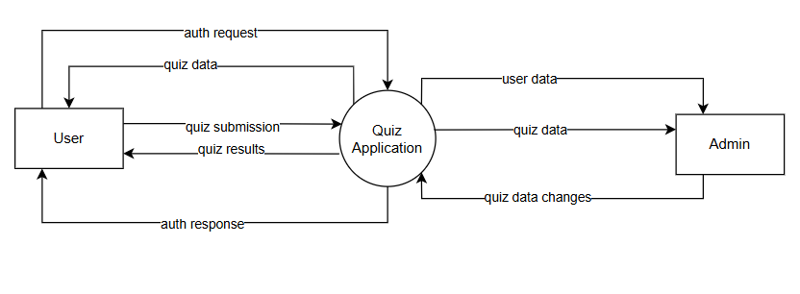

1.2. Main Business Processes

1.2.1. Take a quiz process
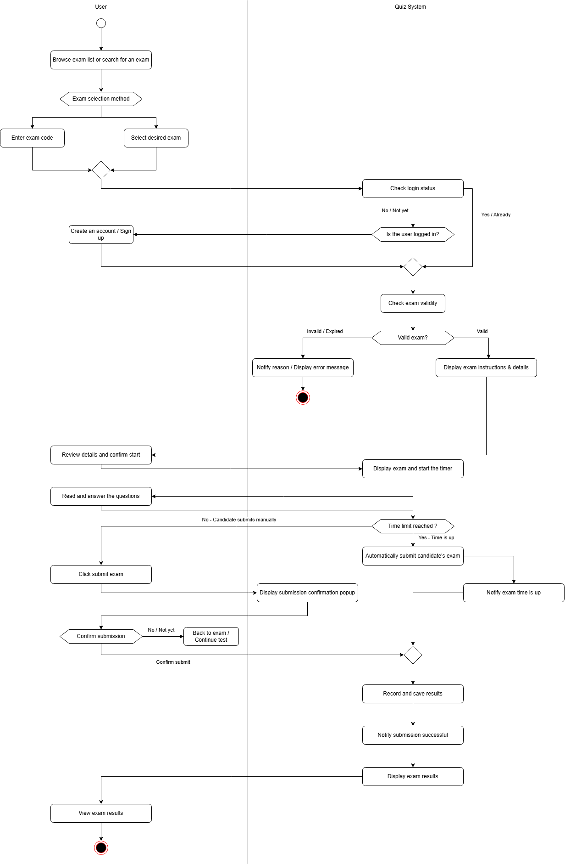

1.2.2. Management quiz content
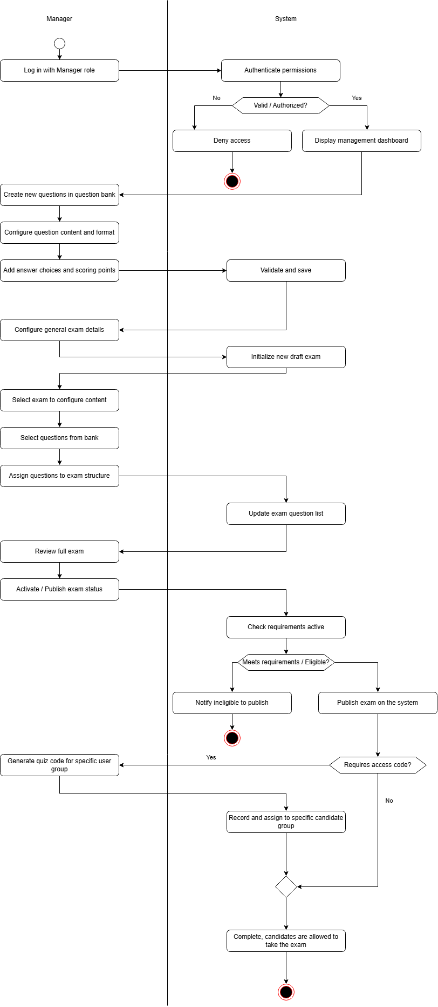
1.3.1. Actor
# | Actor | Description
1 | User | Represents users who access the system to register, log in, view quizzes, take quizzes, and view their quiz results and history.
2 | Administrator | Represents administrators who manage users, roles, quizzes, questions, and answers.

1.3.2. Use case
ID | Use Case | Feature | Use Case Description
UC-01 | View Home Page | Public Content | User views the Home page and browses available active quizzes.
UC-02 | Send Feedback | Public Content | User fills in and submits the Contact form with the required information.
UC-03 | View Quiz List | Quiz Taking | User browses the available quizzes and views their basic information.
UC-04 | View Quiz Detail | Quiz Taking | User views detailed information about a selected quiz before preparing or taking it.
UC-05 | Take Quiz | Quiz Taking | User starts quiz, views questions and chooses the answer, submits quiz and gets quiz result
UC-06 | View Quiz History | Quiz Taking | Authenticated User views their previous quiz attempts and related results.
UC-07 | Register Account | Authentication | Unauthenticated User creates a new account by providing the required registration information.
UC-08 | Log In | Authentication | Unauthenticated User authenticates with the system using the required credentials.
UC-09 | Log Out | Authentication | Authenticated User or Administrator logs out of the system.
UC-10 | Manage Quizzes | Management | Administrator creates, views, updates, and deletes quizzes and manages questions associated with quizzes.
UC-11 | Manage Questions & Answers | Management | Administrator creates, views, updates, and deletes questions and manages their associated answers.
UC-12 | Manage Users | Management | Administrator views user lists and user details, updates user information, and manages user status, assigns permission.

1.3.3. Use Case Diagrams
1.3.3.1. Ucs for User
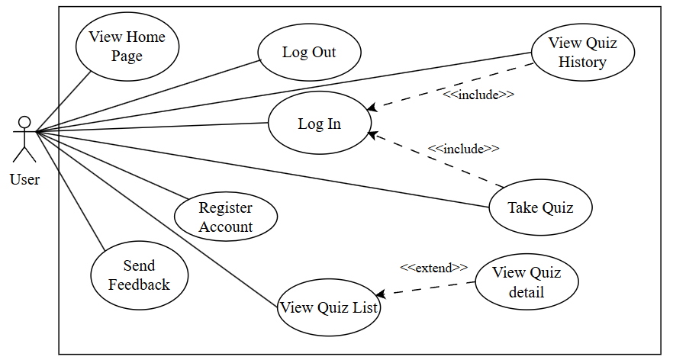
1.3.3.2. Ucs for Administrator
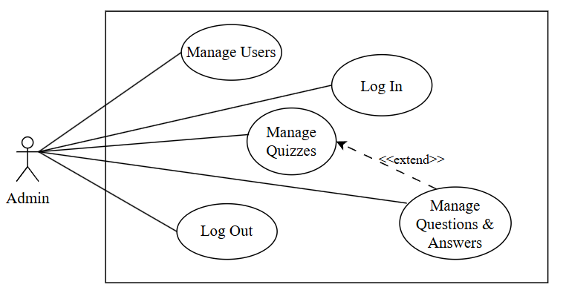

1.4. System Functionalities

1.5. Entity Relationship Diagram
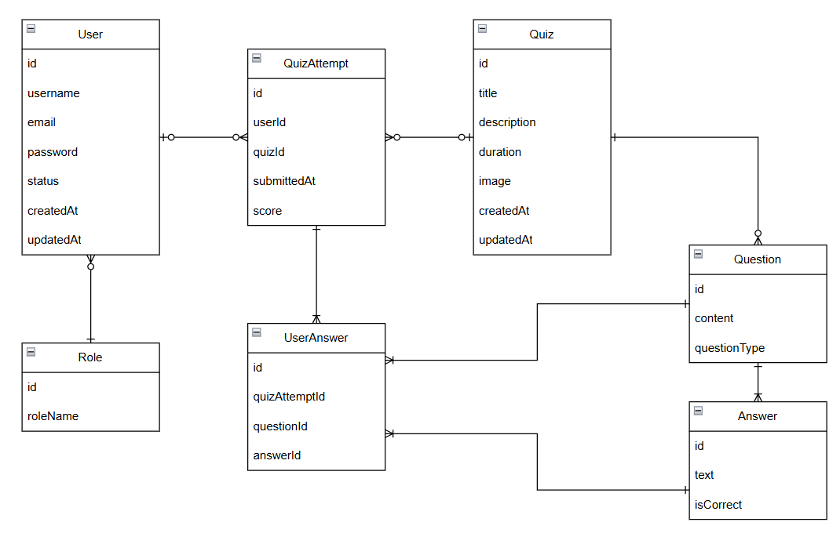

# | Entity | Description
1 | User | Stores user account information in the system.
2 | Role | Defines the role and permissions of a user.
3 | Quiz
  Stores information about a quiz.
4 | Question
  Stores questions belonging to a quiz.
5 | Answer | Stores answer options for a question.
6 | QuizAttempt
  Records a user's attempt to take a quiz.
7 | UserAnswer | Records the answer selected by a user for each question during a quiz attempt.

2. Use Case Specifications

2.1. View Home Page
Primary Actors | User | Secondary Actors | None
Description | As a user, I want to view the Home page so that I can browse available active quizzes.
Preconditions | None.
Postconditions | - The Home page is displayed successfully.  - Available active quizzes are displayed to the User.
Normal Sequence/Flow | View Home Page  1. User accesses the Home page.  2. System displays the Home page.  3. System requests the available active quizzes.  4. System returns the quiz data.  5. System displays the available active quizzes on the Home page.  6. User views the quiz information.
Alternative Sequences/Flows | Step 3.1_System cannot retrieve quiz data  1. System requests the available active quizzes.  2. System returns an error or the request cannot be completed.  3. System displays an appropriate error message.  4. User remains on the Home page.

2.2. View Quiz List
Primary Actors | User | Secondary Actors | None
Description | As a user, I want to view the quiz list so that I can browse the available quizzes and choose a quiz.
Preconditions | None.
Postconditions | - The quiz list is displayed successfully.  - User can view the basic information of available quizzes.
Normal Sequence/Flow | View Quiz List  1. User accesses the quizzes page.  2. System displays the quizzes page.  3. System requests the available quizzes.  4. System returns the quiz list.  5. System displays the available quizzes and their basic information.  6. User browses the quiz list.
Alternative Sequences/Flows | Step 3.1_System cannot retrieve the quiz list  1. System requests the quiz list.  2. System returns an error or the request cannot be completed.  3. System displays an appropriate error message.  4. User remains on the quizzes page.  Step 3.2_No available quizzes  1. System returns an empty quiz list.  2. System displays the quizzes page without any available quiz.  3. User can return to other pages.

2.3. View Quiz Detail
Primary Actors | User | Secondary Actors | None
Description | As a user, I want to view detailed information about a quiz so that I can decide whether to take the quiz.
Preconditions | The selected quiz exists in the system.
Postconditions | - The selected quiz information is displayed successfully.  - User can view the quiz details before taking the quiz.
Normal Sequence/Flow | View Quiz Detail  1. User selects a quiz from the quiz list.  2. System receives the selected quiz ID.  3. System requests the quiz details.  4. System returns the selected quiz information.  5. System displays the quiz details.  6. User views the quiz information.
Alternative Sequences/Flows | Step 3.1_Quiz cannot be found  1. System requests the selected quiz information.  2. The selected quiz cannot be found.  3. System displays an appropriate error message.  4. User can return to the Quiz List page.  Step 3.2_System cannot retrieve quiz details  1. System requests the selected quiz information.  2. System returns an error or the request cannot be completed.  3. System displays an appropriate error message.

2.4. View Quiz History
Primary Actors | User | Secondary Actors | None
Description | As an authenticated user, I want to view my quiz history so that I can review my previous quiz attempts and related results.
Preconditions | User is authenticated.
Postconditions | - The User's previous quiz attempts are displayed.  - The related quiz results are displayed.
Normal Sequence/Flow | View Quiz History  1. User accesses the Quiz History page.  2. System checks the User's authentication status.  3. System requests the User's quiz history.  4. System returns the User's previous quiz attempts and related results.  5. System displays the quiz history.  6. User views the previous quiz attempts and results.
Alternative Sequences/Flows | Step 2.1_User is not authenticated  1. User accesses the Quiz History page.  2. System detects that the User is not authenticated.  3. System redirects the User to the Login page.  4. User logs into the system successfully.  5. System redirects the User to the Quiz History page.  Step 3.1_User has no quiz history  1. System requests the User's quiz history.  2. System returns an empty result.  3. System displays that the User has no previous quiz attempts.

2.5. Take quiz
Primary Actors | User | Secondary Actors | None
Description | As a user, I want to take a quiz by viewing questions, choosing answers, submitting the quiz, and receiving my quiz result.
Preconditions | - User has logged into the system successfully.  - The selected quiz is available and has not expired.
Postconditions | - The system records the user's quiz attempt and selected answers.  - The system calculates and displays the user's quiz result.
Normal Sequence/Flow | Take quiz  1. User selects an available quiz  2. System displays the quiz detail information.  3. User starts the quiz.  4. User views each question and selects an answer.  5. User completes all questions and clicks the Submit button.  6. System validates the quiz submission.  7. System records the user's answers and quiz attempt.  8. System calculates the user's score.  9. System displays the quiz result to the user.
Alternative Sequences/Flows | Step 4.1 – User does not answer all questions  1. System detects that one or more questions have not been answered.  2. System notifies the user about the unanswered questions.  3. User chooses to answer the remaining questions or submit the quiz.  4. Return to Step 5 of the normal flow.  Step 5.1 – User cancels the quiz  1. User clicks the Cancel button.  2. System asks the user to confirm cancellation.  3. User confirms cancellation.  4. System exits the quiz without submitting the attempt.

2.6. View quiz history
Primary Actors | User | Secondary Actors | None
Description | As an authenticated user, I want to view my previous quiz attempts and their results so that I can review my quiz performance.
Preconditions | - User has logged into the system successfully.  - User has completed at least one quiz attempt.
Postconditions | - The system displays the user's previous quiz attempts and their results.  - No quiz data is modified.
Normal Sequence/Flow | View Quiz History  1. User accesses the Quiz History page.  2. System retrieves the user's previous quiz attempts.  3. System displays the list of completed quizzes, including quiz title, submission time, and score.  4. User selects a quiz attempt to view its details.  5. System displays the selected quiz attempt details, including questions, selected answers, and results.
Alternative Sequences/Flows | Step 2.1 – No quiz history found  1. System finds that the user has no previous quiz attempts.  2. System displays a message indicating that no quiz history is available.  3. Use case ends.

2.7. Log In
Primary Actors | User | Secondary Actors | None
Description | As a user, I want to log into the system so that I can access authenticated features of the system.
Preconditions | - User account has been created.  - User is not currently authenticated.
Postconditions | - User logs into the system successfully.  - The system stores the JWT token and User authentication information.  - User can access authenticated features.
Normal Sequence/Flow | Log In  1. User clicks the Login button from the page header or accesses an authenticated feature.  2. System shows the User Login screen.  3. User enters the login details (username, password).  4. User clicks the Login button.  5. System validates the login details.  6. System sends the login request to the system.  7. System authenticates the User.  8. System returns the User information, JWT token, and token expiration time.  9. System stores the authentication information and updates the User's authentication state.  10. System allows the User to access authenticated features.  11. System directs the User to the Home Page or the previously requested page, if any.
Alternative Sequences/Flows | Step 3.1_User provides incomplete login information  1. User leaves the username or password field blank.  2. System displays an appropriate validation message.  3. User enters the required login information.  4. Return to step 4 of the normal flow.  Step 5.1_System cannot authenticate the User  1. System validates the login details.  2. The username or password is incorrect.  3. System displays an appropriate error message.  4. User enters the login information again.  5. Return to step 3 of the normal flow.  Step 1.1_User accesses an authenticated feature without logging in  1. User accesses an authenticated feature, such as taking a quiz.  2. System checks the User's authentication status.  3. System detects that the User is not authenticated.  4. System redirects the User to the Login page.  5. User logs into the system successfully.  6. System allows the User to continue to the previously requested feature.

2.8. Log Out
Primary Actors | User / Administrator | Secondary Actors | None
Description | As an authenticated user, I want to log out of the system so that I can end my authenticated session.
Preconditions | User or Administrator is authenticated.
Postconditions | - User or Administrator is no longer authenticated.  - The current authentication information is removed from the frontend.  - Authenticated features are no longer accessible without logging in again.
Normal Sequence/Flow | Log Out  1. User or Administrator is logged into the system.  2. System displays the profile menu and the Logout button.  3. User or Administrator clicks the Logout button.  4. System executes the logout function.  5. System removes the current authentication information.  6. System updates the authentication state to unauthenticated.  7. System directs the User or Administrator to the Home Page.
Alternative Sequences/Flows | Step 4.1_Authentication information is no longer valid  1. User or Administrator clicks the Logout button.  2. System detects that the current authentication information is no longer valid or has expired.  3. System clears the local authentication state.  4. System directs the User or Administrator to the Home Page.

2.9. Register account
Primary Actors | User | Secondary Actors | None
Description | As a user, I want to register an account so that I can access the authenticated features of the system.
Preconditions | User does not have an account in the system and is not currently authenticated.
Postconditions | - A new user account is created successfully.  - User can use the registered account to log into the system.
Normal Sequence/Flow | Register Account  1. User clicks the Register button from the page header.  2. System shows the Registration screen.  3. User enters the required registration information, including first name, last name, email, username, phone number, date of birth, password, and password confirmation.  4. User clicks the Register button.  5. System validates the registration information.  6. System sends the registration request to the system.  7. System processes the registration request and creates the new user account.  8. System returns the registration result.  9. System processes the registration result.  10. System informs the User that the registration has been completed successfully.  11. User can log into the system using the newly created account.
Alternative Sequences/Flows | Step 5.1_User provides incomplete or invalid registration information  1. User leaves one or more required fields blank or provides invalid information.  2. System validates the registration form.  3. System displays an appropriate validation message.  4. User corrects the registration information.  5. Return to step 4 of the normal flow.  Step 7.1_System cannot create the user account  1. System sends the registration request to the system.  2. System cannot create the user account.  3. System displays an appropriate error message to the User.  4. User corrects the registration information if necessary.  5. Return to step 3 of the normal flow.

2.10. Manage quizzes
Primary Actors | Administrator | Secondary Actors | None
Description | As an administrator, I want to create, view, update, and delete quizzes, and manage the questions assigned to each quiz, so that quiz content remains accurate and ready for use.
Preconditions | - Administrator has logged into the system successfully.  - Administrator has been granted permission to manage quizzes.
Postconditions | - Quiz data (create/update/delete) is saved to the system.  - The quiz list is updated to reflect the changes.
Normal Sequence/Flow | 1. Administrator accesses the Quiz Management page.  2. System displays the list of existing quizzes (title, duration, status).  3. Administrator selects to create a new quiz or edit an existing one.  4. Administrator enters/updates general quiz information (title, description, duration, image).  5. System validates the entered data.  6. Administrator selects questions from the question bank and assigns them to the quiz.  7. System updates the quiz's question list.  8. Administrator reviews the full quiz content and activates/publishes the quiz status.  9. System checks whether the quiz meets the publishing requirements.  10. System saves the quiz and displays a success message.  11. System refreshes and displays the updated quiz list.
Alternative Sequences/Flows | Step 5.1 – Invalid quiz information  1. System detects invalid or missing required fields (e.g., empty title, non-positive duration).  2. System displays an error message and highlights the invalid fields.  3. Administrator corrects the information and resubmits.  Step 3.1 – Delete quiz  1. Administrator selects a quiz and clicks Delete.  2. System asks Administrator to confirm the deletion.  3. Administrator confirms.  4. System deletes the quiz and its question assignments.  5. System displays a success message and updates the quiz list.  Step 9.1 – Quiz not eligible for publishing  1. System finds the quiz does not meet the publishing requirements.  2. System notifies the Administrator of the reason (e.g., quiz has no questions).  3. Quiz remains in draft status.

2.11. Manage Questions & Answers
Primary Actors | Administrator | Secondary Actors | None
Description | As an administrator, I want to create, view, update, and delete questions and manage their associated answers so that the question bank contains accurate content for building quizzes.
Preconditions | - Administrator has logged into the system successfully.  - Administrator has been granted permission to manage questions.
Postconditions | - Question and answer data (create/update/delete) is saved to the question bank.  - The question list is updated to reflect the changes.
Normal Sequence/Flow | 1. Administrator accesses the Question Management page.  2. System displays the list of questions in the question bank.  3. Administrator selects to create a new question or edit an existing one.  4. Administrator enters/updates the question content and question type (Multiple Choice, Single Choice, True/False, Fill in the Blanks, Short Answer, Long Answer).  5. Administrator adds/updates answer choices and marks the correct answer(s).  6. System validates the question and answer data.  7. System saves the question and its answers to the question bank.  8. System displays a success message and updates the question list.
Alternative Sequences/Flows | Step 6.1 – Invalid question or answer data  1. System detects missing question content, missing answer choices, or no correct answer selected.  2. System displays an error message indicating the invalid fields.  3. Administrator corrects the information and resubmits.  Step 3.1 – Delete question  1. Administrator selects a question and clicks Delete.  2. System checks whether the question is currently assigned to any quiz.  3. System asks Administrator to confirm the deletion.  4. Administrator confirms.  5. System deletes the question and its answers, removing it from any assigned quizzes.  6. System displays a success message and updates the question list.

2.12. Manage Users
Primary Actors | Administrator | Secondary Actors | None
Description | As an administrator, I want to view the list of users and their details, update user information, and manage user status and permissions so that user accounts in the system are properly maintained.
Preconditions | - Administrator has logged into the system successfully.  - Administrator has been granted permission to manage users.
Postconditions | - User information, status, or assigned permission is updated and saved.  - The user list is updated to reflect the changes.
Normal Sequence/Flow | 1. Administrator accesses the User Management page.  2. System displays the list of users (username, email, status).  3. Administrator selects a user to view details.  4. System displays the selected user's full information.  5. Administrator updates user information, changes account status, or assigns a permission/role.  6. System validates the updated data.  7. System saves the changes.  8. System displays a success message and updates the user list.
Alternative Sequences/Flows | Step 6.1 – Invalid user data  1. System detects invalid data (e.g., duplicate email/username, invalid format).  2. System displays an error message.  3. Administrator corrects the information and resubmits.  Step 5.1 – Deactivate/lock a user account  1. Administrator changes a user's status to Inactive/Locked.  2. System asks Administrator to confirm the action.  3. Administrator confirms.  4. System updates the user's status; the user can no longer log in.  5. System displays a success message and updates the user list.

3. Functional Requirements

3.1 Feature Name

3.2 User Authentication

3.3 System Administration

4. Non-Functional Requirements

4.1 External Interfaces

4.2 Quality Attributes

5. Requirement Appendix

5.1 Business Rules

5.2 System Messages

5.3 Other Requirements…

