

Dashboard

Embeding Tableu into our website

Website – javascript

Libraries for Javascript?

- D3

- chart.js

- Puppeteer – javascript

- container for tableu

- Node js

# Chart

## #1 Only Finance Data

Trends of closing price & Volume

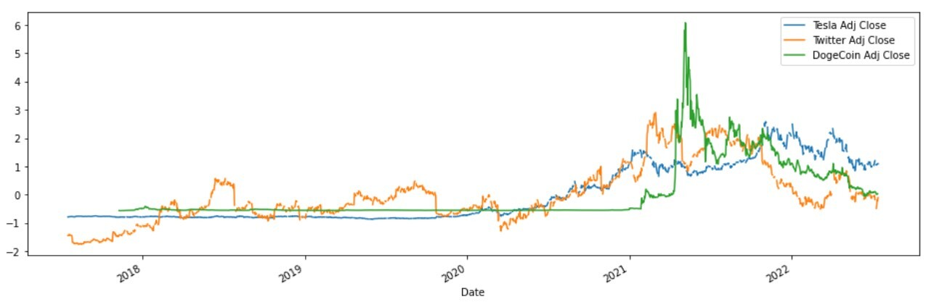

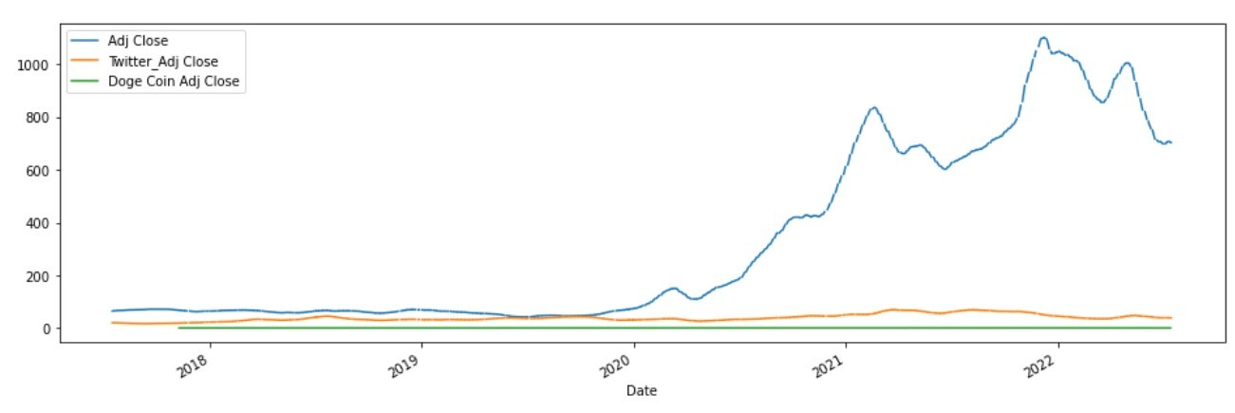

* Pick filter to select stock
* Pick filter to select the volume or close value
* Tableu

## #2 Interactive part

### Tweet mapping & Finance Data

* Interactive part includes picking a date range
* Combined Dates
  + Date range major overall information with tweet sentiment trend against price trend
  + Date range major overall information with tweet date against price trend
* Stats on the side with big numbers
* Potentially tableau / tbd

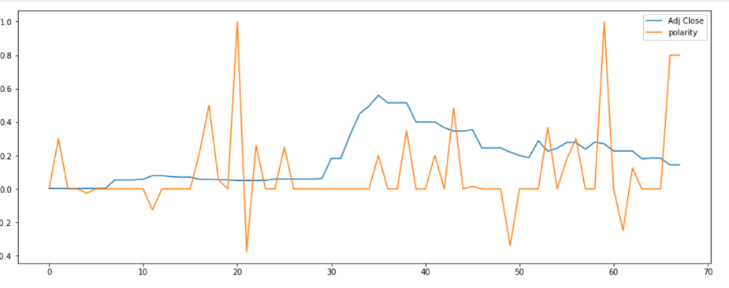

### Drop down of date with tweet info and 7 day trend

* Tweet ID based URL
* 7 day Trend
* Potentially a table with percent increase
* JS graph

### Summary Information / Story

* Tab for the stock type

### Machine Learning

* Price Prediction

### Live updates area

* Stock values for stock today

### Team information

* Github link
* Team members

# References

* UFO and belly button

# Task List

1. Ground work – Deepa

– HTML

* Java script

1. Overall layout – Shreha
2. Creating tableu charts – Vanessa
3. JS chart – Tamara / 7 day / tweets

Searching on the chart tools

Fetching data and displaying into chart

Fetching API information

Interaction of tableu with javascript,

* Can we pass parameters from js to tableu