|  |
| --- |
| Name: Le Do Van Bang  ID: 19521236  Class: Phát triển ứng dụng web - MSIS207.N11.CTTT |

**Lab 1-Home Work - Class .1**

**SUMMARY**

|  |  |  |
| --- | --- | --- |
| **Task** | **Status** | **Page** |
| 1) Using HTML/CSS and making CV | Done | 1 |
| 2)Access to Exercise1 and do as guidance | Done | 2 |
| 3) Access to Exercise2 and do as guidance | Done | 5 |

**Self-scrores:8**

Link GitHub: <https://github.com/VanBang1/MSIS207.N11.CTTT-19521236>

**1) Using HTML/CSS and making CV**

File name: HomeWork_1.html

**2)Access to Exercise1 and do as guidance**

File name: Excercise1.html

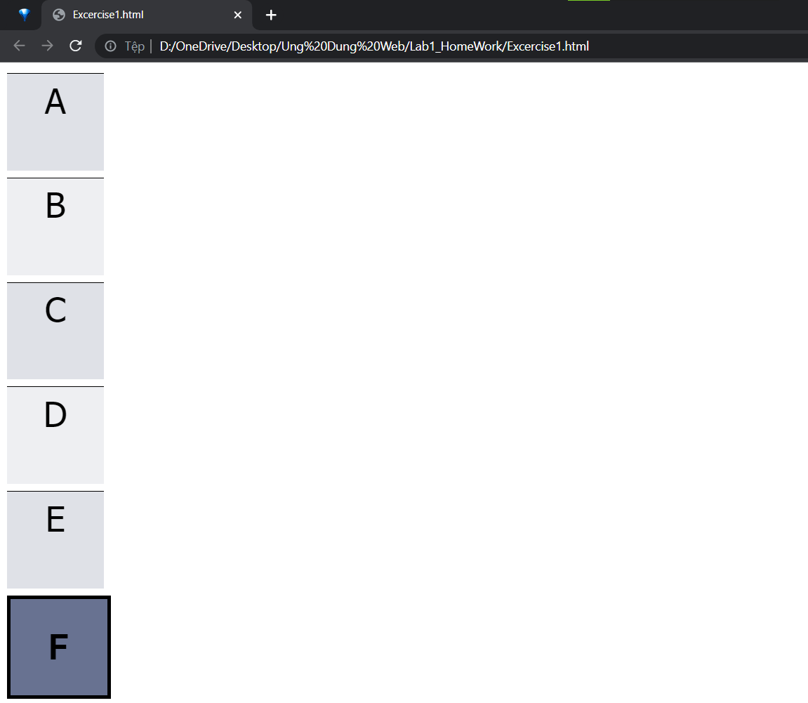

**3) Access to Exercise2 and do as guidance**

File name: Excercise2.html

