## 前端：

### 新组件的注册配置

## 2.图表

Scale：用来控制Y轴的范围，调至令人舒适的程度。

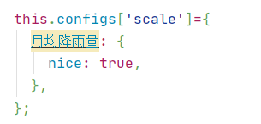控制“月均降雨量”这个Y轴的舒适度

### 1.基础直线 jczx 时间变化

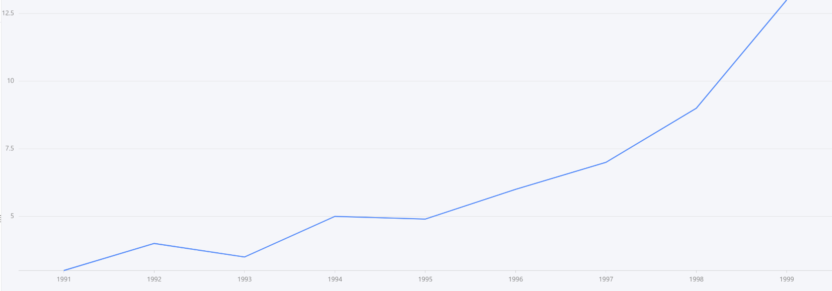

二维，反映变化趋势（一般X轴是时间）

### ddzz 统计划分比例

任务数：select count(*) from dna_comm_task where has_del = 0

查最新创建的任务的id：select r2.id from (SELECt max(i.bae003) as last_task from dna_comm_task i)AS r1 left JOIN dna_comm_task r2 ON (r1.last_task=r2.bae003)

通过task_id寻找它下面扫出来的帐号s：

SELECT count(*) FROM scan_result WHERE

task_his_id = '297e77dc725a79b301725a7aca8a0007'

查询机器数：（总数，没有任务条件限制）

SELECT COUNT(DISTINCT dna_extra_scan_type_value_id) FROM extra_scan_type_vaule_map

查询不同扫描类型的账号占比：

select g1.text,count(DISTINCT g1.id) as count from (SELECT r2.id,r1.text FROM dna_scan_type r1 join dna_extra_scan_type_value r2 ON r1.id= r2.scan_type_id) g1 GROUP BY g1.text

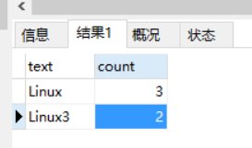

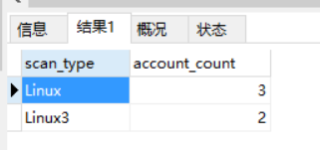

查询不同任务的占比：

SELECT g1.text,count(DISTINCT g1.taskid) from (SELECT text,taskid FROM dna_scan_type r1 join dna_extra_scan_type_value r2 ON r1.id= r2.scan_type_id) g1 GROUP BY text

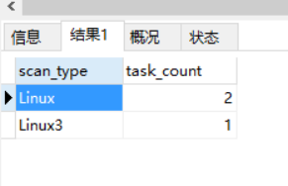

定时和实时。

select frequency, COUNT(DISTINCT id) as count from dna_comm_task where has_del = 0 GROUP BY frequency

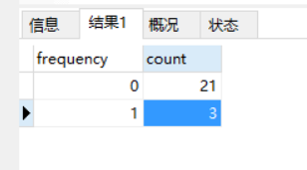

季度查询:

select result_type,COUNT(DISTINCT id) from extra_search_account_his where bae003 > '2020-05-31 12:00:00' and bae003< '2020-06-30 14:59:59' and has_del = '0' GROUP BY result_type

年度查询:

select result_type,COUNT(DISTINCT id) from extra_search_account_his where YEAR(bae003)=2020 and has_del = '0' GROUP BY result_type

月查询:

select result_type,COUNT(DISTINCT id) from extra_search_account_his where MONTH(bae003)=7 and has_del = '0' GROUP BY result_type