## Question 1:

**Exercise 5.1**

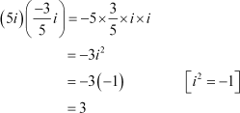Express the given complex number in the form *a* + *ib*: Answer

## Question 2:

Express the given complex number in the form *a* + *ib*: *i*9 + *i*19

Answer

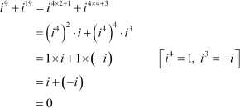

## Question 3:

Express the given complex number in the form *a* + *ib*: *i*–39

Answer

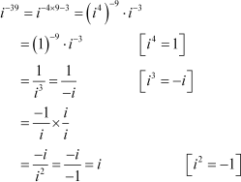

## Question 4:

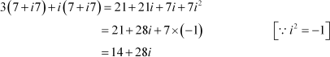Express the given complex number in the form *a* + *ib*: 3(7 + *i*7) + *i*(7 + *i*7) Answer

## Question 5:

Express the given complex number in the form *a* + *ib*: (1 – *i*) – (–1 + *i*6) Answer

## Question 6:

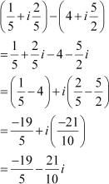Express the given complex number in the form *a* + *ib*: Answer

## Question 7:

Express the given complex number in the form *a* + *ib*: Answer

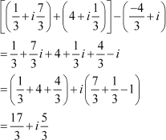

## Question 8:

Express the given complex number in the form *a* + *ib*: (1 – *i*)4

Answer

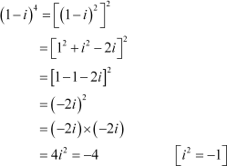

## Question 9:

Express the given complex number in the form *a* + *ib*:  Answer

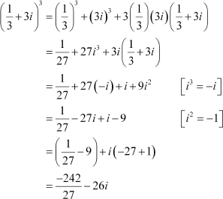

## Question 10:

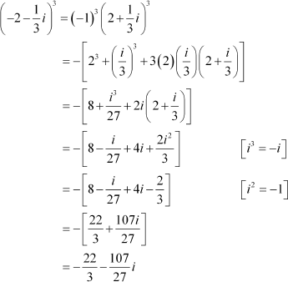Express the given complex number in the form *a* + *ib*: Answer

## Question 11:

Find the multiplicative inverse of the complex number 4 – 3*i*

Answer

Let *z* = 4 – 3*i*

Then, = 4 + 3*i* and

Therefore, the multiplicative inverse of 4 – 3*i* is given by



## Question 12:

Find the multiplicative inverse of the complex number Answer

Let *z* =



Therefore, the multiplicative inverse of is given by



## Question 13:

Find the multiplicative inverse of the complex number –*i* Answer

Let *z* = –*i*



Therefore, the multiplicative inverse of –*i* is given by



## Question 14:

Express the following expression in the form of *a* + *ib*.



Answer

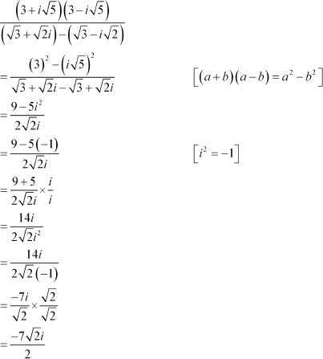

## Question 1:

**Exercise 5.2**

Find the modulus and the argument of the complex number Answer

On squaring and adding, we obtain

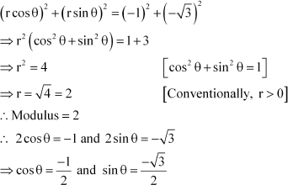

Since both the values of sin *θ* and cos *θ* are negative and sin*θ* and cos*θ* are negative in III quadrant,



Thus, the modulus and argument of the complex number are 2 and respectively.

## Question 2:

Find the modulus and the argument of the complex number Answer

On squaring and adding, we obtain

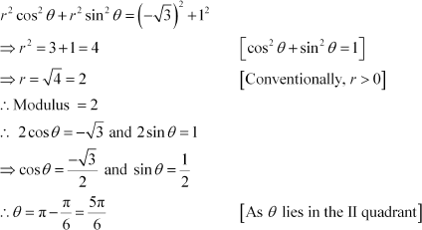

Thus, the modulus and argument of the complex number are 2 and respectively.

## Question 3:

Convert the given complex number in polar form: 1 – *i*

Answer 1 – *i*

Let *r* cos *θ* = 1 and *r* sin *θ* = –1 On squaring and adding, we obtain

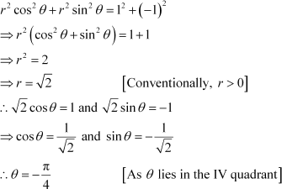

This is

the required polar form.

# Question 4:

Discuss the shape of the following molecules using the VSEPR model: BeCl2, BCl3, SiCl4, AsF5, H2S, PH3

Answer

BeCl2:



The central atom has no lone pair and there are two bond pairs. i.e., BeCl2 is of the type AB2. Hence, it has a linear shape.

BCl3:

The central atom has no lone pair and there are three bond pairs. Hence, it is of the type AB3. Hence, it is trigonal planar.



SiCl4:

The central atom has no lone pair and there are four bond pairs. Hence, the shape of SiCl4 is tetrahedral being the AB4 type molecule.

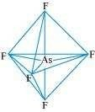AsF5:

The central atom has no lone pair and there are five bond pairs. Hence, AsF5 is of the type AB5. Therefore, the shape is trigonal bipyramidal.

H2S:

The central atom has one lone pair and there are two bond pairs. Hence, H2S is of the type AB2E. The shape is Bent.

PH3:

The central atom has one lone pair and there are three bond pairs. Hence, PH3 is of the AB3E type. Therefore, the shape is trigonal bipyramidal.