## Question 1:

‎Exercise 5.1

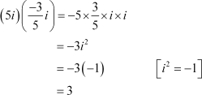Express the given complex number in the form a + ib: Answer

## Question 2:

Express the given complex number in the form a + ib: i9 + i19

Answer

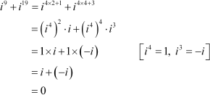

## Question 3:

Express the given complex number in the form a + ib: i–39

Answer

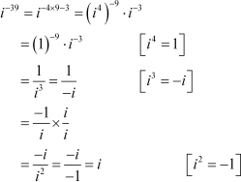

## Question 4:

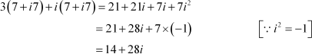Express the given complex number in the form a + ib: 3(7 + i7) + i(7 + i7) Answer

## Question 5:

Express the given complex number in the form a + ib: (1 – i) – (–1 + i6) Answer

## Question 6:

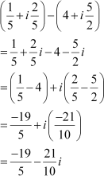Express the given complex number in the form a + ib: Answer

## Question 7:

Express the given complex number in the form a + ib: Answer

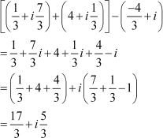

## Question 8:

Express the given complex number in the form a + ib: (1 – i)4

Answer

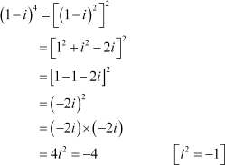

## Question 9:

Express the given complex number in the form a + ib:  Answer

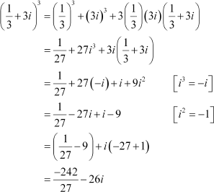

## Question 10:

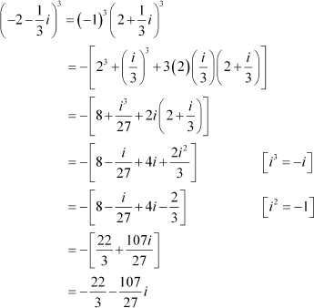Express the given complex number in the form a + ib: Answer

## Question 11:

Find the multiplicative inverse of the complex number 4 – 3i

Answer

Let z = 4 – 3i

Then,= 4 + 3i and

Therefore, the multiplicative inverse of 4 – 3i is given by



## Question 12:

Find the multiplicative inverse of the complex number Answer

Let z =



Therefore, the multiplicative inverse ofis given by



## Question 13:

Find the multiplicative inverse of the complex number –i Answer

Let z = –i



Therefore, the multiplicative inverse of –i is given by



## Question 14:

Express the following expression in the form of a + ib.



Answer

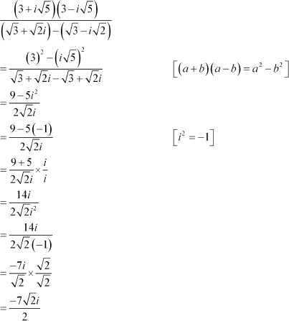

## Question 1:

‎Exercise 5.2

Find the modulus and the argument of the complex number Answer

On squaring and adding, we obtain

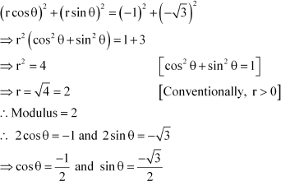

Since both the values of sin θ and cos θ are negative and sinθ and cosθ are negative in III quadrant,



Thus, the modulus and argument of the complex numberare 2 and respectively.

## Question 2:

Find the modulus and the argument of the complex number Answer

On squaring and adding, we obtain

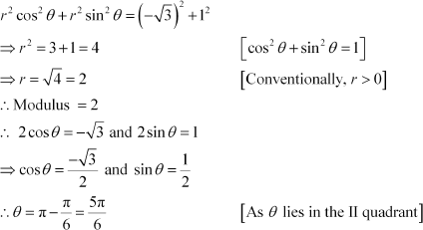

Thus, the modulus and argument of the complex numberare 2 and respectively.

## Question 3:

Convert the given complex number in polar form: 1 – i

Answer 1 – i

Let r cos θ = 1 and r sin θ = –1 On squaring and adding, we obtain

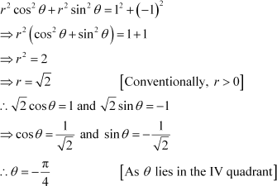

This is

the required polar form.