READ_ME

The main program is the Implicit.py module. At the top of this module there is a clearly marked section where the func variable can be assigned the function string and the h variable can be assigned the max segment length. Implicit needs to be in the same folder as the Geom.py module. The Geom.py module is a pared down version of Program 2. Numpy, SymPy and MatPlotLib are needed to run the program.

Example Run

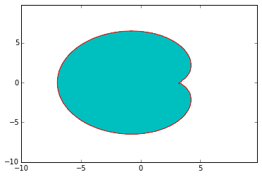

func = '-(((x-3)**2+y**2+5*(x-3))**2-5**2*((x-3)**2+y**2))'
h = 0.5

Number of connected components is: 1

The shape is simply connected.

The figure has a non-empty interior

The max distance from the approximation is 0.500

The shape has at least one sharp corner.

The function is not the distance function.

