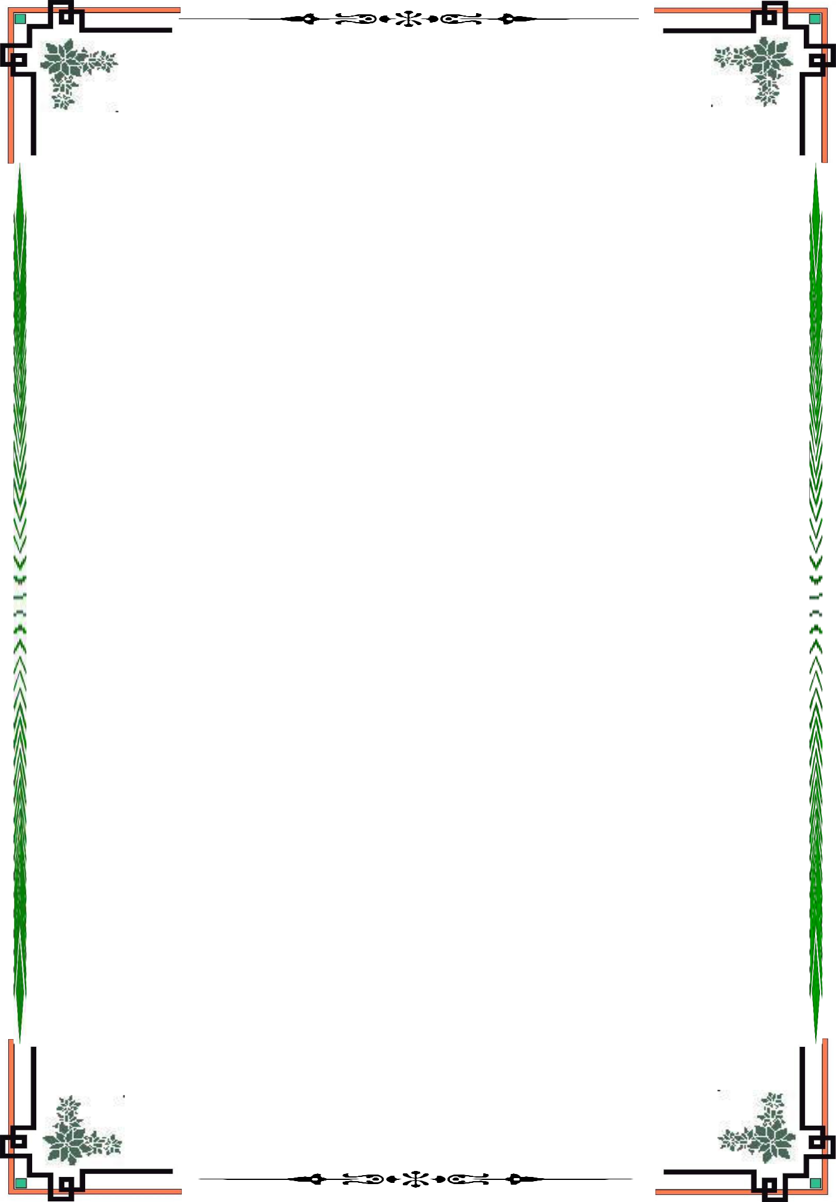**TRƯỜNG ĐẠI HỌC SƯ PHẠM KỸ THUẬT TP. HỒ CHÍ MINH**

**KHOA CƠ KHÍ CHẾ TẠO MÁY**

------🙖🕮🙐------



**BÁO CÁO KẾT THÚC HỌC PHẦN**

**MÔN HỌC: CẢM BIẾN VÀ CƠ CẤU CHẤP HÀNH**

**MÔ HÌNH ĐO MỰC NƯỚC, NHIỆT ĐỘ VÀ BƠM NƯỚC TỰ ĐỘNG**

**GVHD: T.S. Hà Lê Như Ngọc Thành**

**SVTH:**

**TRẦN VĂN HUY­_21146552**

**NGUYỄN MẠNH HÙNG_21146241**

**PHÙNG MẠNH THẮNG_21446316**

**MMH: LLCT120250_46**

**LỚP: THỨ 3 (TIẾT 10-11)**

**HỌC KỲ 2 – NĂM HỌC 2022 - 2023**

**TP. HỒ CHÍ MINH – 05/2023**

**MỤC LỤC**

1. General of HC-SR04 Ultrasonic Sensor manufacturing principles 3

2. Experimental on the HC-SR04 Ultrasonic Sensor 4

**2.1 Operational principle of HC-SR04 Ultrasonic Sensor 4**

**2.2 Technical Specifications 6**

3. Experimental results 6

Figure 1. Plot of the input quantity verus the electrical output signal 8

4. Application of HC-SR04 Ultrasonic Sensor in the model 8

**4.1. Other types of sensor and actuators 8**

**4.1.1. DHT11 Temperature and Humidity Sensor Module 8**

**4.1.2. DS18B20 Temperature Sensor 10**

**4.1.3. LCD Display LCD2004 Module Green Screen with I2C 10**

**4.1.4. DC 12V 365 Motor Pump Large Flow Centrifugal Pump 12**

**4.1.5. Module Relay 5V 10A 12**

**4.2. The model introduction 13**

**4.3. Working principle of the model 14**

**4.4. Exprimental Results 14**

5. Conclusions and recommendations 18

1. **General of HC-SR04 Ultrasonic Sensor manufacturing principles**

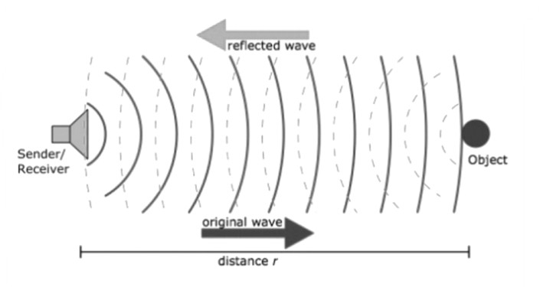

An ultrasonic sensor is a device that uses ultrasonic waves to measure the distance to an object. Ultrasonic is a general term for sounds that have a high frequency and cannot be heard by humans. The human ear can detect frequencies between 20 Hz and 20,000 Hz, but sounds of higher frequencies are called ultrasonic. The ultrasonic sensor is built on principles of wave propagation and reflection, a wave is emitted at a certain point, and it takes time to return from this point after a given object reflects it.

1. **Experimental on the HC-SR04 Ultrasonic Sensor** 
   1. **Operational principle of HC-SR04 Ultrasonic Sensor**

The ultrasonic sensor emits an ultrasound at 40 KHz. It propagate through the air at the speed of sound. If it come into contact with an object, it’s reflected back as an echo to the sensor. The sensor then calculates the distance to the target based on the time between sending the signal and receiving the echo.

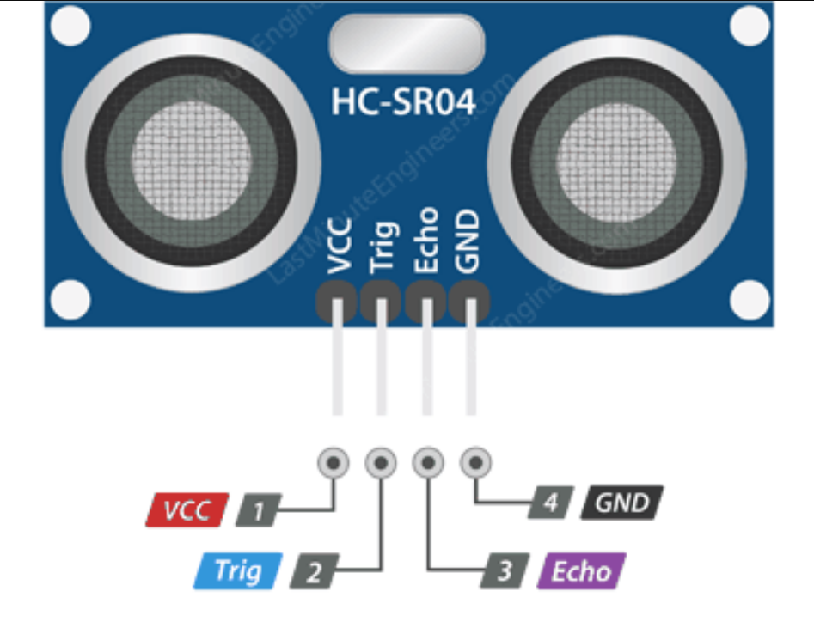

In order to generate the ultrasound we need to set the Trig pin on a High State for 10 µs. That will send out an 8 cycle ultrasonic burst which will travel at the [speed of sound](https://en.wikipedia.org/wiki/Speed_of_sound). The Echo pins goes high right away after that 8 cycle ultrasonic burst is sent, and it starts listening or waiting for that wave to be reflected from an object.

If those pulses are not reflected back, the echo signal times out and goes low after 38ms (38 milliseconds). Thus a pulse of 38ms indicates no obstruction within the range of the sensor.



If those pulses are reflected back, the echo pin goes low as soon as the signal is received. This generates a pulse on the echo pin whose width varies from 150 µs to 25 ms depending on the time taken to receive the signal.



For that purpose we are using the following basic formula for calculating the distance:

**Distance = Speed x Time**

We actually know both the speed and the time values. The time is the amount of time the Echo pin was HIGH (, and the speed is the speed of sound (~343m/s in dry air 20 degC). There’s one additional step we need to do, and that’s divide the end result by 2. and that’s because we are measuring the duration the sound wave needs to travel to the object and bounce back.

Notes: 343m/s = 0.0343 cm/us or sound will takes 29.145us to travel one centimeter.

Therefore:

**Distance = (Speed x Time) / 2= = (cm)**

* 1. **Technical Specifications**
* Power Supply: +5V DC
* Quiescent Current: <2mA
* Working Current: 15mA
* Operating Frequency: 40 KHz
* Effectual Angle: <15°
* Ranging Distance : 2 – 400 cm
* Dead zone: 0 – 2 cm
* Resolution : 0,3 cm
* Measuring Angle: 30 degree
* Trigger Input Pulse width: 10uS TTL pulse
* Echo Output Signal: TTL pulse proportional to the distance range
* Dimension: 45mm x 20mm x 15mm
* Weight: approx. 10 g

Note: The ultrasonic sensor has a cone-shaped emitting wave, so it is easy to noise to the sensor at a long distance or the surface of the object is not flat, resulting in incorrect distance.

1. **Experimental results**

Water level (h) is calculated by taking the height of the tank (b = 19,2 cm) minus the distance measured by the ultrasonic sensor (a):

h = b – a = 19,2 – a (cm)

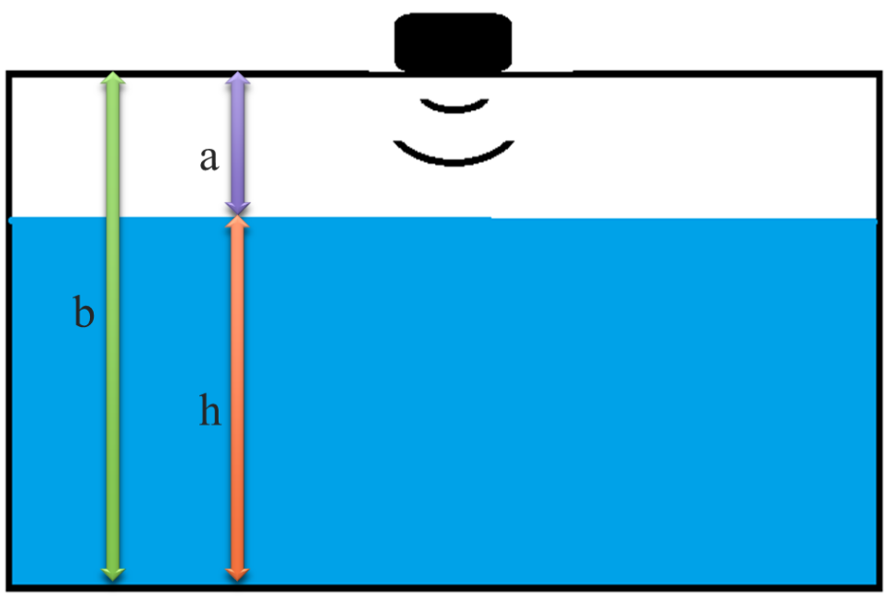

We repeated each experiment for three time, the error percentage is calculated as follows:

The precision percentage is calculated as follows:

With:

**Table 1. Experimental Results of Ultrasonic Sensor for**

**Various Water Level**

|  |  |  |  |  |  |  |
| --- | --- | --- | --- | --- | --- | --- |
| Water Level (cm) | 1st trial | 2nd trial | 3rd trial | Average | % Error | % Precision |
| 5 | 5,25 | 5,24 | 5,19 | 5,23 | 4,53 | 0,5 |
| 7 | 7,30 | 7,33 | 7,33 | 7,32 | 4,57 | 0,2 |
| 10 | 10,42 | 10,20 | 10,23 | 10,28 | 2,83 | 0,95 |
| 12 | 11,71 | 11,85 | 12,22 | 11,93 | 1,83 | 2,23 |
| 15 | 15,24 | 14,73 | 15,00 | 14,98 | 1,08 | 1,99 |

Table 1 shows the ultrasonic sensor level water measurement result by varying the level parameter from 5 to 15 cm. We read the level when water in calm state. The water level is inversely proportional to the distance from the sensor to the water surface, so from the table, the higher the water level, the lower the error reading.

**Table 2. Experimental Results of relationship between the water level and the output voltage**

|  |  |
| --- | --- |
| Water Level (cm) | Output voltage (V) |
| 5,19 | 0,158 |
| 5,25 | 0,141 |
| 7,33 | 0,203 |
| 7,3 | 0,213 |
| 11,71 | 0,331 |
| 12,22 | 0,355 |
| 15,24 | 0,442 |
| 15 | 0,427 |

# **Figure 1. Plot of the input quantity verus the electrical output signal**

From figure 1, linear coefficient is 0,9976 so the ultrasonic sensor is linear. Sensitivity = Output/Input = 0,0289

1. **Application of HC-SR04 Ultrasonic Sensor in the model**
   1. **Other types of sensor and actuators**
      1. **DHT11 Temperature and Humidity Sensor Module**

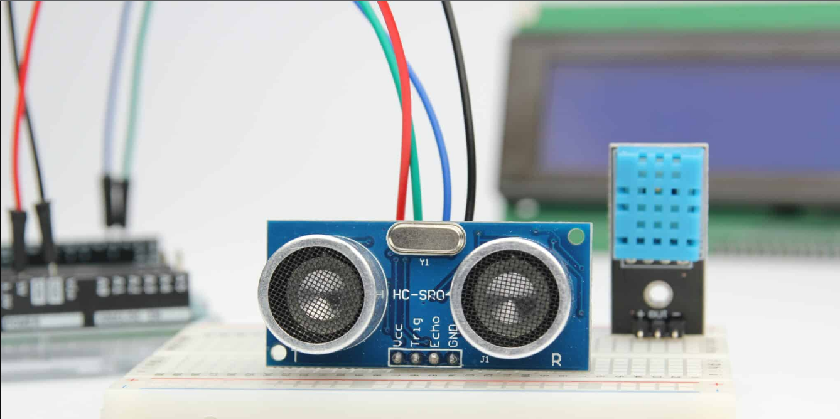

Along the HC-SR04 ultrasonic sensor, we mount the [DHT11 senso](https://howtomechatronics.com/tutorials/arduino/dht11-dht22-sensors-temperature-and-humidity-tutorial-using-arduino/)r on the tank to measure the temperature and the humidity of the environment, and adjust the speed of sound value accordingly to improve accurary of ultrasound sensor.

The HC-SR04 sensor is fairly accurate, but as it works to depends on the speed of sound, for more accurate results we should also take the air temperature into consideration. The speed of sound can significantly change as the air temperature changes. For example, at 20°C, the speed of sound is around 340m/s, but at -20°C the speed of sound is around 315m/s. The relative humidity affects the speed as well and we can do that with the following formula:

**Velocity = 331.4 + 0.6 x Temperature(°C) + 0.0124 x Relative Humidity**

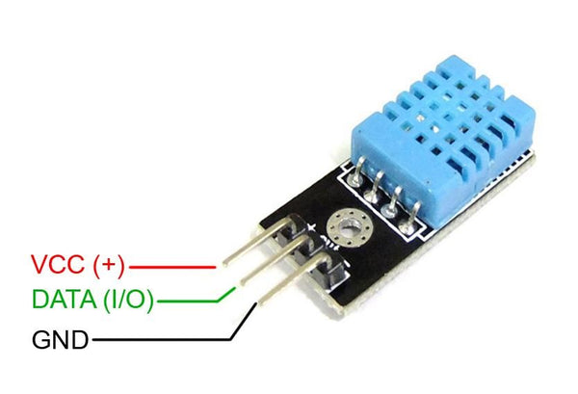

Technical Specifications:

* Operating Voltage: 3,3 to 5V
* Interface: TTL, 1 wire
* Operating current: 0.3mA (measuring) 60uA (standby)
* Humidity range: 20-80% with ± 5% accuracy
* Temperature range: 0-50°C with ± 2°C accuracy
* Resolution: Temperature and Humidity both are 8-bit
* No more than 1 Hz sampling rate (once every second)
* Dimension 28mm x 12mm x 10mm
* 3 pins with 0.1" spacing

.

* + 1. **DS18B20 Temperature Sensor**

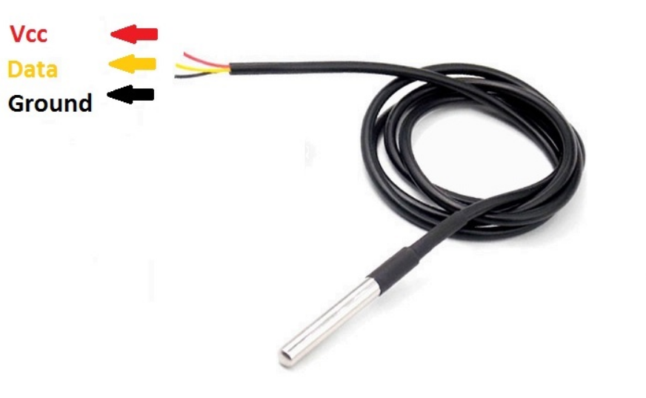

The DS18B20 Temperature Sensor is mounted inside the tank to measure the water temperature.

Technical Specifications:

* Unique 1-Wire Interface Requires Only One Port Pin for Communication
* Each Device has a Unique 64-Bit Serial Code Stored in an On-Board ROM
* Multiple sensors can share one pin
* The range of power supply is 3.0V – 5.5V
* Measures Temperatures from -55°C to +125°C (-67°F to +257°F)
* ±0.5°C Accuracy from -10°C to +85°C
* Resolution is User Selectable from 9 to 12 Bits
* Converts Temperature to 12-Bit Digital Word in 750ms (Max)
* Flexible User-Definable Nonvolatile (NV) Alarm Settings with Alarm Search Command Identifies Devices with Temperatures Outside Programmed Limits
  + Stainless steel pipe (moisture-proof, water-proof) diameter 6mm, length 50mm
  + Probe Diameter: 6mm
  + Wire length: 1m
    1. **LCD Display LCD2004 Module Green Screen with I2C**

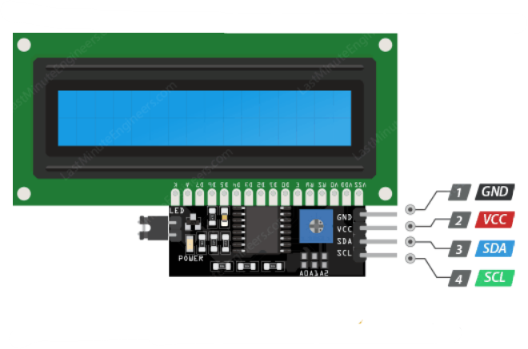

LCD 20x4 is used to display the status and parameters.

LCD has too many pins, making it difficult to connect and occupy many pins on the microcontroller.

The LCD I2C module was born and solved this problem.

Instead of taking 6 microcontroller pins to connect to a 20x4 LCD (RS, EN, D7, D6, D5 and D4), the IC2 module only needs 2 pins (SCL, SDA) to connect.

Technical Specifications:

* + LCD 20x4:
* The operating voltage is 5V.
* Dimensions: 98 x 60 x 13.5mm
* Character Color: White
* Backlight: Green
* The distance between the two connector pins is 0.1 inch handy when connecting to the breadboard.
* The names of the pins are written on the back of the LCD to support the connection and wiring.
* With LED backlight, can use variable resistor or PWM to adjust the brightness to use less power.
* Can be controlled with 6 signal wires.
  + I2C Module:
* Operating voltage: 2.5 - 6V
* Monitor support: LCD1602,1604,2004 (driver HD44780)
* Interface: I2C
* Default address: 0X27 (adjustable by shorting pin A0/A1/A2)
* Integrated Jump latch to supply LCD light or interrupt
* Integrated rheostat for LCD contrast adjustment
  + 1. **DC 12V 365 Motor Pump Large Flow Centrifugal Pump**

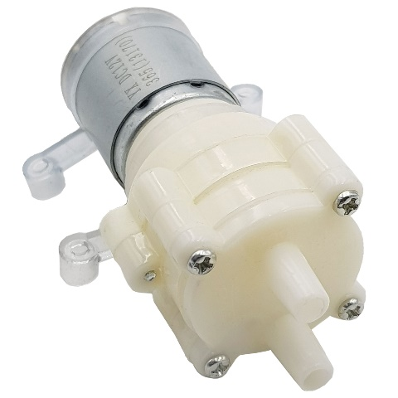

Motor Pump is used to pump water from water sources to the tank.

Technical Specifications

* Working voltage: 12VDC
* Operating Current: 0.23A
* Flow rate: 2-3 liters / min (12V)
* Output pressure: 1-2.5 kg
* Suction depth achieved: 1-2.5 meters
* Normal working life: 2-3 years
* Water Inlet Pipe Diameter: 8mm
* Water Outlet Pipe Diameter: 8mm
* Dimension: 69x40x35 mm
* Weight: 111 g Approx
  + 1. **Module Relay 5V 10A**

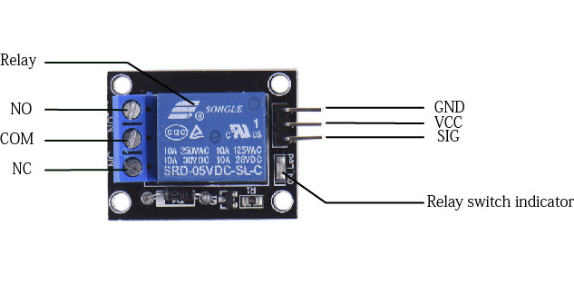

Module Relay is used to control the automatic ON/OFF the pump.

Technical Specifications:

* TTL control signal
* Operating Voltage: 5VDC.
* Relay Maximum output: DC 30V/10A, AC 250V/10A.
* Trigger current: 5mA
* 1 Channel Relay Module with Opto-coupler. LOW Level Trigger expansion board, which is compatible with Arduino control board.
  1. **The model introduction**

The HR-SC04 ultrasonic sensor is mounted on the tank to monitor the water level in the tank and is connected to the pump through relay to perform automatic water pumping. Besides, the DHT11 temperature and humidity sensor is attached to the system for the purpose of improving the accuracy of the HC-SR04 ultrasonic sensor, the DS18B20 temperature sensor is directly immersed in the water to measure the temperature of the water in the tank. Finally, an LCD screen is placed on the system to display the necessary information.

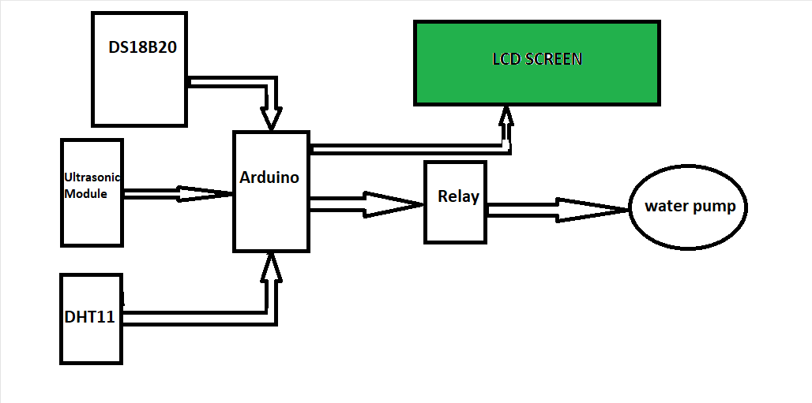

**Figure 2. Block Diagram of the model**

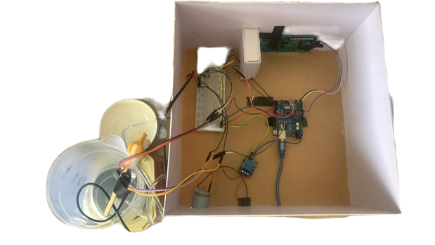

**Figure 3. Actual Prototype**

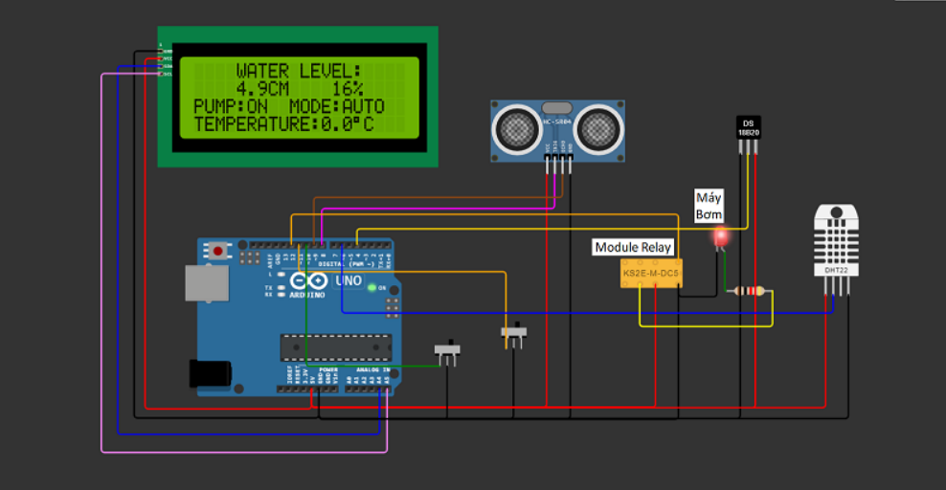

**Figure 4. Pinout Diagram**

* 1. **Working principle of the model**

This is a water pump system with 2 modes:

* Auto mode: when the HC-SR04 ultrasonic sensor detects that the water level is below 25% of the tank, it will automatically start the water pump to pump water into the tank until it is full (>90%) and automatically stops the pump.
* Manual mode: we can start the pump and stop it with the switch.

These 2 modes are switched by switch.

The system will monitor the water level and temperature of the water in the and output it to the screen including the water level, mode, pump status and water temperature in the tank.

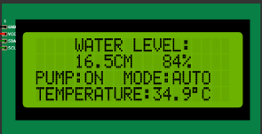

**Figure 5. LCD Display**

* 1. **Experimental results**

**Table 3. Experimental Results of DHT11 Temperature Sensor**

|  |  |  |  |  |  |  |  |
| --- | --- | --- | --- | --- | --- | --- | --- |
| Scenario | 1st trial | 2nd trial | 3rd trial | 4th trial | Average | Standard Temperature (°C) | % Error |
| Room Temperature | 35,21 | 35,22 | 35,26 | 35,25 | 35,24 | 35,5 | 0,7 |
| Body Temperature | 36,21 | 36,23 | 36,23 | 36,33 | 36,25 | 37 | 2 |
| Flame Temperature | 40,01 | 41,02 | 43,56 | 44,23 | 42,21 | 1000 | Out of range |

**Table 4. Experimental Results of relationship between the temperature and the output voltage (DHT11)**

|  |  |
| --- | --- |
| Temperature (°C) | Output voltage (V) |
| 35,21 | 3,52 |
| 35,26 | 3,54 |
| 36,23 | 3,67 |
| 36,33 | 3,69 |
| 36.59 | 3,74 |
| 36.67 | 3,76 |
| 37,12 | 3,81 |
| 37,23 | 3,83 |

**Figure 6. Plot of the input quantity versus the electrical output signal**

**Table 5. Experimental Results of HC-SR04 Ultrasonic Sensor**

**(Use additional DHT11 Temperature and Humidity Sensor)**

**for Various Water Level**

|  |  |  |  |  |  |  |
| --- | --- | --- | --- | --- | --- | --- |
| Distance(cm) | 1st trial | 2nd trial | 3rd trial | Average | % Error | % Precision |
| 5 | 5,21 | 5,22 | 5,19 | 5,21 | 4,13 | 0,35 |
| 7 | 7,25 | 7,3 | 7,29 | 7,28 | 4 | 0,3 |
| 10 | 10,32 | 10,20 | 10,23 | 10,25 | 2,50 | 0,43 |
| 12 | 11,8 | 11,77 | 11,73 | 11,76 | 1,94 | 0,25 |
| 15 | 15,02 | 14,76 | 15,03 | 14,94 | 0,64 | 0,84 |

**Table 6. Experimental Results of DS18B20 Temperature Sensor**

|  |  |  |  |  |  |  |  |
| --- | --- | --- | --- | --- | --- | --- | --- |
| Scenario | 1st trial | 2nd trial | 3rd trial | 4th trial | Average | Standard Temperature (°C) | % Error |
| Ice temperature | 5,5 | 5,7 | 5,4 | 5,6 | 5,55 | 5,4 | 2,78 |
| Normal water temperature | 31,4 | 31,5 | 31,6 | 31,4 | 31,5 | 31,3 | 0,55 |
| Boil water temperature | 98,9 | 98 | 98,3 | 98,3 | 98,38 | 100 | 1,6 |

**Table 7. Experimental Results of relationship between the water level and the output voltage (DS18B20)**

|  |  |
| --- | --- |
| Temperature (°C) | Output voltage (V) |
| 5,5 | 1,68 |
| 5,7 | 1,69 |
| 5,4 | 1,67 |
| 31,4 | 2,43 |
| 34,6 | 2,48 |
| 31,5 | 2,43 |
| 98,9 | 4,27 |
| 98,3 | 4,25 |

**Figure 7. Plot of the input quantity versus the electrical output signal**

**Blue line – Noise-unfiltered**

**Orange line – Noise-filtered**

# **Figure 8. Plot of water level versus time of pumping**

1. **Conclusions and recommendations**

The water level error is about 3% when the pump is not working, when the pump is working the error can be up to 30-40% the cause of the error is the noise of the liquid surface when the water pump is operating. From there, to reduce the error, we add Kalman noise reduction code:

float kalmanFilter(float U) {

  static const float R = 0.2; // Noise measurement convariance

  static const float H = 1.00;

  static const float Q = 5; // Noise system convariance

  static float P = 0;

  static float P = 0;

  static float U_hat = 0;

  static float K = 0;

  K = P*H/(H*P*H+R);

  U_hat = U_hat + K*(U-H*U_hat);

  P = (1-K*H)*P+Q;

  return U_hat;

}

In addition, we have added temperature and humidity sensors to improving the accuracy of the ultrasonic sensor's water level measurement. The temperature error of DHT11 & DS18B20 is about 2%, both within the acceptable range of its datasheet.

The ultrasonic sensor is quite suitable for measuring water level, but it has many disadvantages such as not waterproof and noise appears when the water surface is unstable. We can improve using capacitive level sensor because of its water resistance and noise reduction.