**Model Description —— BiLSTM**

The tree-view of the project.

1. **data/data_parse.py**

The class ‘Corpus’ of this file is used to extract training and test data from the file and generate dictionary objects supported by pytorch, which are stored in the file ‘data.pt’.

1. **data_loader.py**

The class ‘DataLoader’ of this file extracts the corresponding data from the data object returned by ‘torch.load()’ according to the passed parameters.

1. **model.py**

The class ‘Bilstm’ of this file is a BiLSTM model. In this model, I referenced the attention model and added it to the model to implement the BiLSTM + Attention model.

In this attention layer, I mainly rely on the following 3 formulas to achieve:

$$M=tanh⁡(H)$$

$$α=softmax(ω^{T}M)$$

$$r=Hα^{T}$$

1. **main.py**

This file contains all the processes from data import to training.

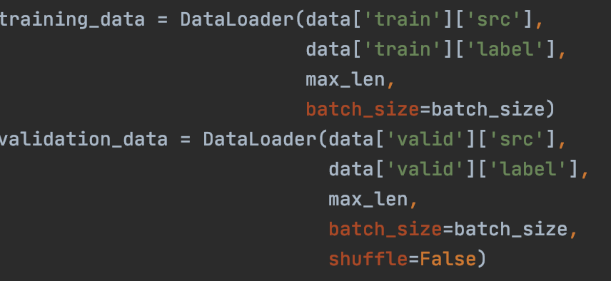

Import training and testing data by using DataLoader.

Initialize the Bilstm class and loss function.

Training process.

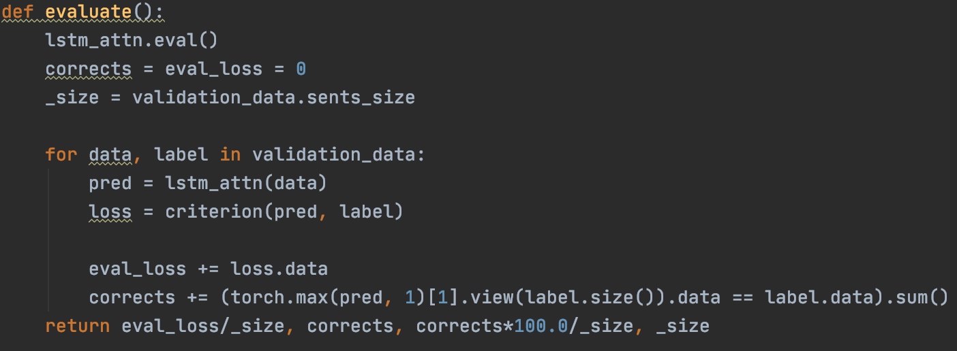

Evaluation process.