LAPORAN RESMI

GRAFIKA KOMPUTER

**PERTEMUAN III**

**MEWARNAI OBJECT**



**NIM : 21104410046**

**NAMA : Moh. Alfan Thariq Istiqlal**

**JURUSAN : Teknik Informatika**

**KELAS : TI 4A**

**JURUSAN TEKNIK INFORMATIKA**

**FAKULTAS TEKNOLOGI INFORMASI**

**UNIVERSITAS ISLAM BALITAR**

**2023**

LEMBAR PERSETUJUAN

**PERTEMUAN III**

**MEWARNAI OBJECT**

**NIM : 21104410046**

**NAMA : Moh. Alfan Thariq Istiqlal**

**JURUSAN : Teknik Informatika**

**KELAS : TI 4A**

## Contoh Mewarnai Object

1. **Ubah Ukuran Garis Warna**

**Script :**

function setup() {

createCanvas(200, 200);

}

function draw() {

background(220);

fill(255, 255, 0, 50);

// Ukuran Garis

strokeWeight(8);

// Garis Hijau

stroke(0, 255, 0);

circle(100, 100, 50);

// Garis Merah

stroke(255, 0, 0);

rect(0, 0, 100, 50);

noFill();

// Garis Biru

stroke(0, 0, 255);

ellipse(50, 70, 30, 30);

// Tanpa Garis

noStroke();

fill(255, 255, 0);

circle(20, 180, 50);

}

**Output :**

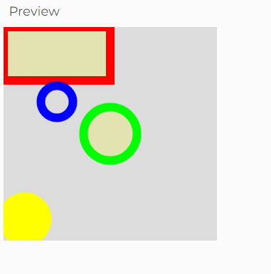

1. **Contoh Kasus Pewarnaan Beberapa Object**

**Script :**

function setup() {

createCanvas(800, 420);

}

function draw() {

background('#ffffff');

strokeWeight(1);

// Objek Coklat

fill('#845542');

square(10,10,230);

// Objek Ungu

fill(58, 18, 94);

triangle(260,10,260,240,490,125);

fill(58,18,94,100);

circle(375,125,230);

// Objek Pelangi

noStroke();

// Merah

fill('#d41a13');

rect(10,260,480,20);

// Jingga

fill('#eb6222');

rect(10,280,480,20);

// Kuning

fill('#fff000');

rect(10,300,480,20);

// Hijau

fill('#0ea21f');

rect(10,320,480,20);

// Biru

fill('#0f1cff');

rect(10,340,480,20);

// Nila

fill('#490083');

rect(10,360,480,20);

// Ungu

fill('#9400d3');

rect(10,380,480,20);

// Objek Abu Abu

strokeWeight(4);

stroke('#000000');

fill('#aaaaaa');

ellipse(650,210,280,400);

}

**Output :**

