**HAZELCAST DEMO**

1. Checkout 2 project at

<https://github.com/VanTien92/hazelcast-demo-first-app.git>

<https://github.com/VanTien92/hazelcast-demo-second-app.git>

1. Build app with maven plugin

mvn clean install

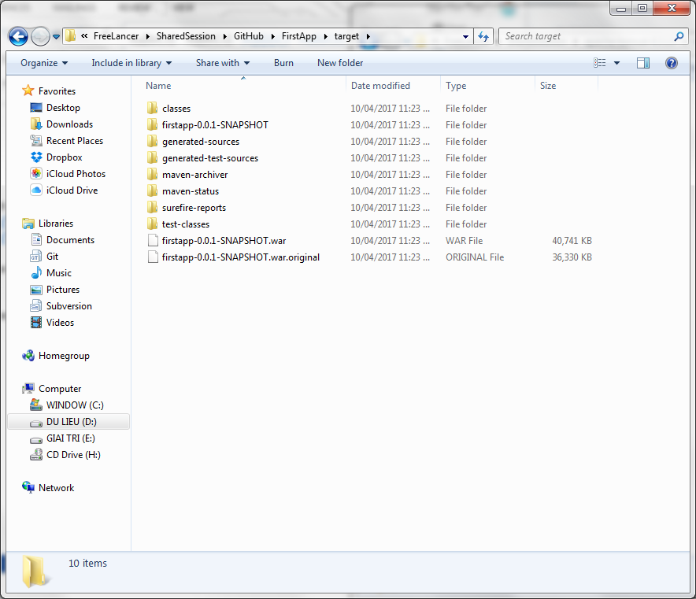

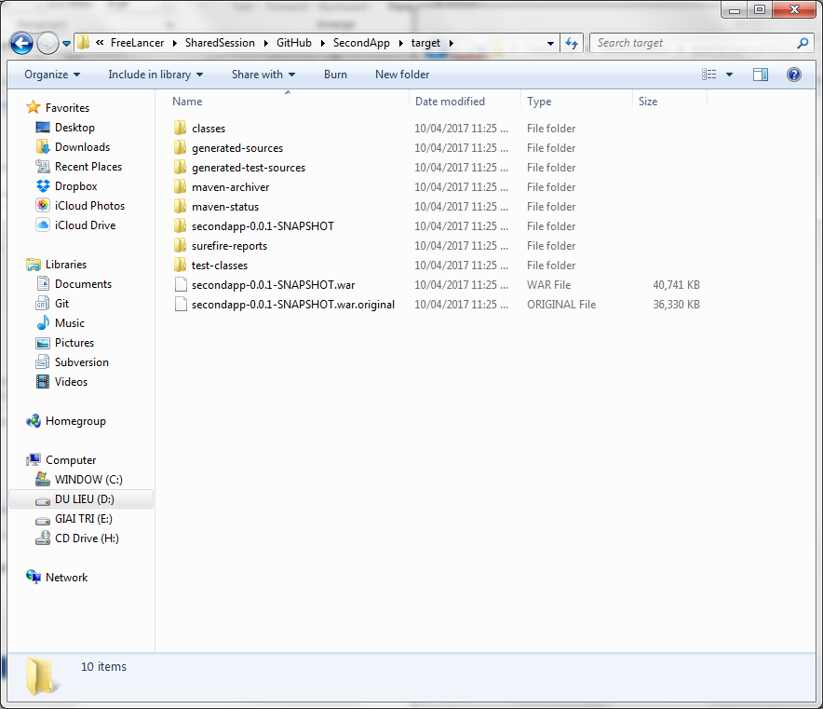

1. Copy war file to tomcat and change the name to firstapp.war and secondapp.war (because second app will redirect to first app and require login)

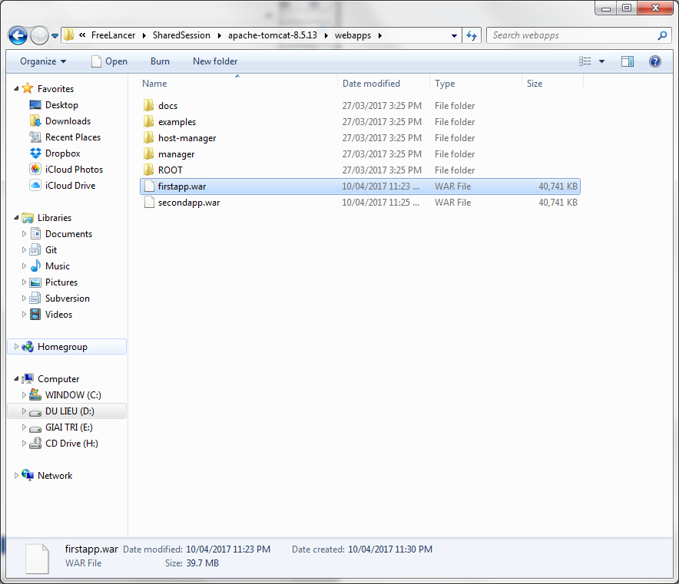

1. Run tomcat

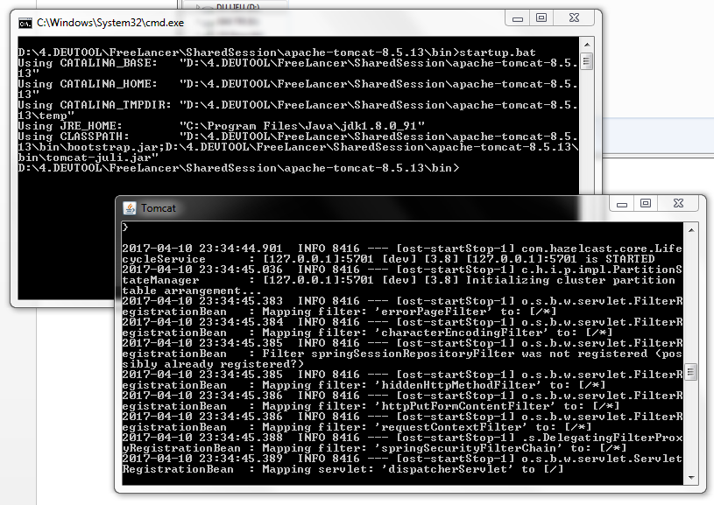

Wait until 2 app are deployed (“Server startup in … ms” displayed)

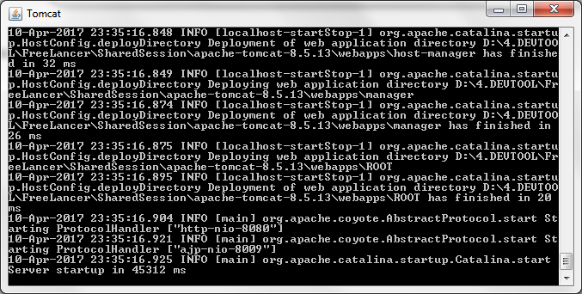

1. Start tomcat at <http://localhost:8080/firstapp> and login with account admin/123456

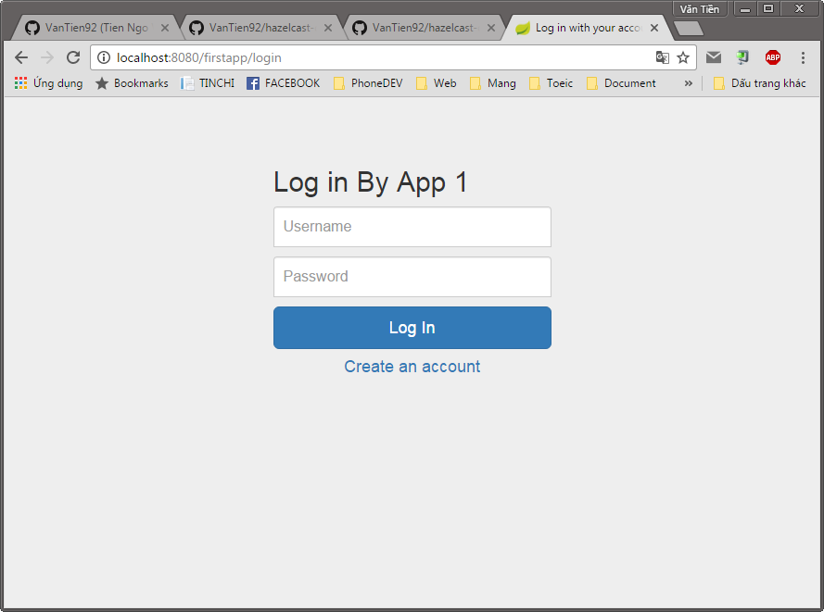

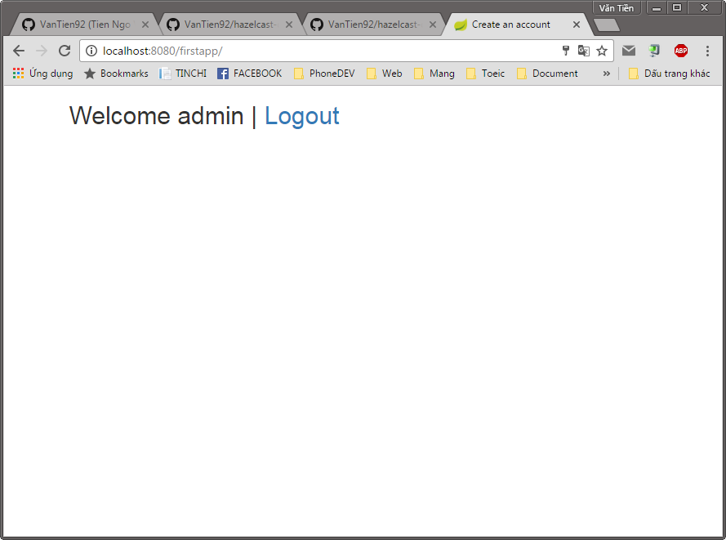

1. Go to second app via url: <http://localhost:8080/secondapp> and second app has already authenticated with admin accout

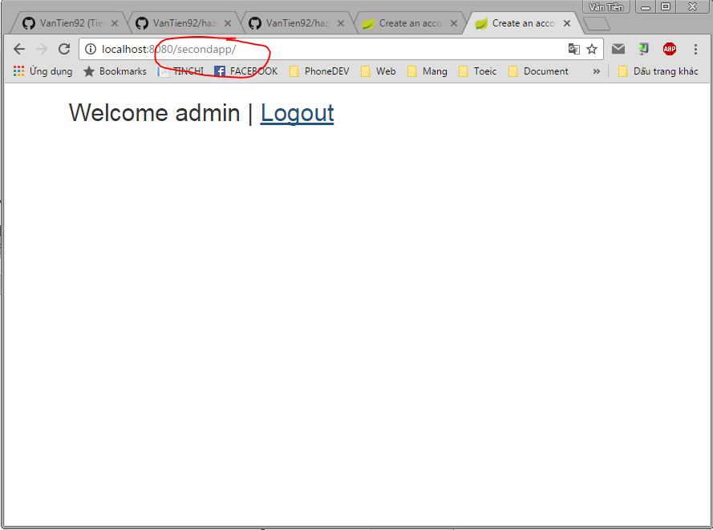

P/S: If first app is not authenticate, the second app will redirect to first app at login form

1. Post message in first app and get it in second app (refresh page to see that message)

<http://localhost:8080/firstapp/addMessage?message=123456>

http://localhost:8080/firstapp/addMessage?message=test message

