Kevin Hinton
Taft Sandbakken
CS 470
Potential Fields Report
Sept. 9, 2014

Potential Fields

Attractive Fields

The attractive fields were generated by using the information from the potential fields specification. Each flag has an attractive field but in our implementation a randomly designated teams flag was given a exceeding weight so as to help pull our tanks to the flag. This is why the field generated is directed completely towards the flags position.

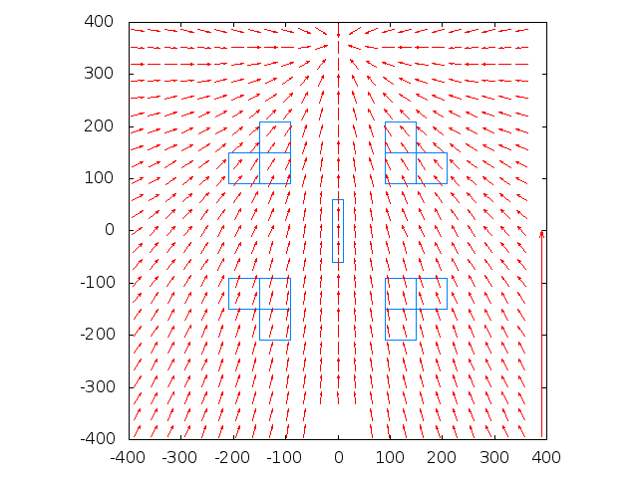

Repulsive Fields
The repulsive fields were generated from the specification and calculated for objects by finding the center and creating a radius. The drawbacks we found with this type of field is that in close spaces, cycles can interrupt even a strong pull from a goal.

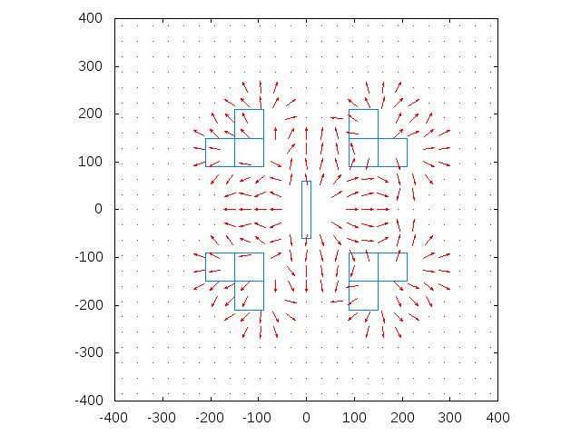

Tangential Fields

Tangential fields were created in a similar fashion to the repulsive fields except 90 degrees were added to the calculated angle before calculating the deltaX and deltaY of a given position. This field allowed for some ability to escape from cycles with a strong enough attractive field.
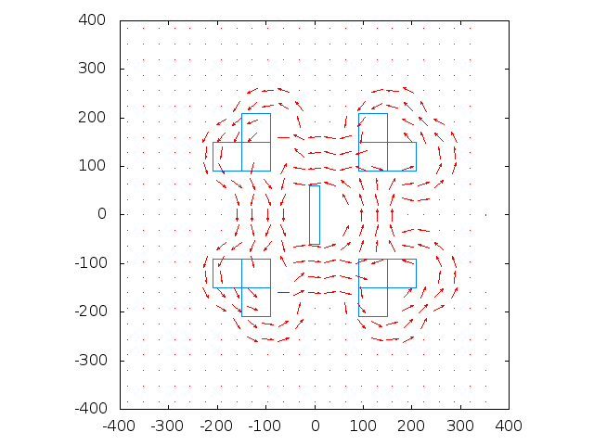

All Fields

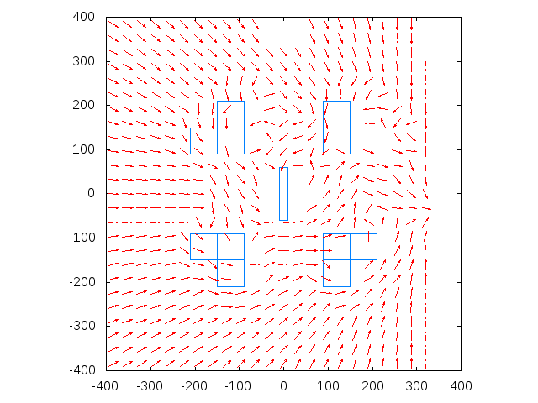

Tests

Other Team
The opposing team consisted of: Cameron _____ and Trevor Fenn.

PF vs Really Dumb Agent
The first time this test was run, the PF agent got stuck and the test needed to be restarted. The second time, the PF agent had no problem getting to the flag, destroying enemy tanks on the way, and getting back to its base. It did this multiple times. The PF agent dodged the obstacles with a much greater curve than was needed. The dumb agent made no progress over the course of ten minutes

PF vs Two Really Dumb Agents
The result of this test was almost exactly the same as the previous test. The PF agent did remarkably well while the two dumb agents didn't do too much. Sometimes the PF agent would get stuck on friendly or enemy tanks, but it would always escape after a few seconds. Twice the dumb agents almost accidentally shot the PF agent, and one dumb agent actually managed to grab a flag of a separate team.

PF vs PF
This test was by far the most interesting thus far. The blue team had no problem getting ream team's flag and getting it back to its base. However, on the second run to get the flag, on its way back it got stuck on friendly tanks. The red team had a harder time getting through the obstacles, but it was also able to get a flag and return it. However, on its second run it got stuck on the obstacles and was unable to escape.

PF vs Other Team's Really Dumb Agent

PF vs Other Team's Two Really Dumb Agents

PF vs Other Team's PF

Time Spent on the Project
Taft Sandbakken: 8 hours
Kevin Hinton:

