Predicting Daily Precipitation Levels in Sri Lankan Cities
for Flood Risk Assessment

Machine Learning Assignment

Table of Contents
1. Problem Description
2. Methodology
2.1 Dataset Description
2.2 Feature Selection
2.3 Data Preprocessing
2.4 Algorithm Selection: XGBoost
2.5 Model Training Strategy
2.6 Hyperparameter Tuning
3. Results
3.1 Performance Metrics
3.2 Model Comparison
3.3 Visual Analysis
4. Interpretation
4.1 Feature Importance
4.2 SHAP Analysis
4.3 Partial Dependence Plots
4.4 Domain Alignment
5. Discussion
5.1 Model Limitations
5.2 Data Quality Concerns
5.3 Bias and Fairness
5.4 Ethical Implications
5.5 Future Work
6. Front-End Integration
7. References

1. Problem Description

1.1 Background
Flooding is one of the most frequent and destructive natural disasters in Sri Lanka. Driven by intense monsoon rainfall and tropical weather systems, flood events routinely cause significant damage to infrastructure, agriculture, and human life. The country experiences two major monsoon seasons — the Southwest monsoon (May–September) and the Northeast monsoon (October–January) — both of which bring sustained periods of heavy rainfall to different geographic regions of the island.
Accurate prediction of daily precipitation levels is a critical prerequisite for effective flood risk assessment. With reliable precipitation forecasts, disaster management authorities can issue timely warnings, allocate emergency resources, and minimize the impact of flood events on vulnerable communities.

1.2 Objective
The objective of this project is to build a machine learning model that predicts daily total precipitation (in millimeters) across 30 Sri Lankan cities using meteorological, geographic, and temporal features. The predicted precipitation values can be classified into flood risk categories (Low, Moderate, High, Very High) to support practical decision-making.

1.3 Real-World Relevance
- Early warning systems: High precipitation predictions can trigger alerts for flood-prone regions.
- Disaster resource allocation: Authorities can pre-position emergency supplies and personnel based on predicted rainfall intensity.
- Agricultural planning: Farmers can make informed decisions about planting, irrigation, and harvest timing.
- Urban infrastructure: City planners can assess drainage system adequacy and plan maintenance schedules around high-rainfall periods.

2. Methodology

2.1 Dataset Description
Property | Details
Data Source | Open-Meteo Historical Weather API (publicly available, open-source)
Geographic Coverage | 30 cities across Sri Lanka
Temporal Coverage | January 1, 2010 — June 17, 2023
Total Records | 147,480 daily observations
Original Columns | 24
Ethical Considerations | No personal or sensitive data; entirely public weather records

The dataset contains daily weather observations for 30 Sri Lankan cities including Colombo, Kandy, Galle, Jaffna, Trincomalee, Ratnapura, Badulla, and others spanning both the wet zone (southwestern Sri Lanka) and the dry zone (northern and eastern regions). Each record includes temperature readings, apparent temperature, solar radiation, wind measurements, evapotranspiration, precipitation totals, and geographic metadata.

Exploratory Data Analysis
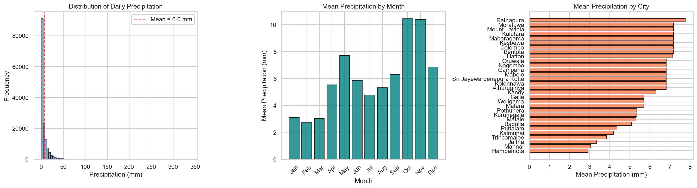
Figure 1: Precipitation distribution, monthly averages, and per-city averages.
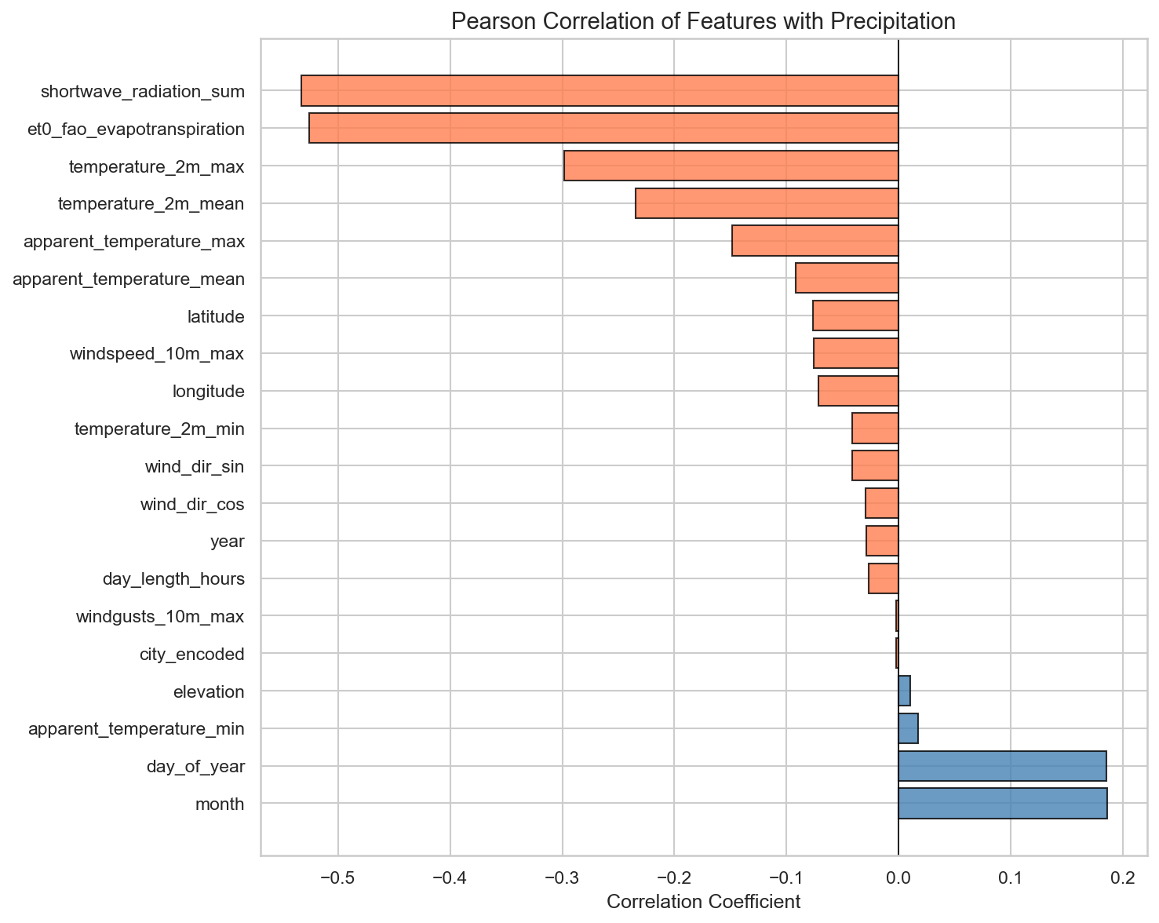
Figure 2: Pearson correlation of features with precipitation.

2.2 Feature Selection
Dependent Variable (Target)
precipitation_sum — Total daily precipitation in millimeters (continuous variable, regression target). Key statistics: Mean = 5.98 mm, Maximum = 338.8 mm, Zero-precipitation days = 18.1% of all records. The distribution is right-skewed, with the majority of days having low to moderate precipitation.
Independent Variables (20 Features)
Category | Feature | Description
Meteorological | temperature_2m_max | Daily maximum temperature at 2m (°C)
 | temperature_2m_min | Daily minimum temperature at 2m (°C)
 | temperature_2m_mean | Daily mean temperature at 2m (°C)
 | apparent_temperature_max | Maximum "feels-like" temperature (°C) — encodes humidity
 | apparent_temperature_min | Minimum "feels-like" temperature (°C)
 | apparent_temperature_mean | Mean "feels-like" temperature (°C)
 | shortwave_radiation_sum | Total shortwave solar radiation (MJ/m²)
 | windspeed_10m_max | Maximum wind speed at 10m height (km/h)
 | windgusts_10m_max | Maximum wind gusts at 10m height (km/h)
 | et0_fao_evapotranspiration | FAO reference evapotranspiration (mm)
Geographic | latitude | City latitude
 | longitude | City longitude
 | elevation | City elevation above sea level (m)
 | city_encoded | Label-encoded city identifier
Temporal | month | Month of year (1–12)
 | day_of_year | Day of year (1–366)
 | year | Calendar year
 | day_length_hours | Daylight duration from sunrise/sunset
Engineered | wind_dir_sin | Sine of wind direction (circular encoding)
 | wind_dir_cos | Cosine of wind direction (circular encoding)

Excluded Variables and Rationale
Feature | Reason for Exclusion
rain_sum | Identical to precipitation_sum (snowfall = 0) — direct data leakage
snowfall_sum | Constant value of 0 — zero variance, no predictive information
precipitation_hours | Hours of precipitation on the same day — direct data leakage
weathercode | Encodes observed weather condition — data leakage
sunrise / sunset | Replaced by derived day_length_hours
country | Always "Sri Lanka" — zero variance
time | Replaced by month, day_of_year, year
winddirection_10m_dominant | Replaced by wind_dir_sin and wind_dir_cos

2.3 Data Preprocessing
The following preprocessing steps were applied:
- Date parsing and temporal feature engineering: Extracted month, day_of_year, and year from the time column.
- Day length calculation: Computed day_length_hours from sunrise and sunset timestamps.
- Circular encoding of wind direction: Encoded as sin(direction) and cos(direction) to preserve circularity.
- Label encoding of city: Transformed the categorical city column to integer codes.
- Missing value check: No missing values found — no imputation required.
- Feature scaling: Not applied. XGBoost is tree-based and invariant to feature scaling.

2.4 Algorithm Selection: XGBoost
XGBoost (eXtreme Gradient Boosting) was selected as the primary algorithm. It is a scalable, optimized implementation of gradient-boosted decision trees that builds an ensemble of weak learners sequentially, where each new tree corrects residual errors.
Key Characteristics:
- Gradient boosting framework: Minimizes squared error by iteratively fitting trees to the negative gradient.
- Built-in regularization: L1 and L2 penalties on leaf weights prevent overfitting.
- Column and row subsampling: Reduces variance and improves generalization.
- Native handling of missing values: Learns optimal split directions automatically.
- Computational efficiency: Parallel tree construction for scalability.
Comparison with Standard Algorithms
Aspect | Linear Regression | Decision Tree | k-NN | XGBoost
Model type | Single linear model | Single tree | Instance-based | Ensemble of boosted trees
Non-linearity | Cannot capture | Captures but overfits | Local averaging | Captures via additive trees
Feature interactions | Manual | Via splits | Via distance | Through tree depth
Regularization | Ridge/Lasso | Pruning | k selection | L1+L2+complexity
Skewed targets | Assumes normality | Moderate | Moderate | Robust (non-parametric)
Scalability | Good | Good | Poor at scale | Excellent

Justification for This Task:
- Non-linear relationships: Precipitation depends on complex interactions that linear models cannot capture.
- Skewed target distribution: 18.1% zero-precipitation days, extreme events >300 mm.
- Mixed feature types: Continuous, cyclical, and categorical features handled naturally.
- Regularization: Prevents overfitting with 147K records and 20 features.
- Explainability: Seamless integration with SHAP for global and local explanations.

2.5 Model Training Strategy
A temporal split was used to prevent future data leaking into training:
Split | Records | Percentage | Approximate Period
Training | 117,984 | 80% | 2010 – mid-2020
Validation | 14,748 | 10% | mid-2020 – mid-2021
Test | 14,748 | 10% | mid-2021 – June 2023

Two baseline models were trained: Linear Regression and Random Forest (200 trees, max depth 15).

2.6 Hyperparameter Tuning
Optuna (Bayesian optimization with TPE sampler) was used for 50 trials, optimizing validation RMSE.
Hyperparameter | Search Range | Best Value
n_estimators | 200 – 1,000 | 900
max_depth | 3 – 10 | 8
learning_rate | 0.01 – 0.3 | 0.021
subsample | 0.6 – 1.0 | 0.695
colsample_bytree | 0.5 – 1.0 | 0.700
reg_alpha (L1) | 0.001 – 10.0 | 0.001
reg_lambda (L2) | 0.001 – 10.0 | 0.278
min_child_weight | 1 – 10 | 9

3. Results

3.1 Performance Metrics
All metrics are reported on the held-out test set (14,748 samples, mid-2021 to June 2023).
Model | RMSE (mm) | MAE (mm) | R²
Linear Regression | 6.464 | 4.166 | 0.4272
Random Forest | 6.544 | 3.251 | 0.4130
XGBoost (Tuned) | 6.354 | 3.123 | 0.4465

3.2 Model Comparison
XGBoost (Tuned) achieves the best performance across all three metrics. Compared to Linear Regression, XGBoost reduces RMSE by 1.7%, MAE by 25.0%, and improves R² by 4.5%. Compared to Random Forest, XGBoost reduces RMSE by 2.9%, MAE by 3.9%, and improves R² by 8.1%.
The R² value of 0.4465 indicates that the model explains approximately 44.7% of the variance in daily precipitation. This is a reasonable result given the inherent stochasticity of daily precipitation, which is influenced by micro-scale atmospheric dynamics that surface-level measurements cannot fully capture.

3.3 Visual Analysis
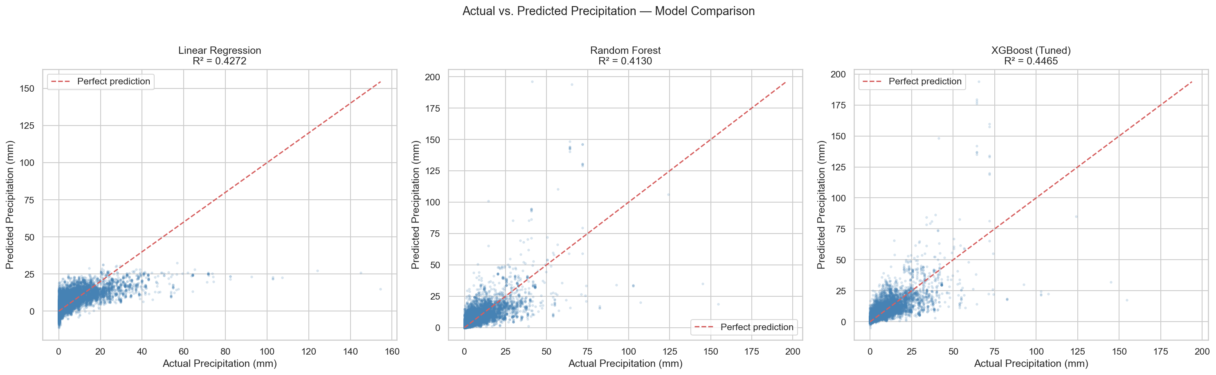
Figure 3: Actual vs. Predicted precipitation scatter plots for all three models.
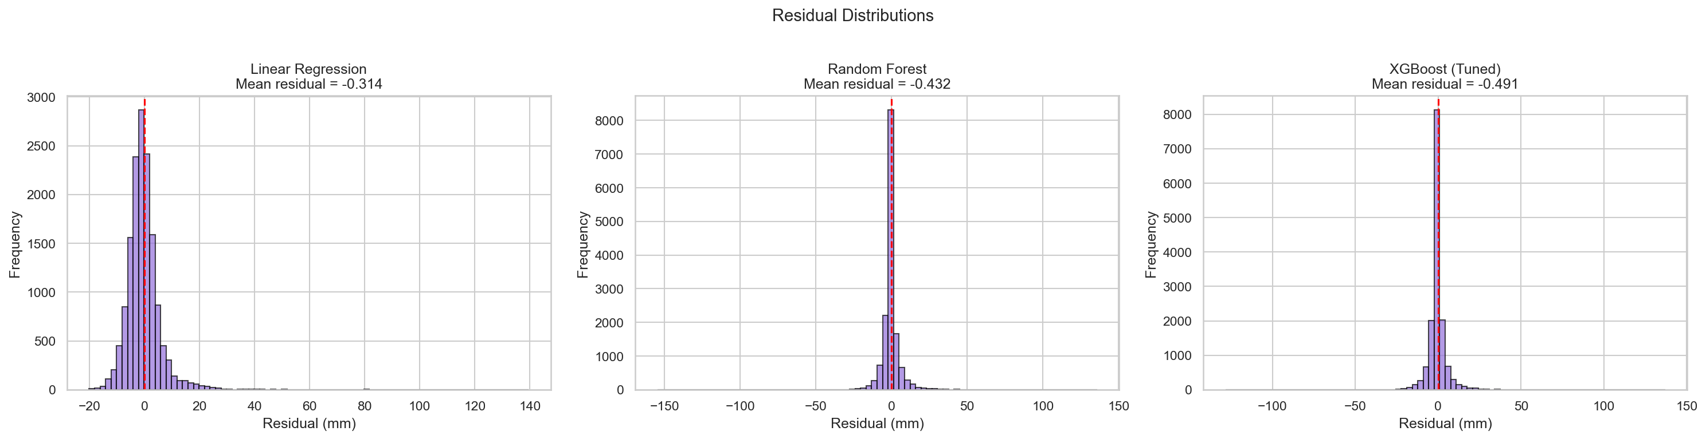
Figure 4: Residual distribution histograms for all three models.
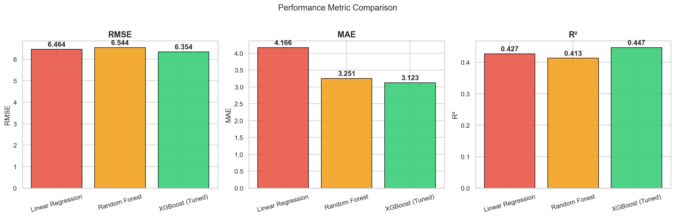
Figure 5: Performance metric comparison (RMSE, MAE, R²) across models.

4. Interpretation

4.1 Feature Importance (XGBoost Gain)
Rank | Feature | Importance
1 | et0_fao_evapotranspiration | 0.1791
2 | shortwave_radiation_sum | 0.1116
3 | temperature_2m_mean | 0.0675
4 | day_length_hours | 0.0533
5 | apparent_temperature_max | 0.0520
6 | apparent_temperature_min | 0.0505
7 | day_of_year | 0.0493
8 | month | 0.0449
9 | windgusts_10m_max | 0.0434
10 | windspeed_10m_max | 0.0414

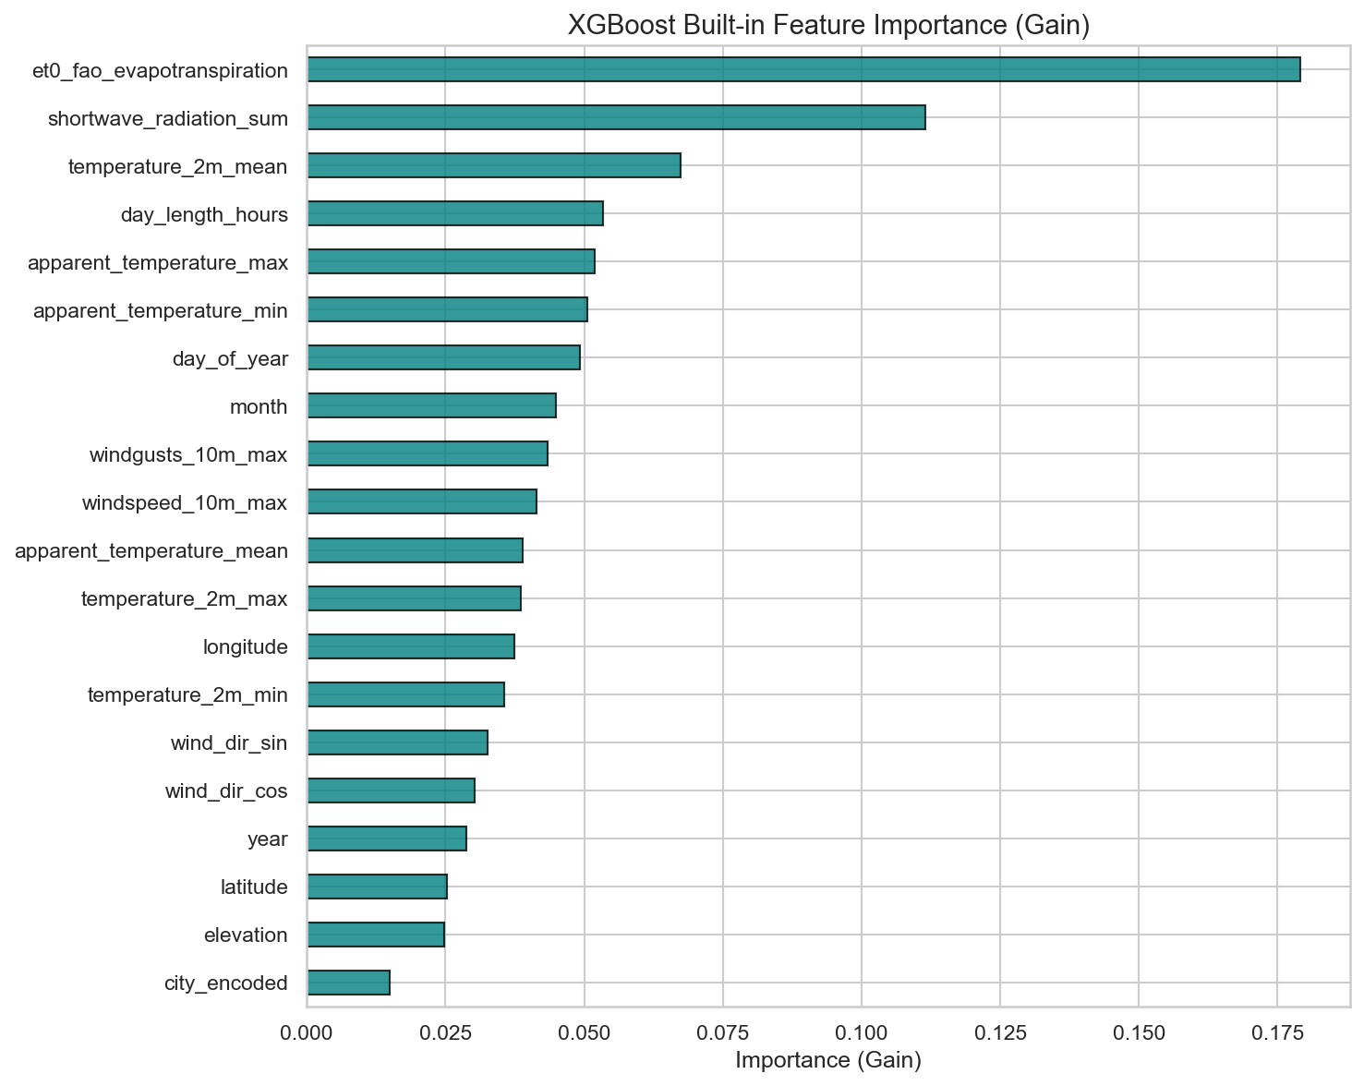
Figure 6: XGBoost built-in feature importance ranked by gain.

4.2 SHAP Analysis
SHAP (SHapley Additive exPlanations) provides both global (which features matter overall) and local (why a specific prediction was made) interpretability grounded in game theory.
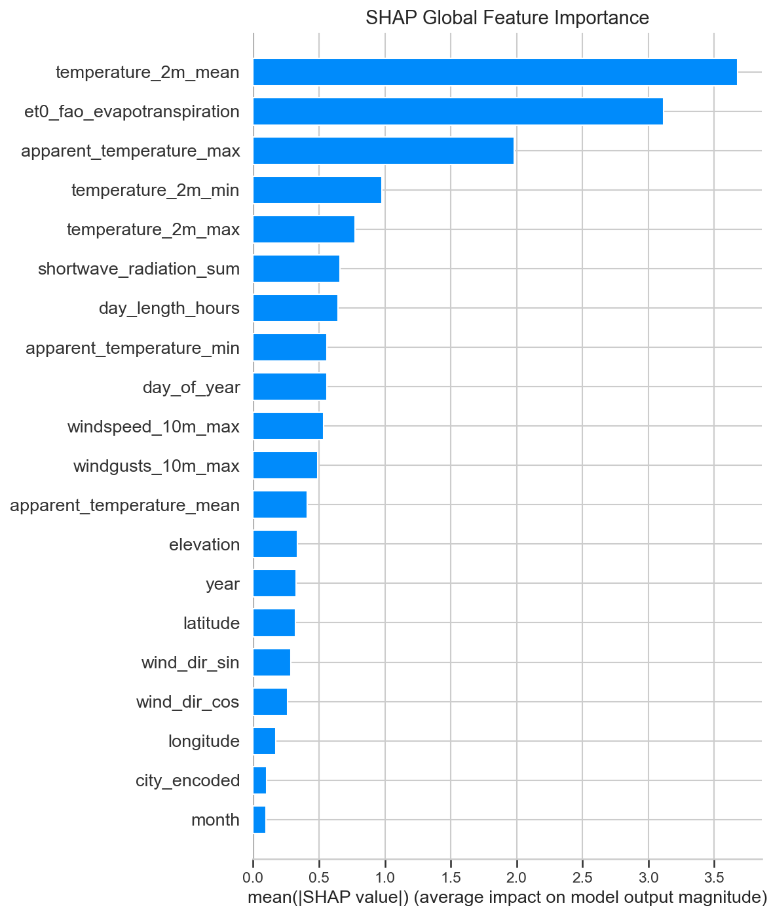
Figure 7: SHAP global feature importance (mean |SHAP value|).
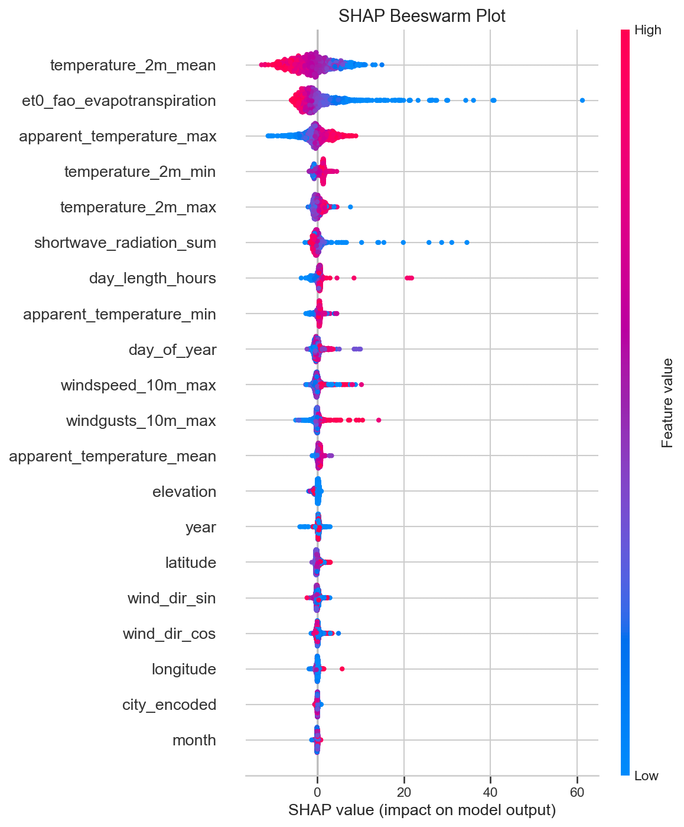
Figure 8: SHAP beeswarm plot showing feature value impacts on predictions.
Key observations from the SHAP beeswarm plot: Low evapotranspiration (blue) strongly increases predicted precipitation, consistent with saturated atmospheric conditions. Low solar radiation increases predicted rain (more cloud cover). Higher apparent temperatures (encoding humidity) tend to increase predicted precipitation.
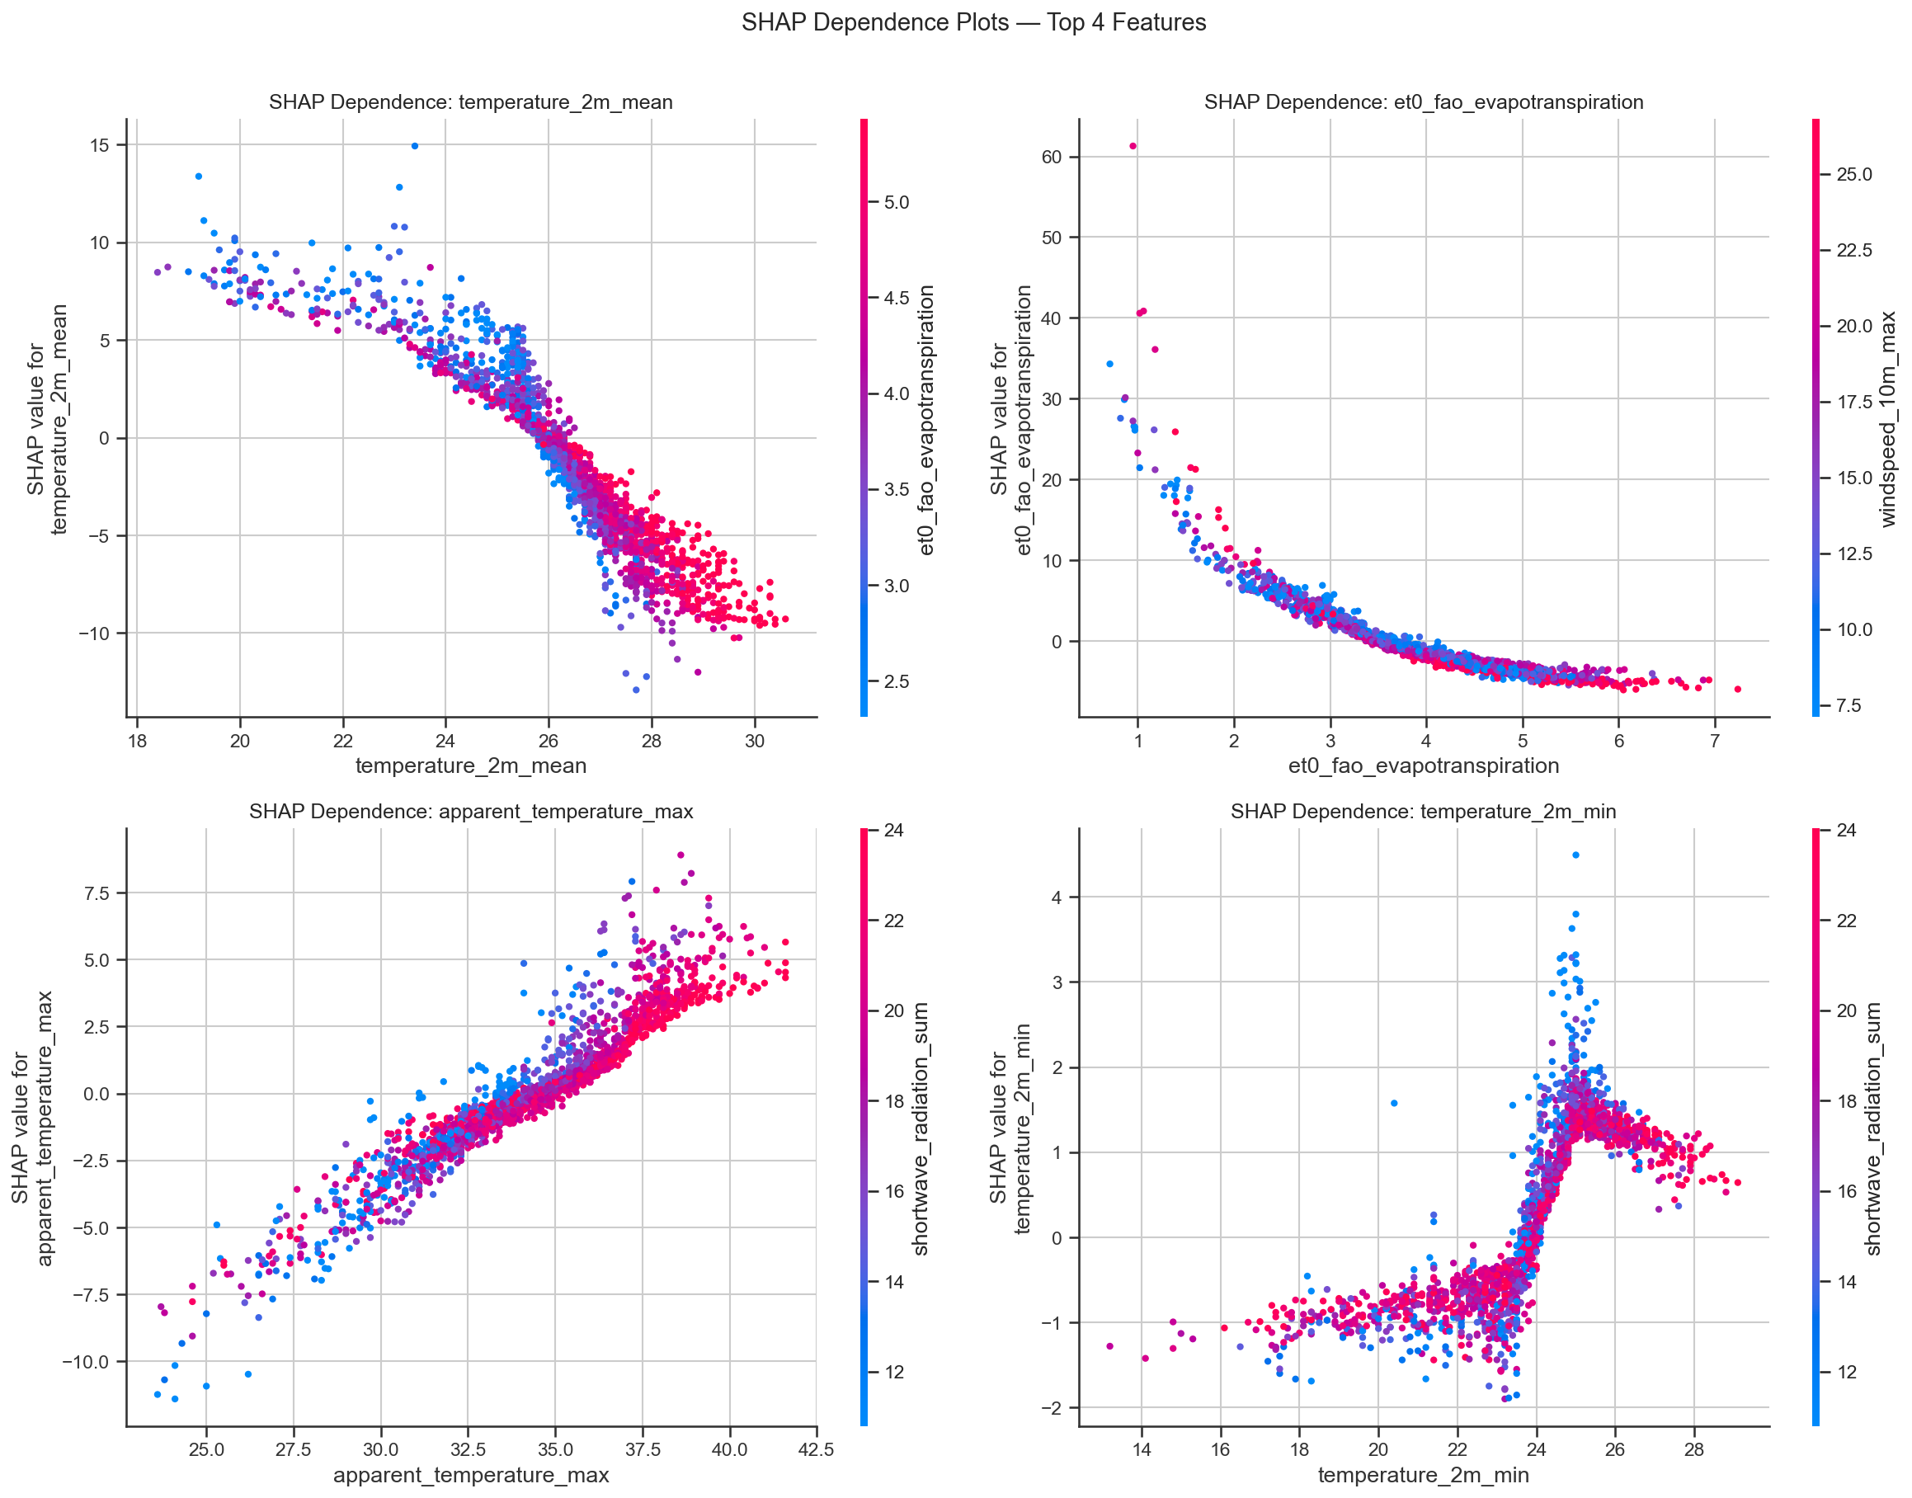
Figure 9: SHAP dependence plots for the top 4 features.
SHAP Local Explanation (Single Prediction)
The following figure shows a SHAP explanation for a single high-rainfall day, demonstrating how each feature pushed the prediction from the baseline average to the final predicted value.
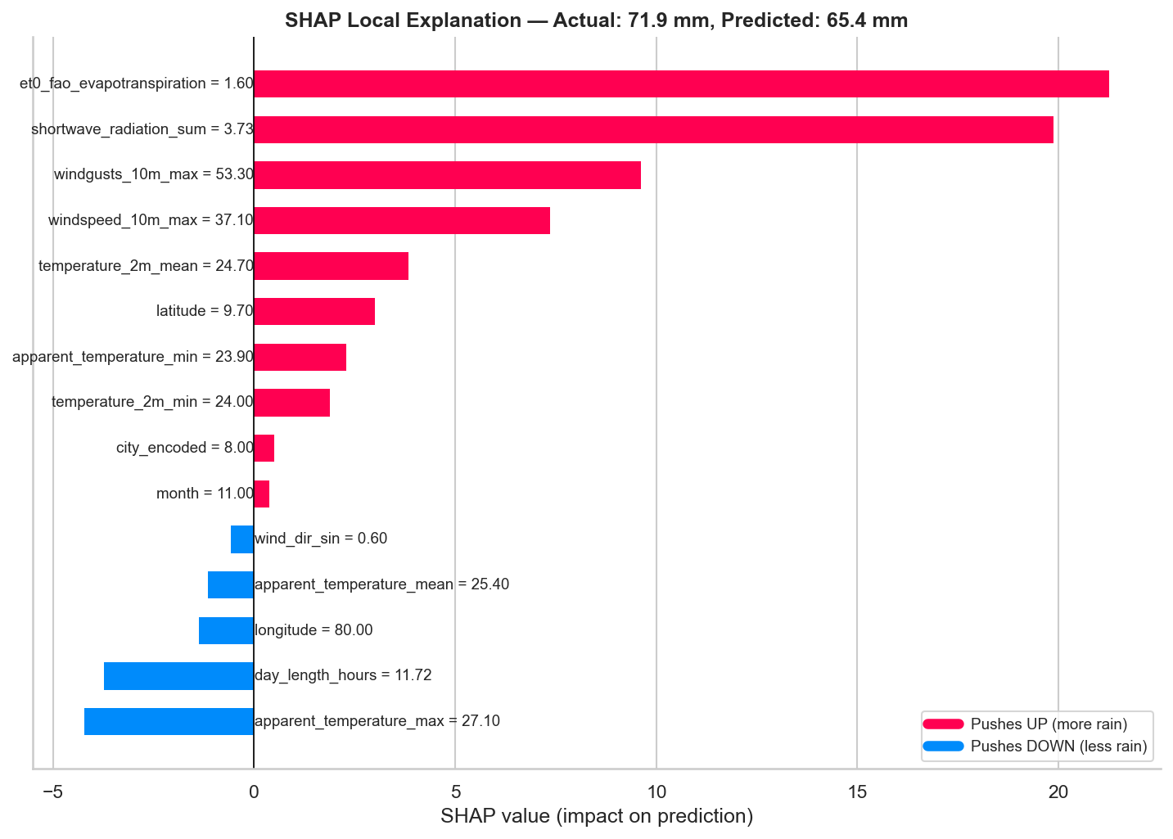
Figure 10: SHAP local explanation for a high-rainfall prediction.

4.3 Partial Dependence Plots
Partial Dependence Plots show the marginal effect of a feature on the predicted outcome, averaged over all other features.
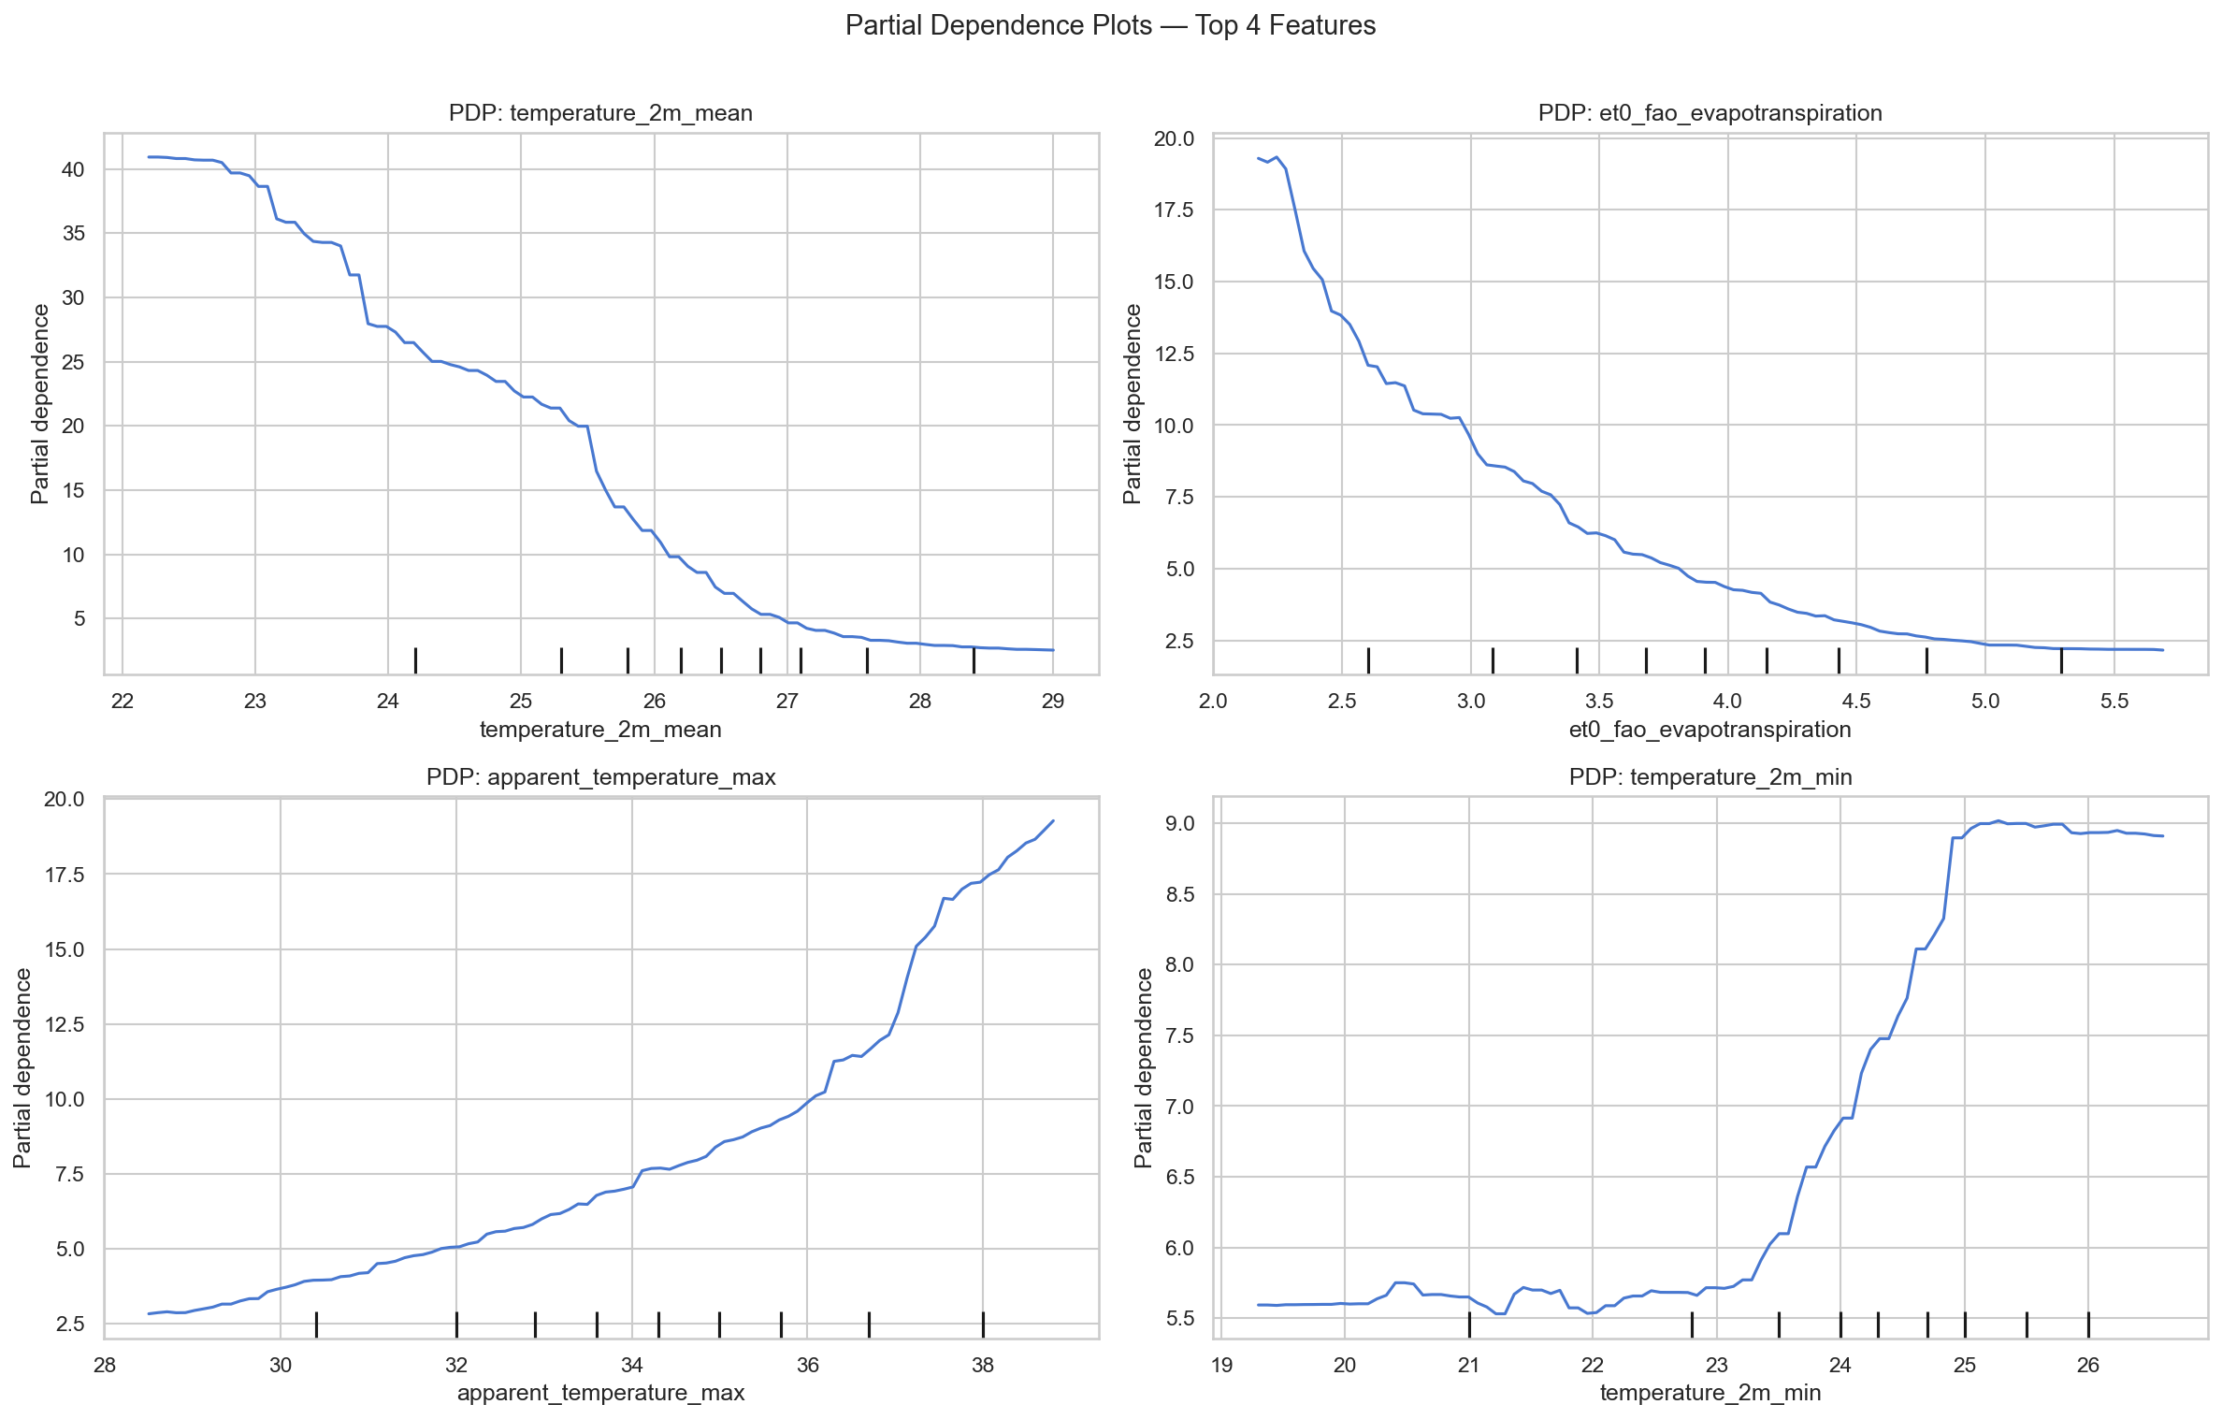
Figure 11: Partial Dependence Plots for the top 4 features.
Key findings: Precipitation decreases sharply as evapotranspiration increases. Solar radiation shows a clear negative relationship. Mean temperature has a moderate positive relationship. Day length captures subtle seasonal signals.

4.4 Domain Alignment
- Evapotranspiration as top predictor: Low ET indicates high humidity and saturated conditions — prerequisites for precipitation.
- Solar radiation inverse relationship: Cloudy skies block radiation and are associated with rainfall.
- Seasonal features (month, day_of_year) capture the bimodal monsoon pattern without explicit programming.
- Geographic features differentiate between the wet zone (SW Sri Lanka, 2,500+ mm/yr) and dry zone (N/E, <1,750 mm/yr).
- Wind patterns reflect moisture-laden air masses from the Indian Ocean during monsoon periods.

5. Discussion

5.1 Model Limitations
Same-day features, not true forecasting: The model uses same-day meteorological measurements. In a real operational setting, these would not be available in advance. A true forecasting model would require lagged features or NWP outputs.
No temporal autocorrelation modeling: Each day is treated independently. Weather patterns often persist over multiple days. Lagged features or time-series approaches could capture these dependencies.
Extreme event underestimation: The model may underpredict rare extreme events (>100 mm) that are critical for flood risk assessment.
R² of 0.45: 55% of precipitation variance remains unexplained due to micro-scale atmospheric dynamics that surface measurements cannot capture.

5.2 Data Quality Concerns
Single data source: All data comes from ERA5 reanalysis via Open-Meteo, which may differ from ground-station measurements.
Urban-centric sampling: 30 cities are primarily urban centers; rural and mountainous areas are underrepresented.
Temporal boundary: Dataset ends June 2023. Climate change may alter future patterns.

5.3 Bias and Fairness
Geographic prediction bias: Accuracy likely varies across cities with different microclimates.
No socioeconomic context: The model predicts precipitation, not flood impact. Vulnerable communities may be disproportionately affected.

5.4 Ethical Implications
False sense of security: Under-predictions for extreme events could lead to inadequate precautions. Prediction uncertainty must be communicated.
Resource allocation risks: Biased predictions could lead to inequitable distribution of disaster response resources.
Data transparency: The dataset uses entirely public weather records with no personal information.

5.5 Future Work
- Lagged features: Incorporate previous-day and multi-day rolling averages for true forecasting capability.
- Probabilistic predictions: Use quantile regression or conformal prediction to communicate uncertainty.
- Extreme value modeling: Apply specialized techniques for predicting tail events.
- Spatial features: Incorporate terrain data and upstream catchment information.
- Model retraining pipeline: Automate retraining as new data becomes available.

6. Front-End Integration
A Streamlit web application (app.py) was developed to make the trained model accessible to non-technical users. The application provides:
- City selection: Dropdown with 30 Sri Lankan cities, auto-populating geographic features.
- Date picker: Automatically derives temporal features (month, day of year, year).
- Weather parameter inputs: Sliders for temperature, radiation, wind, evapotranspiration.
- Precipitation prediction: Displays predicted daily precipitation in millimeters.
- Flood risk indicator: Color-coded risk level (Low <2.5 mm, Moderate 2.5–15 mm, High 15–50 mm, Very High >50 mm).
- XAI explanation: Plain-English explanation of why the model made each prediction, based on SHAP analysis.
- SHAP chart: Visual feature contribution chart for each prediction.
To run: pip install -r requirements.txt && streamlit run app.py

7. References
[1] Chen, T., & Guestrin, C. (2016). XGBoost: A Scalable Tree Boosting System. Proceedings of the 22nd ACM SIGKDD International Conference on Knowledge Discovery and Data Mining, 785–794.
[2] Lundberg, S. M., & Lee, S.-I. (2017). A Unified Approach to Interpreting Model Predictions. Advances in Neural Information Processing Systems, 30, 4765–4774.
[3] Open-Meteo. (2023). Historical Weather API. https://open-meteo.com/en/docs/historical-weather-api
[4] Department of Meteorology, Sri Lanka. Climatological data and monsoon patterns. http://www.meteo.gov.lk/
[5] Akiba, T., et al. (2019). Optuna: A Next-generation Hyperparameter Optimization Framework. Proceedings of the 25th ACM SIGKDD, 2623–2631.
[6] Pedregosa, F., et al. (2011). Scikit-learn: Machine Learning in Python. JMLR, 12, 2825–2830.

Project developed as part of a Machine Learning assignment. All data used is publicly available and contains no personal or sensitive information.

