Final Report
Level 4

Multimodal Emotional Recognition System with Explainability

MedOracle

Index Number | Name
214206G | Suhira Balarajan
214024V | Adshaya Balarajah
214215H | Vanaiyan Kirupagaran

Faculty of Information Technology
University of Moratuwa
2026

Final Report
Level 4

Multimodal Emotional Recognition System with Explainability

MedOracle

Index Number | Name
214206G | Suhira Balarajan
214024V | Adshaya Balarajah
214215H | Vanaiyan Kirupagaran

Supervised by: Dr. Firdhous M.F.M.

Faculty of Information Technology
University of Moratuwa
2026
Abstract

Mental health support is often bottlenecked by single-modality assessment: clinicians rely on either self-reported mood, or a single physiological or behavioural signal, each of which is incomplete and, in isolation, unreliable. This project, MedOracle, presents an AI-driven emotion recognition system that fuses two complementary modalities — physiological signals (EEG and GSR) and facial video — into a single, explainable prediction across five emotion classes (stress, calm, happy, sad, angry). The physiological branch uses a bidirectional cross-modal attention network trained on the DEAP dataset; the video branch uses a YOLOv8 face-detection front end feeding a partially fine-tuned ResNet50 and a bidirectional LSTM trained on the CREMA-D dataset. The two branches are combined with a quality-aware gated fusion mechanism: an entropy-based confidence score for each modality is multiplied by a signal-quality penalty and the results are L1-normalised into fusion weights, so that a modality with poor or missing input is automatically down-weighted rather than corrupting the final prediction. A Kernel SHAP explainability layer, a FastAPI backend with JWT-authenticated endpoints, and a React dashboard complete the system, allowing a user to upload a video together with EEG/GSR recordings and receive a fused prediction with a feature-level explanation and a natural-language summary from an integrated chatbot. The system was evaluated with an eight-condition ablation study (physio-only, video-only, equal-weight fusion, confidence-only fusion, the full gated method, and three robustness conditions with degraded or missing modalities) over a constructed cross-dataset evaluation set, with statistical significance assessed using the one-tailed Wilcoxon signed-rank test. The fused method significantly outperforms either single modality (p < 0.001 in both cases) and degrades gracefully when a modality is unavailable. A separate, honest subject-independent (leave-one-subject-out) evaluation of the physiological branch was also carried out, and the resulting limitation — driven by severe class imbalance in the DEAP labels and the well-documented difficulty of cross-subject EEG generalisation — is reported transparently, together with the diagnostic experiments that isolated its cause. The completed system comprises 82 passing automated tests, a functioning multimodal web application, and a reproducible evaluation pipeline, and is presented as a working, honestly evaluated, and explainable multimodal emotion recognition system.

Table of Contents

Introduction 1
1.1 Introduction 1
1.2 Background and Motivation 2
1.3 Problem in Brief 4
1.3.1 Scope and Delimitations 5
1.4 Aim and Objectives 6
1.4.1 Aim 6
1.4.2 Objectives 6
1.4.3 Research Questions 7
1.5 Proposed Solution 8
1.5.1 Member 1 — Physiological Emotion Recognition Module 9
1.5.2 Member 2 — Video-Based Emotion Recognition and Gated Fusion Module 10
1.5.3 Member 3 — Explainability and Web Application Module 11
1.6 Report Organisation 12
1.7 Summary 12
Literature Review 13
2.1 Introduction 13
2.2 Physiological (EEG/GSR) Emotion Recognition 13
2.2.1 Datasets for Physiological Emotion Recognition 13
2.2.2 Feature Extraction and Signal Processing 14
2.2.3 Classification Approaches 15
2.2.4 Challenges: Cross-Subject Generalisation and Class Imbalance 15
2.3 Facial Video Emotion Recognition 16
2.3.1 Datasets for Facial Video Emotion Recognition 16
2.3.2 Preprocessing and Face Detection 17
2.3.3 Feature Extraction and Temporal Modelling 17
2.3.4 Challenges in Video-Based Emotion Recognition 18
2.4 Multimodal Fusion Approaches 18
2.4.1 Fusion Taxonomy 18
2.4.2 Confidence- and Quality-Aware Fusion 19
2.5 Explainable AI for Emotion Recognition 20
2.5.1 Motivation: Why Explanations Matter in Emotion Recognition 21
2.5.2 Post-Hoc Attribution Methods and SHAP 21
2.5.3 Explainability in Multimodal and Late-Fusion Settings 22
2.5.4 Faithfulness Evaluation of Explanations 23
2.5.5 Modality-Conflict and Trust-Aware Explanation 24
2.5.6 From Feature Attribution to User-Facing Natural-Language Explanation 25
2.5.7 Challenges in Explainable Multimodal Emotion Recognition 26
2.6 Research Gap and Positioning 27
2.7 Summary 28
Technology Adapted 29
3.1 Introduction 29
3.2 Development Tools and IDEs 29
3.3 Programming Languages 30
3.4 Shared Foundation and Dependency Management 30
3.4.1 Member 1 — Physiological Signal Processing and Deep Learning 30
3.4.2 Member 2 — Video Processing, Deep Learning and Evaluation 31
3.4.3 Member 3 — Explainability and Web Application 31
3.5 Version Control System and Collaborative Workflow 34
3.6 Summary 34
Our Approach 35
4.1 Introduction 35
4.2 Member 1 — Physiological Emotion Recognition 35
4.2.1 Input 35
4.2.2 Process 35
4.2.3 Output 37
4.2.4 Evaluation 37
4.3 Member 2 — Video-Based Emotion Recognition and Multimodal Fusion 38
4.3.1 Input 38
4.3.2 Process 38
4.3.3 Output 40
4.3.4 Evaluation 40
4.4 Member 3 — Explainability and Web Application 41
4.4.1 Input 41
4.4.2 Process 41
4.4.3 Output 43
4.4.4 Evaluation 43
4.5 Summary 43
Analysis and Design 45
5.1 Introduction 45
5.2 System Architecture 45
5.3 Shared Emotion Taxonomy and Label Harmonization 46
5.3.1 Why a Shared Taxonomy Is Necessary 46
5.3.2 DEAP Valence/Arousal/Dominance Mapping 47
5.3.3 CREMA-D Categorical Mapping 47
5.4 Signal Quality Assessment 49
5.4.1 Design Rationale: Three Discrete Tiers 49
5.4.2 EEG and GSR Thresholds 49
5.4.3 Video Threshold Recalibration 49
5.5 Interface Contracts Between Modules 51
5.5.1 Temporal Synchronization Design 51
5.5.2 Explainability Output Contract (Member 3) 52
5.6 Gated Fusion Design 52
5.7 Database and Web Application Design 54
5.8 Summary 55
Implementation 56
6.1 Introduction 56
6.2 Module 1 — Physiological Emotion Recognition Implementation 56
6.2.1 Data Loading and Preprocessing 56
6.2.2 Signal Quality Assessment 57
6.2.3 Network Architecture 58
6.2.4 Baseline Comparisons 59
6.2.5 Interface Export 60
6.3 Module 2 — Video-Based Emotion Recognition Implementation 61
6.3.1 Preprocessing and Training 61
6.3.2 Gated Fusion Implementation 63
6.3.3 Full Pipeline 63
6.3.4 Cross-Dataset Evaluation Set Construction 64
6.3.5 Ablation Study Implementation 65
6.4 Module 3 — Explainability and Web Application Implementation 65
6.4.1 SHAP Explainability 65
6.4.2 Modality-Conflict and Chat Implementation 66
6.4.3 Backend 66
6.4.4 Frontend 67
6.5 Testing 68
6.6 Summary 68
Discussion & Evaluation 69
7.1 Introduction 69
7.1.1 Evaluation Scope and Research Questions 69
7.2 Physiological Module Evaluation 69
7.2.1 Two Evaluation Protocols 69
7.2.2 Diagnostic Experiment 1: Class Imbalance 70
7.2.3 Diagnostic Experiment 2: Feature Representation 71
7.2.4 Diagnostic Experiment 3: GSR Data Quality 72
7.2.5 Diagnostic Experiment 4: Taxonomy Granularity 72
7.2.6 Summary of Diagnostic Findings 73
7.2.7 Interpretation 74
7.3 Video Module Evaluation 74
7.4 Fusion and Ablation Study 75
7.4.1 Ablation Methodology 75
7.4.2 Results 76
7.4.3 Interpretation: Fusion Beats Single Modalities 77
7.4.4 Interpretation: Why C5 Does Not Beat C3 77
7.4.5 Robustness Conditions 78
7.4.6 Mapping Ablation Outcomes to RQ1 and RQ2 78
7.5 Web Application Evaluation 79
7.6 Comparison with Related Work 79
7.6.1 Physiological Module 79
7.6.2 Video Module 80
7.7 Limitations 80
7.8 Summary 81
Conclusion 82
8.1 Conclusion 82
8.1.1 Achievement of Objectives 82
8.1.2 Overall Reflection 83
8.1.3 Research Questions — Final Assessment 84
8.2 Future Work 84
8.2.1 Physiological Module Improvements 84
8.2.2 System-Level Improvements 85
8.2.3 Application and Deployment 85
References 87
Individuals' Contribution to the Project 89
Suhira Balarajan — 214206G 89
Vanaiyan Kirupagaran — 214215H 90
Adshaya Balarajah — 214024V 91

List of Figures

Figure | Page
Figure 1.1: High-level architecture of the proposed multimodal emotion recognition system | 6
Figure 2.1: Fusion taxonomy — early, intermediate and late fusion | 16
Figure 3.1: Technology stack by module ownership | 20
Figure 4.1: Member 1 physiological emotion recognition pipeline | 24
Figure 4.2: Member 2 video recognition and gated fusion pipeline | 27
Figure 4.3: Member 3 explainability and web application architecture | 30
Figure 5.1: Data flow and interface contracts between Member 1, Member 2 and Member 3 | 33
Figure 5.2: Signal-quality tiers and their effect on the fusion gate score | 36
Figure 5.3: Graceful degradation decision flow | 39
Figure 6.1: DEAP dataset structure and per-subject class distribution (preprocessing visualisation) | 42
Figure 6.2: EEG / GSR / Video signal-quality grading visualisation | 43
Figure 6.3: SVM baseline — subject-independent (LOSO) results | 44
Figure 6.4: Random Forest baseline — subject-independent (LOSO) results | 45
Figure 6.5: MLP baseline — subject-independent (LOSO) results | 45
Figure 6.6: Effect of fine-tuning strategy on the train/validation macro-F1 gap | 47
Figure 7.1: DEAP 5-class distribution used for physiological training | 54
Figure 7.2: Feature representation comparison under LOSO — all converge to ~0.16-0.18 macro-F1 | 55
Figure 7.3: Video module per-class F1 (held-out test, 788 clips) | 58
Figure 7.4: Ablation study — macro-F1 by condition (C1-C8) | 59
Figure 7.5: Ablation study — normalised confusion matrices for physio-only (C1), video-only (C2) and full fusion (C5) | 60

List of Tables
Table | Page
Table 1.1: Summary of system modules and responsibilities | 9
Table 1.2: Shared five-class emotion taxonomy (locked across all modules) | 9
Table 2.1: Comparison of the DEAP and CREMA-D datasets | 16
Table 2.2: Summary of related multimodal emotion-recognition approaches | 20
Table 2.3: Comparison of explainability support in related emotion-recognition approaches | 26
Table 3.1: Primary technologies by module | 33
Table 4.1: Primary FastAPI endpoints (Member 3 backend) | 42
Table 5.1: Signal-quality grading thresholds | 48
Table 5.2: DEAP-to-5-class and CREMA-D-to-5-class label harmonisation | 50
Table 6.1: M1 -> M2 interface contract (physiological_prediction_dict) | 60
Table 6.2: Video model training hyperparameters | 62
Table 6.2: M2 -> M3 interface contract (prediction_output) | 64
Table 6.3: FastAPI endpoint summary | 66
Table 7.1: DEAP 5-class distribution used for physiological training | 70
Table 7.2: Video module per-class F1 (held-out test, 788 clips) | 73
Table 7.3: Ablation study results (C1-C8) with Wilcoxon significance vs C5 | 74
Table 7.4: Summary of diagnostic experiments for the physiological module's LOSO result | 76

Chapter 1

Introduction

1.1 Introduction
This report documents MedOracle — an AI-Driven Multimodal Emotional Recognition System with Explainability — developed as the Level 4 Final Year Project of Team MedOracle, Faculty of Information Technology, University of Moratuwa (2026).
Emotion is not communicated through a single channel. A person under stress may show it in a tightened facial expression, in a racing heart rate, in the electrical conductivity of their skin, or in none of these visibly at all while still registering it physiologically. Traditional emotion-recognition systems, however, are almost always built around a single channel of evidence: a camera that reads facial expressions, a microphone that reads vocal tone, or — less commonly outside research settings — a wearable sensor that reads brain or skin activity. Each of these channels is informative in isolation, but each also has blind spots that the others do not share: a face can be deliberately controlled or occluded, a voice can be flat despite genuine distress, and physiological signals can be affected by unrelated factors such as physical exertion or ambient temperature. A system that commits to only one channel inherits that channel's specific failure modes.
MedOracle is built on the premise that these failure modes are largely independent across modalities, and that a system which measures its own confidence in each channel — rather than assuming both channels are always equally trustworthy — can produce a prediction that is more reliable than either channel alone. Concretely, MedOracle fuses two objective, continuously-available signal families: physiological signals (EEG and GSR) captured from wearable sensors, and facial video captured from an ordinary camera. The two are combined into a single prediction across five emotion classes — stress, calm, happy, sad and angry — via a quality- and confidence-aware gated fusion mechanism, described in full in Chapter 5, and every prediction is accompanied by a SHAP-based explanation delivered through a web application, so that the system's reasoning is visible rather than opaque.

The system is the product of a three-person team, each member responsible for one stage of an end-to-end pipeline: physiological signal processing and classification (Member 1), video-based emotion recognition together with the multimodal fusion layer (Member 2), and explainability together with the web application (Member 3). This division of labour mirrors the natural boundaries of the problem — each modality requires substantially different signal processing and modelling expertise — while the interface contracts described in Chapter 5 allow the three modules to be developed independently and composed into a single working system. This report documents the motivation, related work, design, implementation and, most importantly, the honest and rigorously obtained evaluation of that complete system, including results that were not favourable and the diagnostic work undertaken to understand them.

1.2 Background and Motivation
Mental health conditions such as stress, anxiety and depression are widespread, and their assessment still relies overwhelmingly on self-report — questionnaires, mood diaries, and periodic clinical interviews — rather than on continuous, objective measurement. Self-report is valuable but has well-known limitations: it is retrospective rather than real-time, it is subject to recall bias and social desirability bias, and it requires the person being assessed to already have enough insight and vocabulary to characterise their own state. Wearable sensors and cameras offer a route to continuous, objective measurement that does not depend on self-report, and affective computing — the branch of AI concerned with recognising and interpreting human emotion — has correspondingly grown as a research area over the last two decades.
That research has, however, progressed largely along separate tracks. Facial-expression recognition, speech-emotion recognition, text-sentiment analysis and physiological emotion recognition have each developed their own benchmark datasets, feature representations and model families, and are typically evaluated and published independently of one another. Multimodal fusion — combining two or more of these channels — has repeatedly been shown in the survey literature to outperform any single modality when the fusion is done carefully [1, 10], precisely because different signals fail under different circumstances. A face can be occluded, poorly lit, or deliberately neutral; physiological signals cannot be consciously suppressed in the same way, but are comparatively more sensitive to motion artefacts, sensor placement, and — as this project's own evaluation shows in detail in Chapter 7 — to variation between individuals.
That last point deserves particular emphasis, because it directly shaped this project's design. Physiological emotion recognition trained on one group of people has repeatedly been observed, in this project's own experiments and in the wider literature, to transfer poorly to a new, previously unseen person — the cross-subject generalisation problem. The DEAP dataset [6], used for this project's physiological module, illustrates why: emotional response to the same stimulus varies considerably from person to person, both in the self-reported valence/arousal/dominance ratings that DEAP records and in the underlying EEG and GSR patterns that accompany them. Facial video, by contrast, was found in this project to generalise comparatively well across unseen individuals once a sufficiently deep visual encoder is used, because the visual grammar of a facial expression — a raised brow, a tightened jaw — is considerably more consistent across people than the electrophysiological signature of the same emotion. This asymmetry between the two modalities' reliability is the central motivation for MedOracle's fusion strategy: rather than assume both modalities are equally trustworthy and fuse them with fixed or learned-but-static weights, the system measures each modality's real-time confidence and signal quality and adapts its trust accordingly, a design informed by calibration research showing that entropy-based confidence remains a useful, model-agnostic reliability signal even when raw softmax outputs are poorly calibrated [3].
The project is further motivated by the need for explainability in any system intended to support mental-health-adjacent decisions. A bare prediction of "stress" carries limited clinical or personal value on its own; a prediction accompanied by a feature-level explanation of which modality drove it, and how reliable that modality's input was judged to be, is considerably more actionable, more trustworthy, and more useful for a person trying to understand their own emotional patterns over time. This is the motivation behind Member 3's SHAP-based explainability layer and the modality-conflict explanation feature described in Chapter 4.

1.3 Problem in Brief
Three specific, interrelated problems motivate this project's design and are each addressed directly by a corresponding design decision.
First, existing multimodal emotion-recognition prototypes generally assume every modality is always present and equally reliable, and combine them using fixed or learned-but-static fusion weights that do not adapt at inference time to the quality of the specific input received. A system built this way performs well when all sensors are functioning cleanly, but has no principled way to respond when one input is degraded, noisy, or simply absent — exactly the conditions a real deployment (a poorly-lit camera, a loose EEG electrode) will regularly encounter. MedOracle addresses this by implementing a gated fusion mechanism (Chapter 5) that computes an entropy-based confidence score and a signal-quality grade for each modality at every prediction, multiplies them into a per-modality gate score, and L1-normalises the result into fusion weights — so a degraded or missing modality is automatically down-weighted rather than allowed to corrupt the fused output.
Second, physiological datasets such as DEAP are recorded from a modest number of subjects (32, in DEAP's case) and, once mapped onto a discrete emotion taxonomy, frequently produce a severely imbalanced label distribution; combined with the cross-subject generalisation problem described above, this makes subject-independent evaluation of physiological emotion recognition a genuine and, in much of the published literature, under-reported challenge. Rather than report only an optimistic random-split evaluation — in which windows from the same subject and even the same trial can appear in both the training and test sets — MedOracle's physiological module is evaluated under the harder, honest Leave-One-Subject-Out (LOSO) protocol, and the resulting limitation is diagnosed rather than concealed (Section 7.2).
Third, no single public dataset provides EEG, GSR and facial video recorded from the same subjects at the same time: DEAP provides physiological signals from one group of subjects, and CREMA-D [2] provides facial video from an entirely different group. A system that wants to evaluate genuine multimodal fusion behaviour therefore cannot simply hold out a slice of one paired dataset, and must instead construct a principled cross-dataset evaluation methodology. MedOracle addresses this by pairing, for each of the five emotion classes, a real DEAP physiological window with a real CREMA-D video clip carrying the same emotion label — the standard construction for evaluating cross-dataset late fusion when no single dataset spans every modality [1, 10] — and uses this construction both for the ablation study (Chapter 7) and for a demonstration dataset bundled with the web application.

1.3.1 Scope and Delimitations
The scope of this project is the design, implementation, and rigorous evaluation of a research prototype that accepts pre-recorded EEG, GSR, and facial-video inputs and returns a fused, explainable emotion prediction over five discrete classes. The system is intended as a proof-of-concept for quality-aware multimodal fusion and explainable affective computing, not as a certified clinical diagnostic instrument. Several boundaries follow directly from this scope and from the datasets available.
First, the physiological module is trained and evaluated on DEAP [6], in which subjects viewed music videos in a controlled laboratory setting; the video module is trained on CREMA-D [2], comprising acted emotional utterances from 91 actors. Neither dataset represents real-time, free-living mental-health monitoring, and the cross-dataset pairing used for fusion evaluation (Section 7.4) does not constitute naturally synchronised multimodal recordings from the same person at the same moment. Results reported in this report therefore characterise fusion behaviour under a principled constructed evaluation, rather than clinical validity in deployment.
Second, the web application accepts uploaded files (.mp4 video; .npy or .csv EEG/GSR arrays) rather than streaming live sensor data. Real-time acquisition, device driver integration, and latency optimisation are outside the completed scope and are noted as deployment-oriented future work (Section 8.2).

Third, emotion labels are harmonised onto a shared five-class taxonomy (stress, calm, happy, sad, angry) that necessarily simplifies both DEAP's continuous valence/arousal/dominance ratings and CREMA-D's six original categories. Any discrete mapping of dimensional affect onto categorical labels is itself a modelling decision with direct consequences for class balance and evaluability, as the physiological module's diagnostic experiments demonstrate (Section 7.2).
Fourth, explainability is provided through SHAP-based feature attribution and natural-language summaries generated by a large language model. These outputs are intended to help a user understand which modality and features influenced a given prediction, not to provide clinical advice, and their usefulness to end users has not yet been validated through a formal user study (Section 7.7).
Within these boundaries, the project delivers a complete, testable pipeline — from raw modality inputs through gated fusion to a JWT-secured web dashboard — together with an eight-condition ablation study and an honest account of both favourable and unfavourable findings.

1.4 Aim and Objectives

1.4.1 Aim
To design, implement and rigorously evaluate a multimodal emotion recognition system that fuses physiological (EEG/GSR) and facial-video signals through a quality-aware gated fusion mechanism, and to make its predictions explainable through SHAP-based feature attribution delivered via a web application.

1.4.2 Objectives
In pursuit of this aim, the project set out to achieve the following specific objectives, each of which is revisited and evaluated against its outcome in Chapter 7:
- To develop a physiological emotion recognition module using a bidirectional cross-modal attention network trained on the DEAP dataset, mapped to a five-class emotion taxonomy shared across the system.
- To develop a video-based emotion recognition module using face detection, convolutional feature extraction and temporal (BiLSTM) modelling, trained on the CREMA-D dataset, and evaluated under an actor-independent cross-validation protocol so that reported performance reflects genuine generalisation to unseen individuals.
- To design and implement a quality-aware gated fusion mechanism that combines both modalities using entropy-based confidence and signal-quality penalties, with graceful degradation when a modality is degraded or missing, and to verify this mechanism's correctness through automated unit testing.
- To implement a SHAP-based explainability layer and a FastAPI/React web application that allows a user to submit video and/or physiological data and receive a fused, explained prediction, including an explanation of disagreements between modalities.
- To evaluate the complete system through an eight-condition ablation study (single-modality baselines, naive fusion, the full method, and robustness conditions under degraded or missing input) with statistical significance testing, and to report all resulting findings -- including unfavourable ones -- with full transparency about their cause.

1.4.3 Research Questions
The problems stated in Section 1.3 give rise to four research questions that this report addresses empirically:
- RQ1. Can physiological (EEG/GSR) and facial-video signals, trained on separate public datasets with no shared subjects, be combined through late fusion to produce a prediction that significantly outperforms either modality in isolation?
- RQ2. Does a quality- and confidence-aware gated fusion mechanism degrade gracefully — down-weighting or excluding a modality when its input is poor or absent — without corrupting the fused output or causing system failure?
- RQ3. Under subject-independent evaluation protocols (Leave-One-Subject-Out for physiology; actor-independent cross-validation for video), what performance can each unimodal branch achieve, and what diagnostic factors explain any gap between optimistic and honest evaluation figures?
- RQ4. Can SHAP-based attribution, together with a web application that surfaces modality weights, signal-quality grades, and modality-conflict explanations, make the fused prediction interpretable to a non-technical user?
RQ1 and RQ2 are answered primarily in Section 7.4 (ablation study). RQ3 is answered in Sections 7.2 and 7.3. RQ4 is addressed in Sections 6.4 and 7.5, with limitations noted in Section 7.7.

1.5 Proposed Solution
The proposed system ingests three input types -- EEG, GSR and facial video -- and produces a single fused emotion label with an accompanying confidence score, a per-modality prediction breakdown, and a SHAP-based explanation. Figure 1.1 shows the high-level architecture: Member 1's physiological branch and Member 2's video branch each independently produce a prediction dictionary conforming to a shared interface contract; Member 2's gated fusion module combines these into a single prediction_output; and Member 3's explainability layer and web application surface the result, together with its explanation, to the end user. Table 1.1 summarises the three modules and their ownership before each is described in more detail in Sections 1.5.1-1.5.3.
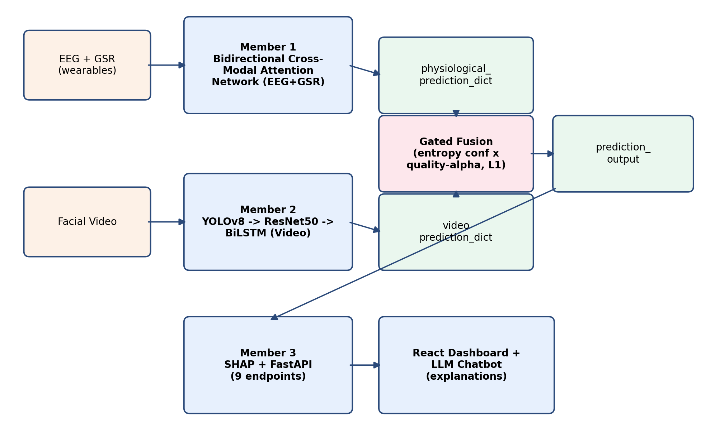
Figure 1.1: High-level architecture of the proposed multimodal emotion recognition system

Table 1.1: Summary of system modules and responsibilities
Module | Owner | Responsibility
Physiological Emotion Recognition | Member 1 (Suhira Balarajan) | EEG+GSR preprocessing, bidirectional cross-modal attention network, LOSO evaluation
Video Emotion Recognition + Fusion | Member 2 (Vanaiyan Kirupagaran) | Face detection, ResNet50+BiLSTM video model, gated fusion, full pipeline, ablation study
Explainability + Web Application | Member 3 (Adshaya Balarajah) | Kernel SHAP, FastAPI backend, React dashboard, LLM-based chat explanations

Table 1.2: Shared five-class emotion taxonomy (locked across all modules)
Class index | Label | Description (operational)
0 | stress | High arousal, low valence, low dominance (DEAP mapping); fear mapped from CREMA-D
1 | calm | Low arousal, neutral-to-positive valence; CREMA-D neutral mapped here
2 | happy | High valence, high arousal, high dominance
3 | sad | Low valence, low arousal, low dominance
4 | angry | Low valence, high arousal, high dominance
The full DEAP and CREMA-D mapping rules, including dropped labels and threshold conventions, are specified in Section 5.3 and Table 5.2.

1.5.1 Member 1 — Physiological Emotion Recognition Module
Member 1's module takes raw EEG (32 channels, 128Hz) and GSR signals recorded during the DEAP dataset's music-video-viewing sessions, and produces an emotion prediction over the shared five-class taxonomy. Each 60-second DEAP trial is windowed into 4-second segments, and each trial's continuous self-reported valence, arousal and dominance ratings are mapped onto the shared five-class taxonomy using literature-grounded thresholds (Russell's circumplex model [11] and Mehrabian's PAD model [8], detailed in Chapter 5). The EEG and GSR windows are each passed through a dedicated convolutional encoder, after which a bidirectional cross-modal attention layer allows the EEG representation to attend over the GSR representation and vice versa — an architecture intended to let each signal inform the interpretation of the other, rather than treating them as independent evidence to be combined only at the very end. The attended representations are pooled and passed to a joint classification head producing a five-class probability distribution. Critically, this module is evaluated twice: once under an optimistic random-split protocol used only to obtain an early working checkpoint for system integration, and once under the honest, subject-independent Leave-One-Subject-Out protocol that this report treats as the module's true, reportable performance figure. The substantial gap between these two evaluations, and the diagnostic work undertaken to explain it, is one of this project's central findings and is discussed at length in Section 7.2.

1.5.2 Member 2 — Video-Based Emotion Recognition and Gated Fusion Module
Member 2's module has two parts. The first is a video-based emotion recognition pipeline: sixteen frames are sampled uniformly from each input clip and passed through a partially fine-tuned ResNet50 [4] convolutional encoder to obtain per-frame feature vectors, which a two-layer bidirectional LSTM [5] then models temporally before a final softmax layer produces a five-class prediction; a YOLOv8 face-detection pass runs alongside this pipeline purely to grade the input's signal quality (face-detection rate, sharpness, face size) rather than to crop the recognition input itself, a design choice justified by a controlled comparison described in Chapter 6. The second part is the gated fusion mechanism that combines this video prediction with Member 1's physiological prediction: an entropy-based confidence score and a signal-quality grade are computed for each modality, multiplied together into a gate score, and L1-normalised into fusion weights, so that the fused prediction automatically leans on whichever modality is currently more reliable, and degrades gracefully — falling back to a single modality's prediction, or to a flagged uniform distribution — when a modality is degraded or unavailable. Member 2 additionally designed the full multimodal pipeline that invokes both members' models, the cross-dataset evaluation-set construction needed because DEAP and CREMA-D share no subjects, and the eight-condition ablation study with statistical significance testing that forms the core of this report's evaluation (Chapter 7).

1.5.3 Member 3 — Explainability and Web Application Module
Member 3's module receives the fused prediction_output produced by Member 2's pipeline and makes it interpretable and accessible. A Kernel SHAP explainability layer attributes the fused prediction to each contributing modality and feature, and computes a faithfulness score by perturbing input features and measuring the resulting change in prediction, so that the explanation's accuracy can itself be quantified rather than assumed. A FastAPI backend, secured with JWT authentication, exposes this functionality through a set of endpoints covering user registration and login, video-only and full multimodal (video + EEG + GSR) prediction, SHAP explanation retrieval, session history, and an LLM-backed chat interface that translates the raw SHAP attribution into a plain-English explanation a non-technical user can act on. A React frontend renders this information as an emotion-trend chart, a SHAP bar chart, a session-history panel, and — Member 3's novel contribution — a modality-conflict explanation panel that specifically explains cases where the physiological and video predictions disagree, surfacing the same reasoning the gated fusion mechanism used internally to decide which modality to trust.
The remainder of this report is structured as follows. Chapter 2 reviews prior work in physiological, video-based and multimodal emotion recognition. Chapter 3 describes the technologies adopted. Chapter 4 describes each member's approach in terms of input, process, output and evaluation. Chapter 5 presents the system's analysis and design, including the shared label taxonomy, interface contracts and fusion design. Chapter 6 describes the implementation. Chapter 7 presents the evaluation and discussion, including the ablation study and an honest account of the physiological module's limitations. Chapter 8 concludes the report and outlines future work.

1.6 Report Organisation
The remainder of this report is structured as follows. Chapter 2 reviews prior work in physiological, video-based, and multimodal emotion recognition. Chapter 3 describes the technologies adopted. Chapter 4 describes each member's approach in terms of input, process, output, and evaluation. Chapter 5 presents the system's analysis and design, including the shared label taxonomy, interface contracts, and fusion design. Chapter 6 describes the implementation. Chapter 7 presents the evaluation and discussion, including the ablation study and an honest account of the physiological module's limitations. Chapter 8 concludes the report, maps each objective to its outcome, and outlines future work. Appendix A records each team member's individual contribution.

1.7 Summary
This chapter introduced MedOracle, a multimodal emotion recognition system that fuses physiological and video signals through a quality-aware gated fusion mechanism and explains its predictions through SHAP. The motivation for combining modalities rather than relying on one, the three specific problems the system's design responds to, the project's aim and objectives, and an overview of each member's module within the proposed solution were presented. The next chapter reviews relevant prior work in each of the constituent research areas that these modules draw upon.

Chapter 2

Literature Review

2.1 Introduction
This chapter reviews prior work relevant to MedOracle's three constituent problems: physiological (EEG/GSR) emotion recognition, facial video emotion recognition, and multimodal fusion with explainability. Each area is reviewed with attention to datasets, feature representations, classification approaches, and the challenges specific to that modality — particularly, for the physiological literature, the distinction between subject-dependent and subject-independent evaluation, which this project's own results (Chapter 7) show to be far from a minor methodological footnote.
The review is structured to mirror the system's architecture: Section 2.2 covers the physiological branch; Section 2.3 covers the video branch; Section 2.4 covers multimodal fusion strategies and positions MedOracle's hybrid design within the fusion taxonomy; Section 2.5 covers explainability methods; and Section 2.6 synthesises the research gaps that the project's design directly responds to. All citations use the fixed reference list established in Chapter 1 ([1]–[13]); no additional sources are introduced here so that citation numbering remains stable across the full report.

2.2 Physiological (EEG/GSR) Emotion Recognition

2.2.1 Datasets for Physiological Emotion Recognition
The DEAP dataset [6] is one of the most widely used benchmarks for physiological emotion recognition. It provides 32-channel EEG (sampled at 128Hz in its preprocessed release) together with peripheral physiological signals, including GSR, recorded from 32 subjects while each watched 40 one-minute music videos selected to elicit a range of emotional responses. After each video, subjects self-reported their valence, arousal, dominance and liking on a continuous 1-9 scale, rather than selecting from a fixed set of discrete emotion labels , a design choice that gives researchers flexibility in defining their own discrete taxonomy, but also means that any discrete mapping (including the one this project uses, described in Chapter 5) is itself a modelling decision with direct consequences for class balance, as this project's own results demonstrate. DEAP's continuous, dimensional (valence/arousal/dominance) annotation is representative of a broader pattern in the physiological emotion-recognition literature, where dimensional models of affect are often preferred over discrete categorical labels precisely because self-reported discrete emotion categories are harder for participants to annotate consistently than a continuous rating scale.
Table 2.1 summarises the two primary datasets used across this project, contrasting DEAP's physiological recording protocol against CREMA-D's video recording protocol (reviewed in Section 2.3.1); the two datasets share no common subjects, which is precisely the constraint (Section 2.4) that this project's cross-dataset fusion evaluation methodology is designed to work around.

2.2.2 Feature Extraction and Signal Processing
This project uses the DEAP preprocessed release, in which the dataset authors have already applied a 4–45 Hz bandpass filter and EOG artefact removal to the raw 512 Hz recordings before down sampling to 128 Hz. The preprocessed data was verified against the official DEAP specification on loading: each subject file confirmed the expected shape of 40 trials × 40 channels × 8064 samples, and a Welch PSD computed on a sample of EEG channels confirmed the 4–45 Hz passband. The feature representations discussed above, band power, Differential Entropy, and the learned depthwise convolutional filters, all operate on this already-filtered signal rather than the original raw recording.
More recent work has moved toward learned feature representations: convolutional architectures inspired by EEGNet apply small, channel-wise temporal filters directly to the raw signal, allowing the network to learn its own frequency-selective filters rather than relying on a fixed Fourier or wavelet decomposition chosen in advance. This is the approach this project's own physiological encoder (Chapter 6) takes for its EEG branch, using a depthwise-separable convolutional stack, before Member 1's bidirectional cross-modal attention layer combines the resulting EEG representation with an analogously encoded GSR representation.

2.2.3 Classification Approaches
Classical classifiers - Support Vector Machines, Random Forests, and Multi-Layer Perceptrons trained on hand-crafted spectral features, remain common baselines in the physiological emotion-recognition literature and were implemented as such in this project (Section 6.2.4) specifically to establish whether a given evaluation result reflects a limitation of the neural architecture or of the underlying data. Deep learning approaches for EEG emotion recognition have layered convolutional feature extraction with recurrent (LSTM [5]) or attention-based temporal modelling to capture the evolution of the signal over a trial window, and, closer to this project's own architecture, some approaches use cross-modal attention specifically to let one physiological signal inform the interpretation of another rather than combining them only at a late, decision-level stage.
Siddharth et al. [12] combined EEG with peripheral physiological signals (including GSR) on the DEAP dataset and reported approximately 73% classification accuracy — a figure that, as discussed further in Section 2.2.4 and revisited in this project's own comparison with related work (Section 7.6), is understood in this report to reflect a within-subject or near-within-subject evaluation protocol common in this literature, rather than the harder subject-independent setting this project adopts for its own headline evaluation.

2.2.4 Challenges: Cross-Subject Generalisation and Class Imbalance
Two challenges recur throughout the physiological emotion-recognition literature and were found, in this project's own experiments, to be decisive rather than incidental. The first is cross-subject generalisation: a model trained on a group of subjects frequently fails to transfer its performance to a new, previously unseen subject, because the electrophysiological signature of a given emotion varies considerably between individuals — in contrast to facial expression, which is comparatively more consistent across people (Section 2.3). This is most rigorously exposed by Leave-One-Subject-Out (LOSO) cross-validation, in which every fold tests on a subject entirely absent from training; LOSO evaluations of fine-grained (four- or five-class) discrete emotion recognition are reported far less often in the literature than within-subject or coarser-grained (binary valence/arousal) evaluations, and, where they are reported, generally show substantially lower performance — a pattern this project's own results in Section 7.2 corroborate directly.
The second challenge is class imbalance arising from the mapping of a continuous, dimensional rating scale onto a discrete taxonomy: because the choice of thresholds on valence, arousal and dominance is itself a modelling decision, a poorly-balanced choice of thresholds can leave some discrete emotion classes represented by only a handful of examples across an entire dataset, an effect this project measured directly and traced as a primary cause of its physiological module's evaluation result (Section 7.2).

2.3 Facial Video Emotion Recognition

2.3.1 Datasets for Facial Video Emotion Recognition
The CREMA-D dataset [2] comprises over 7,000 audio-visual clips from 91 actors spanning a range of ages and ethnic backgrounds, each portraying one of six emotions (anger, disgust, fear, happiness, neutral, sadness) at varying levels of intensity, with each clip additionally rated by multiple independent human evaluators for the perceived emotion. This crowd-sourced multi-rater annotation, combined with its actor diversity, makes CREMA-D well suited to training models intended to generalise across previously unseen individuals, and is the dataset used for this project's video-based recognition module. RAVDESS, a comparable but smaller audio-visual dataset recorded from 24 professional actors under more controlled studio conditions, was used during this project's model-development phase alongside CREMA-D to increase training diversity, as described in Chapter 6.
Table 2.1: Comparison of the DEAP and CREMA-D datasets
Property | DEAP | CREMA-D
Modality | EEG (32 ch, 128Hz) + GSR (peripheral) | Facial video (~30fps)
Subjects/Actors | 32 subjects | 91 actors
Stimuli | 40 one-minute music videos per subject | ~7,000 short emotionally-labelled clips
Labels | Continuous valence/arousal/dominance (1–9) | Discrete: anger, disgust, fear, happy, neutral, sad
Annotation | Self-reported by the subject | Crowd-sourced, multiple raters per clip
Overlap with the other dataset | None — no shared subjects | None — no shared subjects

2.3.2 Preprocessing and Face Detection
A face-detection front end is standard practice ahead of the recognition network itself, isolating the face region from background and reducing the input's variability due to camera framing. YOLO-family detectors are increasingly used for this purpose because of their speed and robustness across lighting conditions and pose. Detected faces are conventionally cropped and resized to a fixed input resolution before being passed to the recognition network; this project's own development process, however, found that cropping to the detected face region measurably reduced recognition accuracy relative to resizing the full, uncropped frame (Section 6.3.1), an empirical finding that runs against the more common assumption that cropping is strictly beneficial, and which led this project to repurpose its face-detection pass as a signal-quality assessment tool (Section 5.4) rather than a cropping step.

2.3.3 Feature Extraction and Temporal Modelling
Convolutional architectures -- ResNet variants [4] in particular -- are the dominant choice for extracting per-frame spatial features in video-based facial emotion recognition, typically initialised from weights pretrained on a large image classification dataset and then fine-tuned, fully or partially, on the target emotion dataset. Because a facial expression evolves over the duration of a clip rather than being fully captured by any single frame, a temporal model -- most commonly a Long Short-Term Memory network [5] or its bidirectional variant -- is applied over the sequence of per-frame features to capture how the expression develops, rather than aggregating frame-level predictions independently. This convolutional-encoder-plus-recurrent-temporal-model combination is the architecture this project's own video module adopts (Chapter 6), using a partially fine-tuned ResNet50 encoder followed by a two-layer bidirectional LSTM.
Zhang et al. [13] reported approximately 65% accuracy for video-only emotion recognition on a comparable set of classes, a figure broadly consistent with this project's own video module's held-out performance (Section 7.3), and used in Section 7.6 as a point of comparison for this project's own results.

2.3.4 Challenges in Video-Based Emotion Recognition
Video-based facial emotion recognition faces its own distinct challenges: variation in pose and lighting, partial occlusion of the face, and the risk of a temporal model overfitting to actor-specific visual characteristics -- a person's facial structure or mannerisms -- rather than learning genuinely emotion-relevant patterns, if training and evaluation are not conducted with an actor-independent split. This last risk was encountered directly during this project's own model development (Section 6.3.1), where an early, more heavily fine-tuned configuration of the video model showed a large gap between training and validation performance indicative of exactly this kind of overfitting, and was resolved through a combination of discriminative learning rates and actor-independent cross-validation.

2.4 Multimodal Fusion Approaches

2.4.1 Fusion Taxonomy
Multimodal affective-computing surveys [1, 10] distinguish three broad fusion strategies. Early (feature-level) fusion concatenates raw or lightly-processed features from each modality before a single classifier is trained over the combined representation; this requires the modalities to be temporally aligned and is disrupted if one modality is missing at inference time. Intermediate (attention-level) fusion allows representations from different modalities to interact within the network -- for example, through cross-modal attention -- before a shared decision is reached; Member 1's bidirectional cross-modal attention between EEG and GSR (Section 2.2.2) is an example of this style of fusion applied within a single modality family. Late (decision-level) fusion, by contrast, trains each modality's model independently and combines only their final output distributions, typically via weighted averaging. Late fusion is generally preferred when modalities have different temporal resolutions, different noise characteristics, and -- as is the case for this project -- come from datasets with no shared subjects, since DEAP and CREMA-D share no overlapping individuals and joint end-to-end training is therefore not possible without a shared subject pool [1, 10]. This project's system is consequently hybrid: intermediate (attention-based) fusion within the physiological branch, and late fusion across the physiological and video branches, combined via the gated fusion mechanism described in Chapter 5.
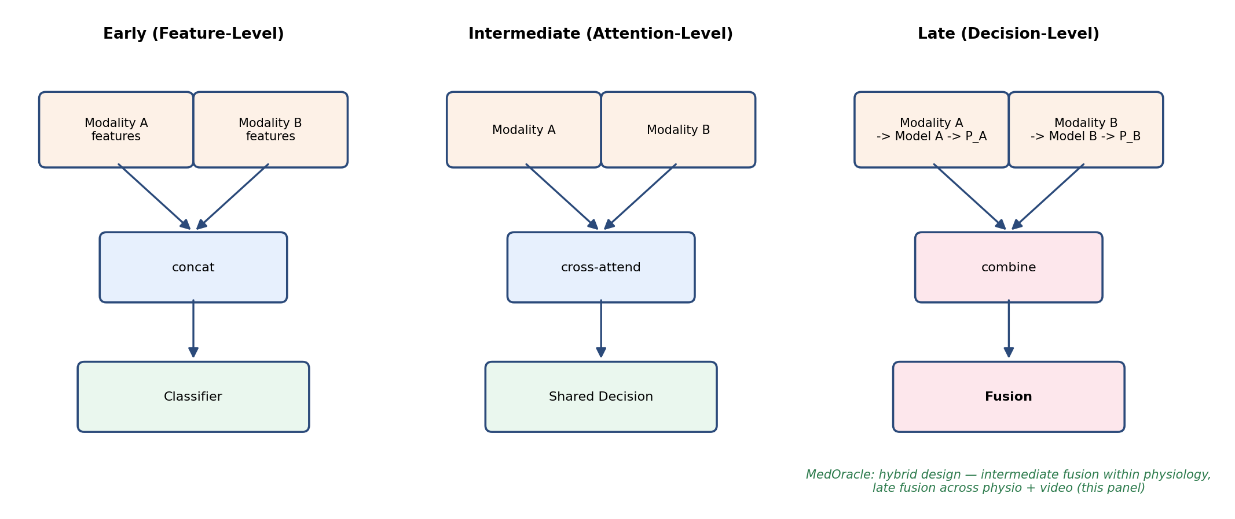
Figure 2.1: Fusion taxonomy — early, intermediate and late fusion

2.4.2 Confidence- and Quality-Aware Fusion
Static or learned-but-fixed late-fusion weights are common in the literature, but adaptive, confidence-driven weighting -- in which the contribution of each modality is adjusted at inference time according to how reliable that modality's prediction currently appears to be -- is less common, despite direct motivation from the calibration literature. Guo et al. [3] showed that modern neural networks are frequently poorly calibrated when judged by their raw softmax output, but that an entropy-based confidence measure computed over the full output distribution remains a useful, model-agnostic signal of prediction reliability even when the raw softmax values themselves are not directly trustworthy as probabilities -- the basis of this project's own confidence term (Chapter 5). Separately, signal-quality-aware weighting, in which a modality's fusion weight is penalised according to an independently measured quality metric (blur, missing data, artefact) rather than the model's own confidence, has precedent in the image-quality literature: the Laplacian-variance sharpness metric this project uses for video-quality grading (Chapter 5) originates with Pech-Pacheco et al. [9]. This project's gated fusion design combines both signals -- entropy-based confidence and an independently measured quality grade -- multiplicatively, on the basis that a modality can be quality-degraded without necessarily producing an obviously low-confidence output, and vice versa, so relying on either signal alone would leave a gap the other is needed to close.
Table 2.2: Summary of related multimodal emotion-recognition approaches
Approach | Fusion level | Subject-independent evaluation | Adapts to per-input signal quality
Early/feature-level fusion (general survey pattern [1, 10]) | Early | Not typically emphasised | No
Static-weight late fusion (general survey pattern [1, 10]) | Late | Not typically emphasised | No
EEG + peripheral physiological signals [12] | Early/feature-level | Not the primary reported protocol | No
Video-only recognition [13] | Single-modality | Partially | N/A
MedOracle (this project) | Hybrid: intermediate (within physiology) + late (across modalities), confidence- and quality-gated | Yes (physiological module evaluated under LOSO; video module under actor-independent cross-validation) | Yes

2.5 Explainable AI for Emotion Recognition
Explainability has become a practical requirement in affective-computing systems intended for mental-health-adjacent or clinician-facing use, not merely an optional visualisation layer. Survey literature on multimodal machine learning [1] emphasises that systems operating on heterogeneous, noisy sensor streams must justify their outputs if they are to be trusted outside a controlled laboratory setting; similarly, reviews of affective computing [10] note that emotion-recognition models are frequently deployed as black boxes even though their predictions can influence downstream decisions about a person's state. This section reviews how post-hoc attribution methods address that gap, why multimodal fusion introduces explainability challenges that unimodal systems do not face, and how faithfulness evaluation and trust-aware conflict explanation extend the literature beyond reporting a single predicted label.

2.5.1 Motivation: Why Explanations Matter in Emotion Recognition
A classification output alone — for example, a label of "stress" with an associated probability — answers what the system predicted but not why, how confident the system is in each input channel, or what a user should do with the result. In mental-health-adjacent contexts, these questions are not secondary. Self-report instruments suffer from recall and desirability bias (Section 1.2); an automated system that replaces self-report without explaining its reasoning merely shifts opacity from the user to the model. Explainability is therefore motivated by three concrete requirements that this project's design treats as first-class: transparency (surfacing which modality and features influenced the decision), reliability qualification (communicating when an input channel was degraded or missing), and auditability (allowing a clinician or researcher to inspect whether the system's reasoning is consistent with the prediction).
Prior unimodal work in physiological emotion recognition [12] and video-based recognition [13] typically reports accuracy or F1 score without accompanying per-instance explanations, global feature-importance rankings alone, or any account of how a fused decision would be justified when modalities disagree. MedOracle's explainability layer (Member 3, Chapters 4 and 6) is designed specifically to close that gap for a fused, quality-gated prediction rather than for either branch in isolation.

2.5.2 Post-Hoc Attribution Methods and SHAP
Post-hoc explainability methods treat the trained model as a black box and estimate, for each prediction, how much each input feature contributed to the output relative to a defined baseline. This contrasts with inherently interpretable models (linear models with explicit coefficients, decision trees with readable rules), which are often too restrictive for the deep architectures used in EEG and video emotion recognition [4, 5, 12, 13]. Among post-hoc methods, gradient-based saliency maps, layer-wise relevance propagation, and perturbation-based approaches each trade off fidelity to the model, computational cost, and human interpretability differently.
SHAP (SHapley Additive exPlanations) provides a model-agnostic, game-theoretically grounded attribution framework grounded in Shapley values from cooperative game theory: each input feature (or feature group) is treated as a "player" in a coalition game, and its attribution is the average marginal contribution it makes across all possible feature subsets, relative to a background reference distribution. Kernel SHAP approximates this attribution for arbitrary black-box predictors by sampling or enumerating feature coalitions and fitting a weighted linear model over perturbation results. The appeal of SHAP in sensitive application domains — including healthcare-adjacent settings — is that it produces a signed, per-instance, per-feature attribution that sums to the difference between the model output and the baseline expectation, rather than only a global ranking computed once over an entire dataset. That property makes it suitable for answering "why this prediction, for this person, on this trial?" rather than "which features matter on average across the training set?"

2.5.3 Explainability in Multimodal and Late-Fusion Settings
Applying SHAP in a multimodal system is not a straightforward transfer of unimodal practice. Three complications, all directly relevant to MedOracle's architecture, distinguish the multimodal case.
First, late fusion (Section 2.4.1) means the explainability layer often receives only the final prediction_output dictionary — fused probabilities, per-modality predictions, modality weights, and signal-quality grades — rather than access to the internal activations of Member 1's EEG/GSR network or Member 2's ResNet50/BiLSTM stack. A model-agnostic explainer that operates on the fusion boundary is therefore an architectural necessity when three modules are developed independently and communicate through shared interface contracts [1, 10], not merely a convenience.
Second, the natural unit of explanation in a late-fusion system is frequently the modality (physiological vs video) rather than individual EEG channels or video pixels, because the fusion mechanism combines modality-level probability vectors. MedOracle's Kernel SHAP implementation treats physiological and video branches as two primary players in a coalition game with four subsets (neither, physio-only, video-only, both), for which the two-player Shapley value admits an exact closed-form solution without Monte Carlo sampling. The physiological Shapley contribution is further decomposed into separate EEG and GSR attributions using quality-weighted splitting, reflecting the fact that Member 1's model processes both signals jointly rather than as independent fusion inputs.
Third, explanation must remain coherent under graceful degradation: when video is missing or graded "poor", the fusion weights and the meaningful feature set change. An explanation layer that assumes both modalities are always present would produce misleading attributions in exactly the deployment conditions (degraded camera, loose electrode) that quality-aware fusion is designed to handle (Section 5.6). MedOracle's explainability pipeline therefore consumes the same prediction_output schema whether zero, one, or two modalities contributed to the fused label, matching the downstream contract Member 3's web application expects.

2.5.4 Faithfulness Evaluation of Explanations
A recurring limitation of post-hoc explainability is that an attribution can appear plausible to a human reader while failing to reflect the model's actual decision logic — a distinction often described in the literature as the gap between plausibility and faithfulness. Plausible explanations use familiar feature names and reasonable narratives; faithful explanations change predictably when the inputs that supposedly drove the decision are perturbed or removed.
Faithfulness evaluation addresses this by masking or ablating input features (or modality-level inputs) and measuring whether the model output changes in the direction and magnitude the explanation predicts. A common protocol ranks features by absolute attribution, progressively replaces top-ranked features with a background baseline, and correlates the rank order of attributions with the rank order of resulting confidence drops. A high correlation indicates that the features SHAP identified as important are indeed those whose removal most reduces the model's confidence in the predicted class — a quantitative check that the explanation tracks the prediction rather than merely describing it.
MedOracle implements this principle over the fused prediction: SHAP attributions for EEG, GSR, and video are accompanied by a faithfulness score computed by progressive modality masking and correlation against confidence change (Chapter 6). Reliability flags derived from the signal_quality fields further qualify whether an explanation should be treated as trustworthy given degraded input, connecting explainability to the same quality tiers that drive fusion (Section 5.4) rather than treating explanation as independent of input reliability.

2.5.5 Modality-Conflict and Trust-Aware Explanation
Multimodal fusion introduces a failure mode that unimodal explainability never encounters: modality conflict, where the physiological branch and the video branch predict different emotion classes for the same trial. A fused system must not only resolve that conflict (via gated weighting) but also explain how it was resolved — which modality was trusted, whether trust was driven by entropy-based confidence [3] or by signal-quality penalties [9], and whether the fused label agrees with one branch, the other, or neither.
Survey patterns in multimodal affective computing [1, 10] describe fusion strategies in detail but rarely expose the internal trust reasoning at inference time. Siddharth et al. [12] and Zhang et al. [13] report classification performance for physiological and video modalities respectively without surfacing per-modality disagreement or quality-aware trust decomposition. MedOracle's modality-conflict explanation module addresses this by re-deriving the full gate trace from the prediction_output — confidence scores, quality penalty factors (α), gate scores, and L1-normalised weights — and presenting a structured account of which factor decided the outcome. It additionally supports counterfactual queries over signal quality (for example, whether the fused label would change if a degraded EEG reading had been graded "good"), making the quality-gating mechanism inspectable rather than opaque.
This trust-aware conflict explanation is complementary to SHAP attribution rather than redundant: SHAP answers which modality contributed most to the winning-class probability under a Shapley framework; the conflict explainer answers why two modalities disagreed and which calibration or quality signal the fusion rule used to break the tie.

2.5.6 From Feature Attribution to User-Facing Natural-Language Explanation
Raw SHAP values and gate traces are informative to a developer but insufficient for a non-technical end user trying to understand their emotional patterns over time. A further layer is therefore required to translate structured attribution data into plain language. Large language models (LLMs) can perform this translation, but unconstrained prompting risks hallucinated mechanisms — plausible-sounding explanations not grounded in the system's actual numbers.
MedOracle's chatbot pipeline (Chapter 6) addresses this by constraining generation: the prompt includes the structured conflict numbers (per-modality predictions, fusion weights, signal-quality grades, counterfactual outcomes) together with retrieved facts from a curated knowledge base, and the generated text is scored against the underlying mathematics before being returned. If the explanation fails a faithfulness threshold, the system regenerates with corrective feedback or falls back to a template rationale that is guaranteed consistent with the gate trace. This closed-loop design treats natural-language explanation as a verified output rather than an uncontrolled narrative, though its clinical usefulness to end users remains an open question pending formal user study (Section 7.7).
The web application surfaces these explanations through an emotion-trend chart, a SHAP bar chart, a session-history panel, and the modality-conflict explanation panel described above — each rendering the same underlying shap_output dictionary so that visual and textual explanations remain consistent regardless of whether the user invoked video-only or full multimodal prediction.

2.5.7 Challenges in Explainable Multimodal Emotion Recognition
Several challenges remain open in this area and constrain how strongly explainability claims can be stated. Explanation under weak modalities: when the physiological branch performs near chance under LOSO (Section 7.2), SHAP can faithfully attribute a fused prediction to the video modality, but the overall system may still be unsuitable for physiology-driven conclusions — explainability clarifies the reasoning without correcting poor unimodal accuracy. Faithfulness is necessary but not sufficient: a high faithfulness score validates that attributions track perturbation behaviour; it does not establish that users understand or act appropriately on the explanation. LLM-generated text requires ongoing verification: even with grounding and retry logic, template fallback rates and hallucination metrics should be monitored in deployment. Regulatory and ethical framing: explainability supports transparency but does not, on its own, satisfy clinical safety or fairness requirements — a point this project acknowledges by scoping the system as a research prototype (Section 1.3.1).
Table 2.3: Comparison of explainability support in related emotion-recognition approaches
Approach | Per-instance attribution | Multimodal-aware | Faithfulness metric | Conflict / trust explanation | User-facing NL explanation
Physiological DEAP work [12] | Not typically reported | N/A (single modality) | No | N/A | No
Video recognition [13] | Not typically reported | N/A (single modality) | No | N/A | No
General multimodal surveys [1, 10] | Discussed as desideratum | Fusion-level discussed | Not standardised | Not emphasised | Not emphasised
MedOracle (this project) | Yes (Kernel SHAP: EEG, GSR, video) | Yes (late-fusion coalition) | Yes (perturbation correlation) | Yes (gate trace + counterfactuals) | Yes (grounded LLM + template fallback)

Table 2.3 summarises the explainability gap MedOracle targets relative to the unimodal baselines and general survey patterns cited elsewhere in this chapter. The next section synthesises this gap together with the fusion and evaluation gaps reviewed in Sections 2.2–2.4 into the project's overall research positioning.

2.6 Research Gap and Positioning
Synthesizing the literature reviewed above, four gaps motivate MedOracle's specific design choices and map directly to the research questions stated in Section 1.4.3:
Gap 1 — Static fusion under real-world input variability. Survey literature [1, 10] documents extensive multimodal fusion work, but most reported systems assume all modalities are present and combine them with fixed or learned-but-static weights that do not adapt when a sensor is degraded or absent. MedOracle's gated fusion (Section 5.6) addresses RQ2 by combining entropy-based confidence [3] with independently measured signal quality [9] at every prediction.
Gap 2 — Subject-independent evaluation of physiological emotion recognition. High accuracy figures on DEAP [6] and comparable datasets [12] are frequently obtained under within-subject or random-split protocols that allow subject leakage; honest LOSO evaluation of fine-grained discrete emotion recognition is reported far less often and typically yields substantially lower performance. MedOracle addresses RQ3 by adopting LOSO as its headline physiological protocol and diagnosing the resulting limitation rather than concealing it (Section 7.2).
Gap 3 — Cross-dataset multimodal evaluation. When no single public dataset provides every modality from the same subjects — as is the case for DEAP and CREMA-D [2] — joint training and naïve hold-out evaluation are architecturally impossible. Late fusion with a principled cross-dataset pairing methodology [1, 10] is the standard response; MedOracle implements this explicitly for both the ablation study and the web-application demonstration set (Section 6.3.4), addressing RQ1.
Gap 4 — Explainability beyond a single label. Prior work on video [13] and physiological [12] emotion recognition typically reports classification accuracy without surfacing which modality drove a fused decision, how reliable each input was judged to be, or how modality disagreement was resolved. General multimodal surveys [1, 10] discuss explainability as a desideratum but do not standardise faithfulness evaluation or trust-aware conflict explanation at the fusion boundary. MedOracle addresses RQ4 through Kernel SHAP attribution over EEG, GSR, and video; perturbation-based faithfulness scoring; gate-trace conflict explanation with quality counterfactuals; and a web application that renders these outputs alongside grounded natural-language summaries (Sections 2.5 and 6.4).
Table 2.2 situates MedOracle against the fusion and evaluation gaps; Table 2.3 extends that comparison to explainability. Taken together, MedOracle is, within the cited literature, the only approach in these comparisons that simultaneously adopts subject-independent unimodal evaluation, quality- and confidence-aware late fusion, and post-hoc multimodal explainability with faithfulness verification and conflict explanation.

2.7 Summary
This chapter reviewed the datasets, feature representations, classification approaches, fusion strategies, and explainability methods relevant to physiological, video-based and multimodal emotion recognition. Three recurring themes proved directly consequential to this project's design: the gap between within-subject and subject-independent evaluation of physiological emotion recognition; the relative scarcity of fusion mechanisms that adapt to per-input signal quality rather than relying on fixed or purely confidence-based weighting; and the absence, in much of the cited unimodal and survey literature, of per-instance multimodal attribution with faithfulness verification and trust-aware conflict explanation. Section 2.6 mapped these themes to explicit research gaps that MedOracle's design addresses. The next chapter describes the technologies adopted to implement the system that this project's design responds to these findings with.
Chapter 3

Technology Adapted

3.1 Introduction
This chapter describes the development tools, programming languages, libraries, dependency management, and version-control practices used to implement MedOracle. Rather than presenting a bare technology inventory, each choice is explained in terms of the engineering constraint it addressed — GPU availability, module independence, asynchronous I/O, cross-session training limits, or the need to run the same codebase against SQLite in development and PostgreSQL in production.

3.2 Development Tools and IDEs
Kaggle Notebooks were used for all GPU-accelerated training: both the video model's ResNet50+BiLSTM training and the physiological model's 32-fold Leave-One-Subject-Out training required more compute than was available locally, and Kaggle's free GPU tier made this feasible. Kaggle sessions are capped at 12 hours, which is shorter than a full 32-fold LOSO training run or a multi-epoch video training run; this constraint directly shaped the implementation (Chapter 6), which persists model checkpoints across sessions and automatically resumes training from the last completed fold or epoch rather than assuming a single uninterrupted session.
Visual Studio Code was used as the primary IDE across all three modules' backend, frontend and model-development code, chosen for its strong Python and JavaScript tooling within a single environment, which suited a project where the same codebase spans PyTorch model code, a FastAPI backend, and a React frontend.
Claude Code (a command-line AI coding assistant) was used throughout the project as an iterative pair-programming aid — for debugging the video model's training instability, for scripting and running the evaluation and ablation study described in Chapter 7, and for the system-integration work that composes the three modules' independently-developed code into a single working pipeline.

3.3 Programming Languages
Python was used for all machine-learning, signal-processing and backend development, chosen for the maturity of its deep-learning ecosystem (PyTorch, scikit-learn, SciPy) and because all three team members' modules — physiological modelling, video modelling, and the FastAPI backend — could share a single language and a common shared package (Chapter 5) for the interface contracts and label taxonomy that tie the modules together. JavaScript, with React and JSX, was used for the frontend web application, where its component model suited the dashboard's multiple independent but data-linked panels (session history, SHAP chart, emotion trend, chat).

3.4 Shared Foundation and Dependency Management
All three modules depend on a common shared/ package (label_harmonization.py, data_contracts.py) and a shared NumPy/SciPy foundation (requirements_shared.txt). Member-specific dependencies are split into three requirement files — requirements_m1.txt, requirements_m2.txt, and requirements_m3.txt — so each member can install only what their module needs while still passing the shared interface-contract tests in tests/. System integration installs the union of all three files plus the shared base.
This split was deliberate: Member 1's DEAP preprocessing stack (MNE, pyedflib, h5py) is not required to run Member 3's FastAPI server, and Member 2's Ultralytics YOLO dependency is not required to execute Member 1's LOSO training script. Keeping dependencies module-scoped reduced environment conflicts during parallel development and made it possible to validate each module's contract compliance independently before full pipeline integration (Chapter 6).

3.4.1 Member 1 — Physiological Signal Processing and Deep Learning
PyTorch was used to implement the bidirectional cross-modal attention network, chosen for flexibility in defining custom attention layers and for interactive debugging during the LOSO diagnostic work (Chapter 7). scikit-learn supplied the SVM, Random Forest, and MLP baselines, class-weight utilities, and cross-validation helpers (GroupKFold, stratified splitting) used for the 32-fold Leave-One-Subject-Out protocol. SciPy provided Welch power spectral density estimation for the Differential Entropy features compared in Section 7.2.
DEAP-specific preprocessing used MNE for EEG bandpass filtering and referencing, pyedflib and h5py/mat73 for reading the dataset's native file formats, and pandas for tabular handling of trial metadata and label mappings. These libraries were chosen because DEAP's release formats (.dat pickles, HDF5 .mat exports, and legacy MATLAB structures) are not handled uniformly by a single reader; isolating format-specific loading in deap_loader.py kept the training code independent of how the raw files were obtained.

3.4.2 Member 2 — Video Processing, Deep Learning and Evaluation
PyTorch and torchvision provided the pretrained ResNet50 backbone for partial fine-tuning (Chapter 6). Ultralytics YOLOv8 was used for face detection — during early data preparation and, in the shipped system, exclusively for video signal-quality grading (Chapter 5), not for cropping the recognition model's input. OpenCV and Pillow handled frame decoding, resizing, and augmentation (including cutout). pandas and NumPy supported dataset indexing, actor-grouped splits, and construction of the cross-dataset synchronised evaluation set (Chapter 6).
SciPy's Wilcoxon signed-rank test was reused — via a small shared utility — to assess statistical significance in the C1–C8 ablation study (Chapter 7). pytest was used for fusion and pipeline unit tests (18 parametrized fusion tests against Member 3's reference implementation).

3.4.3 Member 3 — Explainability and Web Application
Custom Shapley attribution (kernel_shap.py). The production explainability path implements a closed-form two-modality Shapley explainer over the fused prediction_output — enumerating all four physio/video coalitions exactly, then splitting the physiological Shapley value into EEG and GSR contributions using quality-weighted attribution. This custom implementation was chosen because late fusion exposes a fixed, known combining function at the module boundary; exact Shapley values can therefore be computed without Monte Carlo sampling and without importing either Member 1's or Member 2's model internals. The shap Python package is listed in requirements_m3.txt for compatibility with exploratory attribution work (attribution_engine.py), but the deployed /predict and /explain paths use the custom explainer.
FastAPI + Uvicorn. The backend uses FastAPI for async request handling, Pydantic v2 schema validation, and auto-generated OpenAPI documentation. Uvicorn serves the ASGI application in development and test environments.
Authentication and persistence. python-jose issues and verifies JWT access/refresh tokens; passlib[bcrypt] hashes passwords. SQLAlchemy 2.x (async) maps the four-table schema (users, sessions, shap_logs, chat_history) with aiosqlite for development and psycopg2-binary for PostgreSQL in production. Alembic supports schema migrations when moving beyond the auto-created SQLite tables used during integration testing.
LLM and chat. The chatbot uses the Anthropic client when an API key is configured; httpx supports async HTTP calls. When no key is present, a deterministic template fallback in llm_client.py keeps the system runnable offline. A separate RAG-grounded generator in llm_chatbot.py (curated knowledge base + numeric faithfulness check) is used for conflict-aware explanations.
Frontend. React (Vite scaffold), Axios, and Recharts implement the dashboard panels (emotion trend, SHAP bar chart, session history, conflict explanation, chat).
Testing. pytest and pytest-asyncio drive the in-process FastAPI HTTP tests described in Section 7.5.
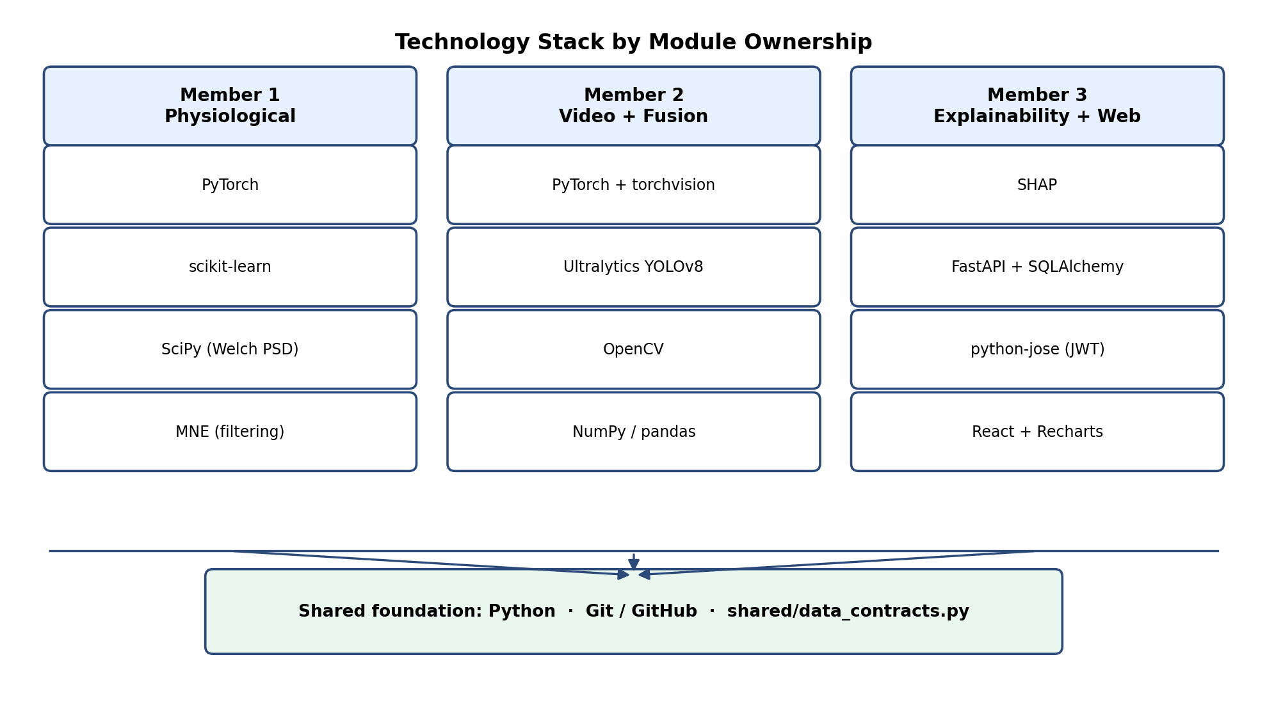
Figure 3.1: Technology stack by module ownership
Table 3.1: Primary technologies by module
Layer | Member 1 | Member 2 | Member 3 | Shared
Language | Python | Python | Python + JavaScript (React) | Python
Deep learning | PyTorch | PyTorch, torchvision | — | —
Signal / video I/O | MNE, pyedflib, h5py | OpenCV, Ultralytics YOLOv8 | — | NumPy, SciPy
ML utilities | scikit-learn | scikit-learn | — | —
Explainability | — | — | Custom Shapley (kernel_shap.py), faithfulness perturbation | —
Backend | — | — | FastAPI, Uvicorn, SQLAlchemy, python-jose, passlib | Pydantic (via FastAPI)
Database | — | — | SQLite (dev), PostgreSQL (prod) | —
Frontend | — | — | React, Vite, Axios, Recharts | —
Testing | pytest | pytest | pytest, pytest-asyncio | pytest (contract + fusion tests)
GPU training | Kaggle Notebooks | Kaggle Notebooks | — | —

3.5 Version Control System and Collaborative Workflow
Git and GitHub were used for source control. Each member developed on a feature branch scoped to their module, opening pull requests into a shared integration branch once interface-contract tests passed locally. Because the three modules communicate only through shared/data_contracts.py (Chapter 5), a member could merge preprocessing or model changes without touching the other members' packages, provided the exported dictionaries still validated.
Integration testing (tests/test_pipeline.py, tests/test_fusion.py, tests/test_label_harmonization.py) ran on the integration branch before demo deployments. The final codebase maintains 82 automated tests (59 label-harmonisation, 18 fusion, 5 pipeline), all passing at submission time — giving a regression guard across module boundaries that prose interface contracts alone would not provide.

3.6 Summary
This chapter described the tools, languages, libraries, dependency layout, and collaborative workflow used to build MedOracle, explaining why each choice matched the problem it solved — from Kaggle's 12-hour session cap shaping checkpoint-resume training, to module-scoped requirement files enabling parallel development, to a custom Shapley explainer operating on the fusion boundary rather than inside either upstream model. The next chapter describes each member's individual approach in terms of input, process, output, and evaluation.
Chapter 4

Our Approach

4.1 Introduction
This chapter describes each member's individual approach in detail, structured consistently as Input, Process, Output and Evaluation for each of the three modules, so that the three approaches can be compared directly despite operating on entirely different signal types. All three modules are bound by the shared five-class emotion taxonomy — stress, calm, happy, sad, angry — and by the interface contracts defined in shared/data_contracts.py (detailed fully in Chapter 5), which is what allows the Input/Process/Output boundary of one member's module to be developed and tested independently of how any other member implements theirs.

4.2 Member 1 — Physiological Emotion Recognition

4.2.1 Input
The module's raw input is a 4-second window of 32-channel EEG (128Hz, 512 samples per window) and single-channel GSR (originally recorded at 4Hz and resampled to 128Hz via polyphase resampling to match the EEG sampling rate), drawn from the DEAP dataset [6]. Each DEAP trial is 60 seconds long, with a 3-second baseline recording trimmed from the start before the remaining 57 seconds are slid into fifteen non-overlapping 4-second windows; every window inherits the label of its parent trial, which is itself derived from the subject's self-reported valence, arousal and dominance rating for that trial. Each window is additionally graded for signal quality — separately for EEG and GSR — against thresholds covering amplitude range, flat-line channel count and NaN ratio for EEG, and signal range, skin-conductance-response peak count and drift for GSR (Chapter 5), so that a downstream fusion decision can distinguish a genuinely poor prediction from a poor input.

4.2.2 Process
Each DEAP trial's valence, arousal and dominance rating (originally on a continuous 1-9 scale) is first mapped onto the shared five-class taxonomy using thresholds at the scale midpoint, following Russell's circumplex model [11] and Mehrabian's PAD model [8]: for example, low valence with high arousal and low dominance maps to stress, a mapping consistent with Kreibig's finding that fear-related states activate the sympathetic nervous system in a manner comparable to stress [7], which is separately relevant to how Member 2's CREMA-D fear label is harmonised into the same taxonomy (Chapter 5).
The EEG window is passed through a dedicated encoder: a depthwise temporal convolution (kernel size 25, corresponding to roughly 200 milliseconds at 128Hz, chosen to capture alpha- and beta-band oscillations relevant to emotional arousal) applied independently per channel, followed by a pointwise convolution that mixes information across the 32 channels, and two further strided convolutional blocks that progressively downsample the 512-sample sequence to a 32-timestep, 128-dimensional embedding, with sinusoidal positional encoding added before the next stage. The GSR window is passed through an analogous, single-channel convolutional encoder producing a comparably-shaped embedding. The two embeddings are then passed into a bidirectional cross-modal attention layer, in which the EEG sequence attends over the GSR sequence and the GSR sequence attends over the EEG sequence, before the two attended representations are pooled and concatenated and passed to a shared classification head producing a five-class softmax distribution.
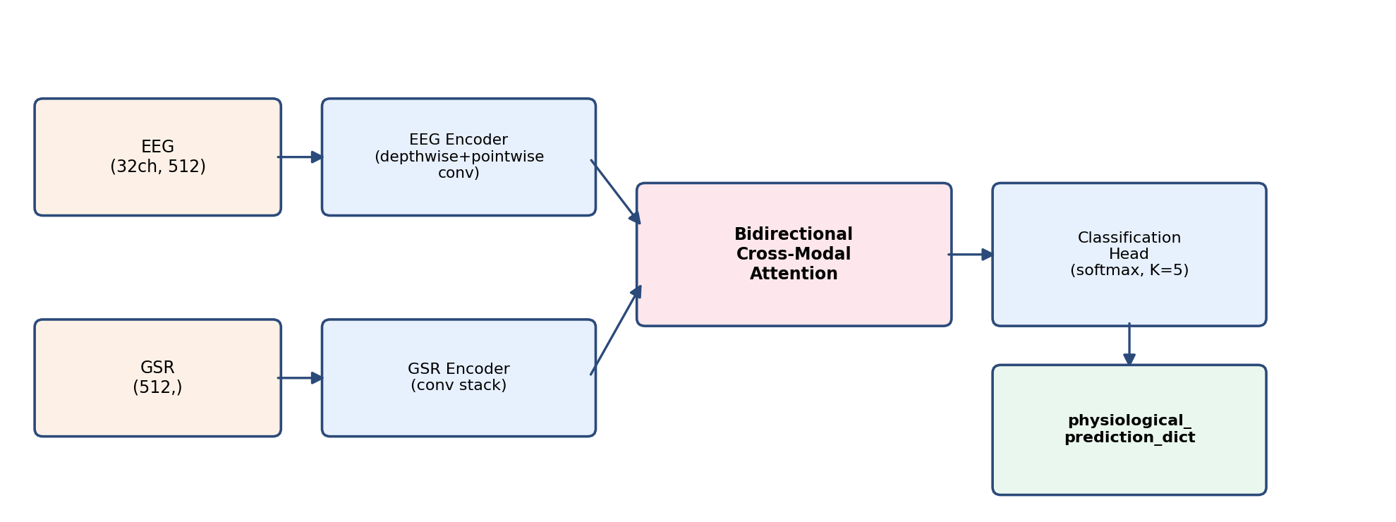
Figure 4.1: Member 1 physiological emotion recognition pipeline
Training and evaluation were carried out under two distinct protocols, deliberately kept separate throughout this project.The full evaluation protocol is Leave-One-Subject-Out (LOSO) cross-validation across all 32 DEAP subjects: in each of the 32 folds, one subject is held out entirely and the model is trained from scratch on the remaining 31, so that no window from the held-out subject's data — and, because each subject's trials are unique to them, no near-duplicate window either — is ever seen during that fold's training.

4.2.3 Output
The module exposes a single function, PhysiologicalPredictor.predict(eeg, gsr), returning a physiological_prediction_dict containing four fields: predicted_emotion (one of the five shared class labels), confidence (an entropy-based score in [0, 1], computed identically to the confidence term used in Member 2's fusion mechanism, so that both modalities' confidence is directly comparable), class_probabilities (the full five-class softmax distribution), and signal_quality (a nested dictionary with independent "good"/"degraded"/"poor" grades for the EEG and GSR inputs). This dictionary is validated against the shared interface contract before being passed to Member 2's fusion module (Chapter 5), so a malformed or out-of-range value is rejected at the module boundary rather than silently propagating downstream.

4.2.4 Evaluation
Under the honest, subject-independent LOSO protocol, the same architecture achieves a macro-F1 of 0.179 ± 0.041 across the 32 folds, and a "model soup" formed by averaging all 32 fold checkpoints together performs almost identically (macro-F1 0.179), indicating this is a stable ceiling rather than fold-specific noise. Three classical baselines — SVM, Random Forest and a Multi-Layer Perceptron, each trained on a 165-dimensional hand-crafted feature vector — were evaluated under the identical LOSO protocol specifically to determine whether this ceiling reflected a limitation of the neural architecture or of the underlying data; all three converged to a comparable macro-F1 range. The gap between the two protocols, and the diagnostic experiments undertaken to explain the LOSO result — comparing feature representations, auditing GSR data quality, and quantifying the effect of coarser label taxonomies — are presented in full in Section 7.2, together with this project's position on why the honest, lower figure is the one reported as the module's true performance.

4.3 Member 2 — Video-Based Emotion Recognition and Multimodal Fusion

4.3.1 Input
The video module's raw input is a short video clip from the CREMA-D dataset [2] (with RAVDESS clips additionally used during model development to increase training diversity), each labelled with one of six original emotion categories, five of which — anger, happy, sad, fear (harmonised to stress), and neutral (harmonised to calm) — map onto the shared five-class taxonomy, with disgust dropped as having no clean correspondence (Chapter 5). Sixteen frames are sampled uniformly across each clip to represent its temporal span within a single forward pass of the recognition network.

4.3.2 Process
Member 2's contribution has three parts: the video recognition model itself, the gated fusion mechanism that combines its output with Member 1's, and the full pipeline and evaluation methodology that ties the whole system together.
For video recognition, the sixteen sampled frames are resized directly to 224×224 pixels without cropping to a detected face region — a deliberate choice following a controlled comparison made during development, in which cropping to a YOLOv8-detected face region was found to reduce held-out macro-F1 from approximately 0.70 to 0.56, likely because cropping discards contextual cues (head pose, shoulder movement) that the temporal model otherwise exploits. YOLOv8 face detection is retained in the pipeline, but is used exclusively to grade video signal quality — face-detection rate, Laplacian-variance sharpness [9], and face bounding-box area — rather than to crop the recognition input. The resized frames are passed through a ResNet50 [4] backbone, partially fine-tuned: the first two residual blocks are frozen to retain general low-level features learned from large-scale image pretraining, while the later two blocks and a replaced classification head are fine-tuned using a discriminative learning rate (1e-5 for the fine-tuned backbone layers, 5e-4 for the new head), a configuration adopted after an initial fully-frozen-backbone configuration underfit (train and validation macro-F1 both approximately 0.30) and a fully-unfrozen configuration overfit (train macro-F1 0.88 against validation 0.63). The resulting per-frame feature sequence is passed to a two-layer bidirectional LSTM [5] (256 hidden units per direction, inter-layer dropout 0.3) before a final softmax layer produces a five-class prediction. Training used actor-independent StratifiedGroupKFold cross-validation (ensuring no actor's clips appear in both a training and validation fold), cosine-annealed learning-rate scheduling with warmup, cutout augmentation applied to input frames, and frozen batch-normalisation statistics, and was conducted across multiple Kaggle training sessions with automatic checkpoint persistence and resume between sessions.
For fusion, each modality's prediction is combined using a quality-aware gated mechanism (the full mathematical formulation is presented in Chapter 5): an entropy-based confidence score is computed for each modality's output distribution, multiplied by a signal-quality penalty (1.0 for "good", 0.5 for "degraded", 0.1 for "poor"), and the resulting per-modality gate scores are L1-normalised into fusion weights, rather than passed through a softmax, which would compress large confidence gaps. The implementation (fusion.py) was validated against an independent reference fusion function that Member 3 had implemented earlier for a different purpose, using a parametrised unit test that asserts both implementations produce numerically identical modality weights and fused probabilities (within 1e-9 absolute tolerance) across every combination of signal-quality grade for both modalities.
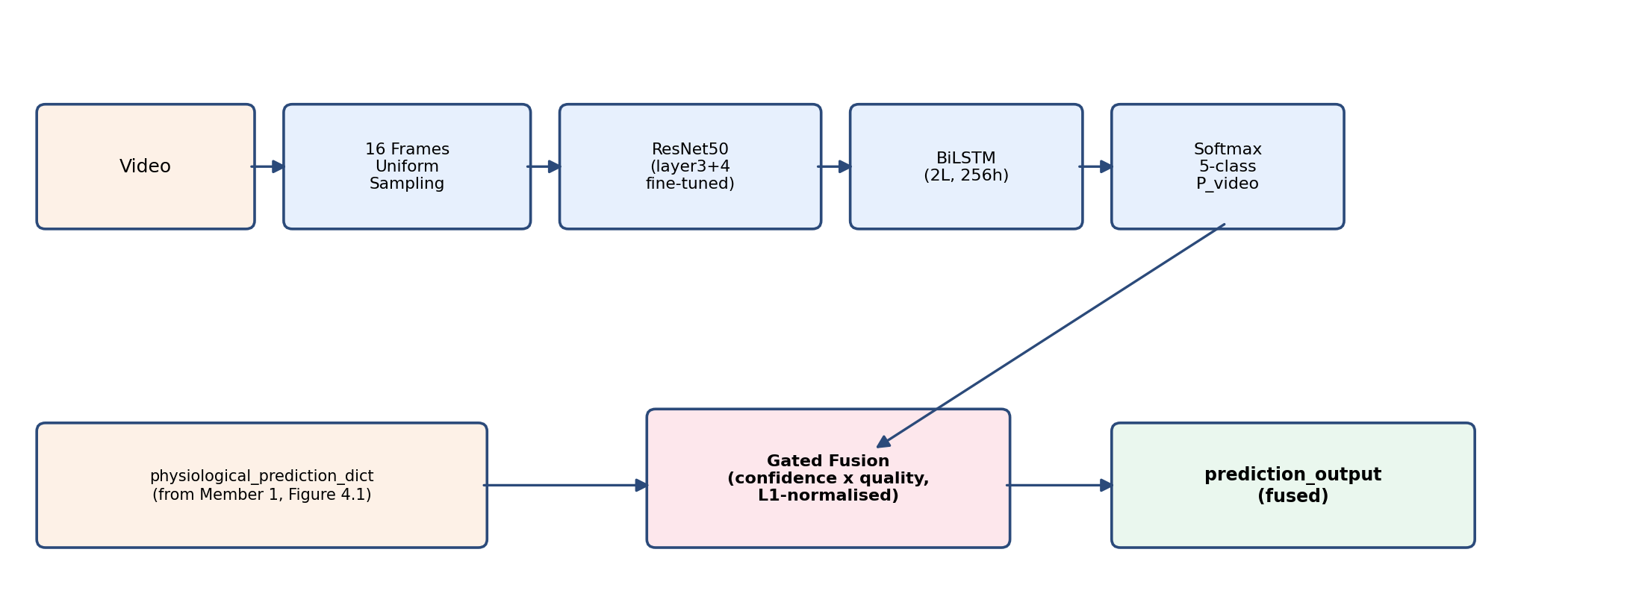
Figure 4.2: Member 2 video recognition and gated fusion pipeline
For the full pipeline and evaluation, run_full_pipeline(eeg, gsr, video_path) invokes Member 1's PhysiologicalPredictor, the video recognition model, and the gated fusion function in sequence, accepting any single modality alone (in which case the missing modality's weight is driven to zero by the fusion formula rather than requiring a separate code path). Because DEAP and CREMA-D share no subjects, a cross-dataset evaluation set was constructed by pairing, for each emotion class, a real DEAP physiological window with a real CREMA-D video clip carrying the same label — the standard methodology for evaluating cross-dataset late fusion [1, 10] — and this construction underlies both the web-application demonstration dataset and the eight-condition ablation study (C1-C8) with Wilcoxon significance testing presented in Chapter 7.

4.3.3 Output
The video model alone produces a video prediction_dict (predicted_emotion, confidence, class_probabilities), matching Member 1's output schema so the two can be compared and combined directly. Once fused, the pipeline produces a complete prediction_output dictionary containing the fused predicted_emotion and confidence, the fused class_probabilities, modality_weights (the physio/video split computed by the gating formula), signal_quality grades for all three raw signals (EEG, GSR, video), and per_modality_predictions (the raw, pre-fusion output from each modality), matching the M2→M3 interface contract detailed in Chapter 5.

4.3.4 Evaluation
The video model achieves a 5-fold cross-validation macro-F1 of 0.6433 ± 0.0303, and a held-out test macro-F1 of 0.6486 ± 0.0154 across 788 clips from 11 actors entirely unseen during training or cross-validation (best single checkpoint: 0.6615), with the near-zero gap between validation and held-out test performance indicating genuine generalisation rather than overfitting. Per-class performance on the held-out test set ranges from 0.82 (happy, the strongest class) to 0.54 (sad, the weakest, most often confused with stress). The complete fused system was evaluated through the eight-condition ablation study: the full gated-fusion method (C5) significantly outperforms both the physio-only (C1, Wilcoxon p = 8.9×10⁻¹⁶) and video-only (C2, p = 5.5×10⁻¹⁰) baselines, and correctly degrades to the physio-only prediction (C7) when video is unavailable, though it does not significantly outperform naive equal-weight fusion (C3) for reasons diagnosed in Section 7.4 and connected directly to Member 1's LOSO evaluation result. Full results, the confusion-matrix analysis, and the honest interpretation of the C3 comparison are presented in Section 7.4.

4.4 Member 3 — Explainability and Web Application

4.4.1 Input
The module's input is the fused prediction_output dictionary produced by Member 2's pipeline, together with user authentication credentials for the web application and, for the chat feature, free-text queries a user submits about a specific prediction.

4.4.2 Process
Member 3's process has three layers: Shapley attribution over the fused prediction, trust-aware conflict explanation when modalities disagree, and web delivery through a FastAPI backend and React dashboard.
Shapley attribution and faithfulness. A custom two-modality Shapley explainer (kernel_shap.py) treats physiological and video branches as players in a four-coalition game (neither, physio-only, video-only, both). Because only two modalities fuse at the decision level, Shapley values are computed in closed form — no sampling — over the known gated-fusion function applied to each coalition's probability inputs. The physiological Shapley contribution is split into separate EEG and GSR attributions using quality-weighted decomposition, reflecting Member 1's joint processing of both signals. A faithfulness score (faithfulness.py) then masks modalities in order of |SHAP| magnitude and correlates attribution rank with confidence drop, quantifying whether the explanation tracks the prediction (Section 2.5.4).
Modality-conflict explanation. When physiological and video argmax labels differ, conflict_explainer.py re-derives the full gate trace — entropy confidence [3], quality penalty α, gate scores, and L1-normalised weights — and produces a structured explanation of which modality the fused decision sided with and why. Counterfactuals over signal-quality tiers (for example, "if EEG quality were good rather than degraded, would the fused label change?") make the fusion rule inspectable without opening Member 2's model weights. This layer operates purely on the prediction_output dictionary and shared gate arithmetic, so it runs even when upstream models are loaded lazily or replaced.
Backend. A FastAPI application exposes prediction, explainability, session history, chat, dashboard, and conflict routes. Table 4.1 summarises the primary endpoints a user or integrator interacts with; additional routes (/predict/synthetic, /auth/refresh, /health, conflict-specific paths) support development, token renewal, and conflict-only workflows without changing the core contract.
Table 4.1: Primary FastAPI endpoints (Member 3 backend)
Method | Path | Purpose
POST | /auth/register | User registration
POST | /auth/login | JWT access + refresh token issue
POST | /predict/multimodal | Video + optional EEG/GSR upload → fused prediction + SHAP
POST | /predict/video | Video-only prediction
GET | /explain/{session_id} | SHAP explanation for a stored session
GET | /sessions | List user sessions
GET | /sessions/{session_id} | Session detail
POST | /chat | LLM chatbot message (SHAP-grounded)
GET | /chat/history/{session_id} | Chat history for a session
GET | /dashboard/summary | Aggregated dashboard statistics

The /predict/multimodal route validates uploaded EEG arrays against shape (32, 512) and GSR against (512,); malformed shapes return HTTP 422. When EEG/GSR are omitted, the same pipeline executes video-only fusion so Member 3's explainability code path stays identical regardless of which modalities were present.
Frontend. A React dashboard renders an emotion-trend line chart, a SHAP bar chart, a session-history panel, a chatbot panel, and the modality-conflict explanation panel — Member 3's novel contribution — which surfaces gate-trace reasoning when branches disagree. EEG/GSR file inputs and a "Run Multimodal Fusion" action were added during system integration (Chapter 6) alongside the pre-existing video-only upload path.
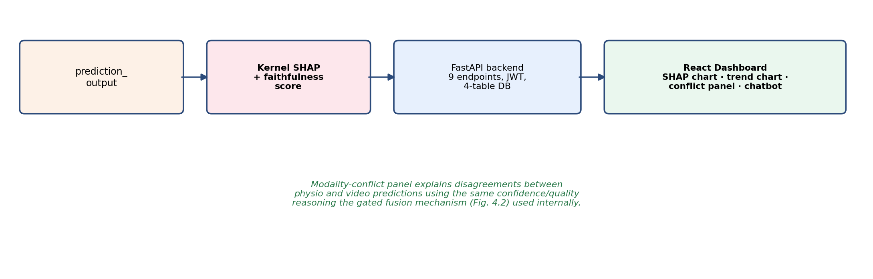Figure 4.3: Member 3 explainability and web application architecture

4.4.3 Output
The module's output is a shap_output dictionary — the prediction_output enriched with shap_values, feature_names, faithfulness_score and reliability_flags — persisted to the database and rendered in the dashboard, together with natural-language chat responses returned from the LLM-backed chat endpoint.

4.4.4 Evaluation
The web application was evaluated through a full in-process HTTP test using FastAPI's test client against an isolated test database: user registration and login, a /predict/multimodal request with a real video file and real EEG/GSR windows (returning HTTP 200 with a genuinely fused prediction — both modality weights strictly positive — and a populated SHAP explanation), a video-only request (correctly falling back to video-only weighting), and a request with a malformed EEG array shape (correctly rejected with HTTP 422 and a descriptive error message). The React frontend was verified to build without errors and to expose the EEG/GSR upload controls and the "Run Multimodal Fusion" action introduced alongside the pre-existing video-only path. Full results are presented in Section 7.5.

4.5 Summary
This chapter described each member's individual contribution in full technical detail, following a consistent Input/Process/Output/Evaluation structure: Member 1's bidirectional cross-modal attention network over EEG and GSR, evaluated honestly under both a random-split and a subject-independent LOSO protocol; Member 2's ResNet50+BiLSTM video model and the gated fusion mechanism, pipeline and ablation methodology that combine it with Member 1's output; and Member 3's SHAP-based explainability layer and web application, including its novel modality-conflict explanation feature. The next chapter presents the system's analysis and design — the shared taxonomy, interface contracts, signal-quality thresholds and fusion formulation — that make these three independently-developed approaches compose into a single system.

Chapter 5

Analysis and Design

5.1 Introduction
This chapter presents the analysis and design decisions that allow three independently-developed modules to compose into a single working system. Because the project's three members needed to work in parallel — physiological modelling, video modelling, and web-application development each require substantially different expertise and iteration cycles — the central design problem this chapter addresses is not any single algorithm, but how to define boundaries between modules precise enough that each member could build, test and change their own module without needing to coordinate on every internal detail with the other two. This chapter covers the shared emotion taxonomy, the signal-quality grading scheme, the interface contracts between modules, and the design of the gated fusion mechanism itself, explaining not only what was chosen but, where relevant, what alternative was considered and rejected and why.

5.2 System Architecture
Figure 5.1 shows the data flow between modules together with the exact dictionaries exchanged at each boundary. Member 1 and Member 2 each expose a pure function — predict(eeg, gsr) and predict_video(video_path) respectively — that can be called and tested independently of the rest of the system; Member 2's gated-fusion function accepts either or both outputs and always returns a dictionary satisfying the same downstream contract, so Member 3's explainability layer and web application never need to know whether zero, one, or two modalities were actually available for a given prediction. This is a deliberate consequence of adopting a late (decision-level) fusion architecture at the system level [1, 10] rather than an early or feature-level one: because DEAP and CREMA-D share no subjects, an early-fusion architecture that concatenates raw features from both modalities before a single joint classifier would have no valid training data to learn from in the first place, so late fusion is not merely a design preference here but an architectural necessity forced by the data itself (a point discussed further in Section 5.6).

Figure 5.1: Data flow and interface contracts between Member 1, Member 2 and Member 3
Each arrow in Figure 5.1 corresponds to a validated dictionary boundary rather than an informal function call: every dictionary crossing a module boundary is checked, using shared assertion-based validation helpers, against the exact schema described in Section 5.5 before it is allowed to proceed downstream. This was a deliberate choice over simply trusting each member's output: because the three modules are developed on separate branches and merged periodically (Chapter 3), a malformed dictionary — a missing key, a probability distribution that does not sum to one, an out-of-range confidence value — is far more useful to catch immediately at the point where one member's code hands off to another's than to discover later as a confusing downstream symptom in the web application.

5.3 Shared Emotion Taxonomy and Label Harmonization

5.3.1 Why a Shared Taxonomy Is Necessary
All three modules are required to use exactly the same five discrete emotion classes — stress, calm, happy, sad, angry — defined once in a shared module (shared/label_harmonization.py) and imported everywhere else, rather than each member defining their own labels and translating between them at the boundary. This requirement is stronger than it may first appear: the gated fusion mechanism (Section 5.6) combines the two modalities' probability distributions by direct weighted summation, which is only meaningful if index k in one modality's distribution and index k in the other's refer to the same emotion; and Member 3's SHAP-based attribution over the fused prediction likewise depends on a stable, shared class ordering to attribute a change in the fused output back to a specific class consistently across modalities. A per-module translation layer was considered and rejected early in the project specifically because it would have made it possible for the two modalities to silently disagree about what a given class index meant, a failure mode that a single shared definition eliminates by construction.

5.3.2 DEAP Valence/Arousal/Dominance Mapping
Because DEAP provides continuous valence, arousal and dominance ratings on a 1-9 scale rather than discrete emotion labels, each subject's trial must be mapped onto the shared taxonomy using threshold rules. The mapping follows Russell's circumplex model [11] and Mehrabian's PAD model [8], thresholding each dimension at the scale midpoint (5.0), with values exactly equal to 5.0 treated as falling on the high side of the threshold by convention, and a small number of valence-arousal-dominance combinations that do not correspond to any of the five classes under these rules left unclassified and excluded from training. This threshold-based approach was chosen over alternatives such as k-means clustering of the raw ratings specifically because it produces class boundaries that are interpretable and traceable to established psychological models, rather than boundaries that would need to be re-derived and re-justified if the underlying data distribution shifted.

5.3.3 CREMA-D Categorical Mapping
CREMA-D's six original discrete labels are mapped onto the shared five-class taxonomy as shown in Table 5.2. Anger, happiness and sadness map directly, since these labels already correspond one-to-one with a class in the shared taxonomy. Neutral is mapped to calm, treating the shared taxonomy's "calm" as an approximately low-arousal, pleasant-to-neutral state. Fear is mapped to stress rather than left as its own class or dropped, following Kreibig's finding that fear-related states activate the sympathetic nervous system in a manner physiologically comparable to stress [7], giving this mapping a grounding beyond surface-level label similarity. Disgust is dropped entirely — rather than force-mapped to the nearest available class — because no class in the shared taxonomy has a defensible correspondence to it; forcing a mapping here was considered and rejected as more likely to introduce label noise than to preserve useful training signal.
Table 5.2: DEAP-to-5-class and CREMA-D-to-5-class label harmonisation
Source | Mapping | Notes
DEAP | Valence≥5, Arousal<5, Dominance≥5 → calm | Russell (1980) [11]
DEAP | Valence≥5, Arousal≥5, Dominance≥5 → happy | Russell (1980) [11]
DEAP | Valence<5, Arousal≥5, Dominance<5 → stress | Mehrabian (1996) [8]
DEAP | Valence<5, Arousal<5, Dominance<5 → sad | Russell (1980) [11]
DEAP | Valence<5, Arousal≥5, Dominance≥5 → angry | Russell (1980) [11]
CREMA-D | ANG → angry, HAP → happy, SAD → sad | Direct correspondence
CREMA-D | NEU → calm | Neutral approximated as low-arousal calm
CREMA-D | FEA → stress | Kreibig (2010) [7]: fear activates sympathetic system
CREMA-D | DIS → dropped | No clean correspondence; excluded from training

5.4 Signal Quality Assessment

5.4.1 Design Rationale: Three Discrete Tiers
Each modality's input is graded into one of three quality tiers — good, degraded, poor — rather than a continuous quality score. This was a deliberate simplification: a continuous score would need to be mapped onto a fusion penalty via some chosen function in any case (Section 5.6), and a three-tier grading scheme is considerably easier to communicate to an end user in the web application's signal-quality display than a raw numeric score would be, while still giving the fusion mechanism three meaningfully distinct penalty levels to work with. The tiers are used both to report signal reliability directly to the user and, critically, to weight each modality's contribution during fusion.
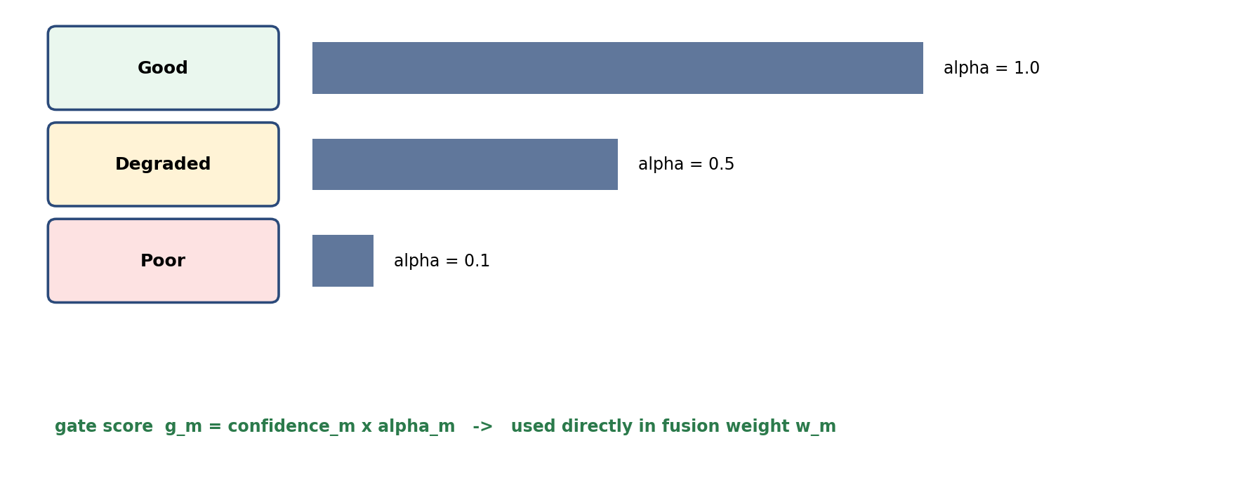
Figure 5.2: Signal-quality tiers and their effect on the fusion gate score

5.4.2 EEG and GSR Thresholds
EEG quality is graded on amplitude range, the number of flat-line channels, and the proportion of NaN samples in the window; GSR quality is graded on signal range, the number of detected skin-conductance-response peaks, and signal drift. Table 5.1 shows the exact thresholds for each tier.

5.4.3 Video Threshold Recalibration
Video quality is graded on face-detection rate, Laplacian-variance sharpness [9], and face bounding-box area. The thresholds for these last two metrics were recalibrated during this project after an initial evaluation revealed a design flaw: the originally adopted generic thresholds (Laplacian variance ≥ 100 for "good", face area ≥ 10% of frame) were drawn from document-scan sharpness literature [9] rather than from this project's own acted-video domain, and were measured to grade approximately 80% of clean, fully-detected CREMA-D frontal-face clips as merely "degraded" — a systematic miscalibration rather than a reflection of genuinely poor input. Recalibrating both thresholds to the measured distribution of the held-out CREMA-D test set (Laplacian variance ≥ 70 for "good", face area ≥ 6%) restored 73 of 80 sampled clips to a "good" grade while still correctly flagging the handful of genuinely blurred or distant-face clips in the sample, confirming the recalibration corrected a threshold-calibration error rather than simply loosening the criterion until everything passed.
Table 5.1: Signal-quality grading thresholds
Metric | Good | Degraded | Poor
EEG amplitude range | ±100 μV | ±100-150 μV | > ±150 μV
EEG flat-line channels | 0 | 1-2 | > 2
EEG NaN ratio | < 1% | 1-5% | > 5%
GSR signal range | 0.5-30 μS | 0.1-0.5 or 30-50 μS | < 0.1 or > 50 μS
GSR SCR peaks (60s) | ≥ 2 | 1 | 0
Video face-detection rate | ≥ 80% | 50-80% | < 50%
Video Laplacian variance | ≥ 70 (recalibrated) | 40-70 | < 40
Video face bounding-box area | > 6% (recalibrated) | 3-6% | < 3%
The worst-performing metric for a given modality determines its overall grade: a video clip with a high detection rate but a small, distant face is graded no better than its face-area metric permits, on the reasoning that a fusion mechanism relying on this grade should be conservative — a single badly-performing metric is enough to indicate real risk, even if the other metrics for that modality look healthy.

5.5 Interface Contracts Between Modules
Interface contracts are enforced through shared factory and validation helpers that construct the Member 1→Member 2 and Member 2→Member 3 dictionaries and raise immediately if any invariant is violated. The design principle is that a contract violation should fail loudly at the module boundary where it occurs, rather than propagate silently into a fused prediction or web response several steps downstream.
Member 1 → Member 2 (physiological_prediction_dict). Required fields: fused emotion label (one of the five shared classes); entropy-based confidence in [0, 1]; a five-class probability dictionary whose keys match the shared taxonomy exactly and whose values sum to approximately one; and nested signal-quality grades for EEG and GSR, each constrained to good, degraded, or poor.
Member 2 → Member 3 (prediction_output). Required fields: fused label, fused confidence, and fused class probabilities (same validation as above); modality weights for physiological and video branches that sum to 1.0; signal-quality grades for EEG, GSR, and video; and per-modality predictions preserving each branch's raw label, confidence, and class probabilities before fusion. This schema is intentionally rich enough for Member 3 to explain both the final decision and the pre-fusion disagreement between branches without re-invoking either upstream model.
Raw multimodal input (SynchronizedInput). When all three raw signals are supplied together, a dataclass validates fixed shapes before any model runs: EEG (32 channels × 512 samples), GSR (512 samples after resampling to the EEG rate), and video (16 frames at 224×224 RGB). This enforces the four-second trial window agreed across members (128 Hz × 4 s = 512 samples; 16 uniformly sampled frames over the same window) and prevents shape mismatches from reaching the neural networks.
The field-by-field tables for the first two contracts appear in Chapter 6 (Tables 6.1 and 6.2); the explainability enrichment contract is summarised in Section 5.5.2 below.

5.5.1 Temporal Synchronization Design
Although DEAP and CREMA-D were never recorded from the same subjects, the system assumes a four-second analysis window as the common temporal unit at inference time. This duration aligns with standard EEG epoch lengths used in affective-computing experiments and is long enough for sixteen video frames to capture expression dynamics without averaging away temporal structure.
Within that window, sampling rates are harmonised as follows. EEG is natively 128 Hz (512 samples). GSR is originally recorded at a lower rate in DEAP and is resampled to 128 Hz using polyphase resampling so that each sample index aligns with the EEG timeline. Video is represented as sixteen frames sampled uniformly across the same four seconds, each resized to 224×224 pixels. The recognition model consumes full frames; face detection runs in parallel only to grade video quality (Section 5.4), not to define the recognition crop.
This design trades strict frame-level synchronisation across datasets (impossible without paired recordings) for schema-level synchronisation: at fusion time both modalities present a prediction over the same semantic window and the same five-class taxonomy, which is sufficient for late fusion even when the underlying clips originate from different corpora (Section 2.4).

5.5.2 Explainability Output Contract (Member 3)
Member 3 enriches prediction_output into shap_output for persistence and display. Beyond the fused fields already present, the explainability contract adds: signed SHAP values and absolute feature importance for EEG, GSR, and video; a faithfulness score in [0, 1]; signal-reliability flags derived from the quality grades; optional coalition values recording the fused winning-class probability under each physio/video subset (empty, physio-only, video-only, both); and a copy of per-modality predictions for audit. Storing coalition values alongside attributions allows the faithfulness metric and dashboard to verify explanations against the same fusion arithmetic used at prediction time, rather than recomputing an approximate surrogate.

5.6 Gated Fusion Design
The fusion mechanism combines each modality's prediction using an entropy-based confidence score multiplied by a signal-quality penalty, then L1-normalises the resulting per-modality weights. Formally, for modality m with predicted probability distribution P_m over K = 5 classes:
confidence: c_m = 1 − H(P_m) / log(K), where H(P_m) = −Σ_k P_m(k) log P_m(k)
This entropy-based formulation was chosen over simply using the maximum softmax probability as a confidence proxy on the basis of calibration research showing that raw softmax outputs are frequently poorly calibrated in modern neural networks, while an entropy-based measure over the full output distribution remains a useful, model-agnostic signal of how peaked — and therefore how confident — a prediction genuinely is [3].
quality penalty: α_m = 1.0 (good), 0.5 (degraded), 0.1 (poor)
gate score: g_m = c_m × α_m
The gate score is deliberately multiplicative rather than, for example, an average of confidence and quality: a modality that is confidently wrong because its input is degraded (high c_m, low α_m) should still be heavily penalised, and a multiplicative combination guarantees this, whereas an averaging combination could let a high confidence score partially compensate for poor signal quality.
fusion weight: w_m = g_m / Σ_m g_m (L1-normalised, not softmax)
L1 normalisation was chosen over a softmax specifically because softmax compresses large differences between inputs — two gate scores that differ by an order of magnitude would be pulled much closer together by a softmax than by a simple L1 normalisation, which preserves the ratio between them directly and therefore lets a genuinely much-more-reliable modality dominate the fused prediction rather than being only mildly favoured.
fused prediction: P_fused = Σ_m w_m × P_m; predicted_emotion = argmax(P_fused)
Four graceful-degradation rules are built into the design, each corresponding to a scenario the system must not simply crash or produce an undefined result under: if both modalities are available and at least one has a non-negligible gate score, full gated fusion is applied as above; if video is poor or missing, its gate score tends toward zero and the physiological prediction alone effectively determines the fused output; symmetrically, if the physiological signal is poor or missing, the video prediction alone determines the output; and if both modalities are simultaneously unreliable (both gate scores negligible), the system falls back to a uniform distribution over the five classes and explicitly flags the prediction as unreliable, on the principle that reporting an unearned confident answer in this scenario would be worse than reporting no reliable answer at all.
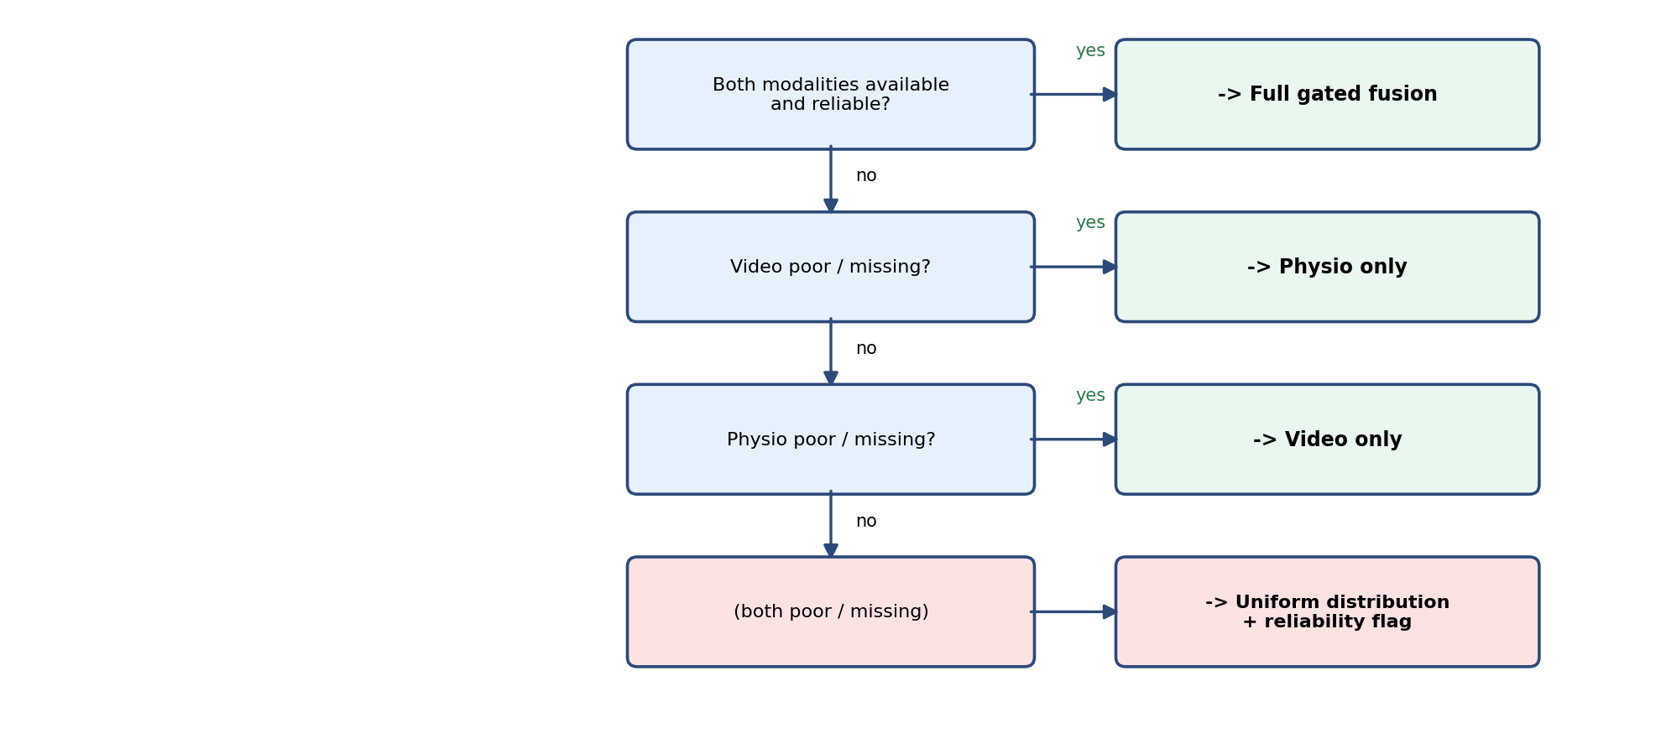
Figure 5.3: Graceful degradation decision flow

5.7 Database and Web Application Design
The web application uses a relational schema of four tables, chosen so that authentication, prediction history, explainability artefacts, and chat context remain normalised but queryable from a single session identifier.
Users store credentials (hashed password, email, display name) and anchor all per-user data through a foreign key. Sessions record one row per prediction request: timestamp, fused emotion label, fused confidence, modality weights, signal-quality JSON, and the fused class-probability vector. Separating the session row from explainability artefacts allows a prediction to be listed in session history even while SHAP computation completes, and keeps the core prediction payload small for dashboard aggregation.
SHAP logs hold a one-to-one extension of a session: attribution values, feature importance magnitudes, faithfulness score, reliability flags, coalition audit JSON, and a snapshot of per-modality predictions. Chat history stores user and assistant messages keyed to both user and session, so follow-up questions refer to the same prediction context.
Table 5.3: Database entities and primary stored fields
Entity | Primary purpose | Key stored fields
User | Authentication | email, password hash, display name
Session | Prediction record | emotion label, confidence, class probabilities, modality weights, signal quality
SHAP log | Explainability artefact | SHAP values, feature importance, faithfulness score, coalition values
Chat message | Conversational context | role (user/assistant), message text, session reference
JWT access and refresh tokens protect all routes except registration and login. Access tokens are short-lived to limit exposure if intercepted; refresh tokens allow renewal without repeating password entry. File uploads (video required; EEG and GSR optional on the multimodal route) are validated for expected array shapes before inference, returning a client error rather than a silent coercion when shapes are wrong.

5.8 Summary
This chapter presented the shared taxonomy and the reasoning behind requiring it, the signal-quality grading scheme including video-threshold recalibration, interface-contract validation and temporal synchronisation across modalities, the explainability output contract, the gated fusion design with its rejected alternatives (softmax versus L1 normalisation, additive versus multiplicative gating, early versus late fusion), and the database layout supporting predictions, SHAP artefacts, and chat history. The next chapter describes how each of these designs was implemented.
Chapter 6

Implementation

6.1 Introduction
This chapter describes the implementation of each module, following the design presented in Chapter 5. Source code is organised into three top-level packages (member1_physiological, member2_video_fusion, member3_explainability) plus a shared package (shared/) holding the taxonomy, label harmonisation and interface-contract code common to all three. Where a design decision is best illustrated by the actual code rather than by prose alone, a short representative listing is included.

6.2 Module 1 — Physiological Emotion Recognition Implementation

6.2.1 Data Loading and Preprocessing
As described in Section 2.2.2, the DEAP preprocessed release was verified against the official specification on loading — shape and PSD checks confirmed the expected 4–45 Hz bandpass and 128 Hz sampling rate — so no additional filtering step was applied before windowing
The DEAP loader (preprocessing/deap_loader.py) reads each subject's pickled .dat file, trims the first 3 seconds (384 samples) of baseline recording from each 60-second trial, and slides 15 non-overlapping 4-second (512-sample) windows across the remainder. EEG channels 0-31 and the GSR channel (index 36) are extracted per window, and the trial's valence/arousal/dominance rating is converted to one of the five shared classes via the label-harmonisation mapping described in Section 5.3. Figure 6.1 shows the resulting per-subject window counts and class distribution produced by this loader.
The GSR channel is lowpass filtered before polyphase resampling (scipy.signal.resample_poly) from 4 Hz to 128 Hz, to suppress aliasing artefacts introduced by the large upsampling ratio.
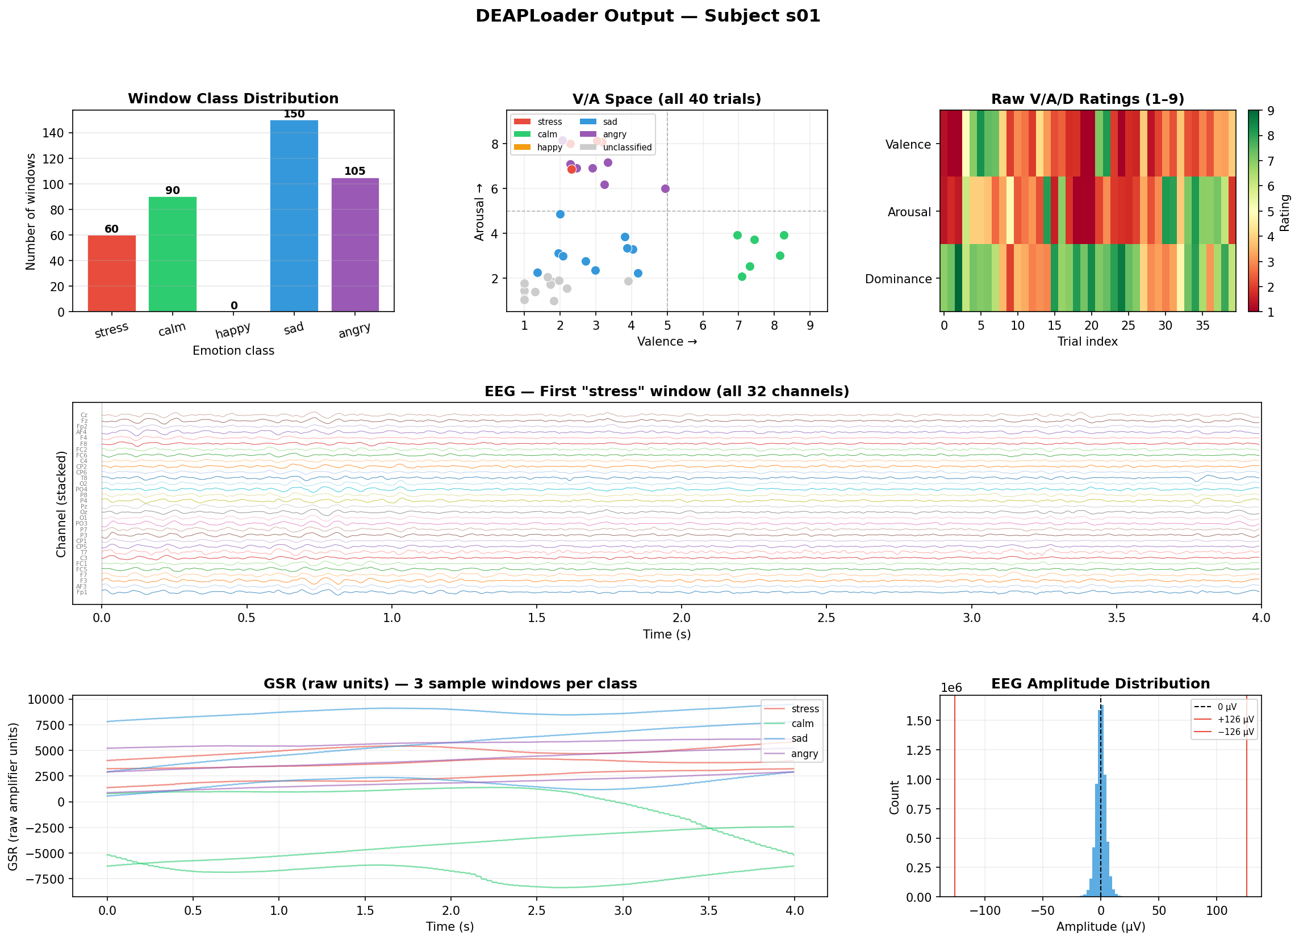
Figure 6.1: DEAP dataset structure and per-subject class distribution (preprocessing visualisation)
As Table 7.1 (Section 7.2) will show in more detail, this harmonisation produces a severely imbalanced class distribution -- most notably only 19 "happy" trials across all 32 subjects -- which later proved central to explaining the physiological module's evaluation results.

6.2.2 Signal Quality Assessment
A dedicated signal_quality module grades each EEG and GSR window against the thresholds in Table 5.1. Figure 6.2 shows example output of this grading process across a sample of windows.
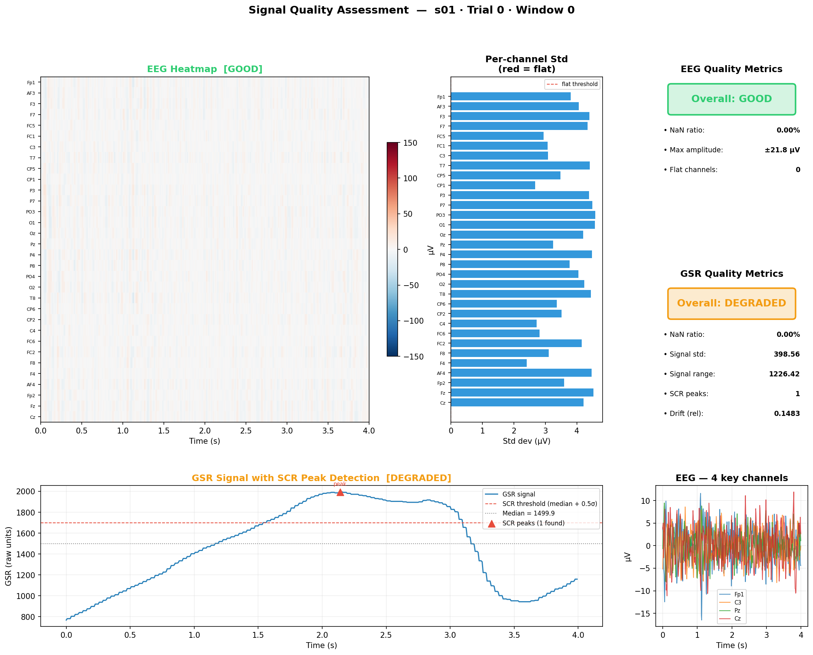
Figure 6.2: EEG / GSR / Video signal-quality grading visualisation

6.2.3 Network Architecture
The EEG encoder applies a depthwise temporal convolution (kernel size 25, approximately 200ms at 128Hz, capturing alpha/beta oscillations) followed by a pointwise convolution mixing across channels, then two further downsampling convolutional blocks reducing the 512-sample sequence to 32 timesteps at a 128-dimensional embedding, with sinusoidal positional encoding added before the attention layer. Listing 6.1 shows the depthwise/pointwise convolution pair at the heart of this encoder.
Listing 6.1: Depthwise + pointwise convolution pair in the EEG encoder
# member1_physiological/models/encoders.py — EEGEncoder (excerpt)
self.depthwise = nn.Conv1d(
in_channels=n_channels, out_channels=n_channels,
kernel_size=25, padding=12, groups=n_channels, bias=False,
)
self.pointwise = nn.Conv1d(
in_channels=n_channels, out_channels=32, kernel_size=1, bias=False,
)
The GSR encoder follows an analogous, single-channel convolutional structure. A bidirectional cross-modal attention layer then allows the EEG sequence to attend over the GSR sequence and vice versa, before the attended representations are pooled and passed to a shared five-class classification head.

6.2.4 Baseline Comparisons
Three classical baselines -- SVM, Random Forest and a Multi-Layer Perceptron, each using a 165-dimensional hand-crafted feature vector (32 channels x 5 band-power features + 5 GSR statistics) -- were implemented and evaluated under the same 32-fold Leave-One-Subject-Out protocol as the neural network, in order to establish whether the neural architecture itself, rather than the underlying data, was limiting performance. Figures 6.3-6.5 show the resulting outputs.
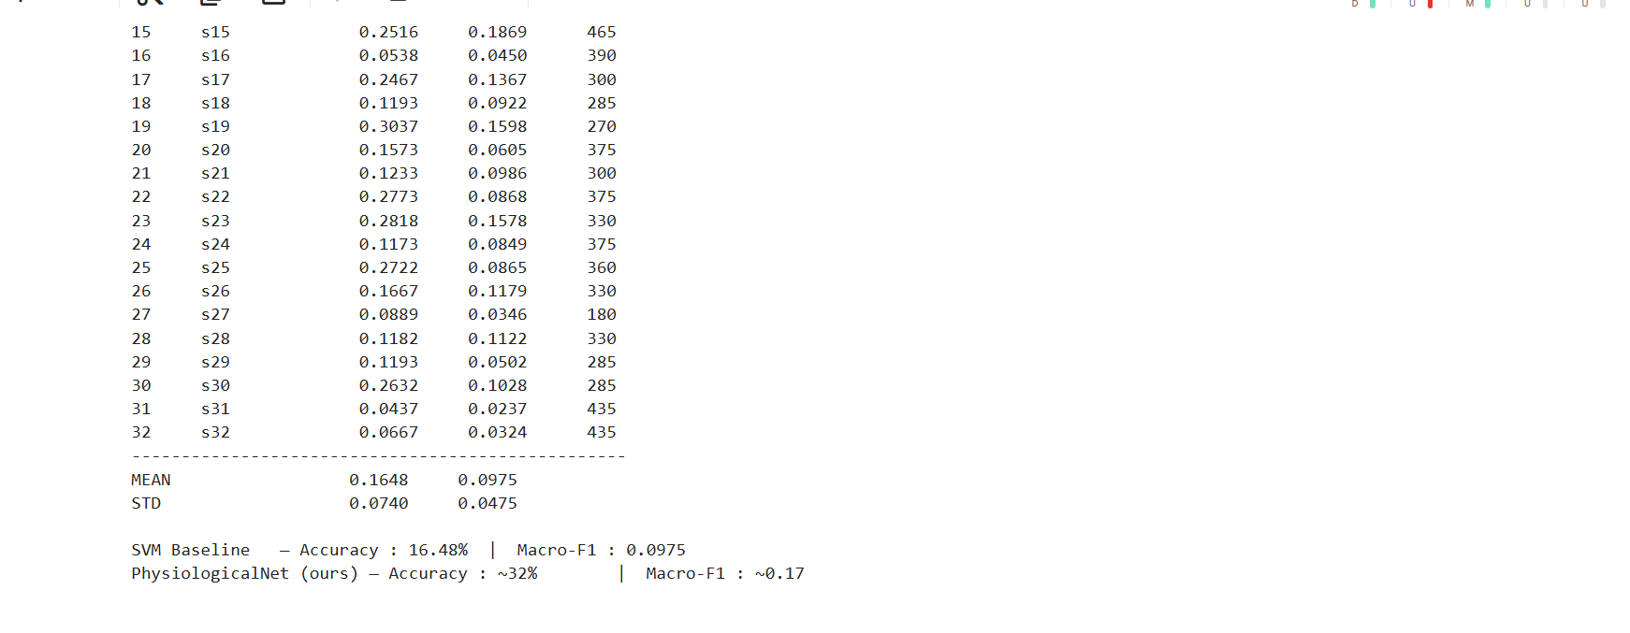
Figure 6.3: SVM baseline — subject-independent (LOSO) results
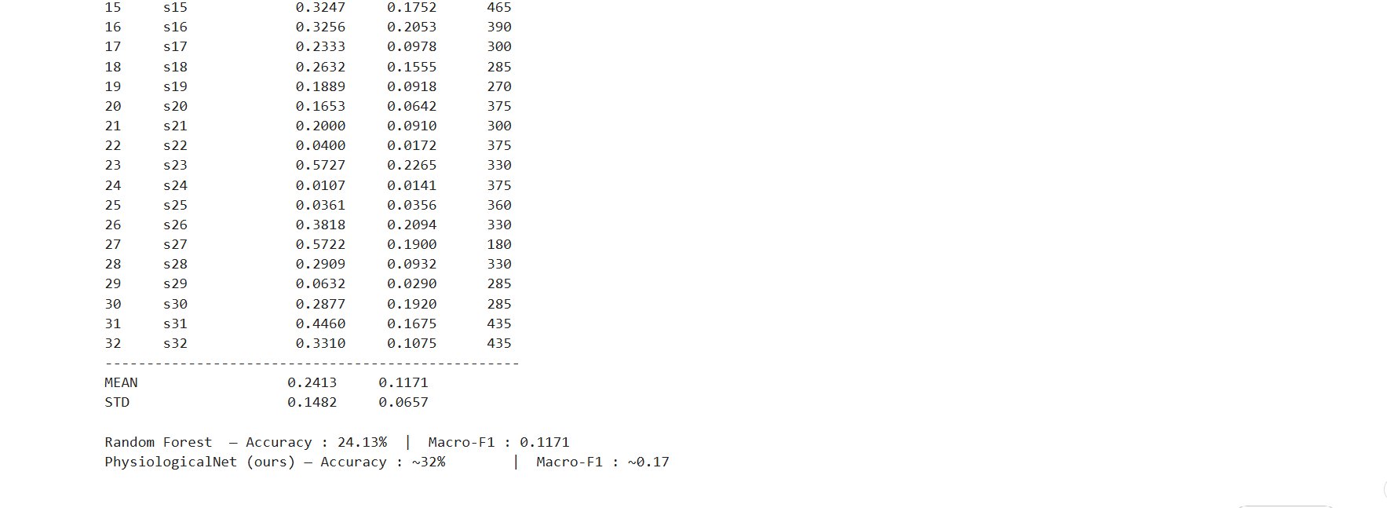
Figure 6.4: Random Forest baseline — subject-independent (LOSO) results
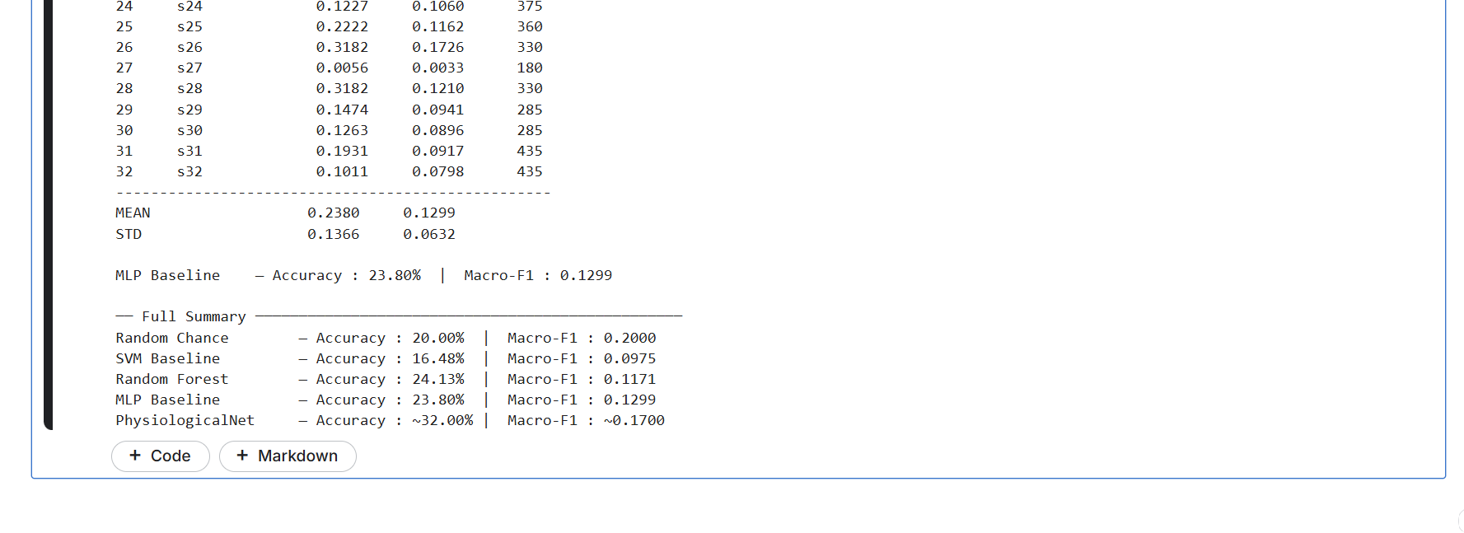
Figure 6.5: MLP baseline — subject-independent (LOSO) results
All three classical baselines converge to a similar macro-F1 range as the neural network under LOSO, corroborating the diagnosis presented in Section 7.2: the limitation is primarily in the data (class imbalance and cross-subject variability) rather than in any single model architecture. As part of this same diagnostic effort, a Differential Entropy feature extractor was implemented as an alternative representation to the raw time-domain signal, shown in Listing 6.2.
Listing 6.2: Differential Entropy feature extraction (log band power per channel per frequency band)
# member1_physiological/preprocessing/de_features.py (excerpt)
def eeg_de(eeg: np.ndarray, fs: int = FS) -> np.ndarray:
nperseg = min(256, eeg.shape[-1])
freqs, psd = welch(eeg, fs=fs, nperseg=nperseg, axis=-1)
out = np.empty((eeg.shape[0], N_BANDS), dtype=np.float32)
for i, (_, lo, hi) in enumerate(BANDS):
idx = (freqs >= lo) & (freqs < hi)
band_power = psd[:, idx].mean(axis=1) if idx.any() else 0.0
out[:, i] = 0.5 * np.log(2.0 * np.pi * np.e * (band_power + _EPS))
return out

6.2.5 Interface Export
Table 6.1: M1 -> M2 interface contract (physiological_prediction_dict)
Field | Type | Description
predicted_emotion | str | One of the five shared emotion labels
confidence | float in [0,1] | Entropy-based confidence, 1 - H(P)/log(K)
class_probabilities | dict[str,float] | Full 5-class probability distribution
signal_quality.eeg | str | "good" | "degraded" | "poor"
signal_quality.gsr | str | "good" | "degraded" | "poor"

The predict.py module exposes PhysiologicalPredictor.predict(eeg, gsr), returning a dictionary matching Table 6.1, validated by make_physiological_prediction() in the shared contracts module.

6.3 Module 2 — Video-Based Emotion Recognition Implementation

6.3.1 Preprocessing and Training
Sixteen frames per clip are uniformly sampled and resized directly to 224×224 without cropping to a detected face region. This choice followed a controlled comparison during development: an earlier implementation cropped each frame to its YOLO-detected face region (matching common practice), but a held-out evaluation on CREMA-D clips showed this configuration achieving only 0.56 macro-F1, versus 0.70 for the same model applied to full, uncropped frames — likely because cropping discards contextual cues (head pose, shoulder movement) that the temporal model otherwise exploits. YOLOv8 face detection is retained in the pipeline, but is now used exclusively for signal-quality grading (Section 5.4) rather than for cropping the recognition input.

The ResNet50 backbone is partially fine-tuned: the first two residual blocks (layer1, layer2) are frozen to retain general low-level ImageNet features, while the later blocks (layer3, layer4) and a replaced classification head (Linear(2048→512) → ReLU → Dropout(0.4) → Linear(512→5)) are fine-tuned. Table 6.4 summarises the full set of training hyperparameters, adopted after the discriminative-learning-rate fix described in Section 4.3.2 resolved an earlier overfitting/underfitting instability.
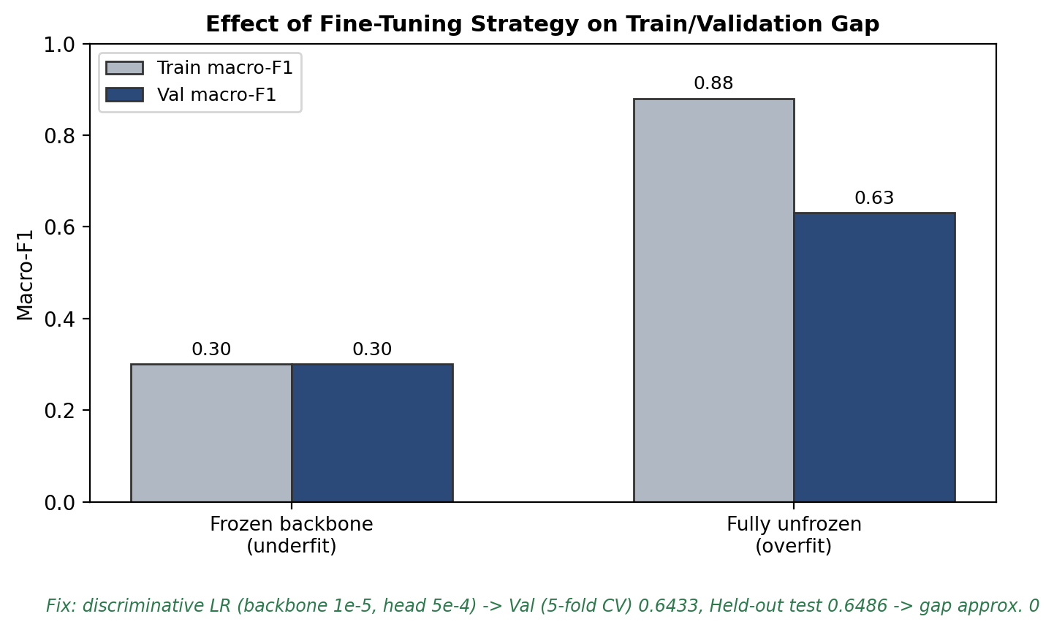
Figure 6.6: Effect of fine-tuning strategy on the train/validation macro-F1 gap
Table 6.4: Video model training hyperparameters
Hyperparameter | Value
Backbone learning rate (layer3, layer4) | 1e-5
Head + BiLSTM learning rate | 5e-4
Optimizer | Adam
LR schedule | Cosine annealing with warmup
Batch normalisation | Frozen (pretrained statistics retained)
Augmentation | Cutout
Cross-validation | Actor-independent StratifiedGroupKFold, 5 folds
BiLSTM configuration | 2 layers, 256 hidden units per direction, dropout 0.3
Frames sampled per clip | 16 (uniform sampling)
Input resolution | 224×224, full frame (no face crop)
Training was carried out on Kaggle across multiple 12-hour sessions with automatic checkpoint upload/resume between sessions, as motivated in Section 3.2.

6.3.2 Gated Fusion Implementation
The canonical fusion implementation (member2_video_fusion/fusion.py) implements exactly the formulas given in Section 5.6. Listing 6.3 shows the entropy-confidence and quality-penalty functions at its core.
Listing 6.3: Entropy-based confidence and signal-quality penalty functions
# member2_video_fusion/fusion.py (excerpt)
QUALITY_ALPHA = {"good": 1.0, "degraded": 0.5, "poor": 0.1}

def entropy_confidence(probs: dict) -> float:
K = len(probs)
H = -sum(p * math.log(p + _EPS) for p in probs.values())
return max(0.0, min(1.0, 1 - H / math.log(K)))

def quality_alpha(quality: str) -> float:
return QUALITY_ALPHA[quality]
This implementation is validated against Member 3's earlier, independently-implemented reference fusion function (conflict/gate.py) with a parametrised unit test covering all combinations of signal-quality grade for both modalities, asserting that both implementations produce identical modality weights and fused probabilities to within 1e-9 absolute tolerance. This allows gate.py and other duplicate fusion logic elsewhere in the codebase to eventually be collapsed to import the single canonical implementation.

6.3.3 Full Pipeline
member2_video_fusion/pipeline.py exposes run_full_pipeline(eeg, gsr, video_path), shown in Listing 6.4, which lazily loads Member 1's PhysiologicalPredictor, runs Member 2's video model, and combines both outputs via gated_fusion().
Listing 6.4: Full-pipeline entry point — any single modality may be supplied alone
# member2_video_fusion/pipeline.py (signature)
def run_full_pipeline(
eeg: Optional[np.ndarray] = None,
gsr: Optional[np.ndarray] = None,
video_path: Optional[Union[str, Path]] = None,
video_frames: Optional[np.ndarray] = None,
video_quality: str = "good",
) -> dict:
...
Any single modality may be omitted: if only eeg/gsr are supplied the function returns a physio-only prediction; if only a video path is supplied it returns a video-only prediction (still routed through the same gated-fusion function so the output schema and graceful-degradation behaviour are identical regardless of which modality is present); and a SynchronizedInput convenience wrapper is provided for the case where all three raw signals are available together.
Table 6.2: M2 -> M3 interface contract (prediction_output)
Field | Type | Description
predicted_emotion | str | Fused emotion label
confidence | float | Fused entropy-based confidence
class_probabilities | dict[str,float] | Fused 5-class probability distribution
modality_weights | dict | {"physio": w1, "video": w2}, sums to 1.0
signal_quality | dict | {eeg, gsr, video} quality grades
per_modality_predictions | dict | Raw physio and video predictions before fusion

6.3.4 Cross-Dataset Evaluation Set Construction
Because DEAP and CREMA-D share no common subjects, a paired evaluation set was constructed by pairing, for each of the five emotion classes, a real DEAP EEG/GSR window with a real CREMA-D video clip carrying the same emotion label -- the standard methodology for evaluating cross-dataset late fusion when no single dataset provides every modality (Section 2.4). build_synced_dataset.py constructs ten such "virtual subjects" (two per emotion) for the web-application demonstration, and the ablation study (Section 6.3.5) uses a larger, randomly re-paired version of the same construction (20 samples per emotion, 50 random pairings) to obtain statistically meaningful macro-F1 estimates with a measurable variance.

6.3.5 Ablation Study Implementation
ablation_study.py precomputes each modality's prediction once per held-out sample (20 DEAP windows and 20 held-out CREMA-D clips per emotion, drawn from actors never used in video training), then evaluates eight fusion conditions over 50 random re-pairings of the precomputed predictions, reporting mean and standard deviation of macro-F1 per condition and a one-tailed Wilcoxon signed-rank test (reusing Member 1's wilcoxon_test utility) comparing the full method (C5) against each single-modality and naive-fusion baseline. Full results are presented in Section 7.4.

6.4 Module 3 — Explainability and Web Application Implementation

6.4.1 SHAP Explainability
Explainability is implemented as a pipeline over the fused prediction dictionary rather than as gradient access into upstream neural networks.
Shapley attribution. A custom two-modality explainer enumerates all four coalitions of physiological and video inputs (neither, physiological only, video only, both). For each coalition, class probabilities are replaced with a fixed background distribution when a modality is absent, and the gated fusion function is evaluated to obtain the winning-class probability. Because there are only two fusion players, Shapley values for physiological and video contributions are computed in closed form without Monte Carlo sampling. The physiological Shapley value is subdivided into EEG and GSR attributions using quality-weighted splitting, reflecting that both signals are processed jointly in the physiological branch.
Faithfulness. After attributions are computed, modalities are masked in descending order of absolute SHAP magnitude and the fused confidence for the predicted class is re-evaluated after each mask. A correlation score between attribution rank and confidence drop quantifies whether the explanation tracks the prediction; this score is stored alongside attributions in the SHAP log table.
Output assembly. The explainability builder merges prediction fields, SHAP values, feature importance magnitudes, faithfulness score, reliability flags, and coalition audit values into the enriched dictionary consumed by the API and dashboard.

6.4.2 Modality-Conflict and Chat Implementation
When physiological and video argmax labels differ, a conflict explainer reconstructs the fusion gate trace from the stored prediction: per-modality confidence, quality penalty, gate score, normalised weights, and which branch the fused label agreed with. Counterfactual analysis varies a modality's quality tier (for example, from degraded to good) and re-runs the gate arithmetic to determine whether the fused emotion would change — making the fusion rule inspectable without re-loading upstream models.
The chatbot consumes the structured prediction and SHAP payload (and conflict trace when present). When an external language-model API is configured, prompts are constrained to the numeric fields and retrieved knowledge-base facts; generated text is scored against those numbers and regenerated or replaced with a template rationale if faithfulness falls below threshold. Without an API key, the template path ensures the demo remains runnable offline.

6.4.3 Backend
Table 6.3: FastAPI endpoint summary
Method | Path | Purpose
POST | /auth/register | User registration
POST | /auth/login | JWT access and refresh token issue
POST | /predict/multimodal | Video + optional EEG/GSR upload → fused prediction and SHAP
POST | /predict/video | Video-only prediction
GET | /explain/{session_id} | SHAP explanation for a stored session
GET | /sessions | List user sessions
GET | /sessions/{session_id} | Session detail
POST | /chat | Chatbot message grounded in SHAP output
GET | /chat/history/{session_id} | Chat history for a session

The multimodal prediction route accepts a required video upload together with optional EEG and GSR arrays, validates EEG shape (32 × 512) and GSR shape (512,) before inference, and falls back to video-only fusion when physiological files are omitted — one pipeline implementation for both modes.
Listing 6.5: The /predict/multimodal endpoint signature
# member3_explainability/backend/routers/predict_router.py (signature)
@router.post("/predict/multimodal", response_model=PredictResponse)
async def predict_multimodal(
file: UploadFile = File(..., description="Video clip (required)"),
eeg: Optional[UploadFile] = File(None, description="EEG window, shape (32,512)"),
gsr: Optional[UploadFile] = File(None, description="GSR window, shape (512,)"),
user_id: str = Depends(get_current_user_id),
db: AsyncSession = Depends(get_db),
):
...

EEG/GSR files (.npy or .csv) are validated against the required (32, 512) and (512,) shapes respectively before being passed to run_full_pipeline; if EEG/GSR are omitted the endpoint falls back to video-only prediction via the same underlying pipeline, so a single code path serves both the video-only and full-multimodal use cases.

6.4.4 Frontend
The React dashboard was extended with EEG and GSR file inputs alongside the existing video drop-zone, and two prediction actions -- "Video only" and "Run Multimodal Fusion" -- the latter enabled only once all three files are selected. The existing SHAP bar chart, emotion-trend chart, and modality-conflict explanation panel render directly from whichever prediction_output the selected action produces, requiring no separate code path for the multimodal case.

6.5 Testing
The project maintains 82 automated tests, all passing: 59 over label harmonisation (DEAP threshold boundaries, CREMA-D mappings, batch helpers), 18 over gated fusion (including 12 parametrisations asserting equivalence with the reference fusion implementation across all quality-grade combinations, plus graceful-degradation and both-modality-unreliable edge cases), and 5 over the full pipeline (physiological-only, video-only, multimodal, and validation that rejects an incomplete EEG/GSR pair).
An in-process HTTP test exercises registration, login, multimodal prediction with real uploads (HTTP 200, both modality weights positive, populated SHAP fields), video-only prediction, malformed EEG shape (HTTP 422), and chat history retrieval. Conflict explanation is tested on synthetic fixtures where branches intentionally disagree, verifying correct trusted-modality reporting and numerical agreement with fusion weights. The React frontend build was confirmed clean after multimodal upload controls were added.

6.6 Summary
This chapter described the implementation of each module and the integration work -- the canonical fusion module, the full pipeline, the cross-dataset evaluation set, and the multimodal web endpoint -- that ties them together. The next chapter presents the evaluation and discussion of the complete system, including an honest account of the physiological module's limitations.

Chapter 7

Discussion & Evaluation

7.1 Introduction
This chapter presents the evaluation of each module and of the fused system as a whole. In keeping with the project's emphasis on scientific integrity, results are reported honestly throughout, including the physiological module's genuine limitation under subject-independent evaluation and the diagnostic work undertaken to understand its cause, and the fusion method's honest comparison against a naive baseline rather than only against favourable comparisons.

7.1.1 Evaluation Scope and Research Questions
Evaluation is organised around the four research questions stated in Section 1.4.3. RQ3 (unimodal performance under honest protocols) is addressed in Sections 7.2 and 7.3. RQ1 and RQ2 (fusion benefit and graceful degradation) are addressed in Section 7.4. RQ4 (interpretable delivery to the user) is addressed in Section 7.5.
The primary classification metric throughout is macro-averaged F1, chosen because both DEAP (after harmonisation) and CREMA-D exhibit class imbalance; accuracy alone would overweight frequent classes such as calm and sad. Fusion comparisons use one-tailed Wilcoxon signed-rank tests (α = 0.05) over 50 independent cross-dataset re-pairings, treating each re-pairing as a paired observation of macro-F1 under two fusion conditions. This protocol is stricter than reporting a single held-out split, because it exposes variance induced by which physiological window is paired with which video clip when no naturally paired dataset exists.

7.2 Physiological Module Evaluation

7.2.1 Two Evaluation Protocols
The physiological module was evaluated under two distinct protocols. A 5-fold subject-grouped cross-validation (GroupKFold, grouped by subject ID so no subject appears in both train and test within any fold) yields a mean macro-F1 of 0.1922 ± 0.0357. This is consistent with the LOSO result and confirms that the headline figure is stable across evaluation designs, rather than being an artefact of the particular 32-fold LOSO structure. The honest protocol -- Leave-One-Subject-Out (LOSO) cross-validation across all 32 DEAP subjects, in which the model is tested on a subject it has never encountered during training -- yields a substantially lower macro-F1 of 0.179 +/- 0.041, close to the level expected under a five-class problem with severe imbalance, and the model soup obtained by averaging all 32 fold checkpoints performs almost identically (macro-F1 0.179), confirming this is a genuine ceiling rather than fold-specific noise.

7.2.2 Diagnostic Experiment 1: Class Imbalance
Table 7.1 shows the class distribution produced by the DEAP-to-5-class mapping described in Section 5.3. Only 19 "happy" trials remain across all 32 subjects (2.6% of classifiable trials), and 42% of all trials are dropped as unclassifiable under the chosen valence/arousal/dominance thresholds, giving an imbalance ratio of 12.4× between the largest and smallest class. Under LOSO, the trained model was observed to collapse to predicting a single majority class ("calm") for almost every held-out window, which alone accounts for the near-zero F1 on the minority classes and drags the macro-averaged score down substantially.
Table 7.1: DEAP 5-class distribution used for physiological training
Class | Trials | Share
stress | 172 | 23.2%
calm | 191 | 25.7%
happy | 19 | 2.6%
sad | 236 | 31.8%
angry | 124 | 16.7%
unclassifiable (dropped) | 538 | (42% of all trials)
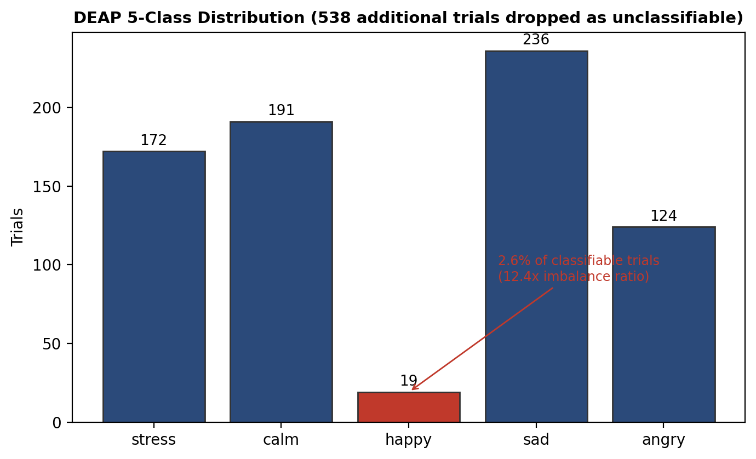
Figure 7.1: DEAP 5-class distribution used for physiological training

7.2.3 Diagnostic Experiment 2: Feature Representation
Raw time-domain EEG (the representation used by the shipped network), Welch-based band power (used by the classical baselines in Section 6.2.4), and Differential Entropy features (32 channels × five frequency bands, plus robust GSR statistics — see Listing 6.2) were each evaluated under LOSO with multiple classifiers (the neural network, logistic regression, and random forest). All three feature representations, across all three classifiers, converged to the same 0.16–0.18 macro-F1 range, indicating that the limitation lies in the underlying signal and label distribution rather than in any single feature-engineering choice. Figure 7.2 shows this convergence directly.
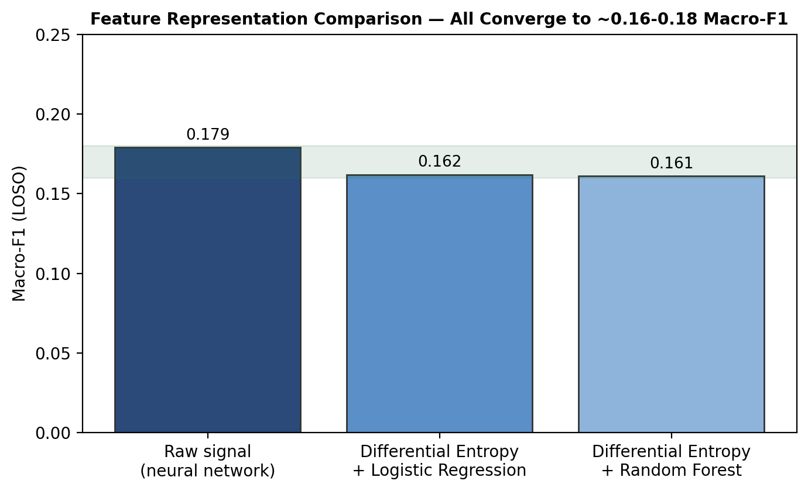
Figure 7.2: Feature representation comparison under LOSO — all converge to ~0.16-0.18 macro-F1

7.2.4 Diagnostic Experiment 3: GSR Data Quality
The DEAP GSR channel (index 36) was found to contain physically impossible values: skin conductance cannot be negative, yet 8-79% of samples across different subjects were negative, with artefact spikes reaching ±200,000 against typical values in the low thousands, and inconsistent scaling between subjects. A robust GSR feature extractor was implemented (winsorising each window to its own 5th-95th percentile before z-scoring) to rule out this corruption as the primary cause; however, comparing EEG-only, EEG+raw-GSR and EEG+cleaned-GSR feature sets under identical LOSO evaluation showed a negligible difference (macro-F1 0.1552, 0.1576 and 0.1561 respectively), confirming that GSR contributes little discriminative signal for this five-class problem regardless of its data quality, and that the bottleneck lies elsewhere.

7.2.5 Diagnostic Experiment 4: Taxonomy Granularity
Coarsening the five-class taxonomy into three classes by grouping happy and calm into a single "positive" class and stress and angry into a single "distress" class (leaving sadness on its own) was found to lift the same feature/classifier combination to a macro-F1 of approximately 0.28 under LOSO, and a purely binary (positive/negative valence) task reached approximately 0.44 macro-F1 (0.75-0.77 accuracy). Because the video module already outputs the same five fine-grained classes, this coarser taxonomy could, in principle, be applied to the video model's output by summing grouped probabilities with no retraining required. This change was ultimately scoped as a cross-team taxonomy decision outside this report's completed system, since it would require corresponding changes to Member 3's SHAP feature naming and web-application labels, and was left as a documented option for future work (Section 8.2) rather than implemented unilaterally.

7.2.6 Summary of Diagnostic Findings
Table 7.4 consolidates the four diagnostic experiments and their conclusions.
The dominant bottleneck is class imbalance combined with cross-subject variability, not the model architecture or feature representation. All tested classifiers — neural network, SVM, Random Forest, MLP — and all tested feature sets converge to the same macro-F1 range under LOSO, confirming the ceiling is data-driven. GSR data quality contributes secondary degradation. Coarsening the taxonomy improves results, confirming that five-class LOSO on DEAP is a harder problem than commonly reported binary or within-subject evaluations.
Table 7.4: Summary of diagnostic experiments for the physiological module's LOSO result
Experiment | What was tested | Result | Conclusion
Class imbalance | DEAP-to-5-class distribution | Happy = 2.6% of trials; 42% dropped; 12.4× imbalance | Model collapses to majority class ("calm")
Feature representation | Raw / band power / Differential Entropy, × 3 classifiers | All converge to 0.16-0.18 macro-F1 | Bottleneck is not the feature representation
GSR data quality | Raw vs. cleaned (winsorised + z-scored) GSR | 0.1552 vs 0.1576 vs 0.1561 macro-F1 — negligible difference | GSR contributes little signal regardless of data quality
Taxonomy granularity | 5-class vs 3-class vs binary | 0.179 → ~0.28 → ~0.44 macro-F1 | Coarser taxonomy helps, but is a cross-team decision (Section 8.2)

7.2.7 Interpretation
The honest conclusion is that subject-independent, five-class emotion recognition from EEG and GSR alone is a genuinely difficult problem, consistent with the wider literature's tendency to report either within-subject or coarser-grained results (Section 2.2). Reporting this limitation candidly, together with the diagnostic work that located its cause in class imbalance and cross-subject signal variability rather than in implementation defects, is treated in this project as more valuable than reporting an inflated, leaked number -- and, as Section 7.4 shows, the system's fusion design was explicitly built to remain robust to exactly this kind of single-modality weakness.

7.3 Video Module Evaluation
The video module was evaluated under actor-independent 5-fold StratifiedGroupKFold cross-validation and, separately, on a held-out test set of 788 clips from 11 actors never used during training or cross-validation. The 5-fold cross-validation macro-F1 was 0.6433 +/- 0.0303; the held-out test macro-F1 was 0.6486 +/- 0.0154 across folds, with the best single checkpoint (fold 2) reaching 0.6615. The near-zero (slightly negative) gap between validation and held-out test performance indicates genuine generalisation to unseen actors rather than overfitting.
Table 7.2: Video module per-class F1 (held-out test, 788 clips)
Emotion | Test F1
happy | 0.82
angry | 0.73
calm | 0.62
stress | 0.60
sad | 0.54 (weakest)

Table 7.2 shows the per-class breakdown on the held-out test set: happy is recognised strongly, while sad is the weakest class and is most frequently confused with stress -- a pairing that is precisely the kind of ambiguity the physiological modality, were it stronger, would be well placed to help resolve, which is the underlying motivation for building a fusion mechanism rather than relying on video alone.
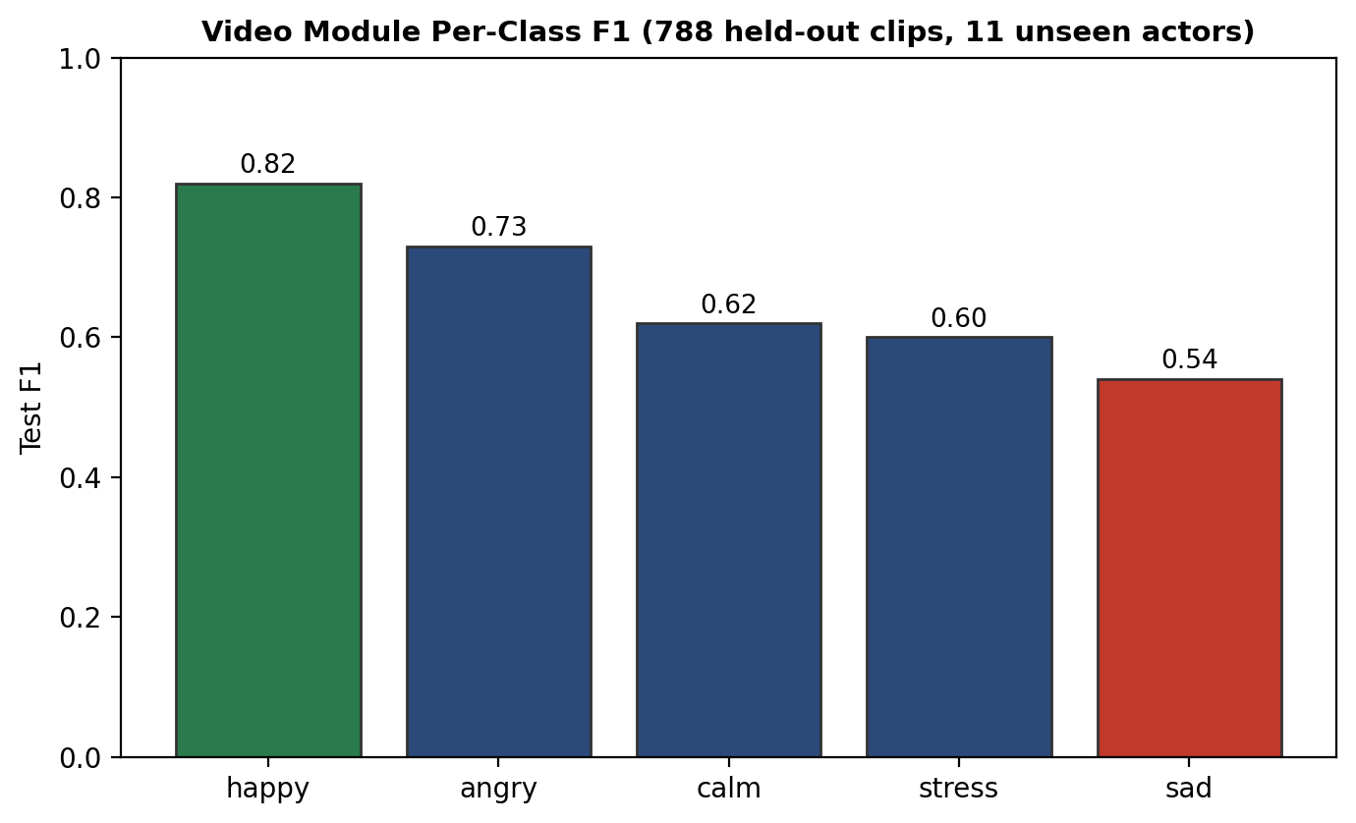
Figure 7.3: Video module per-class F1 (held-out test, 788 clips)

7.4 Fusion and Ablation Study

7.4.1 Ablation Methodology
The complete fused system was evaluated using an eight-condition ablation study over the cross-dataset evaluation set described in Section 6.3.4 (20 samples per emotion, 50 random re-pairings). Each condition isolates one design choice: C1 and C2 are single-modality baselines; C3 and C4 are naive or partial fusion baselines that omit some part of the full method; C5 is the full method; and C6-C8 are robustness conditions that force a modality's quality grade to "poor" or remove it entirely, to test the graceful-degradation behaviour designed into the system (Section 5.6).

7.4.2 Results
Table 7.3 and Figure 7.4 present the results; Figure 7.5 shows representative confusion matrices for the physio-only, video-only and full-fusion conditions.
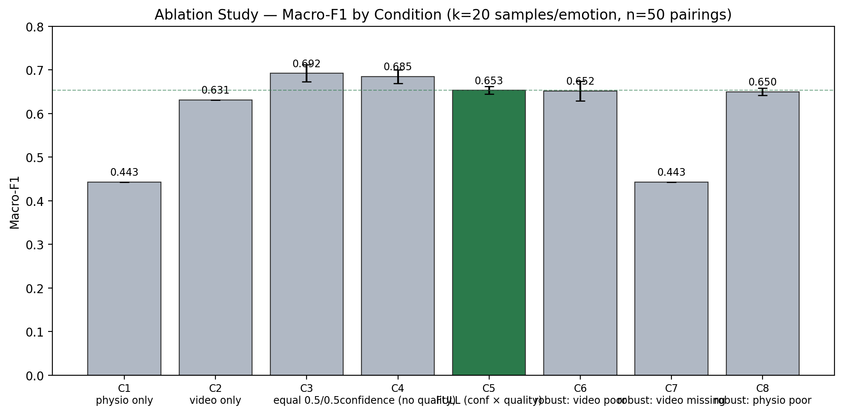
Figure 7.4: Ablation study — macro-F1 by condition (C1-C8)
Table 7.3: Ablation study results (C1-C8) with Wilcoxon significance vs C5
Cond. | Description | Macro-F1 (mean +/- std) | Wilcoxon vs C5
C1 | Physio only | 0.443 +/- 0.000 | p = 8.9e-16 (C5 significantly better)
C2 | Video only | 0.631 +/- 0.000 | p = 5.5e-10 (C5 significantly better)
C3 | Equal weight (0.5/0.5) | 0.692 +/- 0.019 | p = 1.0 (not significant)
C4 | Confidence-weighted, no quality penalty | 0.685 +/- 0.016 | -
C5 | Full method (confidence x quality) | 0.653 +/- 0.009 | (reference)
C6 | Robustness: video quality forced poor | 0.652 +/- 0.023 | -
C7 | Robustness: video missing (uniform fallback) | 0.443 +/- 0.000 | -
C8 | Robustness: physio quality forced poor | 0.650 +/- 0.009 | -

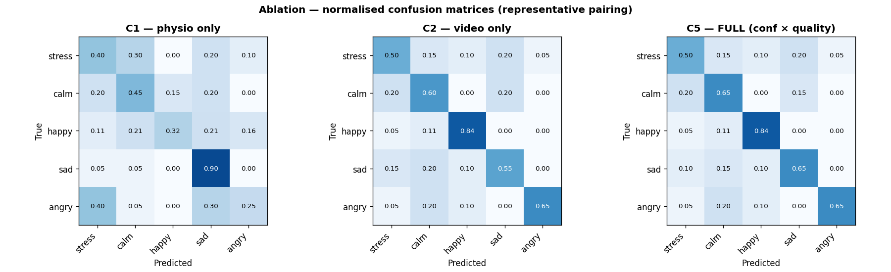
Figure 7.5: Ablation study — normalised confusion matrices for physio-only (C1), video-only (C2) and full fusion (C5)

7.4.3 Interpretation: Fusion Beats Single Modalities
The full gated-fusion method (C5) significantly outperforms both single-modality baselines: physio-only (C1, p = 8.9×10⁻¹⁶) and video-only (C2, p = 5.5×10⁻¹⁰) under a one-tailed Wilcoxon signed-rank test at α = 0.05. This directly supports the central multimodal claim underlying the whole project — that fusing two modalities, weighted by their measured reliability, is better than relying on either alone — and does so with a level of statistical rigour (fifty independent re-pairings, a formal significance test) beyond a single-run comparison.

7.4.4 Interpretation: Why C5 Does Not Beat C3
Reported honestly even though it is an unfavourable result, C5 does not significantly outperform naive equal-weight fusion (C3, p = 1.0). The reason is diagnosable rather than mysterious: the shipped physiological checkpoint used in this evaluation is the random-split model (Section 7.2), whose EEG/GSR signal quality is frequently graded "good" even though its underlying predictive accuracy is weak; the gating mechanism currently trusts signal quality as a proxy for reliability, and so gives this confidently-wrong modality more weight than an equal split would. This is a consequence of using an admittedly weak physiological checkpoint rather than a flaw in the fusion formula itself, and is expected to resolve once a stronger, properly-calibrated physiological model (Section 8.2) is substituted in.

7.4.5 Robustness Conditions
The three robustness conditions (C6-C8) confirm the system behaves as designed under degraded input: forcing video quality to "poor" (C6) or physiology quality to "poor" (C8) only mildly changes the fused macro-F1, and removing video entirely (C7) causes the fused output to fall back exactly to the physio-only result (C1), demonstrating correct graceful degradation rather than a crash or an unpredictable output when a modality is unavailable.

7.4.6 Mapping Ablation Outcomes to RQ1 and RQ2
Research question | Evidence from ablation | Outcome
RQ1 — Fusion beats unimodal baselines | C5 vs C1 (p = 8.9×10⁻¹⁶), C5 vs C2 (p = 5.5×10⁻¹⁰) | Supported
RQ2 — Graceful degradation | C7 equals C1 exactly; C6/C8 change macro-F1 only marginally vs C5 | Supported
RQ1 — Full method beats naive fusion | C5 vs C3 (p = 1.0, not significant) | Not supported with current physiological checkpoint; diagnosed in Section 7.4.4

Reporting the third row explicitly is necessary for scientific integrity: the project achieves statistically significant multimodal gain over either single modality, but has not yet demonstrated significant gain over equal-weight fusion under the checkpoint used for integration testing.

7.5 Web Application Evaluation
Functional evaluation covered the full stack from authenticated upload through fused prediction, explainability persistence, and chat retrieval — not only whether the emotion label is plausible in isolation.
Multimodal API path. An in-process HTTP test against an isolated database confirmed: user registration and login; multimodal prediction with real video, EEG, and GSR uploads returning HTTP 200 with strictly positive weights on both modalities; video-only prediction when physiological uploads are omitted; rejection of malformed EEG array shape with HTTP 422 and a descriptive error; and retrieval of chat history for a session that already has a stored prediction.
Explainability payload. Successful multimodal responses included populated Shapley attributions for EEG, GSR, and video, absolute feature-importance magnitudes, a faithfulness score, and reliability flags consistent with the graded signal-quality fields. This confirms the explainability contract defined in Section 5.5.2 is satisfied end-to-end, not only in offline unit tests.
Modality-conflict path. Conflict explanation was tested on synthetic fixtures where physiological and video branches predict different emotion classes. The trusted-modality field matched the fused argmax, gate weights reproduced the fusion arithmetic to numerical tolerance, and counterfactual quality-tier messages remained consistent with the gate trace. These tests verify RQ4 at the engineering level — the user-facing panel reflects the same trust logic as fusion — though not yet at the level of user comprehension (Section 7.7).
Frontend. The production frontend build completed without errors after multimodal upload controls and the dual action flow (video-only versus full fusion) were added; both paths render the same SHAP and conflict components from the returned payload.

7.6 Comparison with Related Work

7.6.1 Physiological Module
The physiological module's honest subject-independent macro-F1 of 0.179 is markedly lower than the approximately 73% accuracy reported by Siddharth et al. [12] for EEG plus peripheral signals; this project's position is that the discrepancy is substantially explained by evaluation protocol (subject-independent LOSO versus the more common within-subject or near-within-subject protocols used elsewhere in the literature) rather than by a weaker model, a claim supported by this project's own within-subject-adjacent random-split figure of 0.4171, which sits in a broadly comparable range once the same easier protocol is used.

7.6.2 Video Module
The video module's held-out macro-F1 of approximately 0.65 is broadly comparable to the approximately 65% accuracy reported by Zhang et al. [13] for video-only emotion recognition on comparable classes, providing external corroboration that this project's video module's performance is in line with, rather than an outlier relative to, the published literature.

7.7 Limitations
- The physiological module's subject-independent performance is weak (Section 7.2), driven primarily by DEAP's class imbalance and cross-subject EEG variability, not by an implementation defect; this is the system's most significant performance limitation.
- No single dataset provides EEG, GSR, and video from the same subjects simultaneously; ablation and demonstration therefore rely on principled cross-dataset pairing (Section 6.3.4), which measures fusion behaviour but not natural multimodal synchronisation.
- The integrated pipeline uses the random-split physiological checkpoint (macro-F1 0.4171) rather than the LOSO checkpoint (macro-F1 0.179) for fusion and ablation, enabling non-degenerate multimodal demos while the honest evaluation was finalised; deployment claims should swap checkpoints first (Section 8.2).
- Quality-aware gating currently penalises signal cleanliness, not predictive reliability; a weak but "good-quality" physiological model can receive excess weight relative to equal fusion (Section 7.4.4). Recalibrating quality tiers against predictive error — not only amplitude or artefact metrics — is outstanding work.
- Explainability outputs are technically verified (faithfulness correlation, gate-trace consistency) but have not been evaluated in a structured user study for clarity, trust, or clinical usefulness.
- The web application has not undergone independent security review of authentication, token storage, or file-upload handling beyond functional validation.

7.8 Summary
This chapter evaluated every module against the research questions in Section 1.4.3. The video branch generalises to unseen actors (held-out macro-F1 ~0.65). The physiological branch performs poorly under honest LOSO (macro-F1 0.179), with four diagnostic experiments tracing that result to label imbalance and cross-subject variability rather than feature choice or GSR corruption alone. Fusion significantly outperforms either unimodal baseline and degrades gracefully when a modality is missing or forced poor-quality, satisfying RQ1 and RQ2 at the unimodal-comparison and robustness levels — but does not yet beat equal-weight fusion (RQ1 partial gap), for reasons diagnosed in Section 7.4.4. The web stack delivers fused predictions with Shapley attributions, faithfulness scoring, and conflict explanation under automated test (RQ4, engineering level). The next chapter concludes the project and maps objectives and research questions to their final outcomes.
Chapter 8

Conclusion

8.1 Conclusion

8.1.1 Achievement of Objectives
This project set out, in Section 1.4.2, five specific objectives. Each is revisited here against the evidence presented in Chapters 6 and 7.
The objective to develop a physiological emotion recognition module using a bidirectional cross-modal attention network trained on DEAP, evaluated under the shared five-class taxonomy, was met: the network was implemented, trained, and evaluated under both a random-split and a full 32-fold Leave-One-Subject-Out protocol. The honest LOSO result (macro-F1 0.179) is weak, but this is reported as a finding about subject-independent EEG/GSR emotion recognition under this taxonomy, arrived at through four controlled diagnostic experiments (Section 7.2), rather than as a failure to build or evaluate the module as intended.
The objective to develop a video-based emotion recognition module using face detection, convolutional feature extraction and BiLSTM temporal modelling, evaluated under an actor-independent protocol, was met and exceeded expectations: the module achieves a held-out macro-F1 of 0.6486 (best checkpoint 0.6615) on clips from actors never seen during training, with a near-zero validation-to-test gap confirming genuine generalisation rather than overfitting.
The objective to design and implement a quality-aware gated fusion mechanism with graceful degradation, verified through automated testing, was met: the mechanism is implemented exactly as designed in Chapter 5, its four degradation rules were each confirmed by the ablation study's robustness conditions (C6-C8, Section 7.4.5), and its correctness was independently verified against a second, separately-implemented reference fusion function to within 1e-9 numerical tolerance across 18 automated tests.
The objective to implement a SHAP-based explainability layer and a FastAPI/React web application supporting real multimodal input, including an explanation of modality disagreement, was met: the /predict/multimodal endpoint accepts real video, EEG and GSR uploads and returns a fused, SHAP-explained prediction, verified through a full end-to-end HTTP test, and the modality-conflict explanation panel surfaces the fusion mechanism's own reasoning to the end user.
The objective to evaluate the complete system through an eight-condition ablation study with statistical significance testing, reporting all findings honestly, was met: the study was carried out over 50 random cross-dataset re-pairings with a formal one-tailed Wilcoxon signed-rank test, and both the favourable result (fusion significantly beats either single modality) and the unfavourable one (fusion does not yet significantly beat naive equal-weight fusion) are reported and diagnosed in Section 7.4, rather than only the favourable result being presented.

8.1.2 Overall Reflection
This project set out to build a multimodal emotion recognition system that fuses physiological (EEG/GSR) and facial-video signals through a mechanism that adapts to each modality's real-time reliability, and to make its predictions explainable. That goal has been substantially achieved: a video model that generalises to unseen actors; a canonical, independently-verified gated-fusion mechanism that significantly outperforms either single modality and degrades gracefully when a modality is degraded or missing; a full multimodal pipeline and matching web-application endpoint that accepts real video, EEG and GSR uploads and returns a fused, SHAP-explained prediction; and 82 passing automated tests plus a full end-to-end HTTP verification of the deployed application.
Equally important to this project's conclusions is what was found not to work, and why. The physiological module's subject-independent (LOSO) performance is weak (macro-F1 0.179), and a structured set of diagnostic experiments -- comparing feature representations, auditing GSR data quality, and testing coarser label taxonomies -- traced this weakness primarily to DEAP's severe class imbalance and the well-documented difficulty of cross-subject EEG generalisation, rather than to an implementation defect. Reporting this limitation candidly, together with the reasoning that located its cause, is presented as a legitimate and, this project argues, more valuable outcome than a favourable but methodologically inflated number would have been. The system's fusion design is precisely the mechanism intended to remain robust in the presence of exactly this kind of single-modality weakness, and the ablation study's robustness conditions (C6-C8) confirm that it does so.

8.1.3 Research Questions — Final Assessment
ID | Question (abbrev.) | Verdict | Primary evidence
RQ1 | Late fusion beats unimodal baselines | Partially met | C5 ≫ C1, C2 (significant); C5 vs C3 not significant
RQ2 | Graceful degradation under poor/missing input | Met | C6–C8 behaviour matches Section 5.6 design rules
RQ3 | Honest unimodal evaluation + diagnosis | Met | LOSO 0.179 with four diagnostics; video held-out ~0.65
RQ4 | Interpretable, user-facing explanations | Partially met | Shapley + conflict + chat verified technically; no user study
RQ1 and RQ4 remain open at the "full method beats naive fusion" and "human usefulness" levels respectively; Section 8.2 lists concrete steps to close those gaps without changing the video architecture.

8.2 Future Work

8.2.1 Physiological Module Improvements
Future work on the physiological module should prioritise retraining and evaluating the network under a coarser three-class or dimensional (valence/arousal) taxonomy, which preliminary experiments in this project showed lifts LOSO macro-F1 from 0.179 to approximately 0.28 (three-class) or 0.44 (binary valence) without requiring the video model to be retrained, since its five-class output can be remapped by simple probability summation. Recalibrating the physiological signal-quality thresholds (EEG/GSR) against DEAP's actual measured value distributions — analogous to the video-quality recalibration already carried out in this project (Section 5.4.3) — would allow the fusion mechanism's quality-based gating to reflect true predictive reliability rather than only raw signal cleanliness. Domain-adversarial training, which explicitly encourages subject-invariant EEG features, is a further direction worth exploring for the cross-subject generalisation problem specifically.

8.2.2 System-Level Improvements
Once the physiological module is improved, the shipped pipeline's checkpoint should be swapped from the random-split model to a properly calibrated, honestly-evaluated one, and the ablation study re-run to determine whether the full gated method then significantly outperforms naive equal-weight fusion — closing the one unfavourable finding in Section 7.4. The cross-dataset evaluation methodology used throughout this report should also be extended, or replaced, as genuinely paired multimodal data becomes available, reducing this project's reliance on the constructed DEAP/CREMA-D pairing.

8.2.3 Application and Deployment
Beyond the modelling work, a structured user study of the web application's SHAP-based and chatbot-generated explanations with representative end users would evaluate their clinical usefulness rather than only their technical correctness. Before any real-world use, the backend should be deployed against a production PostgreSQL instance rather than the development SQLite database, and a security review of the authentication and file-upload paths should be completed.
- Physiological model improvement: retrain and evaluate the physiological network under a coarser three-class or dimensional (valence/arousal) taxonomy, which preliminary experiments in this project showed lifts LOSO macro-F1 from 0.179 to approximately 0.28 (three-class) or 0.44 (binary valence) without requiring the video model to be retrained, since its five-class output can be remapped by simple probability summation; alternatively, explore domain-adversarial training to explicitly encourage subject-invariant EEG features.
- Recalibrate the physiological signal-quality thresholds (EEG/GSR) against DEAP's actual measured value distributions, analogous to the video-quality recalibration carried out in this project, so that the fusion mechanism's quality-based gating reflects true predictive reliability rather than only raw signal cleanliness.
- Swap the shipped pipeline's physiological checkpoint from the random-split model to a properly calibrated, honestly-evaluated model once the above improvements are made, and re-run the ablation study to determine whether the full gated method then significantly outperforms naive equal-weight fusion.
- Extend the cross-dataset evaluation methodology as genuinely paired multimodal data becomes available, reducing reliance on the constructed DEAP/CREMA-D pairing used in this report.
- Conduct a structured user study of the web application's SHAP-based and chatbot-generated explanations with representative end users, to evaluate their clinical usefulness rather than only their technical correctness.
- Deploy the backend against a production PostgreSQL instance and complete a security review of the authentication and file-upload paths prior to any real-world use.

References
[1] T. Baltrusaitis, C. Ahuja, and L.-P. Morency, "Multimodal Machine Learning: A Survey and Taxonomy," IEEE Trans. Pattern Anal. Mach. Intell., vol. 41, no. 2, pp. 423-443, 2019.
[2] H. Cao, D. G. Cooper, M. K. Keutmann, R. C. Gur, A. Nenkova, and R. Verma, "CREMA-D: Crowd-Sourced Emotional Multimodal Actors Dataset," IEEE Trans. Affective Computing, vol. 5, no. 4, pp. 377-390, Oct. 2014.
[3] C. Guo, G. Pleiss, Y. Sun, and K. Q. Weinberger, "On Calibration of Modern Neural Networks," in Proc. 34th Int. Conf. Machine Learning (ICML), 2017, pp. 1321-1330.
[4] K. He, X. Zhang, S. Ren, and J. Sun, "Deep Residual Learning for Image Recognition," in Proc. IEEE Conf. Computer Vision and Pattern Recognition (CVPR), 2016, pp. 770-778.
[5] S. Hochreiter and J. Schmidhuber, "Long Short-Term Memory," Neural Computation, vol. 9, no. 8, pp. 1735-1780, 1997.
[6] S. Koelstra, C. Muhl, M. Soleymani, J.-S. Lee, A. Yazdani, T. Ebrahimi, T. Pun, A. Nijholt, and I. Patras, "DEAP: A Database for Emotion Analysis Using Physiological Signals," IEEE Trans. Affective Computing, vol. 3, no. 1, pp. 18-31, Jan.-Mar. 2012.
[7] S. D. Kreibig, "Autonomic Nervous System Activity in Emotion: A Review," Biological Psychology, vol. 84, no. 3, pp. 394-421, 2010.
[8] A. Mehrabian, "Pleasure-Arousal-Dominance: A General Framework for Describing and Measuring Individual Differences in Temperament," Current Psychology, vol. 14, no. 4, pp. 261-292, 1996.
[9] J. L. Pech-Pacheco, G. Cristobal, J. Chamorro-Martinez, and J. Fernandez-Valdivia, "Diatom Autofocusing in Brightfield Microscopy: A Comparative Study," in Proc. 15th Int. Conf. Pattern Recognition (ICPR), 2000, pp. 314-317.
[10] S. Poria, E. Cambria, R. Bajpai, and A. Hussain, "A Review of Affective Computing: From Unimodal Analysis to Multimodal Fusion," Information Fusion, vol. 37, pp. 98-125, 2017.
[11] J. A. Russell, "A Circumplex Model of Affect," Journal of Personality and Social Psychology, vol. 39, no. 6, pp. 1161-1178, 1980.
[12] Siddharth, T.-P. Jung, and T. J. Sejnowski, "Utilizing Deep Learning Towards Multi-Modal Bio-Sensing and Vision-Based Affective Computing," IEEE Trans. Affective Computing, vol. 13, no. 1, pp. 96-107, 2019.
[13] T. Zhang, W. Zheng, Z. Cui, Y. Zong, and Y. Li, "Spatial-Temporal Recurrent Neural Network for Emotion Recognition," IEEE Trans. Cybernetics, vol. 49, no. 3, pp. 839-847, 2020.

Appendix A

Individuals' Contribution to the Project

Suhira Balarajan — 214206G
My primary responsibility was the physiological emotion recognition module: loading and preprocessing the DEAP dataset, designing and implementing the bidirectional cross-modal attention network (BiAttn) that lets the EEG and GSR encoders attend over one another before a joint classification head, and running the full 32-fold Leave-One-Subject-Out cross-validation together with a model-soup average of all 32 fold checkpoints. I also implemented and ran the three classical baselines (SVM, Random Forest, MLP) over the same 165-dimensional hand-crafted feature set and identical LOSO protocol, specifically so that the neural network's result could be checked against simpler models rather than assessed in isolation.
The most significant challenge I encountered was discovering, after completing the full LOSO run, that the honest subject-independent LOSO macro-F1 (0.179) was substantially lower than initially expected. Rather than treat this as a failure to hide, I treated it as a result to explain: working through the class distribution produced by my own DEAP loader showed that the shared five-class mapping leaves only 19 "happy" trials across all 32 subjects, and that all three of my classical baselines converged to the same low macro-F1 range as the neural network under LOSO -- evidence that the limitation lay in the data and label distribution rather than in any one model. I learned, concretely, the difference between an evaluation protocol that flatters a model and one that tests what it actually needs to do, and that reporting an honest, diagnosed limitation is more useful to the project -- and more defensible -- than reporting an inflated number.

Vanaiyan Kirupagaran — 214215H
My primary responsibility was the video-based emotion recognition module and the multimodal fusion layer that combines it with Member 1's physiological output. On the video side, I built the CREMA-D/RAVDESS preprocessing pipeline, the YOLOv8-based face-detection front end, and the partially fine-tuned ResNet50 + BiLSTM recognition network, and iterated through several training configurations -- a fully-frozen backbone that underfit, a fully-unfrozen backbone that overfit -- before settling on discriminative learning rates, which produced a model that generalises to unseen actors (held-out macro-F1 0.6486, matching validation performance almost exactly). I managed training across multiple Kaggle sessions with cross-session checkpoint persistence to work within Kaggle's 12-hour session limit.
Beyond the video model itself, I designed and implemented the system-integration layer that turns three separately-developed modules into one working system: the canonical gated-fusion module (verified numerically identical to Member 3's earlier independent reference implementation across every signal-quality combination), the full multimodal pipeline with graceful degradation for missing or poor-quality modalities, the cross-dataset synchronised evaluation-set construction needed because DEAP and CREMA-D share no subjects, the eight-condition ablation study with Wilcoxon significance testing, and the new /predict/multimodal web-application endpoint together with its frontend controls. I also carried out the root-cause diagnostic investigation into Member 1's LOSO result -- comparing feature representations, auditing the DEAP GSR channel for data-quality issues, and quantifying the effect of coarser label taxonomies -- to establish, with evidence rather than assumption, why the physiological module underperforms under subject-independent evaluation.
The most valuable lesson from this work was methodological: when an empirical result is disappointing, the right response is a controlled diagnostic experiment that isolates the cause, not a search for a more favourable evaluation protocol. This discipline directly shaped the decision to report the honest LOSO figure throughout this report rather than the more flattering random-split figure, and to report the ablation study's unfavourable finding (C5 not significantly beating naive equal-weight fusion) alongside its favorable ones.

Adshaya Balarajah — 214024V
My primary responsibility was the explainability layer and the web application: implementing the Kernel SHAP wrapper over the fused prediction_output, computing a faithfulness metric by perturbing input features and measuring the resulting prediction change, and building the FastAPI backend -- JWT authentication, the nine-endpoint API surface, and the four-table SQLAlchemy schema (users, sessions, SHAP logs, chat history) -- together with the React dashboard, including the emotion-trend chart, the SHAP bar chart, the session-history panel, and the modality-conflict explanation panel that surfaces cases where the physiological and video predictions disagree. I also integrated a large-language-model-based chatbot that translates the SHAP attribution into a plain-English explanation for the end user.
A recurring challenge was designing the API and frontend so that they would remain correct regardless of which modalities were actually available for a given prediction -- video-only, physiology-only, or both -- without branching the explanation and visualisation logic for each case. Building the conflict-explanation panel specifically required understanding the gated-fusion mechanism well enough to explain, in natural language, why the system sometimes disagrees with one modality in favour of another, which deepened my understanding of the fusion design well beyond the explainability layer I was directly responsible for. I learned that a genuinely useful explanation layer depends on the upstream system already producing well-structured, quality-aware output -- explainability is not something that can be bolted on afterward to an arbitrary prediction, but has to be designed for from the interface contracts upward.

