- Registrstion – POST - http://localhost:5000/register
{
"email": "vanaja@gmail.com",
"password": "123456"
}
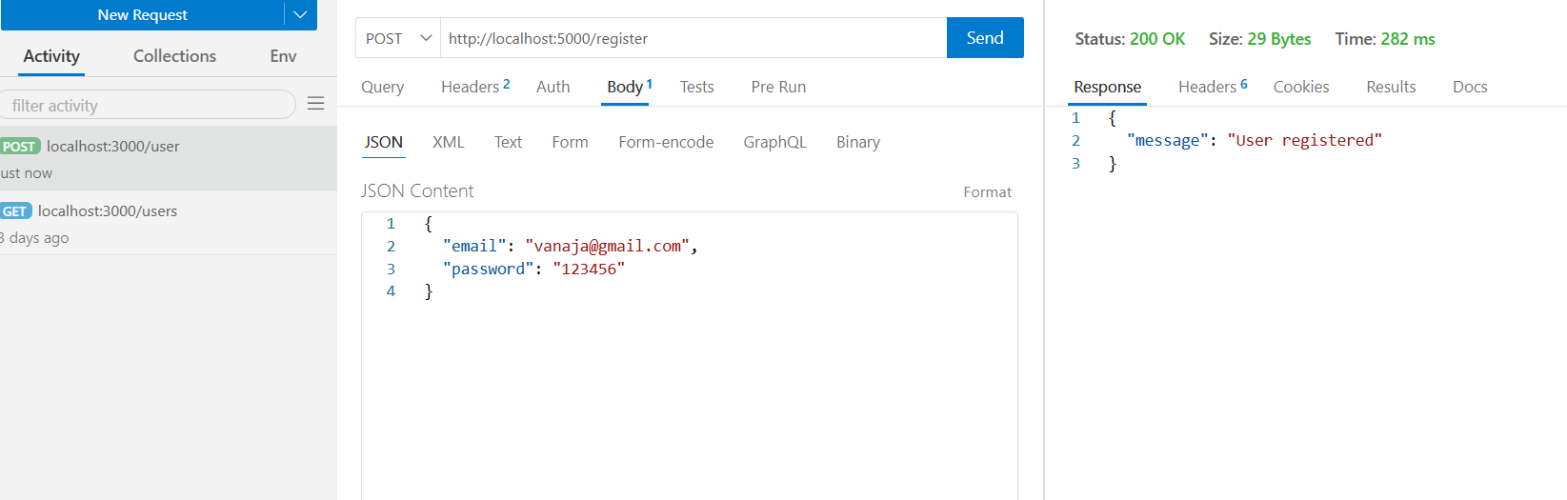
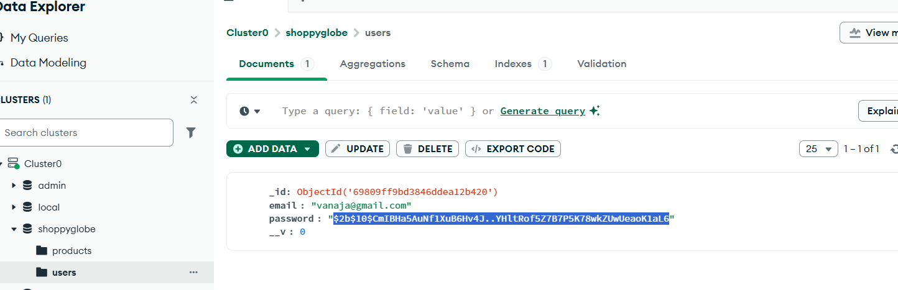
- Login – POST - http://localhost:5000/login
{
"email": "vanaja1@gmail.com",
"password": "123456"
}
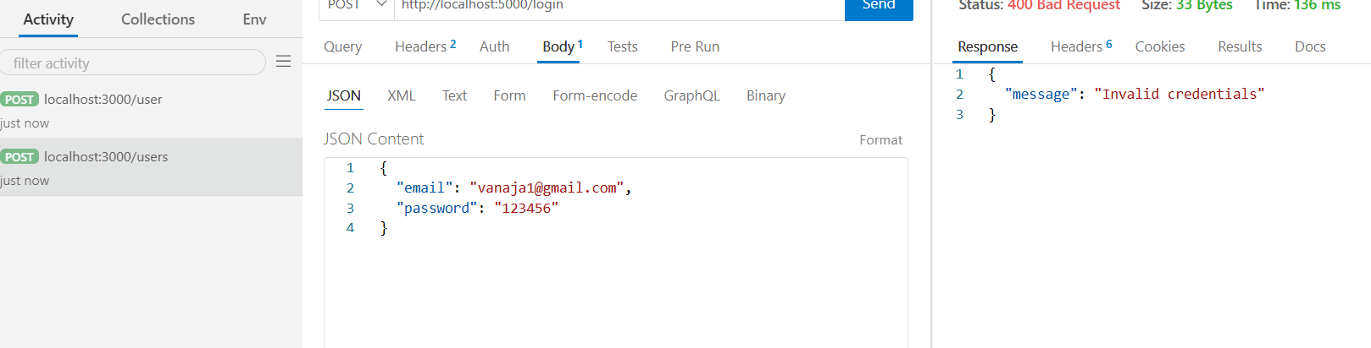
Login Invalid Username
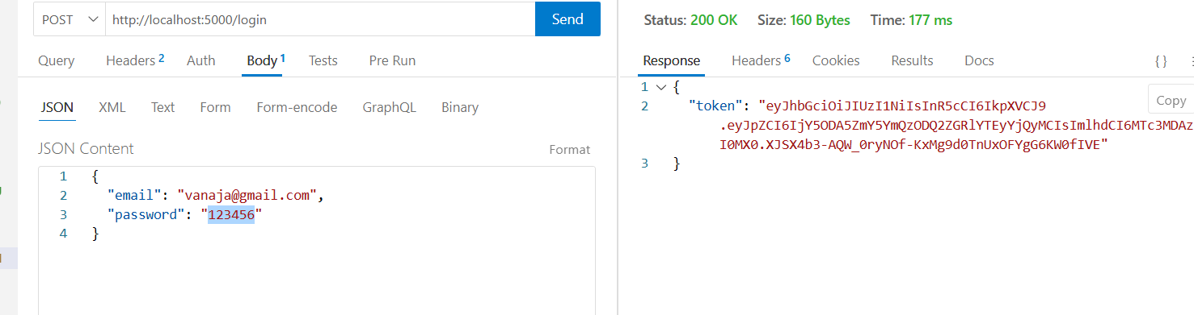
- Product – POST - http://localhost:5000/products
{
"name": "Laptop",
"price": 55000,
"description": "Gaming laptop",
"stockQuantity": 10
}
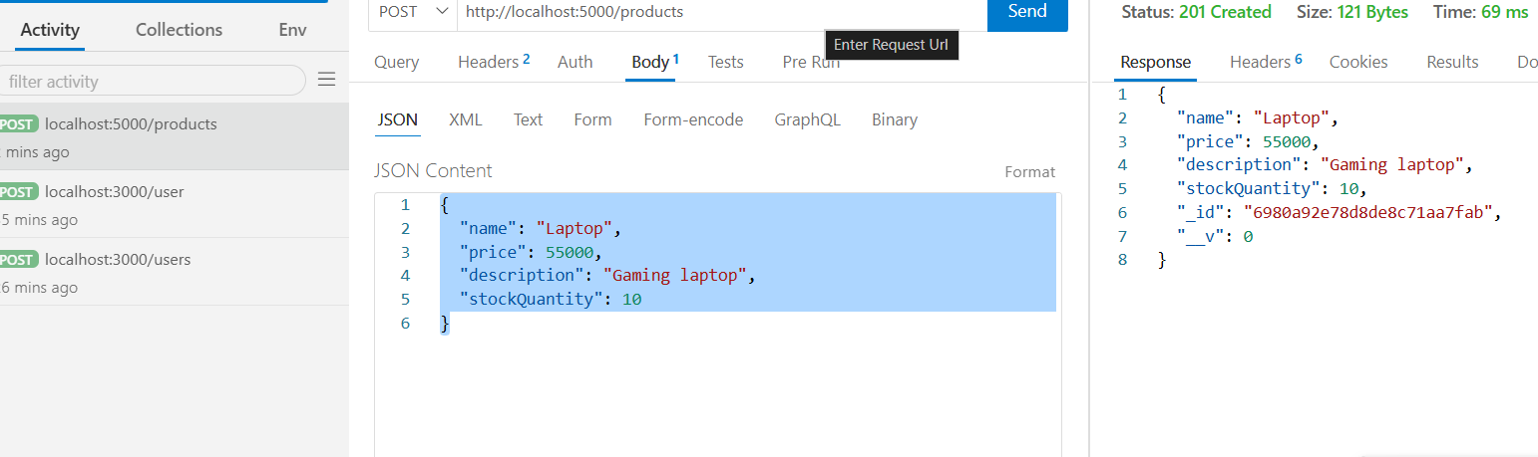

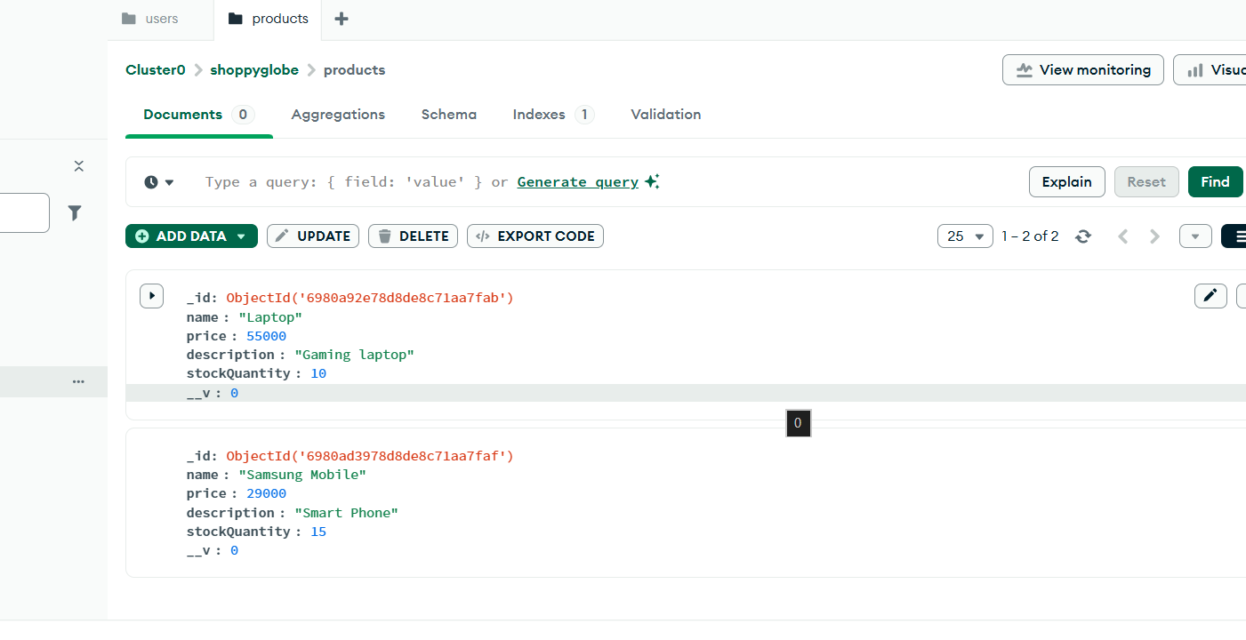

- Product – GET - http://localhost:5000/products
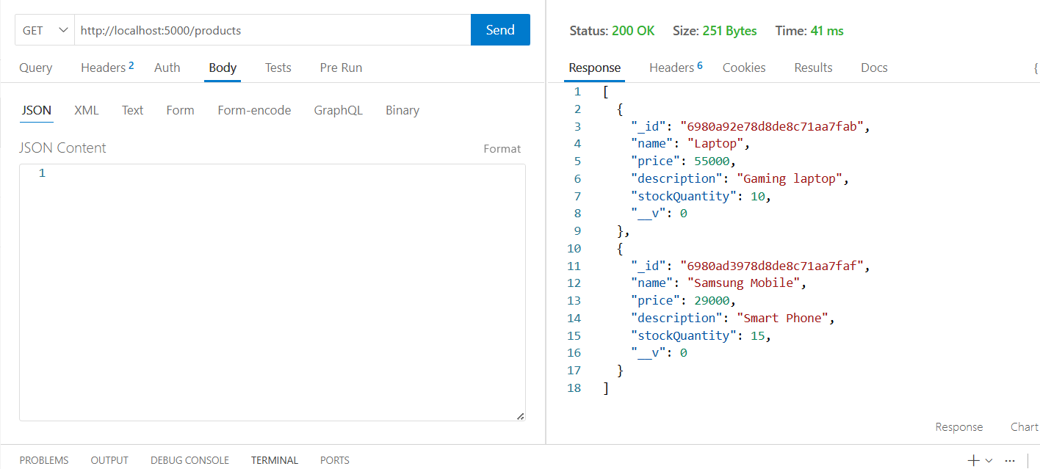
- Product – GET by ID - http://localhost:5000/products/6980a92e78d8de8c71aa7fab 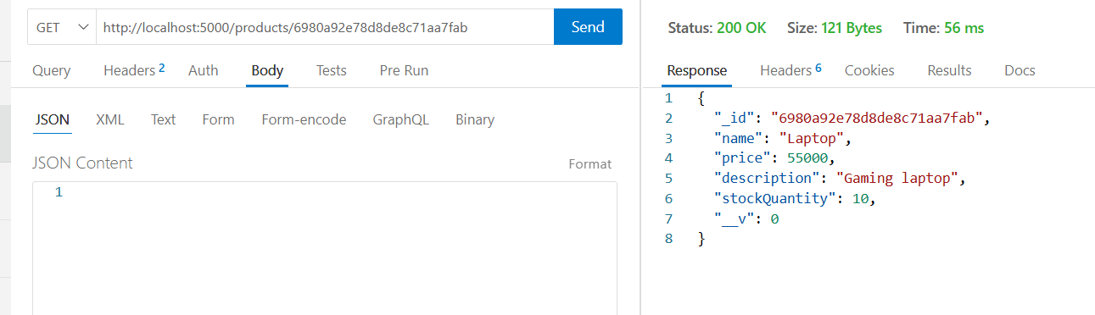
- Cart – POST - http://localhost:5000/cart
{
"productId": "6980a92e78d8de8c71aa7fab",
"quantity": 2
}
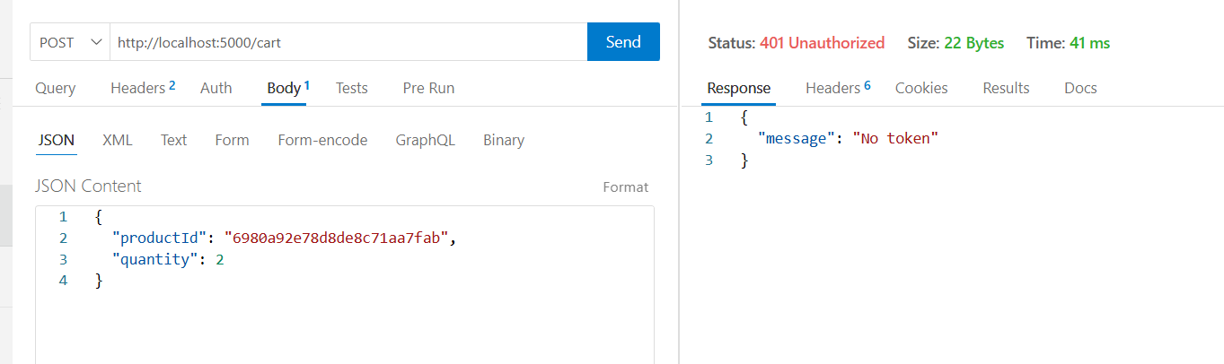
Without Token
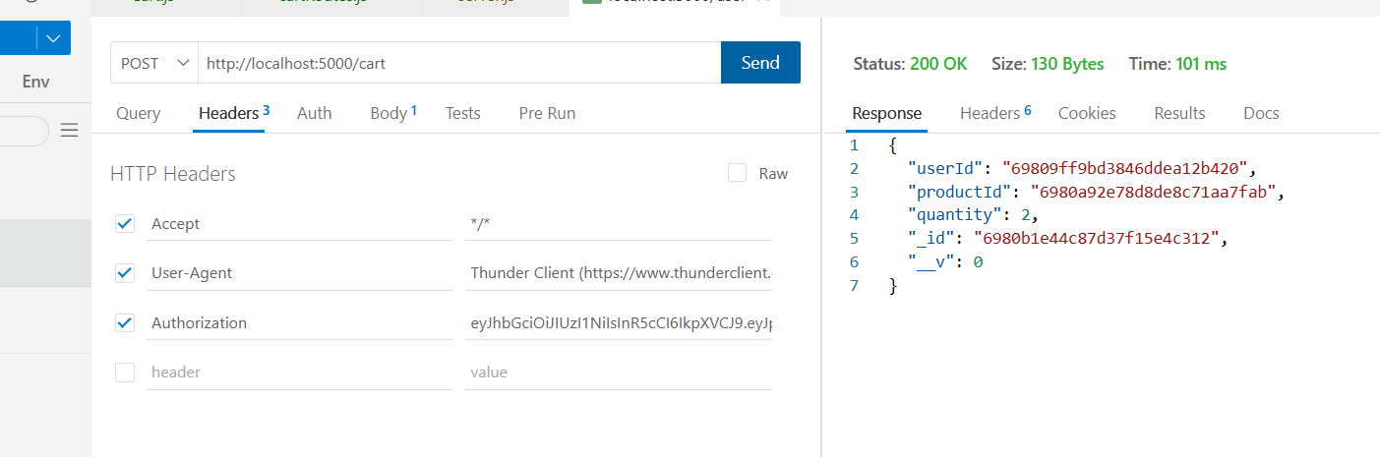
With token in header

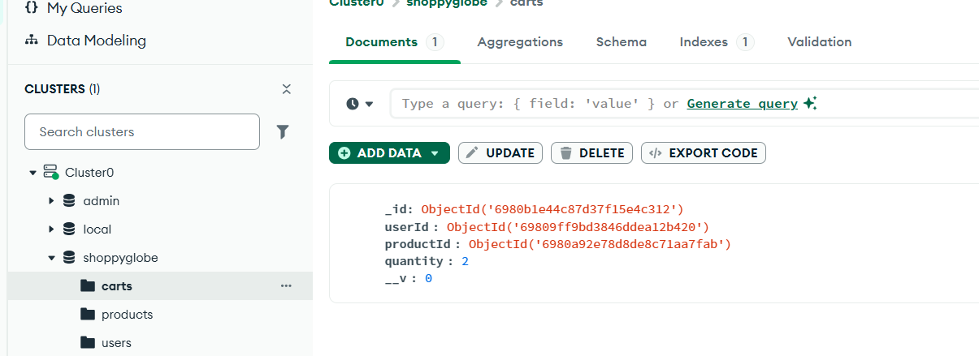

- Cart - PUT – http://localhost:5000/cart/6980b1e44c87d37f15e4c312
{
"quantity": 5
}
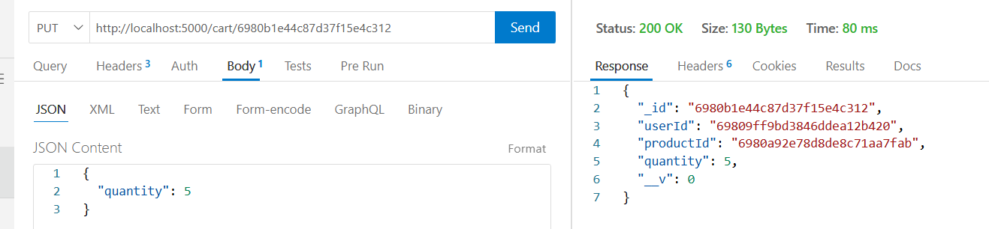

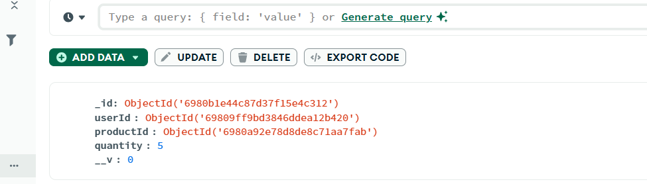
- Cart – DELETE – http://localhost:5000/cart/6980b1e44c87d37f15e4c312

