**SAP Integration Suite   
Cloud Integration - Technical Specification  
 iFlow Name : Get_Data_SV**

Version: 1.0

Author: Generated by AI

Date: 2025-10-24

# Table of Contents

1. Change History

2. Overview

3. High level iFlow Design

4. Message Flow

5. Technical Description

5.1. Main Integration Process

5.2. Local Integration Process

5.3. Sender

5.4. Receiver

5.5. Mappings

5.6. Security

5.7. Groovy Scripts

5.8. Error Handling & Logging

6. Version and Metadata

7. Appendix

# 1. Change History

|  |  |  |  |
| --- | --- | --- | --- |
| **Version** | **Date** | **Author** | **Description** |
| 1.0 | 2025-10-24 | Generated by AI | Initial version |

# 2. Overview

This technical specification document provides a comprehensive overview of the Get_Data_SV iFlow's configuration. It serves as a central repository for key properties and parameters, including namespace mappings, HTTP session handling, logging behavior, and CORS settings. The document details the iFlow's participants (Sender, Receiver, Integration Process) and their respective types. Furthermore, it outlines the configurations of message flows, particularly the OData receiver adapter, including address, authentication method, and query parameters. This documentation aids in understanding the iFlow's design, facilitating troubleshooting, and ensuring consistent deployment and operation.

# 3. High level iFlow Design

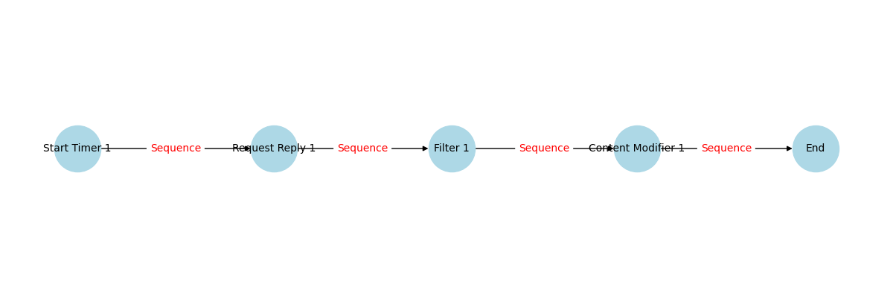

Figure: High level BPMN iFlow message and sequence flow

# 4. Message Flow

|  |  |  |
| --- | --- | --- |
| **Source** | **Target** | **Name** |
| Request Reply 1 | Receiver | OData |

# 5. Technical Description

## 5.1. Main Integration Process

|  |  |  |
| --- | --- | --- |
| **Component Name** | **Key** | **Value** |
| Integration Process | Transaction Timeout | 30 |
| Integration Process | Component Version | 1.2 |
| Integration Process | Cmd Variant Uri | ctype::FlowElementVariant/cname::IntegrationProcess/version::1.2.1 |
| Integration Process | Transactional Handling | Not Required |

### callActivity Filter 1 Properties

|  |  |
| --- | --- |
| **Key** | **Value** |
| Xpath Type | String |
| Wrap Content | /Customers/Customer/CompanyName |
| Component Version | 1.1 |
| Activity Type | Filter |
| Cmd Variant Uri | ctype::FlowstepVariant/cname::Filter/version::1.1.0 |

### serviceTask Request Reply 1 Properties

|  |  |
| --- | --- |
| **Key** | **Value** |
| Component Version | 1.0 |
| Activity Type | ExternalCall |
| Cmd Variant Uri | ctype::FlowstepVariant/cname::ExternalCall/version::1.0.4 |

### endEvent End Properties

|  |  |
| --- | --- |
| **Key** | **Value** |
| Component Version | 1.1 |
| Cmd Variant Uri | ctype::FlowstepVariant/cname::MessageEndEvent/version::1.1.0 |

### callActivity Content Modifier 1 Properties

|  |  |
| --- | --- |
| **Key** | **Value** |
| Body Type | constant |
| Property Table |  |
| Header Table |  |
| Wrap Content |  |
| Component Version | 1.6 |
| Activity Type | Enricher |
| Cmd Variant Uri | ctype::FlowstepVariant/cname::Enricher/version::1.6.1 |

## 5.2. Local Integration Process

No process with id='Process_1' found.

## 5.3. Sender

## 5.4. Receiver

|  |  |
| --- | --- |
| **Key** | **Value** |
| Description |  |
| Pagination | 0 |
| Odata Cert Auth Private Key Alias |  |
| Api Artifact Type |  |
| Provider Auth |  |
| Component N S | sap |
| Resource Path | Customers |
| Custom Query Options |  |
| Metadata Allowed U R I Params |  |
| Name | OData |
| Internet Proxy Type |  |
| Transport Protocol Version | 1.26.0 |
| Proxy Port |  |
| Component S W C V Name | external |
| Enable M P L Attachments | true |
| Receive Time Out | 1 |
| Alias |  |
| Content Type | application/atom+xml |
| Component S W C V Id | 1.26.0 |
| Provider Name |  |
| Message Protocol | OData V2 |
| Direction | Receiver |
| Scc Location Id |  |
| Metadata Allowed Headers |  |
| Component Type | HCIOData |
| Address | https://services.odata.org/V2/northwind/northwind.svc |
| Query Options | $select=CustomerID,CompanyName,ContactName,ContactTitle,Address,City,Region,PostalCode,Country,Phone,Fax |
| Proxy Type | default |
| Is C S R F Enabled | true |
| Component Version | 1.26 |
| Proxy Host |  |
| Edmx File Path | edmx/services_odata_org_V2_northwind_northwind_svc.edmx |
| Provider Url |  |
| Enable T L S Session Reuse | true |
| Odatapagesize |  |
| System | Receiver |
| Authentication Method | None |
| Whitelist Response Headers |  |
| Enable Batch Processing | 0 |
| Transport Protocol | HTTP |
| Character Encoding | none |
| Fields |  |
| Cmd Variant Uri | ctype::AdapterVariant/cname::sap:HCIOData/tp::HTTP/mp::OData V2/direction::Receiver/version::1.26.0 |
| Whitelist Request Headers |  |
| Operation | Query(GET) |
| Message Protocol Version | 1.26.0 |
| Provider Relative Url |  |

## 5.5. Mappings

No mapping activities found in the iFlow.

## 5.6. Security

|  |  |
| --- | --- |
| **Key** | **Value** |
| Namespace Mapping |  |
| Http Session Handling | None |
| Access Control Max Age |  |
| Return Exception To Sender | false |
| Log | All events |
| Cors Enabled | false |
| Exposed Headers |  |
| Component Version | 1.2 |
| Allowed Header List |  |
| Server Trace | false |
| Allowed Origins |  |
| Access Control Allow Credentials | false |
| Allowed Headers |  |
| Allowed Methods |  |
| Cmd Variant Uri | ctype::IFlowVariant/cname::IFlowConfiguration/version::1.2.4 |

## 5.7. Groovy Scripts

No Groovy scripts found in the specified folder.

## 5.8. Error Handling & Logging

No exception subprocesses found in the iFlow.

# 6. Version and Metadata

|  |  |
| --- | --- |
| **Key** | **Value** |
| componentVersion | 1.4 |
| ComponentNS | sap |
| ComponentSWCVName | external |
| ComponentSWCVId | 1.26.0 |

# 7. Appendix

No additional appendix info found in XML.