**SAP Integration Suite   
Cloud Integration - Technical Specification  
 iFlow Name : TEST%2001**

Version: 1.0

Author: Generated by AI

Date: 2025-10-24

# Table of Contents

1. Change History

2. Overview

3. High level iFlow Design

4. Message Flow

5. Technical Description

5.1. Main Integration Process

5.2. Local Integration Process

5.3. Sender

5.4. Receiver

5.5. Mappings

5.6. Security

5.7. Groovy Scripts

5.8. Error Handling & Logging

6. Version and Metadata

7. Appendix

# 1. Change History

|  |  |  |  |
| --- | --- | --- | --- |
| **Version** | **Date** | **Author** | **Description** |
| 1.0 | 2025-10-24 | Generated by AI | Initial version |

# 2. Overview

# 3. High level iFlow Design

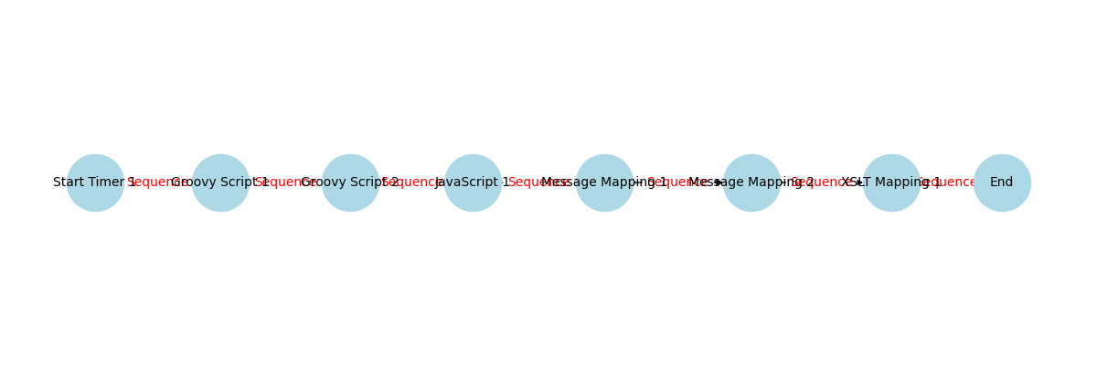

Figure: High level BPMN iFlow message and sequence flow

# 4. Message Flow

# 5. Technical Description

## 5.1. Main Integration Process

|  |  |  |
| --- | --- | --- |
| **Component Name** | **Key** | **Value** |
| Integration Process | Transaction Timeout | 30 |
| Integration Process | Component Version | 1.2 |
| Integration Process | Cmd Variant Uri | ctype::FlowElementVariant/cname::IntegrationProcess/version::1.2.1 |
| Integration Process | Transactional Handling | Not Required |

### callActivity XSLT Mapping 1 Properties

|  |  |
| --- | --- |
| **Key** | **Value** |
| Mappingoutputformat | Bytes |
| Mappinguri | dir://mapping/xslt/src/main/resources/mapping/XSLTMapping1.xsl |
| Mappingname | XSLTMapping1 |
| Mapping Header Name Key |  |
| Mappingpath | src/main/resources/mapping/XSLTMapping1 |
| Mapping Source | mappingSrcIflow |
| Component Version | 1.2 |
| Activity Type | Mapping |
| Cmd Variant Uri | ctype::FlowstepVariant/cname::XSLTMapping/version::1.2.0 |
| Sub Activity Type | XSLTMapping |

### callActivity Groovy Script 1 Properties

|  |  |
| --- | --- |
| **Key** | **Value** |
| Script Function |  |
| Script Bundle Id |  |
| Component Version | 1.1 |
| Activity Type | Script |
| Cmd Variant Uri | ctype::FlowstepVariant/cname::GroovyScript/version::1.1.2 |
| Sub Activity Type | GroovyScript |
| Script | script1.groovy |

### callActivity Groovy Script 2 Properties

|  |  |
| --- | --- |
| **Key** | **Value** |
| Script Function |  |
| Script Bundle Id |  |
| Component Version | 1.1 |
| Activity Type | Script |
| Cmd Variant Uri | ctype::FlowstepVariant/cname::GroovyScript/version::1.1.2 |
| Sub Activity Type | GroovyScript |
| Script | script2.groovy |

### endEvent End Properties

|  |  |
| --- | --- |
| **Key** | **Value** |
| Component Version | 1.1 |
| Cmd Variant Uri | ctype::FlowstepVariant/cname::MessageEndEvent/version::1.1.0 |

### callActivity JavaScript 1 Properties

|  |  |
| --- | --- |
| **Key** | **Value** |
| Script Function |  |
| Script Bundle Id |  |
| Component Version | 1.1 |
| Activity Type | Script |
| Cmd Variant Uri | ctype::FlowstepVariant/cname::JavaScript/version::1.1.2 |
| Sub Activity Type | JavaScript |
| Script | script1.js |

### callActivity Message Mapping 2 Properties

|  |  |
| --- | --- |
| **Key** | **Value** |
| Mappinguri | dir://mmap/src/main/resources/mapping/MM02.mmap |
| Mappingname | MM02 |
| Mapping Source Value |  |
| Mapping Type | MessageMapping |
| Mapping Reference | static |
| Mappingpath | src/main/resources/mapping/MM02 |
| Component Version | 1.3 |
| Activity Type | Mapping |
| Cmd Variant Uri | ctype::FlowstepVariant/cname::MessageMapping/version::1.3.1 |
| Message Mapping Bundle Id |  |

### callActivity Message Mapping 1 Properties

|  |  |
| --- | --- |
| **Key** | **Value** |
| Mappinguri | dir://mmap/src/main/resources/mapping/MM01.mmap |
| Mappingname | MM01 |
| Mapping Source Value |  |
| Mapping Type | MessageMapping |
| Mapping Reference | static |
| Mappingpath | src/main/resources/mapping/MM01 |
| Component Version | 1.3 |
| Activity Type | Mapping |
| Cmd Variant Uri | ctype::FlowstepVariant/cname::MessageMapping/version::1.3.1 |
| Message Mapping Bundle Id |  |

## 5.2. Local Integration Process

No process with id='Process_1' found.

## 5.3. Sender

## 5.4. Receiver

## 5.5. Mappings

### Mapping Activity 1 Properties

|  |  |
| --- | --- |
| **Key** | **Value** |
| mappingoutputformat | Bytes |
| mappinguri | dir://mapping/xslt/src/main/resources/mapping/XSLTMapping1.xsl |
| mappingname | XSLTMapping1 |
| mappingHeaderNameKey |  |
| mappingpath | src/main/resources/mapping/XSLTMapping1 |
| mappingSource | mappingSrcIflow |
| componentVersion | 1.2 |
| activityType | Mapping |
| cmdVariantUri | ctype::FlowstepVariant/cname::XSLTMapping/version::1.2.0 |
| subActivityType | XSLTMapping |

### Mapping Activity 2 Properties

|  |  |
| --- | --- |
| **Key** | **Value** |
| mappinguri | dir://mmap/src/main/resources/mapping/MM02.mmap |
| mappingname | MM02 |
| mappingSourceValue |  |
| mappingType | MessageMapping |
| mappingReference | static |
| mappingpath | src/main/resources/mapping/MM02 |
| componentVersion | 1.3 |
| activityType | Mapping |
| cmdVariantUri | ctype::FlowstepVariant/cname::MessageMapping/version::1.3.1 |
| messageMappingBundleId |  |

### Mapping Activity 3 Properties

|  |  |
| --- | --- |
| **Key** | **Value** |
| mappinguri | dir://mmap/src/main/resources/mapping/MM01.mmap |
| mappingname | MM01 |
| mappingSourceValue |  |
| mappingType | MessageMapping |
| mappingReference | static |
| mappingpath | src/main/resources/mapping/MM01 |
| componentVersion | 1.3 |
| activityType | Mapping |
| cmdVariantUri | ctype::FlowstepVariant/cname::MessageMapping/version::1.3.1 |
| messageMappingBundleId |  |

## 5.6. Security

|  |  |
| --- | --- |
| **Key** | **Value** |
| Namespace Mapping |  |
| Http Session Handling | None |
| Access Control Max Age |  |
| Return Exception To Sender | false |
| Log | All events |
| Cors Enabled |  |
| Exposed Headers |  |
| Component Version | 1.2 |
| Allowed Header List |  |
| Server Trace | false |
| Allowed Origins |  |
| Access Control Allow Credentials |  |
| Allowed Headers |  |
| Allowed Methods |  |
| Cmd Variant Uri | ctype::IFlowVariant/cname::IFlowConfiguration/version::1.2.3 |

## 5.7. Groovy Scripts

No Groovy scripts found in the specified folder.

## 5.8. Error Handling & Logging

No exception subprocesses found in the iFlow.

# 6. Version and Metadata

|  |  |
| --- | --- |
| **Key** | **Value** |
| componentVersion | 1.3 |

# 7. Appendix

|  |  |
| --- | --- |
| **Key** | **Value** |
| mappingoutputformat | Bytes |
| mappinguri | dir://mapping/xslt/src/main/resources/mapping/XSLTMapping1.xsl |
| mappingname | XSLTMapping1 |
| mappingpath | src/main/resources/mapping/XSLTMapping1 |
| mappingSource | mappingSrcIflow |
| mappinguri | dir://mmap/src/main/resources/mapping/MM02.mmap |
| mappingname | MM02 |
| mappingType | MessageMapping |
| mappingReference | static |
| mappingpath | src/main/resources/mapping/MM02 |
| mappinguri | dir://mmap/src/main/resources/mapping/MM01.mmap |
| mappingname | MM01 |
| mappingType | MessageMapping |
| mappingReference | static |
| mappingpath | src/main/resources/mapping/MM01 |