*&---------------------------------------------------------------------*  
*&---------------------------------------------------------------------*  
*&  
*&---------------------------------------------------------------------*  
*& Developer's Name:   280407   : Srija Vanam  
**                     280406   : Rajavardhan Reddy Kadapa             *  
*&                                                                     *  
*& Object Description: Create Sales Contract using BAPI  
*&                                                                     *  
*&                                                                     *  
*&                                                                     *  
*&                                                                     *  
*&---------------------------------------------------------------------*  
  
  
  
*&---------------------------------------------------------------------*  
REPORT ZG05_OOALV_INT MESSAGE-ID Z280407_SRI_MSG.  
  
*&---------------------------------------------------------------------*  
*&    TOP INCLUDE FOR DECLARATIONS  
*&---------------------------------------------------------------------*  
INCLUDE ZSRIJA_TEST1_TOP.  
  
*&---------------------------------------------------------------------*  
*&    INCLUDES FOR SELECTION SCREEN  
*&---------------------------------------------------------------------*  
INCLUDE ZALV_SELECTION_SCREEN.  
  
  
*&---------------------------------------------------------------------*  
*&    INCLUDES FOR LINE ITEMS  
*&---------------------------------------------------------------------*  
INCLUDE ZALV_ITEMS.  
  
  
*&---------------------------------------------------------------------*  
*&    INCLUDE FOR SALES_ORDER  
*&---------------------------------------------------------------------*  
INCLUDE ZALV_HEADER.

*&---------------------------------------------------------------------*  
*& Include          ZSRIJA_INCLUDE_TOP  
*&---------------------------------------------------------------------*  
  
  
**TOP INCLUDES FOR DECLARATIONS:**

*&---------------------------------------------------------------------*  
*& Top include  declarations  
*&---------------------------------------------------------------------*  
  
  
  
data : i_container  type ref to cl_gui_custom_container,        "CL_GUI_CUSTOM_CONTAINER for first alv  
       i_grid       type ref to cl_gui_alv_grid,                "CL_GUI_ALV_GRID for first alv  
       i_container2 type ref to cl_gui_custom_container,        "cl_gui_custom_container for second alv  
       i_grid2      type ref to cl_gui_alv_grid,                "CL_GUI_ALV_GRID for first alv it_tab2 type table of zg05_item,                    " IT_TAB2 FOR VBAP TABLE  
       wa_tab2      type zg05_item,                             "work area for line items  
       it_tab5      type table of zg05_header,                  "internal table for headers  
       wa_tab5      type zg05_header,                           "work area for headers  
       it_tab2      type table of zg05_item.                    "internal table for line items  
  
data : lv_erdat type vbak-erdat,  
       lv_vbeln type vbak-vbeln,  
       lv_var   type vbeln_va,  
       lv_con_no type zg05_table1-contract_num.

**SELECTION SCREENS:**

*&---------------------------------------------------------------------*  
*& Include          ZALV_SELECTION_SCREEN  
*&---------------------------------------------------------------------*  
  
  
  
*&---------------------------------------------------------------------*  
*& Selection screens with input screen-designs  
*&---------------------------------------------------------------------*  
  
  
selection-screen begin of block b1.  
  select-options p_erdat for lv_erdat. " select options for contract date  
selection-screen end of block b1.  
  
  
selection-screen begin of block b2.  
  select-options s_con_no for lv_vbeln.  " Select option for Contract number  
selection-screen end of block b2.  
  
  
  
*&---------------------------------------------------------------------*  
*& Input screen validations  
*&---------------------------------------------------------------------*  
  
at selection-screen on block b1.  
*****validate the user inputs at selection screen event  
  
  select single erdat from vbak into lv_erdat  
    where erdat in p_erdat.  
  
  if sy-subrc is not initial. " if the table is empty or sy-subrc = 4  
    message e000.  
  endif.  
  
  
 at selection-screen on block b2.  
******* validate the user inputs at selection screen event  
  select single contract_num from zg05_table1 into lv_con_no  
      where contract_num in s_con_no.  
  
  if sy-subrc is not initial." if the table is empty or sy-subrc = 4  
    message e000.  
  endif.

**INCLUDE FOR LINE ITEMS:**

*&---------------------------------------------------------------------*  
*& Include          ZALV_IMPLEMENTATION  
*&---------------------------------------------------------------------*  
  
  
  
*&---------------------------------------------------------------------*  
*&  class defination for the double-click  
*&---------------------------------------------------------------------*  
  
class lcl_alv_inter definition.  
  public section.  
    methods : handle_double_click for event double_click of cl_gui_alv_grid  importing e_row.  
  
endclass.  
  
  
*&---------------------------------------------------------------------*  
*&   class implementation of double click  
*&---------------------------------------------------------------------*  
  
class lcl_alv_inter implementation.  
*-------------------------------------------------------------------------------------------------*  
  method handle_double_click.  
    " Implementation for handle_double_click method  
    read table it_tab5 into wa_tab5 index e_row-index.  
    select  
       vbeln  
       matnr  
       posnr  
       arktx  
       kwmeng  
       netpr  
       vstel  
       into corresponding fields of table it_tab2 from vbap  
                     where vbeln = wa_tab5-vbeln.  
    loop at it_tab2 into wa_tab2.  
      lv_var = wa_tab2-vbeln.  
    endloop.  
    if it_tab2 is initial.  
      message text-001 type 'I'.  
    else.  
      call screen 200.  
    endif.  
  endmethod.  
endclass.  
  
*----------------------------------------------------------------------*  
*&---------------------------------------------------------------------*  
*& Module STATUS_0200 OUTPUT  
*&---------------------------------------------------------------------*  
*&  
*&---------------------------------------------------------------------*  
module status_0200 output.  
  set pf-status  space.  
  "SET TITLEBAR 'xxx'.  
endmodule.  
  
*&---------------------------------------------------------------------*  
*&      Module  USER_COMMAND_0200  INPUT  
*&---------------------------------------------------------------------*  
*       text  
*----------------------------------------------------------------------*  
  
  
module user_command_0200 input.  
  case sy-ucomm.  
    when 'BACK'.  
      leave to screen 0.  
  endcase.  
  
*&---------------------------------------------------------------------*  
************************ABAP System Fields******************************  
*----------------------------------------------------------------------*  
  
  case sy-ucomm.  
    when 'FORM'.  
  
      export  lv_var to memory id 'Z08'.  
  
      submit zg05_adobe_form_prog and return.  
  
  endcase.  
endmodule.  
  
*&---------------------------------------------------------------------*  
*& Module LINE_ITEM OUTPUT  
*&---------------------------------------------------------------------*  
*&  
*&---------------------------------------------------------------------*  
module line_item output.  
  
  if  i_container2 is initial.  
    create object i_container2  
      exporting  
        container_name = 'CNT2'.  
  
  endif.  
  create object i_grid2  
    exporting  
      i_parent = i_container2.  
  
  
  data :  
        it_fcat2 type lvc_t_fcat.  
  
  call method i_grid2->set_table_for_first_display  
    exporting  
      i_structure_name = 'ZG05_ITEM'  
    changing  
      it_outtab        = it_tab2  
      it_fieldcatalog  = it_fcat2.  
  
endmodule.

**INCLUDE FOR SALES ORDER:**

*&---------------------------------------------------------------------*  
*& Include          ZALV_SCREEN_EVENTS  
*&---------------------------------------------------------------------*  
  
  
START-OF-SELECTION.  
  
CALL SCREEN 0100.  
  
*&---------------------------------------------------------------------*  
*& Module STATUS_0100 OUTPUT  
*&---------------------------------------------------------------------*  
*&  
*&---------------------------------------------------------------------*  
MODULE status_0100 OUTPUT.  
 SET PF-STATUS SPACE.  
  
ENDMODULE.  
*&---------------------------------------------------------------------*  
*&      Module  USER_COMMAND_0100  INPUT  
*&---------------------------------------------------------------------*  
*       text  
*----------------------------------------------------------------------*  
MODULE user_command_0100 INPUT.  
 CASE sy-ucomm.  
    WHEN 'BACK'.  
      LEAVE TO SCREEN 0.  
  ENDCASE.  
ENDMODULE.  
  
*&---------------------------------------------------------------------*  
*& Module GET_SALES_ORDER OUTPUT  
*&---------------------------------------------------------------------*  
*&  
*&---------------------------------------------------------------------*  
MODULE get_sales_order OUTPUT.  
SELECT  
       vbak~vbeln,  
       vbak~auart,  
       vbak~erdat,  
       vbak~ernam,  
       vbak~vkorg,  
       vbak~vtweg,  
       vbak~bstnk  
  INTO TABLE @it_tab5  
  FROM vbak  
  INNER JOIN ZG05_TABLE1 ON ZG05_TABLE1~contract_num = vbak~vbeln   .  
  "WHERE ZG05_TABLE1~bstnk = vbak~bstnk.  
  
ENDMODULE.  
  
  
MODULE display_alv1 OUTPUT.  
  
    CREATE OBJECT i_container  
    EXPORTING  
      container_name              = 'CNT1'  
      .  
  
  CREATE OBJECT i_grid  
    EXPORTING  
      i_parent          = i_container  
      .  
  
DATA : it_fcat TYPE lvc_t_fcat.  
  
" Populate field catalog  
CALL FUNCTION 'LVC_FIELDCATALOG_MERGE'  
  EXPORTING  
    i_structure_name = 'ZG05_HEADER'  
  CHANGING  
    ct_fieldcat      = it_fcat  
  EXCEPTIONS  
    others           = 1.  
IF  sy-subrc <> 0.  
*implemnet error code  
  
ENDIF.  
  
  
  
DATA i_handler TYPE REF TO lcl_alv_inter.  
  
  CREATE OBJECT i_handler.  
  
  SET HANDLER : i_handler->handle_double_click FOR i_grid.  
  
CALL METHOD i_grid->set_table_for_first_display  
  CHANGING  
    it_outtab                     = it_tab5  
    it_fieldcatalog               = it_fcat  
        .  
  
ENDMODULE.

**SELECTION SCREEN INPUT:**

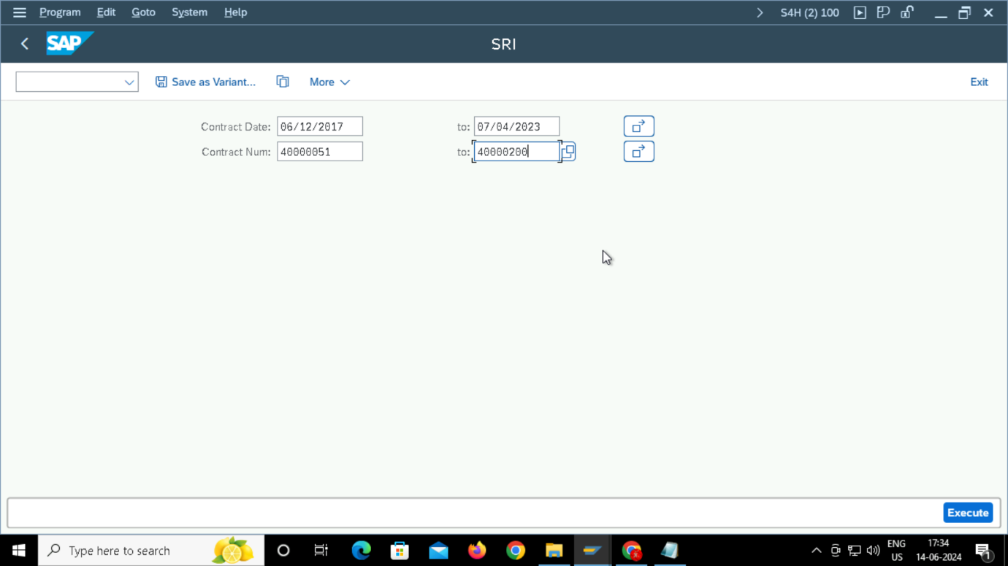

**OOALV INTERACTIVE OUTPUT:**

**AFTER CLICKING ON THE “GENERATE FORM” WE ARE GOING TO GET THE ADOBE FORM FOR THE PARTICULAR CONTRACT NUMBER**

