1. **FIRST PAGE OUTPUT WITH HEADER ITEMS , LINE ITEMS, LOGO, PAGE NUMBER, HEADING WITH PAGE BY PAGE LAYOUT.**

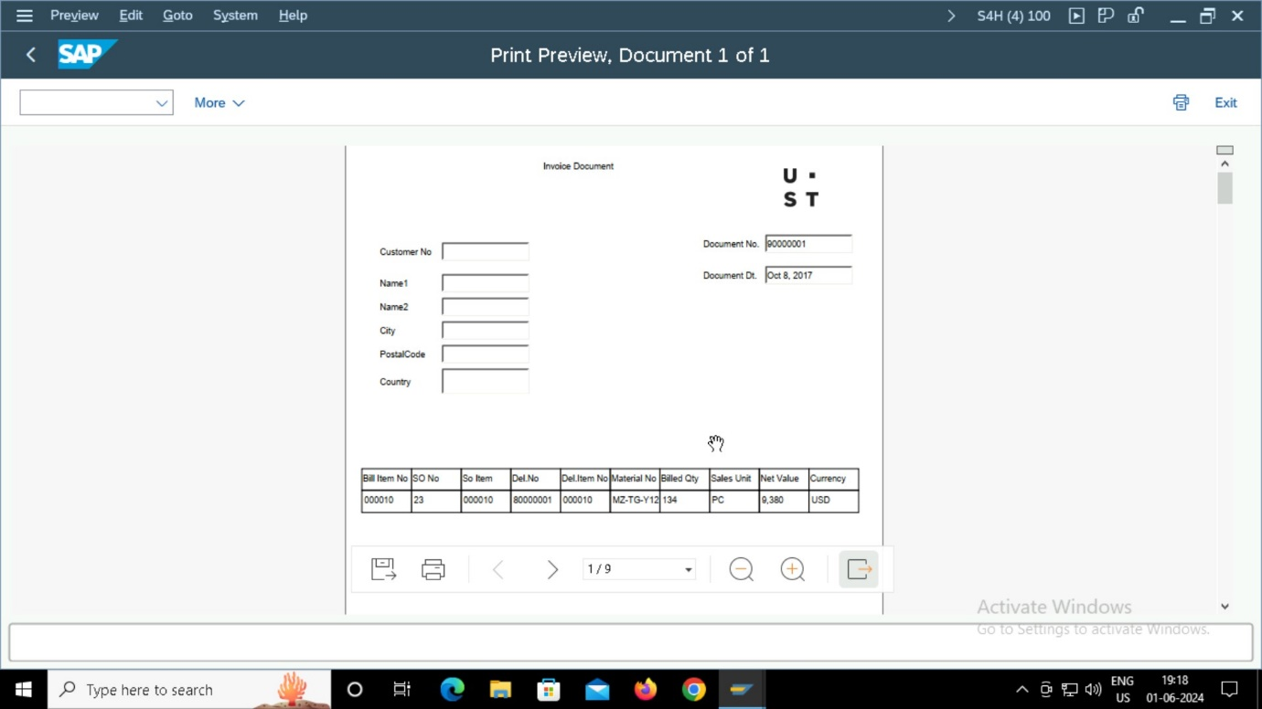

1. A screenshot of a computer

   Description automatically generated

**SELECTION SCREEN:**

