**Datasets:**

[**https://dj2taa9i652rf.cloudfront.net/**](https://dj2taa9i652rf.cloudfront.net/)

* **Enigma_jhud.**
* **Enigma_nytimes_data_in_usa.**
* **Rearc_covid_19_testing_data.**
* **Rearc_usa_hospital_beds.**
* **Static_datasets.**

**Overview:**

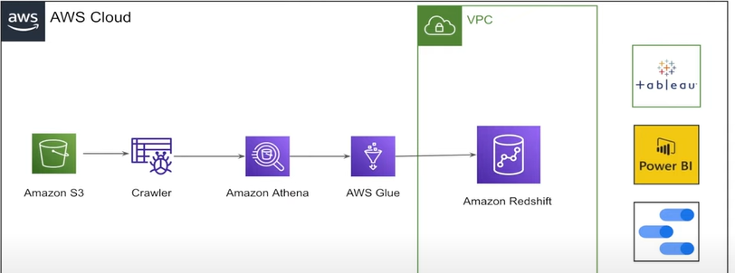

**DATA MODEL:**

