1. Find 675^307 mod 713

Lets look at the ring Z713. It is clear that 675 is equivalent to '-38' in this ring. Therefore we can write;

(-38)^307 == 675^307 mod 713.

-38\*-38 is equal to 18 mod 713, therefore, we can instead of write;

-38\*(18)^153

Next we can write this as -38\*(18^3)^51 . 18^3 = 128 mod 713.. so we get;

-38\*(128)^51 == 675^307 mod 713

The result is 3.

2. With a relation on {0,1,2,3}. Draw directed graph for each relation and indicate which relation are Antisymmetric.

R = {(0,0), (0,2), (1,0), (1,3), (2,2), (3,0), (3,1)}.

Let A={1,2,3}  
A relation R on A is defined as R={(1,2),(2,1)}.  
It is seen that (1,1),(2,2),(3,3)∈/R.  
∴R is not reflexive.  
Now, as (1,2)∈R and (2,1)∈R, then R is symmetric.  
Now, (1,2) and (2,1)∈R  
However,  
(1,1)∈/R  
∴R is not transitive.  
Hence, R is symmetric but neither reflexive nor transitive.

3. Consider the “subset” relation on P(S) for the following sets S.

Draw the Hasse diagram of s = {0,1}

DEFINITIONS

The power set of S is the set of all subsets of S

Notation: P(S)

X is a subset of Y if every element of X is also an element of Y.

Notation: X $⊆$ Y

SOLUTION

S=({0,1}

Let us first determine the power set, which contains all subsets of S.

P(S) = {$∅$,{0},{1}, {0,1)}

Let R represent the subset relation on A, which means that (B, C) ∈ R if B $⊆$ C

R = {($∅, ∅$), ($∅$, {0}) ($∅$, {1}), ($∅$, {0, 1}), ({0}, {0}), ({0}, {0, 1}), ({1}, {1}), ({1}, {0, 1}), ({0, 1}, {0,1})}

We note that P(S) contains 4 elements and thus we wil draw 4 points.

We labelt these points $∅$, {0}, {1}, {0, 1} (which are the elements of P(S)

For every element (x, y) ∈ R with x $≠$ y, we draw an arrow from x to y.

For every element (x, x) ∈ R, we draw a loop at the point x:

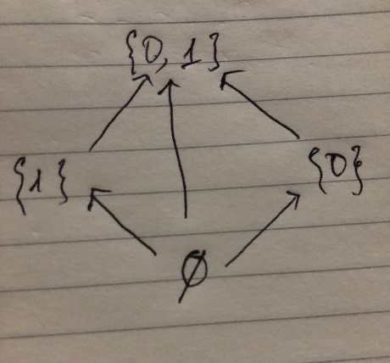

In the directed graph, we remove:

* the loops at all vertices
* all arrows which are impties by transitivity
* the direction on the arrows

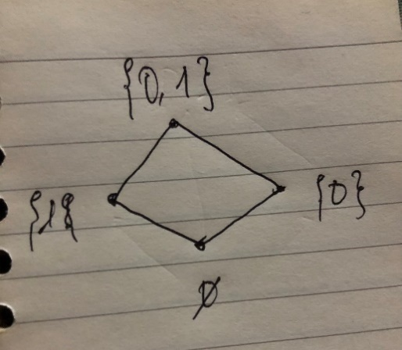

4. Consider the “divides” relation on each of the f sets A. Draw the Hasse Diagram for each relation. A = {1,2,4,5,10,15,20}

Solution.

Recall that the Hasse diagram of a partial order relation R over X is the graph whose vertices are given by X and there is an edge that goes upward from x to y whenever y covers x, i.e.,x≤ y, x 6= y, and there is no z such that x ≤ z with x 6= z and y 6= z. Note that 1 divides all the elements of X. However, there will be a line from 1 to 2 and 5 because they the remaining numbers are divisible by them. In the same way, one can see that 4 covers 2, 10 covers 5, 15 covers 5, 20 covers 4 and 10, and 10 covers 2. Therefore, the Hasse diagram is the following:

