Programming Exercise
Questions
- What change was needed for the app to now respond to class to http://localhost:5000/tasks instead of http://localhost:5000/students?
- To respond to http://localhost:5000/tasks, I simply changed the route in the Flask app from /students to /tasks. This tells Flask to listen for requests made to the new /tasks endpoint.

In Flask, the endpoint a route responds to is determined by the string argument provided to the @app.route() decorator. Initially, if the route was defined as @app.route('/students'), Flask would only respond to HTTP calls made to /students. By updating this to @app.route('/tasks'), the server is now configured to handle requests to /tasks. This change is essential for aligning the API design with the purpose of the application—managing tasks. Clear and meaningful endpoint naming also improves readability and maintainability of RESTful APIs.

- What code did you use to list the tasks in the GET operation?
- Here’s the code used to list all tasks (task name: status):
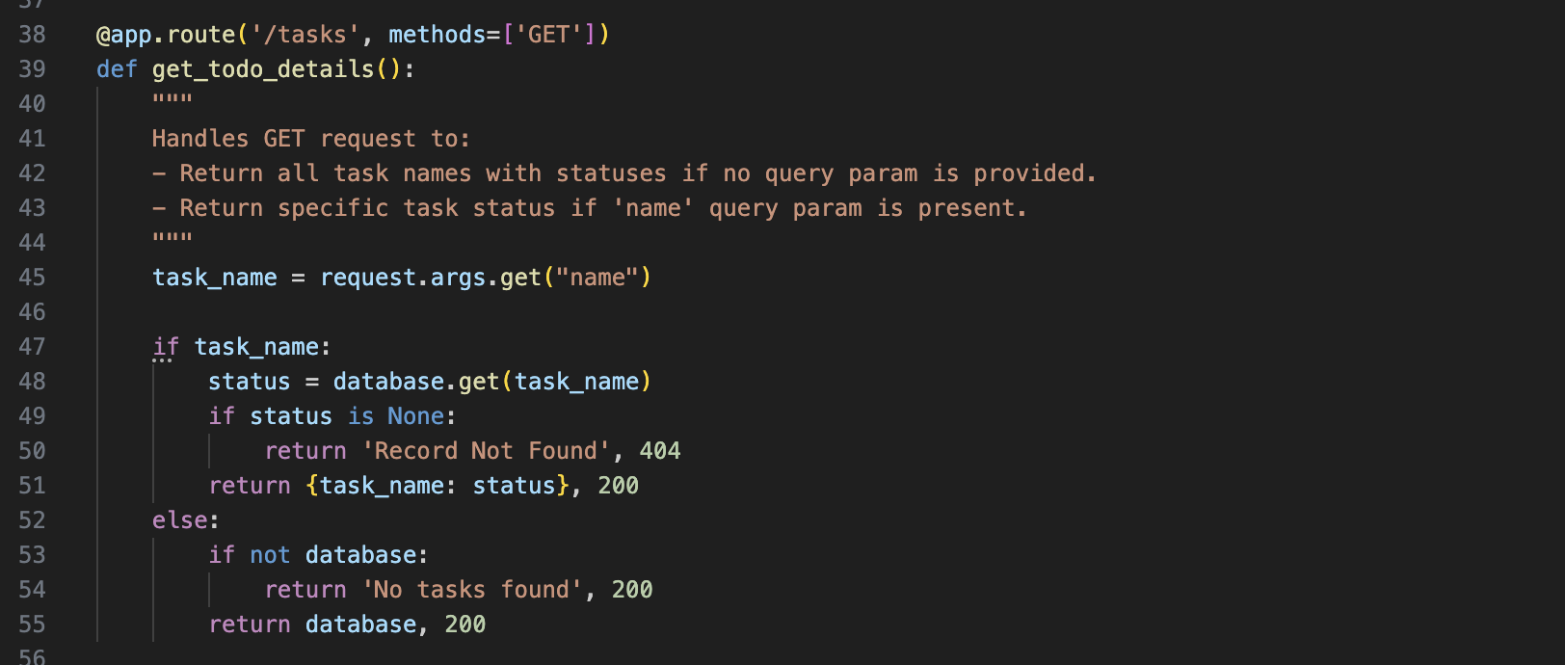
This GET endpoint serves two purposes. When no query parameter is passed, it returns all existing tasks from the in-memory database dictionary in a simple key-value format (task_name: status). If a query parameter is provided (?name=taskName), it fetches and returns only that specific task. This dual functionality adds flexibility and efficiency to the endpoint. The use of request.args.get("name") helps in conditionally tailoring the response, making the API adaptable to both general and targeted data retrieval.

- What status code does the following call return?
http://localhost:5000/tasks/get
- 404 Not Found
The URL http://localhost:5000/tasks/get results in a 404 Not Found error because there is no defined route in the Flask app for /tasks/get. Flask only recognizes the exact paths that have been decorated with @app.route(). In this app, we have /tasks, not /tasks/get. RESTful API design relies on HTTP methods (GET, POST, etc.) rather than action words in the URL (like /get). Hence, accessing an undefined route like this will always return a 404 unless explicitly handled.

