**Software Project Management Plan for “Tender Management System”**

**Bachelor of Technology**

**Computer Science and Engineering**

Submitted By

ANUVAB CHAKRAVARTY (13000121036)

SEPTEMBER 2023



**Techno Main**

**EM-4/1, Sector-V, Salt Lake**

**Kolkata- 700091**

**West Bengal**

**India**

**Table of Contents**

1. Introduction 3

I. Project Overview 3

II. Project Deliverables 3

III. Evolution of this document 4

IV. References 4

V. Definitions, Acronyms, and Abbreviations 4

2. Project Organization 4

I. Process Model 5

II. Organizational Structure 5

III. Organizational Boundaries and Interfaces 6

IV. Project Responsibilities 6

3. Managerial Process 7

I. Management Objectives and Priorities 7

II. Assumptions, Dependencies, and Constraints 7

III. Risk Management 8

IV. Monitoring and Controlling Mechanisms 9

4. Technical Process 9

I. Methods, Tools, and Techniques 9

II. Software Documentation 9

III. Project Support Functions 9

5. Work Elements, Schedule, and Budget 9

6. Conclusion 10

7. References 11

Software Project Management Plan for “Tender Management System”

# Introduction

For the Tender Management System (TMS) project, the primary objective is to develop a robust electronic procurement platform. This software application will encompass a minimum of three core functionalities that seamlessly communicate over the internet. The core features of the system will encompass fundamental e-commerce operations, including user authentication, product catalog browsing, and bidding and procurement activities. The development approach for the entire system will prioritize the use of the Python programming language using Flask for the Backend, with a strong emphasis on maintainability and scalability, ensuring that future enhancements can be seamlessly integrated.

## Project Overview

The project is to create a comprehensive initiative aimed at designing and developing an efficient digital platform for streamlined tender procurement processes. The TMS will facilitate the entire tender lifecycle, from announcement and document submission to evaluation and awarding. It will harness advanced technologies and intuitive interfaces to enhance user experience and ensure transparency and compliance. This project endeavors to revolutionize tender management, improving efficiency and accountability, while offering a user-friendly interface for both buyers and suppliers. The TMS represents a pivotal step towards modernizing and digitizing our procurement operations, ultimately reducing costs, saving time, and fostering a more competitive and fair tendering environment.

## Project Deliverables

1. Preliminary Project Plan 10.09.2023

2. Requirements Specification 30.09.2023

3. Analysis [Object model, Dynamic model, and User interface] 15.10.2023

4. Architecture Specification 26.10.2023

5. Component/Object Specification 11.11.2023

6. Source Code 18.12.2023 - 31.01.2024

7. Test Plan 01.02.2024 - 27.02.2024

8. Final Product Demo 15.03.2024 - 20.03.2024

## Evolution of this document

This document will be updated as the project progresses. Updates should be expected in the following sections:

1. ***References*** - updated as necessary.
2. ***Definitions, acronyms, and abbreviations*** - updated as necessary.
3. ***Organizational Structure*** will be updated as the team leaders are assigned for each phase.
4. ***Technical Process -*** this section will be revised appropriately as the requirements and design decisions become clearer.
5. ***Schedule –*** as the project progresses, the schedule will be updated accordingly.

**Revision History**

|  |  |  |  |
| --- | --- | --- | --- |
| **Revision** | **Date** | **Updated By** | **Update Comments** |
| 0.1 | 07.08.2023 | Anuvab Chakravarty | First Draft |
| 0.2 | 06.09.2023 | Anuvab Chakravarty | Second Draft/Final Draft |

## References

* "Software Engineering: A Practitioner's Approach" by Roger S. Pressman
* "Agile Software Development, Principles, Patterns, and Practices" by Robert C. Martin

## Definitions, Acronyms, and Abbreviations

1. TMS – Tender Management System
2. UML - Unified Modeling Language
3. AD - Architectural Design
4. ADD - Architectural Design Document
5. ATP - Acceptance Test Plan Client Monitor, Agent or Submitter
6. DD - Detailed Design
7. DDD - Detailed Design Document
8. PM - Project Manager
9. QAM - Quality Assurance Manager
10. SM - Senior Management SPMP Software Project Management Plan (this document)
11. SR - Software Requirements
12. STP - Software Test Plan Submitter Application that submits jobs to dispatchers

# Project Organization

## Process Model

The process used for this project will be a V-model such that each stage of the model allows us to do testing after completing a phase. Referring to the diagram below, each phase is tested after completion.

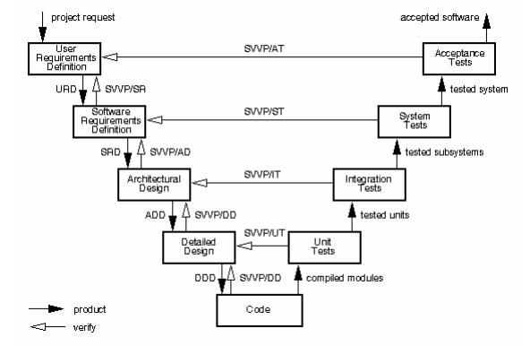

## Organizational Structure

Team Members –

* + 1. Anuvab Chakravarty
    2. Arif Ali

|  |  |  |
| --- | --- | --- |
| **Name** | **Organization/**  **Position** | **Contact Information** |
| Anuvab Chakravarty | Project Manager | [anucbs2018@gmail.com](mailto:jrdnsegundo@gmail.com)  +91-8334999569 |
| Arif Ali | Business Analyst | Arifali2015@gmail.com  09468847142 |

|  |  |  |  |
| --- | --- | --- | --- |
| **Days** | **Deliverable** | **Team Leader** | **Deliverable Description** |
| 4 | 1 | Anuvab Chakravarty | Project Plan |
| 20 | 2 | Arif Ali | Requirements Specification |
| 15 | 3 | Anuvab Chakravarty | Analysis |
| 11 | 4 | Arif Ali | Architecture Specification |
| 37 | 5 | Anuvab Chakravarty | Component/Object Specification |
| 47 | 6 | Anuvab Chakravarty | Source Code |
| 26 | 7 | Arif Ali | Test Plan |
| 5 | 8 | Anuvab Chakravarty | Final Deliverable |

## Organizational Boundaries and Interfaces

Team leaders throughout each development of the phases will be responsible for coordinating team meetings, updates, communications, and team deliverables.

## Project Responsibilities

For the most vital responsibilities per phase of each team members, please refer to segment 2.2. Ultimately the project team is responsible for the successful delivery of the product. The team member tasks per deliverable according to expertise and the phases are as given below:

1. Project Plan – Whole Team
2. Requirements Specification – Arif Ali
3. Analysis – Anuvab Chakravarty
4. Architecture Specification – Arif Ali
5. Component/Object Specification – Anuvab Chakravarty
6. Source Code – Anuvab Chakravarty
7. Test Plan – Arif Ali
8. Final Deliverable – Entire Team

|  |  |  |
| --- | --- | --- |
| **Name** | **Organization/**  **Position** | **Role/Responsibilities** |
| Anuvab Chakravarty | Project Manager | * Managing and leading the project team. * Developing and maintaining a detailed project plan. * Monitoring project progress and performance. * Managing project evaluation and dissemination activities. * **Develop corrective actions when necessary.** |
| Arif Ali | Business Analyst | * Prepare reports on project plans, status, progress, risks, deadlines and resource requirements. * Develop and perform work flow analysis to find out the difficulties in reaching goals. * Provide project cost estimates. |
| Anuvab Chakravarty | Designer | * Propose effective design solutions to meet project goals. * Prepare design layouts and sketches according to company design standards. * Keeping of records and files. |
| Arif Ali | Staff | * Documentation of daily activities. * Making kick-off meeting reports. * In-charge of materials needed for team building activities. |

# Managerial Process

## Management Objectives and Priorities

The management objective is to deliver the product in time and of high quality. The PM and QAM work together to achieve this by respectively checking that progress is made as planned and monitoring the quality of the product at various stages.

## Assumptions, Dependencies, and Constraints

In this project plan, a number of factors are taken into account. The following list shows the way milestones on various project phases have been scheduled:

• The team budget of 2 persons x 4593.6 hours = 9187.2 hours

• The project deadline of 20th March, 2024.

• The final presentation is on 15th March, 2024.

• The peer evaluation deadline is on 31st January, 2024.

• Other days the weekends holiday is closed.

NOTE: Due to the deadline of 20th March 2024, running out of time will have its reflection on the product, and not on the duration of the project. By assigning a priority to every user requirement, a selection can be made of user requirements that may be dropped out if time runs out.

## Risk Management

This section mentions any potential risks for the project. Also, schedules or methods are defined to prevent or to reduce the risks as below:

1. Technology risk
2. People risk
3. Financial risk
4. Market risk
5. Structure/process risk

The following are the possible risks to be encountered during the development of the project and how they can be prevented.

1. Miscommunication

*Prevention*: Team members should not hesitate to ask and re‐ask questions if things are unclear. Team members should have a written copy of the tasks assigned to them every meeting.

*Correction*: When it becomes clear that miscommunication is causing problems, the team members should gather in a meeting to clear things up.

1. Time shortage

*Prevention*: Care is taken to plan enough spare time.   *Correction*: When tasks fail to be finished in time or when they are finished earlier than planned the project planning is adjusted

1. Illness or absence of team members

*Prevention*: Team members should warn their team leader or the PM timely before a planned period of absence.

*Correction*: Work can be taken over quickly by someone else or be distributed among the team members if a person gets ill.

**Monitoring and Controlling Mechanisms:**

The monitoring of progress is done by the PM using the following means:

**Project Kick-off Meetings**

The project group meetings take place within the class room or through chat. These meetings are meant to inform each other of the progress made on various tasks and to assign new tasks.

**Progress Report**

Progress report is done every Friday. This is meant to inform and show the progress in the development of the project and how things are going.

## Monitoring and Controlling Mechanisms

The monitoring of progress is done by the PM using the following means:

1. Weekly project status meetings
2. Shared document repository
3. Project tracking by MS project plan
4. Tracking utilizing baselines in MS project

# Technical Process

## Methods, Tools, and Techniques

The project will be implemented utilizing V-model methodology, and tools such as Dreamweaver, Microsoft Project, Star UML, Java, MySQL, QTP, and Load Runner will be utilized. The risks for each category are listed to complete the project successfully. For each risk, a description, a probability of occurrence, the associated action and the impact of the risk are given.

## Software Documentation

Documentation such as Project Charter, Business Requirement Document, Functional Specification document, Cost Benefit Analysis, Technical Specification document, Detail Design Document, Test Plan, Implementation Plan, Detailed Project Report, and Benefit Realization document.

## Project Support Functions

All project support documents will be completed in applicable phases.

# Work Elements, Schedule, and Budget

1. The project is accounted for project resources, technologies and tools required to whole analysis, implementation, and test of the application.
2. The project lead will be rotated for each phase within 2 team members.
3. The document for all phases will be revised in subsequent phases if applicable.

Budget and Resource Allocation

Salary 2,00,000.00

Office Operations/Supplies/Equipment/Consumables 80,000.00

Miscellaneous 30,000.00

**Total**  **Rs. 3,10,000.00**

**Schedule:**

|  |  |  |  |
| --- | --- | --- | --- |
| Identify The Company | 4 days | Wed 6/9/23 | Tue 12/9/23 |
| Conceptualize the project | 1 day | Tue 12/9/23 | Wed 13/9/23 |
| Establish the mission, vision and Objectives | 3 days | Wed 13/9/23 | Tue 19/9/23 |
| Identify the scope of the project | 1 day | Tue 19/9/23 | Wed 20/9/23 |
| Develop preliminary schedules and cost estimates | 1 day | Wed 20/9/23 | Thu 21/9/23 |
| Create Project Charter | 1 day | Thu 21/9/23 | Fri 22/9/23 |
| Develop the business case for the project | 1 day | Mon 25/9/23 | Tue 26/9/23 |
| Select development tools | 2 days | Tue 26/9/23 | Thu 28/9/23 |
| Identify Customer Needs | 3 days | Thu 28/9/23 | Mon 2/9/23 |
| Establish Target Specifications | 2 days | Mon 2/9/23 | Wed 4/9/23 |
| Generate Product Concepts | 2 days | Wed 4/9/23 | Fri 6/9/23 |
| Refine Product Specifications | 2 days | Mon 9/9/23 | Wed 11/9/23 |
| Plan the remaining Development Project | 1 day | Wed 11/9/23 | Thu 12/9/23 |
| Detail Design | 4 days | Thu 12/9/23 | Tue 17/9/23 |
| 3D Modelling | 5 days | Tue 17/9/23 | Tue 24/9/23 |

**Schedule (Gantt Chart):**

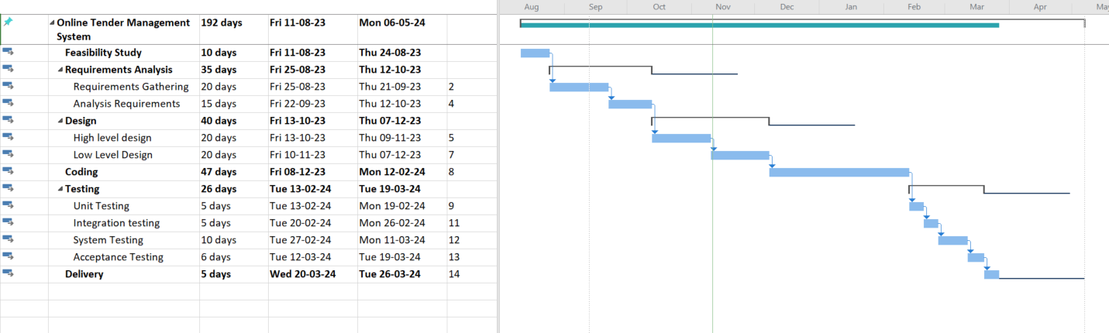

# Conclusion

In conclusion, the Tender Management System's Software Project Management Plan (SPMP) serves as a comprehensive guide outlining the project's objectives, scope, and execution strategies. It establishes a robust framework for seamless collaboration, risk mitigation, and timely delivery. Through diligent adherence to this plan, we aim to optimize the tender management process, ensuring efficiency, transparency, and client satisfaction. This SPMP lays the foundation for a successful project implementation, fostering a cohesive and adaptive approach to meet the evolving needs of our stakeholders.

# References

Some of the important guideline documents from expert authorities that must be consulted beforehand are:

* "Public Procurement and the EU Competition Rules: Second Edition" by Albert Sánchez Graells, Oxford University Press, 2020.
* "Electronic Tendering" by Caroline P. Evans, Routledge, 2019.
* "Tender Evaluation Using Qualitative Method" by P. Balachandra, International Journal of Advanced Engineering Research and Science, Volume 2, Issue 4, April 2015.
* "Digital Transformation of Public Procurement in Europe: The Path Towards Efficiency and Transparency" by Raluca Nestor, European Institute of Romania, 2022.
* "Tender Management: A Systematic Approach" by Susan J. Wright, Journal of Purchasing and Supply Management, Volume 22, Issue 4, December 2016.