MATH 6060

Vance Turnewitsch

Problem 4.12

First, we present our code for a circular convolution:

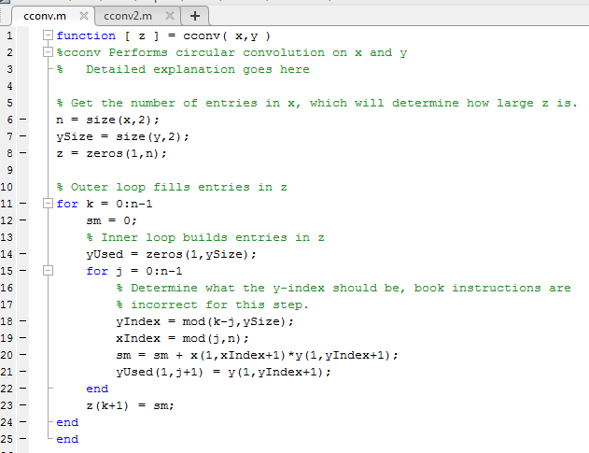

Next, we present a simple test of it:

