MTH 6060

Vance Turnewitsch

Problem 4.13

First, we present our circular convolution algorithm:

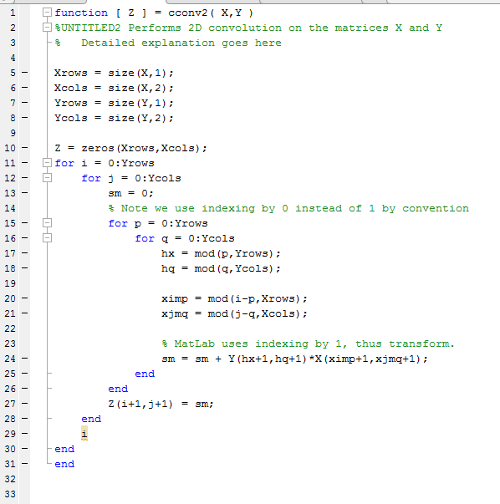

Next we present Routine 4.3 from the textbook:

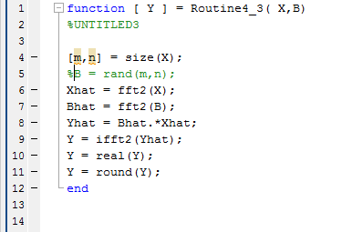

Next, we present the script that tests each of these methods performance:

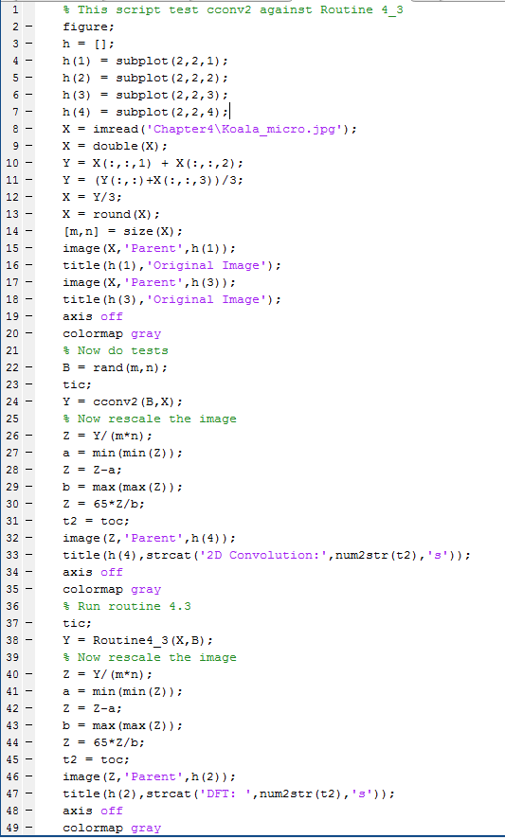

Finally, we present the plots from running the above script:

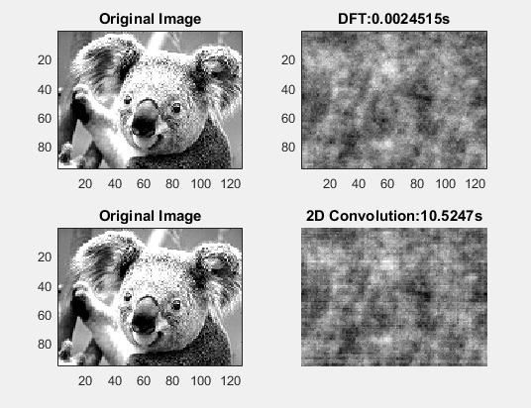

As can be the seen, the Discrete Fourier Transform achieves similar results but is much faster!