# Homework Chapter 1

# Excerise #7

## Campaign Staffer Problem

First, we present a screenshot of the code we entered into MatLab:

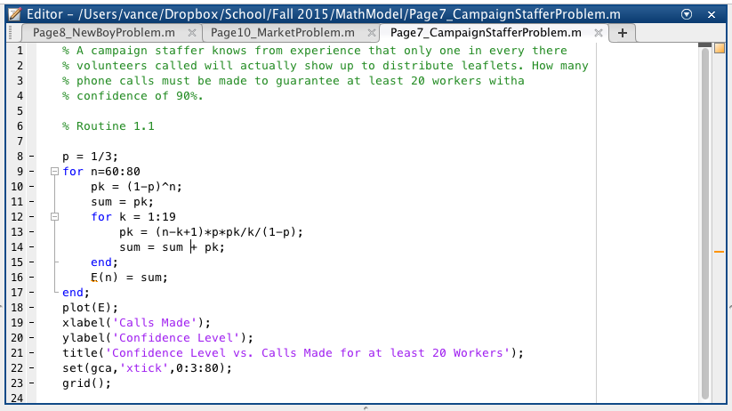

Now we present the plot from running this code:

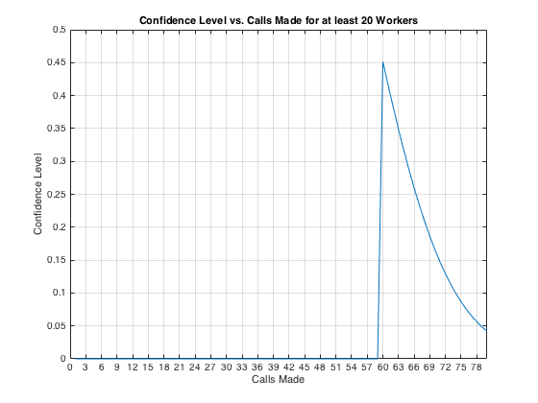

## The Newsboy Problem

Now we present a screenshot of the code we entered into MatLab for the Newsboy problem:

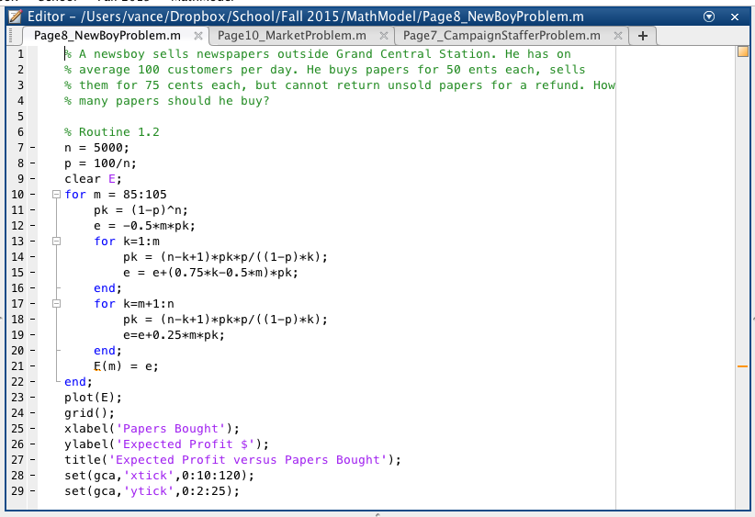

Now we present the plot for the Newsboy problem:

* 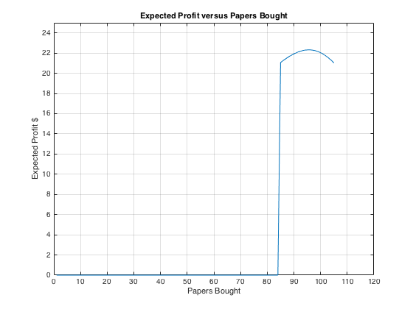

# Exercise #10

## Market Problem

We present the code for the market problem here:

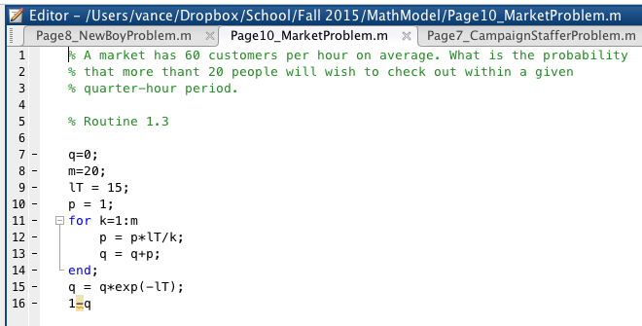

Now we present a screenshot of the results for this problem:

