**ACTIVITY 1**

**INTERNET HISTORY**

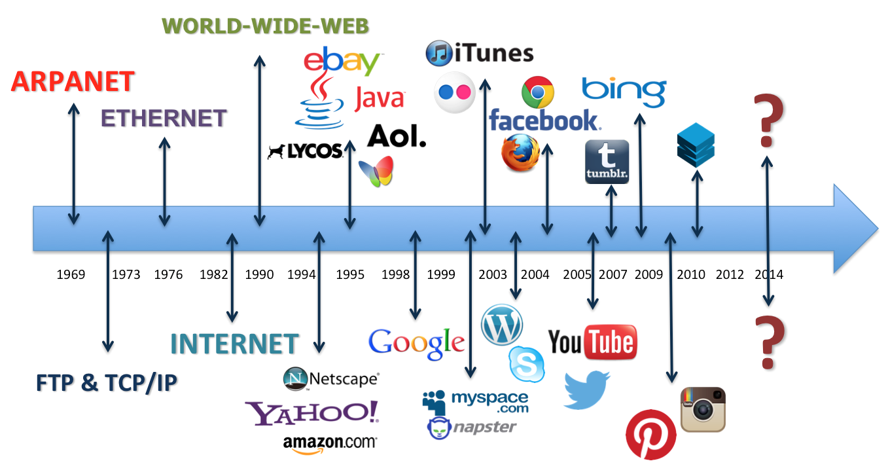

## The Birth of the ARPAnet

Scientists and military experts were especially concerned about what might happen in the event of a Soviet attack on the nation’s telephone system. Just one missile, they feared, could destroy the whole network of lines and wires that made efficient long-distance communication possible. In 1962, a scientist from M.I.T. and ARPA named J.C.R. Licklider proposed a solution to this problem: a “galactic network” of computers that could talk to one another. Such a network would enable government leaders to communicate even if the Soviets destroyed the telephone system.

In 1965, another M.I.T. scientist developed a way of sending information from one computer to another that he called “packet switching.” Packet switching breaks data down into blocks, or packets, before sending it to its destination. That way, each packet can take its own route from place to place. Without packet switching, the government’s computer network now known as the ARPAnet would have been just as vulnerable to enemy attacks as the phone system.

## The Network Grows

By the end of 1969, just four computers were connected to the ARPAnet, but the network grew steadily during the 1970s. In 1971, it added the University of Hawaii’s ALOHAnet, and two years later it added networks at London’s University College and the Royal Radar Establishment in Norway. As packet-switched computer networks multiplied, however, it became more difficult for them to integrate into a single worldwide “Internet.”

By the end of the 1970s, a computer scientist named Vinton Cerf had begun to solve this problem by developing a way for all of the computers on all of the world’s mini-networks to communicate with one another. He called his invention “Transmission Control Protocol,” or TCP. (Later, he added an additional protocol, known as “Internet Protocol.” The acronym we use to refer to these today is TCP/IP.) One writer describes Cerf’s protocol as “the ‘handshake’ that introduces distant and different computers to each other in a virtual space.”

## The World Wide Web

Cerf’s protocol transformed the Internet into a worldwide network. Throughout the 1980s, researchers and scientists used it to send files and data from one computer to another. However, in 1991 the Internet changed again. That year, a computer programmer in Switzerland named Tim Berners-Lee introduced the World Wide Web: an Internet that was not simply a way to send files from one place to another but was itself a “web” of information that anyone on the Internet could retrieve. Berners-Lee created the Internet that we know today.

Since then, the Internet has changed in many ways. In 1992, a group of students and researchers at the University of Illinois developed a sophisticated browser that they called Mosaic. (It later became Netscape.) Mosaic offered a user-friendly way to search the Web: It allowed users to see words and pictures on the same page for the first time and to navigate using scrollbars and clickable links. That same year, Congress decided that the Web could be used for commercial purposes. As a result, companies of all kinds hurried to set up websites of their own, and e-commerce entrepreneurs began to use the Internet to sell goods directly to customers. More recently, social networking sites like Facebook have become a popular way for people of all ages to stay connected.

## Difference between internet and the World Wide Web

The internet is a global computer network providing information and communicating facilities and the world wide web is basically a part of the internet, it holds the information stored by different users around the world.