Assistive Technology Analysis: Directional Haptic Alerting for Blind Spot Monitoring
585.617 Rehabilitation Engineering | Module 3 Assignment | [Your Name] | [Date]
The Technology and the Disability
Blind spot monitoring (BSM) uses short-range radar in the rear bumper corners to detect vehicles in the adjacent lanes, illuminating an icon in the side mirror and escalating to an audible chime if the driver signals toward an occupied lane. The disability it can serve, though it was not designed for it, is restricted cervical range of motion from cervical fusion, spondylosis, rheumatoid arthritis, ankylosing spondylitis, or age-related stiffening. A shoulder check requires roughly 60 degrees of cervical rotation; below about 30 degrees, clinical guidance directs referral to physical therapy or a driver rehabilitation specialist [2].
Is the Current Design Meeting the Need?
Not fully. BSM was developed and validated on a general driving population that retains the shoulder check as a backup, and the Insurance Institute for Highway Safety measured a 14 percent reduction in lane-change crashes against that baseline [1]. For a driver who cannot turn their head, BSM is not a redundancy but the sole means of clearing the lane, and that inversion exposes three weaknesses. First, the alert is a small icon in the side mirror, so a system meant to substitute for a head movement still requires one. Second, the escalation chime occupies a crowded auditory channel and is unavailable to deaf drivers. Third, and most seriously, silence is ambiguous: a clear lane and an occluded sensor produce the identical absence of any signal, which a driver with no means of independent verification cannot tell apart.
Modification 1: Directional Seat-Bolster Haptic Alerting
Install a linear resonant actuator in each seat-back bolster, left and right, driven from the existing BSM message on the vehicle CAN bus. A detection on one side vibrates the bolster on that side, making the cue spatially congruent with the hazard rather than symbolic. The seat is the correct mounting location for two reasons. It is a fixed reference frame, whereas a steering-wheel actuator rotates with the wheel, so its left-right mapping degrades precisely during the merge or lane change when the wheel is off-center and the alert matters most, and the torso stays in contact with the seat back even when the hands leave the wheel. Haptics also occupy an uncontested channel, competing with neither the visual scene nor cabin noise, and remain accessible to deaf drivers. Spatially predictive vibrotactile cues are known to speed drivers’ orienting responses to approaching vehicles [3].
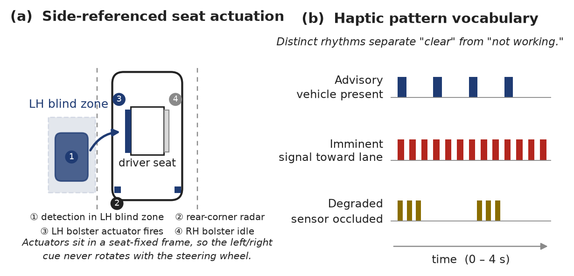
Figure 1. (a) Side-referenced actuation: a detection in the left blind zone fires the left seat bolster. (b) The three haptic patterns, including the bilateral degraded-mode burst that resolves the ambiguity of silence.
Modification 2: Positive System-Health Confirmation on the Haptic Channel
Extend the same actuators to report system state. At ignition, a single pulse on each side confirms that both actuators and both radar sensors passed self-test, so every trip begins with the driver knowing the system is live. In operation, the BSM module monitors radar return statistics for the signature of an aperture occluded by road spray, packed snow, or mud, and on detecting degradation issues a distinct bilateral triple-burst rhythm with a dash message instructing the driver to resume visual checks. Being bilateral and rhythmically unlike either advisory cue, it cannot be mistaken for a detection. This modification is inseparable from the first: adding a channel the driver comes to depend on, without also telling them when it has failed, would deepen the original ambiguity rather than resolve it. Vibration salience for both modifications must be validated through clothing and across seat cushion constructions, with intensity adjustable during a driver rehabilitation evaluation.
References
[1] Insurance Institute for Highway Safety. Lane departure warning, blind spot detection help drivers avoid trouble. Arlington, VA.
[2] Merck Manual Professional Edition. Functional assessment of the older driver.
[3] Ho, C., Tan, H. Z., and Spence, C. Using spatial vibrotactile cues to direct visual attention in driving scenes. Transportation Research Part F, 2005.

