Module 7 Assignment: Concept Generation – Finger Prosthetic
585.617 Rehabilitation Engineering | [Your Name] | [Date]
A design team has been asked to develop a state-of-the-art prosthetic limb for trans-radial amputees, and the first branch point is whether to pursue the device biomimetically — replicating the appearance and the functionality of the human hand — or non-biomimetically. This report does not settle that question in the abstract. It decomposes the hand into physical sub-assemblies, generates biomimetic and non-biomimetic concepts for each one, ranks them, and lets the answer fall out of the ranking.
The method follows the concept-generation sequence in Engineering Design [1]. Physical decomposition breaks a complex artefact into units small enough to work with while each still meaningfully represents part of the original [1]. Concepts within each unit were generated by brainstorming, disciplined with two structured aids from the same chapter: the SCAMPER checklist, which asks what could be substituted, eliminated or rearranged and produces the non-biomimetic branch, and synectics by direct analogy, whose biological case produces the biomimetic branch [1], [9]. Generating from two prompts guards against the priming block, in which an early example silently fences in everything that follows [1].
Part A — Physical Decomposition and Concept Generation
A.1 Physical decomposition map
The system boundary is drawn distal to the socket lamination ring. The socket, its suspension and the residual limb are interfacing systems, not part of the hand [2]. Within that boundary the hand divides into the five sub-assemblies of Figure 1. The split is made so that each sub-assembly owns a distinct physical function and can be re-conceived without forcing a redesign of its neighbours — the property that makes the decomposition useful for generating alternatives rather than merely cataloguing parts [1].
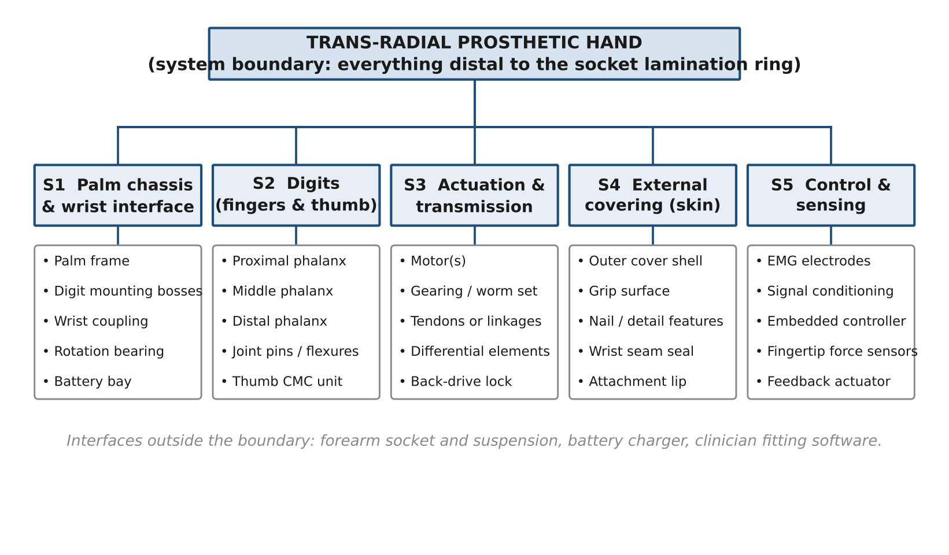
Figure 1. Physical decomposition of a trans-radial prosthetic hand into five sub-assemblies.
A.2 How the concepts were generated
For every sub-assembly the brainstorming session was run twice. The first pass asked the synectics question — how does the human hand solve this? — and produced the biomimetic candidates. The second pass ran the SCAMPER list against the first pass: substitute the material or the power source, combine units, eliminate a part, rearrange the layout. That second pass is what generated the monolithic chassis, the whiffletree drive and the exposed shell, none of which has an anatomical counterpart. Three concepts per sub-assembly are carried forward, with at least one from each branch, as the task requires. Ideas were not filtered during generation; quantity was allowed to run ahead of quality, and sorting was deferred to Part B [1].
A.3 S1 — Palm chassis and wrist interface
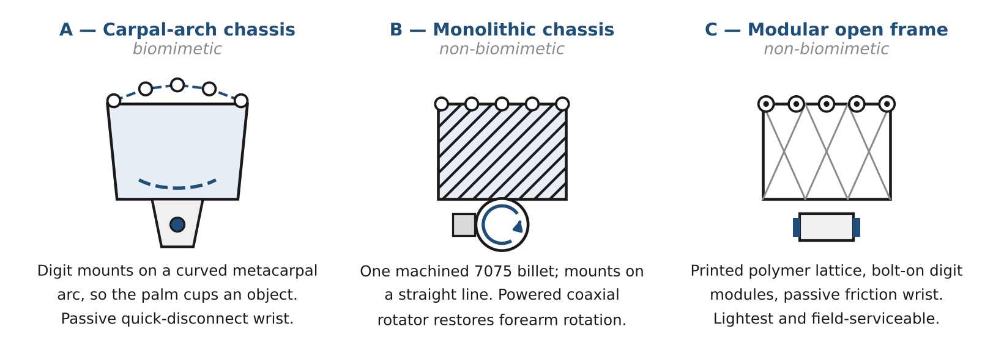
Figure 2. Palm chassis and wrist interface concepts (S1).
S1-A, carpal-arch chassis (biomimetic). The metacarpal mounting bosses sit on a curved arc rather than a straight line, and a compliant transverse member lets the palm cup slightly as the digits close, reproducing the transverse metacarpal arch. The wrist is a passive quick-disconnect coupling with indexed detents, so the user positions the hand with the sound limb and it stays put.
S1-B, monolithic alloy chassis (non-biomimetic). The palm is machined from a single 7075 billet, flat, with the digit bosses on a straight line. A powered coaxial rotator beneath the palm drives the hand in roll under the same control system that drives the digits.
S1-C, modular open frame (non-biomimetic). A printed polymer lattice carries bolt-on digit modules, each removable with two fasteners. The wrist is a passive friction joint. This is the SCAMPER eliminate and rearrange result: remove the enclosing shell, make every interface serviceable in the clinic rather than at the factory.
A.4 S2 — Digits (fingers and thumb)
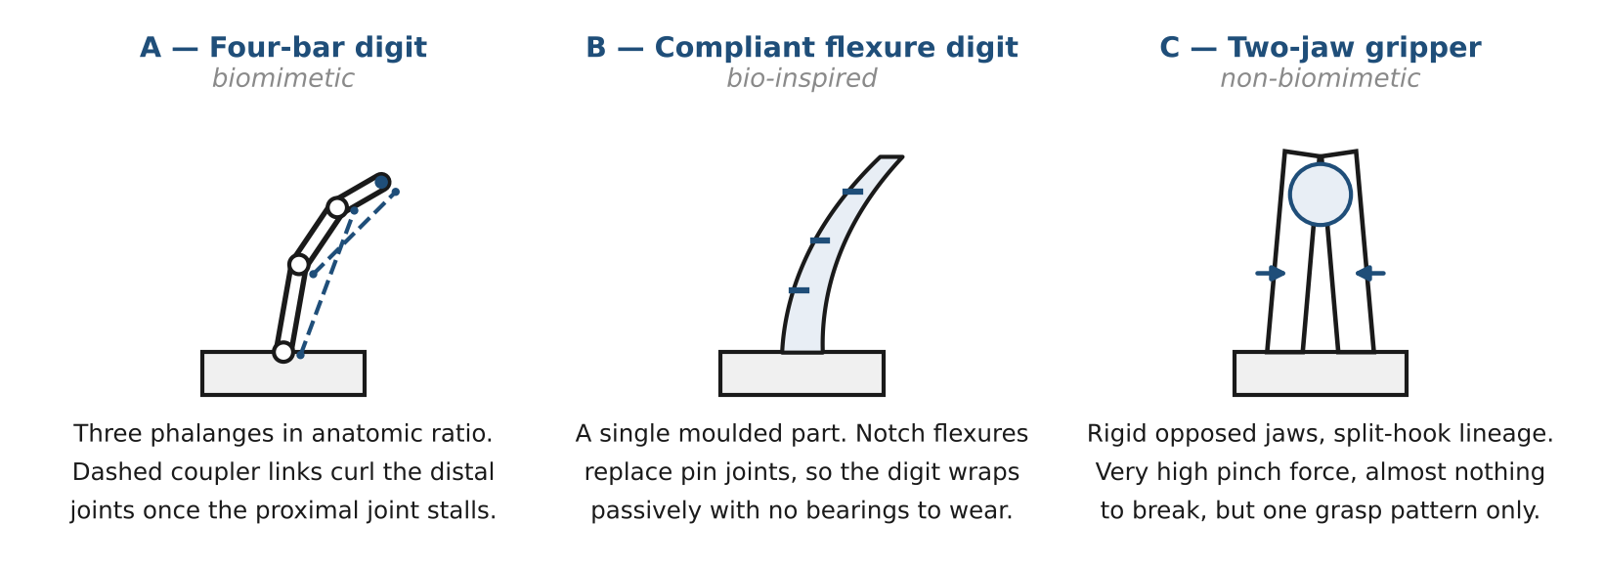
Figure 3. Digit concepts (S2).
S2-A, underactuated four-bar digit (biomimetic). Three phalanges in roughly anatomic length ratio, with MCP, PIP and DIP joints coupled by linkages so that a single input curls the whole digit. When the proximal phalanx stalls against an object, the remaining input continues to drive the distal joints, and the digit wraps. The thumb adds a two-degree-of-freedom saddle joint so it can be positioned for both palmar and lateral grasp.
S2-B, compliant flexure digit (bio-inspired). The digit is a single moulded elastomer-and-polymer part in which notch flexures replace pin joints. It reproduces the behaviour of a finger wrapping a object without reproducing its anatomy, and it carries no bearings to wear or contaminate [8].
S2-C, opposed two-jaw gripper (non-biomimetic). Two rigid jaws in the split-hook lineage, driven to a single opposed pinch. The SCAMPER eliminate pass taken to its limit: remove articulation entirely and keep only the prehension.
A.5 S3 — Actuation and transmission
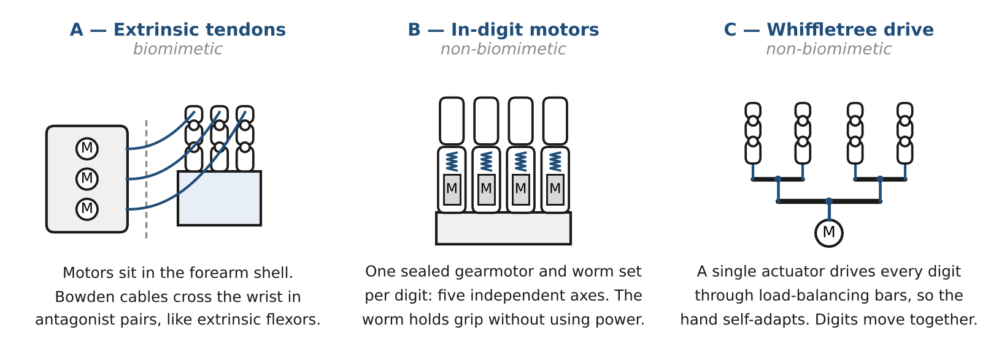
Figure 4. Actuation and transmission concepts (S3).
S3-A, extrinsic tendon drive (biomimetic). Motors are housed in the forearm shell and pull Bowden cables across the wrist in antagonist pairs, exactly as the extrinsic flexors and extensors act on the human digits. Distal mass is low because the heavy elements sit proximally.
S3-B, intrinsic in-digit motors (non-biomimetic). A sealed gearmotor with a worm-and-wheel reduction lives inside each digit, giving five independent axes. The worm set is non-back-drivable, so a closed grip holds its force with the motor unpowered. This is the architecture most current multi-articulating commercial hands use [4], [5].
S3-C, single motor with whiffletree differential (non-biomimetic). One actuator drives all digits through a tree of load-balancing bars, so the digits distribute themselves around whatever shape they meet. It is the SCAMPER combine result — five actuators collapsed into one — and it is the cheapest and most robust of the three [8].
A.6 S4 — External covering (skin)
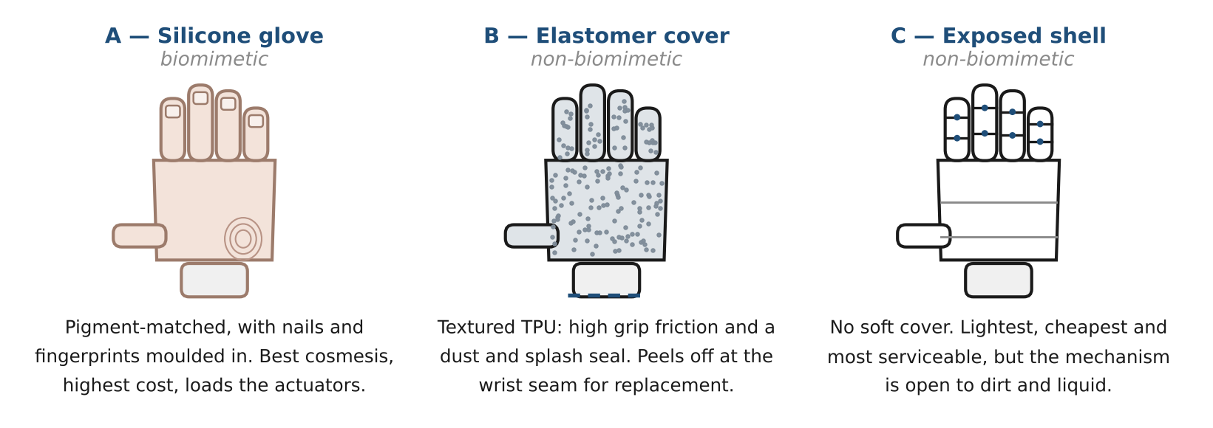
Figure 5. External covering concepts (S4).
S4-A, high-definition silicone glove (biomimetic). A custom glove pigment-matched to the sound hand, with nails, nail beds, knuckle creases and fingerprints moulded in. It is the only concept that addresses appearance directly.
S4-B, textured elastomer functional cover (non-biomimetic). A moulded TPU cover chosen for grip friction and ingress protection rather than likeness. It seals the mechanism against dust and splash and peels off at the wrist seam when it is worn out.
S4-C, exposed structural shell (non-biomimetic). No soft cover at all. The anodised structure is the exterior, with optional snap-on panels for personalisation. SCAMPER eliminate applied to the covering itself.
A.7 S5 — Control and sensing
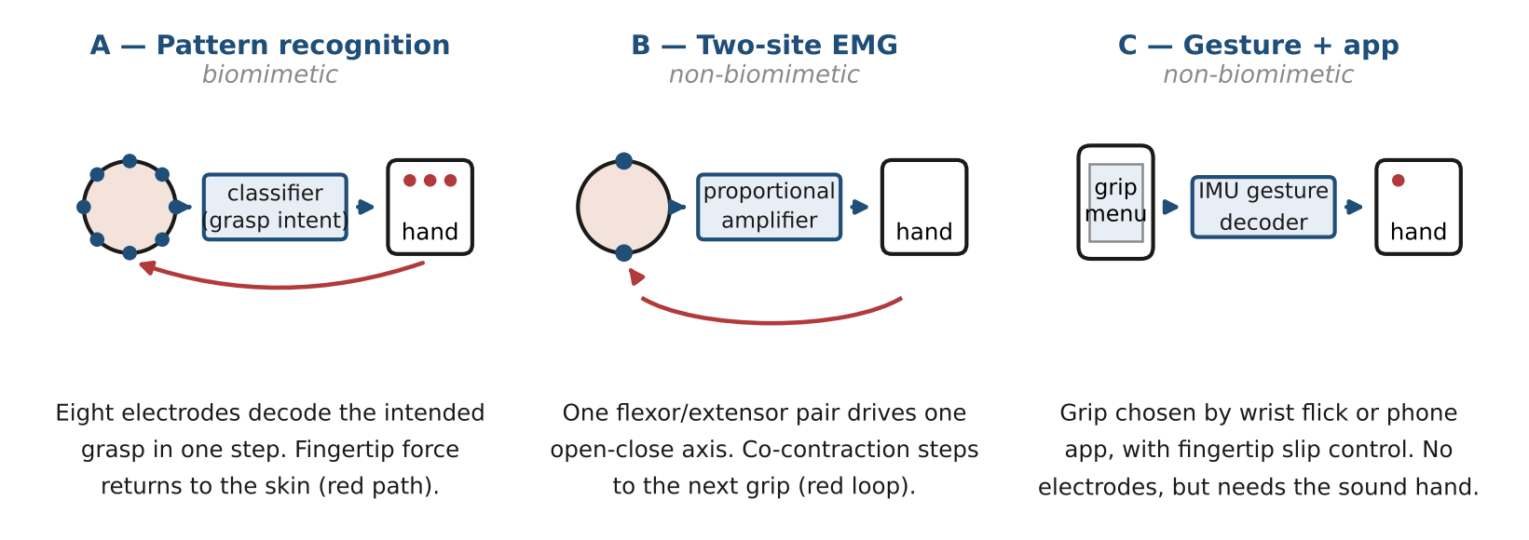
Figure 6. Control and sensing concepts (S5).
S5-A, pattern-recognition EMG with force feedback (biomimetic). An eight-channel electrode ring on the residual limb feeds a classifier that recognises the muscle-activation pattern belonging to each intended grasp, so the user selects a grip in one step rather than cycling to it [6], [7]. Fingertip force sensors drive a vibrotactile band against the skin, closing a crude version of the cutaneous afferent loop the biological hand relies on.
S5-B, two-site proportional EMG (non-biomimetic). One flexor and one extensor site drive a single open-close axis in proportion to contraction strength. Grip changes are made by co-contracting both sites to step through a stored list. This is the long-standing clinical standard and the benchmark any new scheme has to beat [7].
S5-C, gesture and application selection (non-biomimetic). No electrodes. An inertial sensor reads a deliberate wrist flick, and a phone application sets the grip from a menu, while force-sensing resistors in the fingertips regulate slip automatically. It removes electrode siting and skin-impedance problems entirely.
Part B — Concept Assessment
B.1 Evaluation criteria and their weights
Ranking concepts needs a stated basis, so the five evaluation criteria were themselves put through a pairwise comparison (Table 1) before any concept was judged. Functional performance leads because insufficient function is a first-order driver of upper-limb prosthesis rejection, and device weight follows closely for the same reason [3]. Durability is placed above mass because a device that is in for repair delivers no function at all. Cosmesis is ranked last, which is the most contestable judgement in this report: appearance genuinely matters to many users [3], but the covering is a separable, replaceable element, so a low weight here costs less than a low weight anywhere else. Section C.4 shows what changes if that ordering is wrong.
Criterion | C1 | C2 | C3 | C4 | C5 | Wins | Weight
C1 Functional performance (grasp variety, force, speed) | — | 1 | 1 | 1 | 1 | 4 | 0.33
C2 Durability and reliability in daily use | 0 | — | 1 | 1 | 1 | 3 | 0.27
C3 Mass and bulk at the distal limb | 0 | 0 | — | 1 | 1 | 2 | 0.20
C4 Cost and manufacturing complexity | 0 | 0 | 0 | — | 1 | 1 | 0.13
C5 Cosmesis and social acceptance | 0 | 0 | 0 | 0 | — | 0 | 0.07
Table 1. Pairwise comparison of the evaluation criteria. A 1 means the row criterion is preferred to the column criterion. Weights are (wins + 1) normalised, which keeps the lowest-ranked criterion in play rather than zeroing it.
Every pairwise concept table below is decided on these weights. Where a comparison is close, the deciding criteria are named explicitly so the judgement can be checked rather than taken on trust.
B.2 S1 — Palm chassis and wrist interface
Concept | Advantages | Disadvantages
A Carpal arch | Palm conforms around irregular objects; natural silhouette under a glove; no wrist motor to power or fail. | Compliant member is a fatigue path; user must set wrist angle with the sound hand; most expensive to tool.
B Monolithic alloy | Stiffest and most durable; powered roll restores a degree of freedom trans-radial users lose; simplest load path. | Heaviest option; rotator adds a motor, a driver and a current draw; machining cost is high and the part is not field-repairable.
C Modular open frame | Lightest and cheapest; a damaged digit module is swapped in the clinic in minutes; easy to iterate during development. | Polymer frame is the least stiff; open structure admits dirt; many fasteners mean many loosening paths.
Table 2. Advantages and disadvantages, S1.
 | vs A | vs B | vs C | Wins | Rank
A Carpal arch | — | 0 | 0 | 0 | 3
B Monolithic alloy | 1 | — | 1 | 2 | 1
C Modular open frame | 1 | 0 | — | 1 | 2
Table 3. Pairwise ranking, S1.
A vs B → B. Powered roll returns a degree of freedom the trans-radial user has genuinely lost, which is worth more under C1 than the arch's modest conformity gain, and the billet also wins C2. A vs C → C. The arch buys little once the digits are underactuated and conform anyway, while C takes C3 and C4 outright. B vs C → B. C1 and C2 together (0.60) outweigh C3 and C4 (0.33).
B.3 S2 — Digits
Concept | Advantages | Disadvantages
A Four-bar digit | Several distinct grip patterns; high fingertip force; wraps passively on contact; anatomic proportions fit tools and handles built for hands. | Most parts and most pin joints of the three; pins wear; tightest packaging if a motor must fit inside.
B Compliant flexure | One moulded part, no bearings; inherently safe against impact; lightest; silent. | Stiffness fixed at the moulding stage; elastomer creeps over service life; low pinch force; hard to instrument.
C Two-jaw gripper | Very high pinch force per watt; almost nothing to break; cheapest by a wide margin; proven in service. | One grasp pattern only; cannot wrap or support large objects; appearance is the least accepted of the three.
Table 4. Advantages and disadvantages, S2.
 | vs A | vs B | vs C | Wins | Rank
A Four-bar digit | — | 1 | 1 | 2 | 1
B Compliant flexure | 0 | — | 1 | 1 | 2
C Two-jaw gripper | 0 | 0 | — | 0 | 3
Table 5. Pairwise ranking, S2.
A vs B → A. A delivers distinct grips and far higher fingertip force, and creep in a moulded flexure degrades C2 over the service life. A vs C → A. C offers a single grasp; this is the widest C1 gap anywhere in the study. B vs C → B. C takes C2 and C4, but B's passive wrap covers a far wider range of object shapes and it is lighter, taking C1 and C3.
B.4 S3 — Actuation and transmission
Concept | Advantages | Disadvantages
A Extrinsic tendons | Distal mass is low, so the device feels lighter than it weighs; motors are large, accessible and easy to cool; slim digits. | Cable friction, stretch and fraying are the dominant maintenance item; routing must cross the wrist; needs forearm volume the short residual limb may not have.
B In-digit motors | Five independent axes, so the full grip repertoire is reachable; sealed modules; worm drive holds grip without current; nothing crosses the wrist. | Highest distal mass and inertia; five motors, five drivers, highest cost; a failed motor means a digit out of service.
C Whiffletree | One actuator, fewest parts, lowest cost, lowest power draw; self-adapts to object shape with no sensing at all. | All digits move together, so grip patterns cannot be selected; no independent thumb control; force distribution is set by the linkage, not the user.
Table 6. Advantages and disadvantages, S3.
 | vs A | vs B | vs C | Wins | Rank
A Extrinsic tendons | — | 0 | 1 | 1 | 2
B In-digit motors | 1 | — | 1 | 2 | 1
C Whiffletree | 0 | 0 | — | 0 | 3
Table 7. Pairwise ranking, S3.
A vs B → B. Independent digit axes are what make a multi-grip hand possible (C1), and sealed gearmotors avoid the cable wear that dominates tendon-hand servicing (C2); A keeps C3. A vs C → A. A retains graded antagonist control and places mass where the user feels it least. B vs C → B. C is simpler, lighter and cheaper, but a single coupled actuator cannot produce the grip repertoire a state-of-the-art device is being built for, and C1 is the heaviest weight.
B.5 S4 — External covering
Concept | Advantages | Disadvantages
A Silicone glove | By far the best appearance; soft contact with the user's own body and with other people; some grip friction. | Elastic resistance loads the actuators continuously; stains and tears; the most expensive consumable; must be re-ordered to a cast.
B Elastomer cover | High grip friction where it matters; seals the mechanism against dust and splash; peels off at the seam for replacement; cheap to mould. | Obviously artificial; adds a little mass and a little actuator load; attenuates fingertip force readings slightly.
C Exposed shell | Lightest, cheapest, most serviceable; no actuator load at all; some users actively prefer the look. | Mechanism is open to dirt and liquid; poor grip on smooth surfaces; pinch points exposed; least acceptable to users who want the device to pass unnoticed.
Table 8. Advantages and disadvantages, S4.
 | vs A | vs B | vs C | Wins | Rank
A Silicone glove | — | 0 | 0 | 0 | 3
B Elastomer cover | 1 | — | 1 | 2 | 1
C Exposed shell | 1 | 0 | — | 1 | 2
Table 9. Pairwise ranking, S4.
A vs B → B. The glove's elastic resistance is a continuous tax on C1, it is the shortest-lived part of the device under C2, and it is the costliest consumable under C4; it wins only C5, the lightest weight. A vs C → C. With cosmesis weighted last, C's lower mass, lower cost and absence of actuator load decide it. B vs C → B. Grip friction and ingress protection both read on C1 and C2, and ingress matters more once motors and sensors sit inside the digits.
B.6 S5 — Control and sensing
Concept | Advantages | Disadvantages
A Pattern recognition | Selects a grasp in one step, with no mode cycling; scales to many grips; adds a force channel back to the user; hands-free. | Needs training and periodic retraining; sensitive to electrode shift, sweat and limb position; highest processing and electrode cost.
B Two-site EMG | Simplest, cheapest and best-proven; two electrodes to site and maintain; predictable behaviour; hands-free. | One open-close axis at a time; every added grip lengthens the co-contraction sequence; co-contraction is tiring and conspicuous.
C Gesture and app | No electrodes, no skin-impedance problems; grip menu is easy to reconfigure; slip control works without user attention. | Changing grip needs the sound hand or a visible phone; fails exactly when both hands are occupied; unusable for a bilateral fitting.
Table 10. Advantages and disadvantages, S5.
 | vs A | vs B | vs C | Wins | Rank
A Pattern recognition | — | 1 | 1 | 2 | 1
B Two-site EMG | 0 | — | 1 | 1 | 2
C Gesture and app | 0 | 0 | — | 0 | 3
Table 11. Pairwise ranking, S5.
A vs B → A. B cannot address a five-axis hand without cycling modes by co-contraction, and the time cost grows with every grip added; A selects in one step and returns a force channel, taking C1 and C5 against B's C2 and C4. This is the closest call in the study and it is decided by C1 alone. A vs C → A. C needs the sound hand or a phone to change grip, which fails precisely when both hands are occupied. B vs C → B. B is hands-free and needs no second device, even with one axis.
B.7 Compatibility between sub-assemblies
Ranking each sub-assembly in isolation is only half the assessment. Several concepts carry constraints that reach across the decomposition, and two of them are hard incompatibilities rather than preferences. Table 12 lists the couplings found.
Concepts | Coupling | Consequence
S1-B × S3-A | Bowden cables cannot cross a continuously rotating wrist without a slip arrangement or a rotary take-up. | Hard incompatibility. Choosing the powered rotator rules out extrinsic tendons; actuation must be intrinsic.
S2-B × S3-B | A monolithic flexure digit has no internal cavity for a gearmotor and worm set. | Hard incompatibility. In-digit actuation forces a jointed digit.
S3-C × S5-A | A single coupled actuator cannot execute distinct grasps, whatever the classifier outputs. | Pattern recognition is wasted on the whiffletree; the control concept must be matched to the number of axes.
S3-B × S5-B | Mode-cycling time grows with the number of selectable grips. | With five axes, control bandwidth rather than mechanism becomes the limit on usable function.
S4-A × S2-B, S3-C | Glove elasticity adds a continuous restoring torque at every joint. | The penalty falls hardest on low-torque underactuated drives, which are exactly the cheap options.
S4-C × S3-B | An exposed structure leaves motors, drivers and sensors open to dust and liquid. | The bare shell is admissible only if each digit module is independently sealed.
S4-A, S4-B × S5-A | Cover thickness attenuates the force reaching a fingertip sensor. | The sensor must sit outboard of the structural shell, under a locally thinned cover region.
Table 12. Compatibility couplings between sub-assembly concepts.
The first two rows matter most, because they would have invalidated a naive combination of top-ranked concepts if the rankings had fallen differently. As it happens the winning set is self-consistent: S1-B and S3-B agree with the first row, and S2-A and S3-B agree with the second.
Part C — The Ideal Concept
C.1 Description
Combining the first-ranked concept from each sub-assembly gives S1-B + S2-A + S3-B + S4-B + S5-A: a hand on a monolithic machined chassis with a powered coaxial wrist rotator; five underactuated four-bar digits in anatomic phalanx ratio, the thumb on a two-degree-of-freedom saddle joint; a sealed worm gearmotor inside each digit giving five independent axes that hold their grip without drawing current; a replaceable textured elastomer cover that seals the mechanism and supplies grip friction; and an eight-channel pattern-recognition EMG interface with fingertip force sensing returned to the user through a vibrotactile band.
In use, the wearer produces the muscle-activation pattern associated with a grasp and the classifier selects it directly, with no co-contraction sequence. The digits close under independent control until each one stalls against the object, at which point the four-bar coupling continues to curl the distal joints so the hand wraps rather than merely pinches. The worm sets hold the resulting grip with the motors unpowered, which is what makes all-day battery life reachable. Fingertip force is fed back as vibration intensity, so the user can judge grip strength without watching the hand. The powered rotator replaces the forearm rotation lost at the trans-radial level, which is the single most useful added degree of freedom at that amputation level.
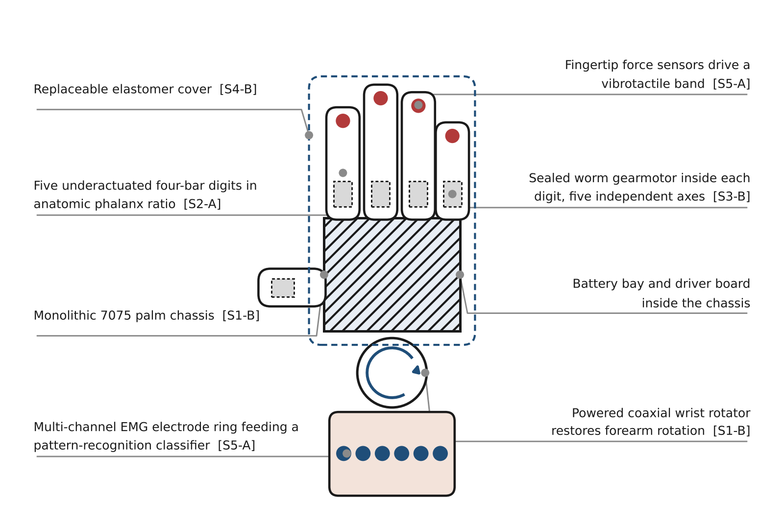
Figure 7. The combined concept, with each element traced to its ranked source.
C.2 Functional decomposition
Figure 8 restates the design in functional rather than physical terms. Each block is phrased so that it can be described without an “and” or an “or”, which is the test that keeps a function pure and lets it be re-allocated to a different physical part later [1]. The mapping from function to sub-assembly is deliberately not one-to-one: F2.2 and F2.3 both land inside a single digit module under S3-B, while F4.1 and F4.2 are split between the rotator and the chassis of S1-B. That is the point of keeping the two decompositions separate — the functional view is solution-neutral and survives a change of concept, whereas the physical view does not [1].
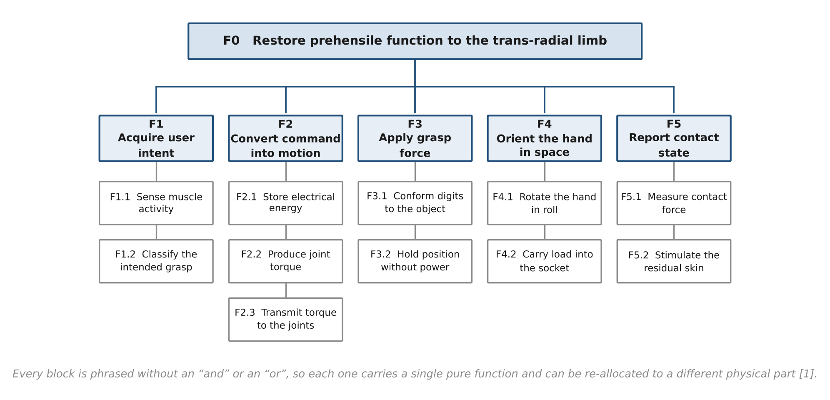
Figure 8. Functional decomposition of the combined concept.
C.3 Is the design biomimetic or non-biomimetic?
By count, the design is non-biomimetic: three of the five winning concepts came from the SCAMPER branch, and one of them — intrinsic in-digit actuation — is the direct opposite of how a human hand is built, since the biological hand drives the digits with extrinsic forearm muscles and keeps its mass proximal. The device accepts a real penalty in distal inertia to gain independent digit control.
But the count is the less interesting answer. What the ranking actually separated was biomimicry that buys function from biomimicry that buys only appearance. The two biomimetic concepts that survived are the ones that earn their place functionally: anthropomorphic digit kinematics, which matter because the object world the user has to operate in — door handles, tools, cups, keyboards — was shaped around human hands; and an interface that decodes motor intent and returns tactile information, which mimics the biological control loop rather than the biological structure. The two that were ranked out — the carpal arch and the silicone glove — are the ones whose principal return is likeness.
The honest description is therefore functionally biomimetic and structurally non-biomimetic: a hand that moves and is commanded like a hand, built out of mechanisms that look nothing like one. That is also the position most current multi-articulating commercial devices have converged on, which is some evidence that the weighting used here is not idiosyncratic [4], [5].
C.4 What this assessment does not settle
Three limits should travel with the result. First, the verdict is sensitive to the weight vector. Cosmesis was ranked last; if a particular user placed appearance above mass and cost — which is a legitimate preference, not an error — S4-A would take the covering and S1-A would become competitive, and the design would read as biomimetic on the count as well. The ranking is a statement about this weighting, not about prosthetic hands in general. Second, pairwise ranking is ordinal: it says that B beats C but not by how much, and with three concepts per sub-assembly a single changed judgement moves a rank. A weighted decision matrix, or a Pugh matrix against the two-site EMG hand as datum, is the natural next step [1]. Third, nothing here has been costed, modelled or prototyped. Distal inertia, battery life under the five-motor load, and classifier accuracy after electrode shift are all quantitative questions that the concept stage cannot answer, and all three bear directly on the criteria weighted most heavily [4], [6].
References
[1] G. E. Dieter and L. C. Schmidt, Engineering Design, 5th ed. New York, NY, USA: McGraw-Hill, 2013.
[2] R. A. Cooper, H. Ohnabe, and D. A. Hobson, Eds., An Introduction to Rehabilitation Engineering. Boca Raton, FL, USA: CRC Press, 2007.
[3] E. A. Biddiss and T. T. Chau, “Upper limb prosthesis use and abandonment: A survey of the last 25 years,” Prosthetics and Orthotics International, vol. 31, no. 3, pp. 236–257, Sep. 2007.
[4] J. T. Belter, J. L. Segil, A. M. Dollar, and R. F. Weir, “Mechanical design and performance specifications of anthropomorphic prosthetic hands: A review,” Journal of Rehabilitation Research and Development, vol. 50, no. 5, pp. 599–618, 2013.
[5] C. Cipriani, M. Controzzi, and M. C. Carrozza, “The SmartHand transradial prosthesis,” Journal of NeuroEngineering and Rehabilitation, vol. 8, art. 29, 2011.
[6] E. Scheme and K. Englehart, “Electromyogram pattern recognition for control of powered upper-limb prostheses: State of the art and challenges for clinical use,” Journal of Rehabilitation Research and Development, vol. 48, no. 6, pp. 643–659, 2011.
[7] B. Hudgins, P. Parker, and R. N. Scott, “A new strategy for multifunction myoelectric control,” IEEE Transactions on Biomedical Engineering, vol. 40, no. 1, pp. 82–94, Jan. 1993.
[8] A. M. Dollar and R. D. Howe, “The highly adaptive SDM hand: Design and performance evaluation,” The International Journal of Robotics Research, vol. 29, no. 5, pp. 585–597, Apr. 2010.
[9] G. Thompson and M. London, “A review of creativity principles applied to engineering design,” Proceedings of the Institution of Mechanical Engineers, Part E, vol. 213, no. 1, pp. 17–31, 1999.

