Application of Basic Anatomy and Biomechanics: High-Level Systems Design of a Transtibial Prosthesis
585.617 Rehabilitation Engineering | Module 4 Assignment | [Your Name] | [Date]
1. Case Framing and Design Assumptions
The client sustained a bilateral transtibial (below-knee) amputation following meningitis. The critical consequence for this design is that both knees are anatomically intact. The prosthesis therefore replaces the ankle-foot complex only, and the single most important design constraint is to restore ankle-foot function without compromising the natural knees that remain [1]. Because the client is bilaterally affected, every design penalty is paid twice: mass, cost, maintenance burden, and failure exposure all double, and there is no sound limb to serve as a kinematic reference or to compensate during a fault. The baseline device is scoped for everyday level walking; sport-specific requirements are addressed in Part B.
Quantitative analysis requires an anthropometric basis. The following values are stated as design assumptions rather than clinical data for this individual, and all results scale linearly with body weight.
Parameter | Value | Basis
Body mass, m (incl. prostheses) | 60 kg | Assumed; representative adult female athlete
Body weight, BW = mg | 588.6 N | g = 9.81 m/s²
Prosthetic foot length, L | 0.24 m | ≈ 0.152 × stature for 1.65 m height
Ankle joint height above ground, h | 0.07 m | Standard transtibial build height
Ankle-to-forefoot COP distance, d | 0.13 m | COP under metatarsal heads at terminal stance
Functional level | MFCL K3–K4 | High-activity community ambulator
Duty cycle | ≈ 5,000 steps/day | Typical active user; drives fatigue sizing [3]
2. Part A — Technical Approach for Everyday Walking
2.1 Joints Spanned and Replication Decisions
The prosthesis physically spans the knee — the socket brim and suspension extend proximal to the joint line — but it must not replicate it. The decision for each joint is summarised below.
Joint | Anatomical role | Replicate? | Rationale
Tibiofemoral (knee) | Sagittal flexion/extension; primary shock absorption and limb shortening in swing | No | Intact. A retained biological knee preserves proprioception and gait economy no prosthetic knee can match. The socket trim line is the design issue: it must clear the hamstring tendons and permit ≥ 120° flexion for sitting and stairs.
Talocrural (ankle) | Dorsiflexion / plantarflexion; the dominant sagittal power source at push-off | Yes | Non-negotiable. Absent controlled plantarflexion at loading response and dorsiflexion through midstance, the user vaults over a rigid lever, producing the classic gait deviations and elevated socket pressures the module identifies [2], [5].
Subtalar | Inversion / eversion; accommodates coronal-plane terrain variation | Partially | Provide compliance, not a controlled degree of freedom. An elastomeric bushing gives ±6° of passive give at negligible mass and cost. A fully articulated subtalar joint adds mass, wear surfaces and alignment complexity for benefit confined to uneven ground.
Transverse tarsal (Chopart) | Couples forefoot and rearfoot; midfoot stiffening for push-off | No (as a joint) | Function is reproduced by the graded bending stiffness of a one-piece carbon keel. Discretising it would add joints without adding function.
Metatarsophalangeal | Toe break; forefoot rocker at terminal stance | Yes (passively) | Replicated by a split-toe keel geometry whose bending compliance reproduces the rocker. A hinged toe would be a wear item in the dirtiest, most highly loaded location on the device.
Shank transverse rotation | ±8–10° internal/external rotation during gait | Optional | Omitted from the walking baseline. Torsional accommodation matters for turning and for court and board sports; a torsion adapter is a modular addition (Part B) rather than a baseline cost.
2.2 Range of Motion: Anatomical Envelope versus Gait Demand
The governing design principle is that a prosthesis should reproduce the range of motion that walking actually uses, not the full anatomical envelope. The two differ by roughly a factor of two at the ankle, and every degree of unused range costs build height, mass and a potential instability mode.
Joint / motion | Anatomical ROM | ROM used in level walking | Design target | Decision
Talocrural dorsiflexion | 0–20° | ≈ 10° | 15° | Replicate with margin for ramps
Talocrural plantarflexion | 0–50° | ≈ 20° | 20° | Replicate; damped, not free
Subtalar inversion | 0–35° | ≈ 4° | ±6° combined | Compliance only
Subtalar eversion | 0–15° | ≈ 2° | (as above) | Compliance only
Transverse rotation | ±10° | ≈ ±8° | 0° baseline | Deferred to sport module
MTP extension | 0–70° | 30–60° | Passive keel bending | Geometric, not articulated
Knee flexion (intact) | 0–135° | 0–60° | Unobstructed to 120° | Socket trim constraint
2.3 Proposed Mechanisms
The selected architecture is a modular endoskeletal transtibial prosthesis: a total-surface-bearing socket with a silicone liner and elevated vacuum suspension, a modular pylon, a hydraulically damped ankle carrying an elastomeric multiaxial bushing, and a one-piece energy-storing-and-returning (ESAR) carbon keel with a split toe. Figure 1 shows the arrangement.
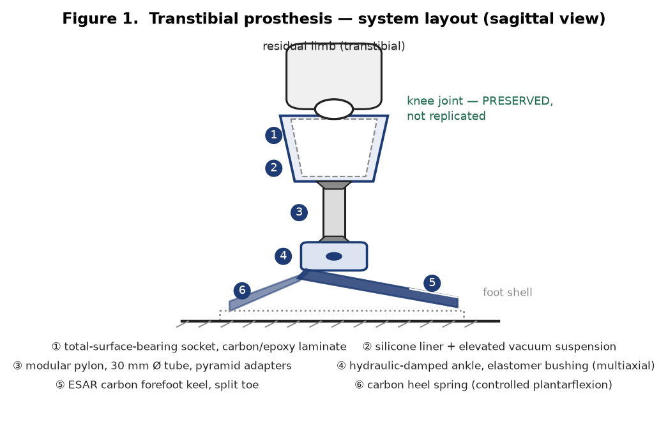
Figure 1. Sagittal system layout of the proposed transtibial prosthesis. The knee is spanned by the socket but deliberately not replicated.
Candidate mechanism | Function | Assessment
SACH foot (solid ankle, cushion heel) | Compliant heel wedge, rigid keel | Rejected. Lowest cost and mass, no moving parts, but returns almost no energy and cannot accommodate ramps. Inappropriate for a K3–K4 bilateral user.
Single-axis ankle with bumpers | Sagittal rotation against elastomer stops | Rejected as sole mechanism. Gives plantarflexion at loading response but no velocity-dependent control and no energy return.
ESAR carbon keel | Stores strain energy in midstance, returns it at push-off | Selected. Principal energy-return element; see §2.6 for sizing.
Hydraulic ankle damper | Velocity-dependent resistance; hydrostatic ramp adaptation | Selected. Controls heel descent and sets dorsiflexion resistance. Particularly valuable bilaterally, where neither limb can borrow stability from a sound side.
Elastomeric multiaxial bushing | Passive coronal and transverse compliance | Selected. Supplies the ±6° of subtalar give from §2.2 at minimal mass.
Powered (motorised) ankle | Active net-positive push-off work | Considered, deferred. Restores physiological push-off power and is attractive bilaterally, but adds ≈ 2 kg, a charging regimen and a large cost increment. Retained as a growth path, not the baseline.
Microprocessor control layer | Phase detection and adaptive damping | Selected (optional module). Control logic in Figure 3.
2.4 Control Logic
Because a microprocessor-controlled hydraulic ankle is included, its control logic is specified. The controller samples an inertial measurement unit and a pylon-mounted load cell, classifies the gait phase, and modulates valve orifice area accordingly. A slope-estimation branch shifts the neutral ankle angle on grades — the single highest-value adaptive behaviour for a bilateral user, who cannot compensate for a ramp with a sound ankle.
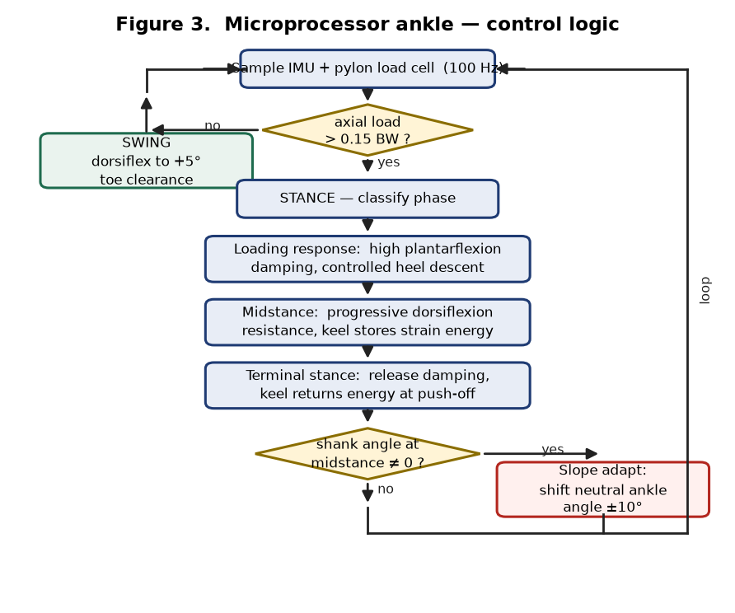
Figure 3. Control logic for the microprocessor-regulated hydraulic ankle.
2.5 Ground Reaction Forces and Joint Reaction Forces
Vertical ground reaction force in level walking follows the characteristic double-humped profile, peaking near 1.1 BW at loading response and 1.2 BW at terminal stance with a midstance trough near 0.8 BW; anteroposterior shear reaches roughly ±0.2 BW, braking in early stance and propulsive in late stance [6]. Terminal stance governs the ankle, because the centre of pressure has advanced to the metatarsal heads and the moment arm about the ankle is greatest. Figure 2 gives the loading profile and the foot-segment free-body diagram.
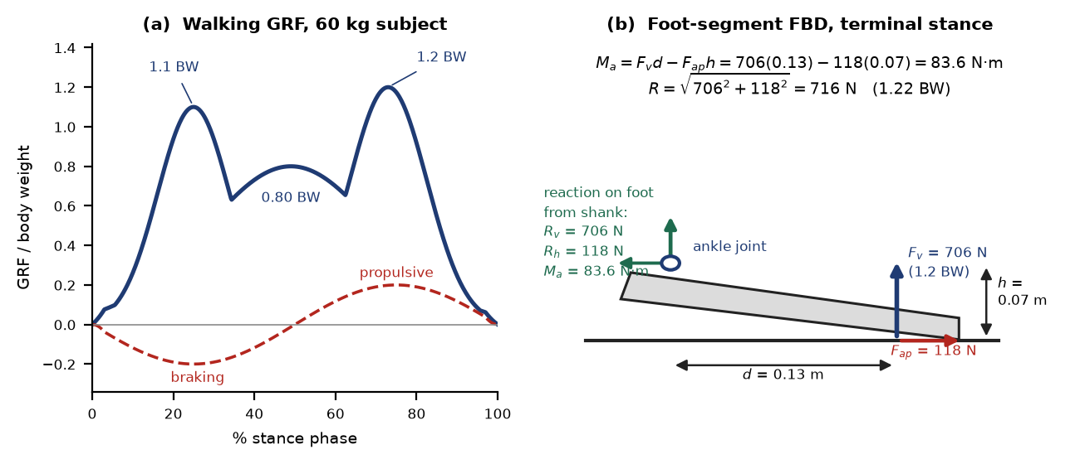
Figure 2. (a) Walking ground reaction force profile for the 60 kg design case. (b) Foot-segment free-body diagram at terminal stance.
Taking the prosthetic foot as a free body and neglecting its weight (≈ 4 N, under 1% of the applied load), static equilibrium gives:
ΣFy = 0 : Rv = Fv = 1.2 (588.6) = 706 N
ΣFx = 0 : Rh = Fap = 0.2 (588.6) = 118 N
ΣMankle = 0 : Ma = Fv d − Fap h = 706 (0.13) − 118 (0.07) = 83.6 N·m
R = √(Rv² + Rh²) = √(706² + 118²) = 716 N = 1.22 BW
Sanity check. The computed ankle moment normalises to 83.6 / 60 = 1.39 N·m/kg, against a literature norm for peak plantarflexor moment in walking of roughly 1.4–1.6 N·m/kg [6]. The model is therefore slightly conservative in the right direction and the geometry assumptions are sound.
2.6 Structural Sizing and Material Selection
Pylon. Taking a 30 mm outside diameter tube with 2 mm wall: A = 175.9 mm², I = 17,329 mm⁴, Z = I/c = 1,155 mm³. The ankle moment is transmitted up the pylon, so combined axial and bending stress is:
σ = P/A + Ma/Z = 706/175.9 + 83,600/1,155 = 4.0 + 72.3 = 76.4 MPa
Keel. The forefoot keel is treated as a cantilever of width b = 60 mm and thickness t, loaded at d = 0.13 m, with Z = bt²/6. Setting an allowable of 350 MPa (safety factor 2 on a 700 MPa unidirectional carbon flexural strength) gives t = 5.13 mm, and with E ≈ 120 GPa the tip deflection is 6.4 mm, storing ½Fδ ≈ 2.3 J per step. Thinning the keel to 4.5 mm raises stress to 453 MPa (safety factor 1.5) but increases deflection to 9.5 mm and stored energy to 3.3 J. Keel thickness is therefore a direct trade between energy return and structural margin — a 12% reduction in thickness buys 46% more returned energy at the cost of a third of the safety factor. This is the central tuning parameter of the design and should be set per patient against measured cadence and body mass.
Component | Material | Yield / strength | Computed stress | SF | Justification
Pylon | 6061-T6 aluminium | 276 MPa | 76.4 MPa | 3.6 | Adequate for walking. Aluminium has no true fatigue endurance limit, so ISO 10328 cyclic qualification over millions of cycles governs, not the static number [3].
Pylon (alt.) | Ti-6Al-4V | 880 MPa | 76.4 MPa | 11.5 | Large static margin and superior fatigue behaviour; 64% denser, so mass penalty is doubled bilaterally. Selected only if Part B loading applies.
Forefoot keel | Unidirectional carbon/epoxy | ≈ 700 MPa flexural | 349 MPa | 2.0 | High specific stiffness and excellent fatigue behaviour make it the only practical energy-return material.
Socket | Carbon/epoxy laminate | ≈ 600 MPa | Distributed | — | Stiffness governs, not strength; the design driver is pressure distribution over the residual limb, not fracture.
Liner | Medical-grade silicone | — | ≤ 30 kPa interface | — | Pressure redistribution and shear management over bony prominences; directly addresses the pressure problems noted in the module [2].
Ankle bushing | Polyurethane elastomer | Shore 80–95A | — | — | Durometer sets the ±6° compliance of §2.2; selected against operating temperature.
Qualification would follow ISO 10328 for the structural assembly — static proof and ultimate tests representing worst-case loading, plus cyclic testing representing normal walking — and ISO 22675 for the ankle-foot device specifically [3], [8].
3. Part B — Adapting the Design for Snowboarding
Snowboarding is selected because it loads the prosthesis in a plane the walking design barely sees. Walking is an essentially sagittal, cyclic, low-amplitude activity. A carved turn is a sustained frontal-plane event, and landing is a high-magnitude transient. These are different design problems, not a scaled version of the same one.
3.1 Carved-Turn Analysis
In a steady carved turn the rider is in equilibrium under gravity and the centripetal force required by the turn radius. For a representative turn at v = 12 m/s (43 km/h) and radius r = 15 m:
ac = v²/r = 12²/15 = 9.6 m/s² Fc = m ac = 60 (9.6) = 576 N
R = √((mg)² + Fc²) = √(588.6² + 576²) = 824 N = 1.40 BW
θ = arctan(ac /g) = arctan(9.6/9.81) = 44.4° from vertical
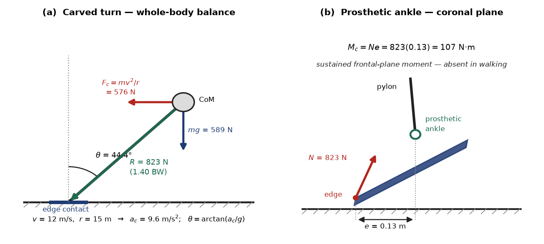
Figure 4. (a) Whole-body force balance in a steady carved turn. (b) Frontal-plane free-body diagram at the prosthetic ankle.
The resultant is only 1.40 BW — modest against the 6 BW landing case below — but it acts continuously through the turn and in the frontal plane. With the ankle offset e = 0.13 m from the engaged edge (half the board width), and conservatively assuming the prosthetic ankle and pylon react the full moment rather than sharing it with the boot cuff and binding highback:
Mc = R e = 824 (0.13) = 107 N·m σ = Mc /Z + R/A = 92.6 + 4.7 = 97.4 MPa (SF 2.8 on 6061-T6)
3.2 Landing Case
The governing structural case is landing. Taking a 0.5 m drop decelerated over 0.10 m of combined limb and suspension travel:
v = √(2gh) = 3.13 m/s a = v²/2s = 49.0 m/s² F = m(g + a) = 3,532 N = 6.0 BW
Applied at the same 0.13 m offset this produces M = 459 N·m and a pylon stress of 417 MPa. Against 6061-T6 at 276 MPa the safety factor is 0.66 — the aluminium pylon yields. This single calculation is the decisive result of Part B: the walking design is not merely under-optimised for snowboarding, it is structurally inadequate. Switching to Ti-6Al-4V restores a safety factor of 2.1; upsizing the aluminium section to 34 mm × 3 mm reaches only 1.19, which is insufficient margin for an impact load with this much scatter.
3.3 Comparison of Demands
Design parameter | Level walking | Snowboarding | Consequence for the design
Peak resultant force | 716 N (1.22 BW) | 824 N sustained (1.40 BW); 3,532 N landing (6.0 BW) | Impact case governs structure, not the steady case
Dominant loading plane | Sagittal | Frontal, plus sagittal and torsional | Biaxial bending; pylon can no longer be sized on one plane
Peak ankle moment | 83.6 N·m sagittal | 107 N·m frontal; 459 N·m on landing | Ankle unit must react moments it was never sized for
Dorsiflexion required | ≈ 10° | 25–30°, sustained in a flexed stance | Greater range and a shifted neutral angle
Inversion/eversion | ≈ 6° accommodation | ±15°, actively used for edge control | Compliance is no longer sufficient; range is functional
Transverse rotation | ≈ ±8°, not replicated | ±15°, needed for rotation and to shed torsional shock | Torsion adapter becomes mandatory
Load character | Cyclic, ≈ 5,000/day | Sustained turns plus high-energy transients | Both fatigue and ultimate strength govern
Ambient temperature | 15–25 °C | −10 to 0 °C | Elastomer stiffening; material selection by glass transition
Pylon stress (30 × 2 mm, 6061-T6) | 76.4 MPa (SF 3.6) | 417 MPa (SF 0.66 — fails) | Material change to titanium required
3.4 Required Design Modifications
1. Pylon material and section. Substitute Ti-6Al-4V (SF 2.1 against the landing case). This is a direct consequence of the §3.2 calculation, not a preference.
2. Torsion and shock adapter. Add a modular torsion unit providing ±15° of transverse compliance with an axial shock element. This both supplies the rotation the activity demands and attenuates the landing transient, reducing the peak the pylon must carry.
3. Frontal-plane articulation. Replace the passive ±6° bushing with a multiaxial unit giving ±15° of controlled inversion/eversion. Edge control is an active frontal-plane task; passive give is not equivalent.
4. Reconsider the keel. The board is itself the lever. A split-toe forefoot keel contributes little and introduces an unwanted compliance in the frontal plane. A stiffer, laterally symmetric keel — or a dedicated board-specific foot with no toe break — is the better alternative, and is the approach several sport prostheses already take.
5. Cold-temperature material selection. Polyurethane elastomers stiffen sharply as temperature approaches their glass transition, so a bushing tuned at room temperature will not behave as designed at −10 °C. Specify a low-glass-transition silicone, and verify damper fluid viscosity across the operating range.
6. Suspension and interface. Impact loading argues for a mechanical backup to vacuum suspension (pin-lock or lanyard), and for a dedicated sport socket rather than reusing the walking socket, whose trim lines are cut for a different stance.
References
[1] Nordin, M. and Frankel, V. H. Basic Biomechanics of the Musculoskeletal System, 3rd ed. Baltimore, MD: Lippincott Williams & Wilkins, 2001. Chapters 7 and 9.
[2] Cooper, R. A. Introduction to Rehabilitation Engineering, Chapter 18. Boca Raton, FL: Taylor & Francis.
[3] International Organization for Standardization. ISO 10328:2016 — Prosthetics: Structural testing of lower-limb prostheses — Requirements and test methods. Geneva: ISO, 2016.
[4] OpenStax College Physics. "Forces and Torques in Muscles and Joints." BCcampus Open Textbooks.
[5] Physiopedia. "Biomechanics in Prosthetic Rehabilitation."
[6] Winter, D. A. Biomechanics and Motor Control of Human Movement, 4th ed. Hoboken, NJ: Wiley, 2009.
[7] ASM International. ASM Handbook, Volume 2: Properties and Selection — Nonferrous Alloys and Special-Purpose Materials. Materials Park, OH: ASM International.
[8] International Organization for Standardization. ISO 22675 — Prosthetics: Testing of ankle-foot devices and foot units — Requirements and test methods. Geneva: ISO.

