Module 6 Kano Diagram Assignment
585.617 Rehabilitation Engineering | [Your Name] | [Date]
Product and Customer Definition
The product considered is a pressure-injury prevention system for a hospital or long-term-care bed — a support surface integrated with skin and tissue monitoring. Following the assignment guidance, the customer is treated as all three stakeholders: the patient who lies on the surface, the nurse who operates and documents it, and the physician who is accountable for the outcome. Several requirements below are satisfying to one stakeholder and invisible to another, which is itself a reason the Kano categories differ by audience.
A note on where the Unspokens sit. Dieter’s Figure 3.5 draws three curves and an indifferent region, while the four-level breakdown names Expecters, Spokens, Unspokens and Exciters. Unspokens are plotted here on a dashed curve just below the threshold/basic curve because they produce the same satisfaction response as basics — their absence causes dissatisfaction and their presence earns no credit — but they differ in how they are elicited. A nurse will not ask for shear management at the cover layer; they will only report that patients "keep sliding down the bed." Unspokens are therefore found by observation and product dissection rather than by interview or survey, which is exactly the distinction the module lecture draws.
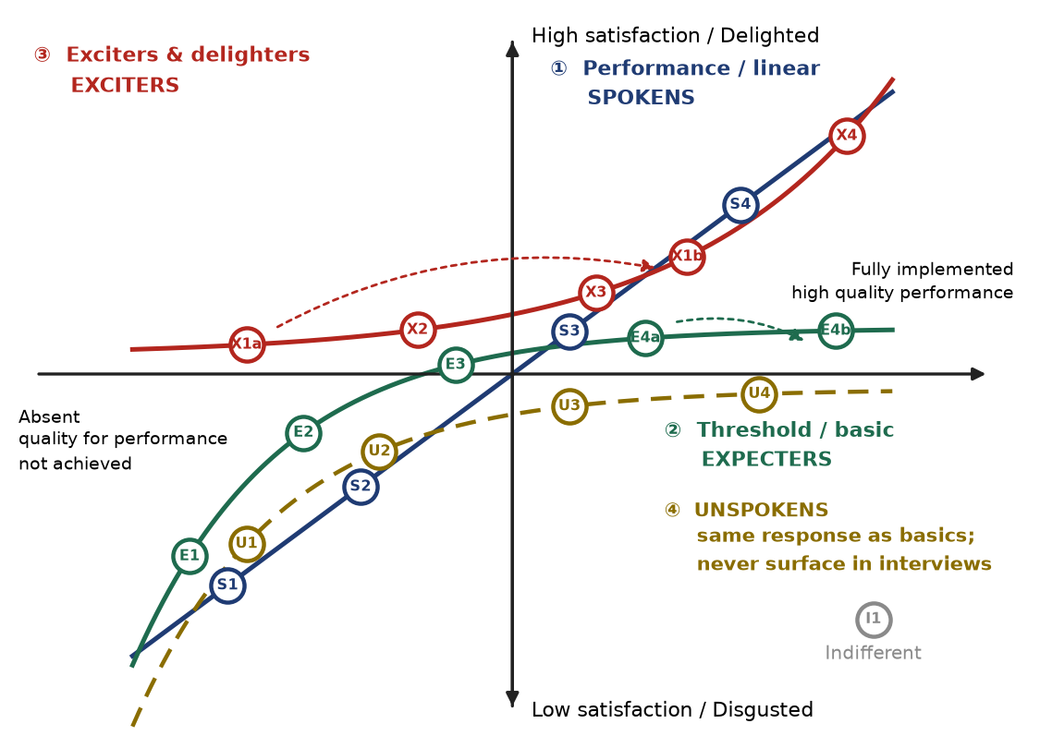
Figure 1. Kano diagram in the format of Dieter Fig. 3.5, with requirements placed on the curve matching their satisfaction response. Dashed arrows link the same feature at a low-investment and a high-investment level of implementation (E4a→E4b, X1a→X1b).
Requirement Listing
ID | Requirement | Customer | Why it sits where it does
E1 | Redistributes interface pressure at the sacrum and heels below the tissue-damage threshold | Patient, physician | The entire reason the product exists. Absent, the product is worthless; present, nobody praises it.
E2 | Cover is fluid-resistant, cleanable and disinfectable to facility infection-control protocol | Nurse | A surface that cannot be cleaned between patients cannot be used at all. Pure threshold.
E3 | Rapid CPR deflate with a clearly marked manual override | Nurse, physician | Safety basics are invisible until the one moment they are needed, then their absence is catastrophic.
E4a | Supports the standard adult weight range without bottoming out | All | Basic capability at minimum implementation — meets the threshold and no more.
E4b | Supports the full bariatric range with the same immersion performance | All | Same feature, higher investment. Still a basic — it saturates rather than delights, which is why E4b sits further right on the same curve.
S1 | Measured peak interface pressure (mmHg) at the sacrum | Physician | Classic one-dimensional attribute: lower is better, continuously, and clinicians ask for the number.
S2 | Pump noise at the bedside (dB at 1 m) | Patient, nurse | Patients and night staff complain about it explicitly; every decibel removed adds satisfaction.
S3 | Setup and transfer time (minutes from delivery to patient on surface) | Nurse | Directly requested, linearly valued — time is the currency of a nursing shift.
S4 | Battery autonomy during intra-hospital transport (hours) | Nurse | Spoken, and more is straightforwardly better up to the length of a transport.
U1 | Microclimate control — skin temperature and humidity at the support interface | Patient | Nobody requests it, but moisture and heat drive maceration and lower the tissue tolerance to deformation. Absence shows up as a wound, not a complaint.
U2 | Shear and friction management in the cover and slip layers | Patient, nurse | Shear is a primary etiological contributor yet is never named by users, who instead report that patients slide down the bed.
U3 | Low false-alarm rate on any monitoring function | Nurse | Never specified in advance; if violated it produces alarm fatigue and the feature is switched off, which is a silent product failure.
U4 | Preserves the patient’s own ability to shift position | Patient | An over-immobilising surface removes the micro-movements patients make for themselves. Articulated by nobody, felt by everybody.
X1a | Early tissue-damage detection — handheld spot-check at the sacrum and heels | Nurse, physician | A delighter at low investment: it reveals damage before it is visible, but requires staff to remember to scan.
X1b | Early tissue-damage detection — continuous embedded sensing with per-patient trending | Nurse, physician | Same feature fully implemented. Removes the compliance dependency entirely, so it sits far right on the exciter curve.
X2 | Detection performance independent of patient skin tone | Patient, physician | Visual assessment systematically under-detects early injury in darkly pigmented skin. A measurement that does not depend on seeing colour change is a genuine differentiator.
X3 | Automated lateral turn assist that repositions without manual lifting | Patient, nurse | Removes the single most injury-prone task from the nursing workload. Unexpected, and delightful when present.
X4 | Repositioning interval set by measured tissue response rather than a fixed two-hour clock | Physician | Replaces a convention of unclear evidentiary basis with a per-patient measurement. Nobody asks for it because nobody believes it is possible.
I1 | Choice of cover colour | — | Indifferent: implementing it well or badly moves satisfaction essentially not at all. Included to complete the Dieter format.
On Levels of Implementation
Two requirements are shown at two investment levels, as the assignment invites. E4a→E4b stays on the basic curve: extending weight capacity is expensive but it never becomes a delighter, because capacity is something a buyer assumes rather than admires — the extra investment buys the right to be considered, not enthusiasm. X1a→X1b behaves differently: a handheld spot-check device already surprises clinicians, but it inherits the compliance problem of anything that must be remembered. Making the same function continuous and automatic moves it far to the right on the exciter curve, where the satisfaction return on additional investment is steepest. The contrast is the practical lesson of the diagram: the same incremental dollar buys very different satisfaction depending on which curve the feature lives on, and a programme that spends its margin perfecting basics while leaving exciters at minimum implementation will produce a product that offends nobody and attracts nobody.

