Vance Vanvolkenburgh
655.662 — Introduction to Healthcare Systems Engineering
Module 8 | M8A2: Test & Assessment Approach
Test and Assessment Approach — Peritoneal Dialysis Remote Patient Monitoring (PD-RPM)

1. Approach
The approach is organized on two axes. By level, testing is incremental: the same obligation is retested at five rising levels, each with more of the real system present. By path, the module’s own definition of integration demands that execution be checked on all nominal and exceptional paths, so two scenarios are carried end to end — one of each.
Scenario A is the nominal path and is run at every level, growing in fidelity from a unit test on one function to a clinical pilot. Scenario B is the exceptional path and exists only as a total-system test, because the failure it reproduces cannot be staged in any smaller piece of the system.
Both scenarios are assessed twice over: for functionality, meaning the system does what the specification says, and for utility, meaning a care team is measurably better off. A system can pass every functional test and still be useless, so the two are scored separately.

2. Test levels
Level | Name | What is under test | Where it happens | V&V class
L1 | Unit | One function or module in isolation | Vertex of Figure 1 — entry bar for every stage | Verification
L2 | Component | A configuration item against its B-spec | Stages S1–S3, gates G1–G3 | Verification
L3 | Subsystem | Platform services and the transport link | Stages S4–S5, gates G4–G5 | Verification
L4 | System | Every element integrated, all interfaces live | Stages S6–S7, gates G6–G7 | Verification
L5 | Operational | Intended users in the intended environment | Stage S8, gate G8 | Validation

3. Assessment methods
Method | Definition | Worked example in PD-RPM
Inspection | Physical and visual examination | Confirming the HG-1 diagnostic port and labeling match the B-spec
Analysis | Mathematical models, simulation, algorithms, calculation | Reliability block diagram showing the alerting path meets Aₒ ≥ 0.98
Demonstration | Observing qualitative results of an operation | A nurse working a triage queue end to end during the pilot
Test | Test procedures under specified conditions, results analyzed | Fault injection on the carrier link with record counts reconciled

4. Coverage model
Dimension | What is required
Requirement coverage | Every OR, KPP and Module 7 requirement appears in the verification cross-reference matrix with one owning test at one named level. Target 100 percent.
Interface coverage | All 17 interfaces I-1 to I-17 are exercised at least once at L4.
Path coverage | Nominal and exceptional paths both carried end to end — Scenarios A and B.
Data coverage | Each bounded value tested at its limit and one step beyond: 500-record buffer, 72-hour retention, 150 records per minute, 15-minute alert latency.

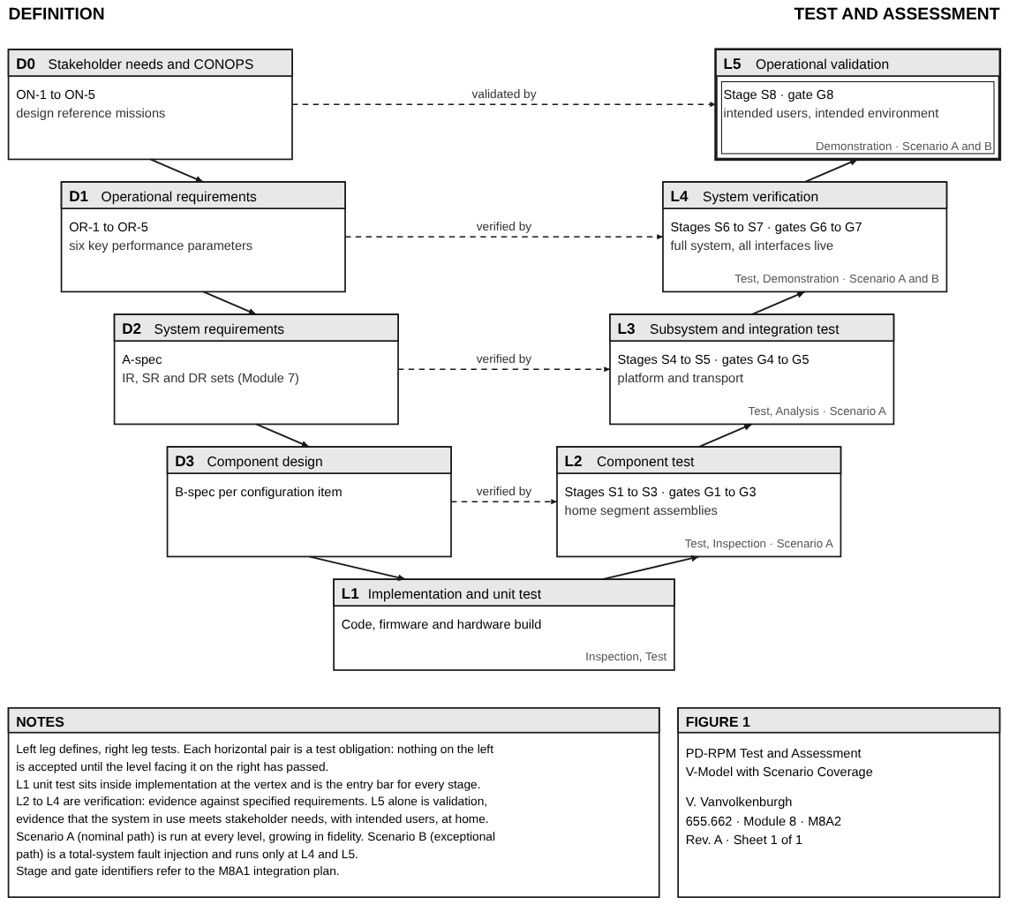
Figure 1. Test and assessment V-model for PD-RPM. Each horizontal pair binds a definition artifact to the level that tests it. Scenario A climbs every level; Scenario B exists only at L4 and L5.

5. Scenario A — declining ultrafiltration trend (nominal path, incremental)
A patient’s net ultrafiltration falls steadily across 14 treatments. This is operational requirement OR-1, the system’s primary clinical purpose, and it is retested at all five levels.
Level | Configuration under test | Stimulus | Pass criterion | Method
L1 | AE-1 trend function alone | 14 synthetic sessions, 22 percent decline against the 30-day mean | Flag set; both means computed to within 0.1 percent of the reference | Test
L2 | AE-1 joined to DS-1 | Records persisted through the production API | Flag raised within 10 minutes of persistence | Test
L3 | Monitoring platform (S4) | Injector replays 60 recorded patient-months | No more than one non-actionable alert per patient-month across the whole replay | Test, Analysis
L4 | Full system, cycler simulator at the home end | 14 consecutive sessions compressed into one night | Flag reaches the CW-1 triage queue and the EH-1 summary within 15 minutes | Test
L5 | Clinical pilot, real patients | Naturally occurring decline during the 60-day pilot | Nurse opens the flagged patient, documents an action, nephrologist reviews before the next scheduled visit | Demonstration

6. Scenario B — silent gateway across three Sunday nights (exceptional path, total system)
Step | Action | Condition | Expected system response and pass criterion
1 | Establish baseline | Full system live, 20 patients, 7 nights nominal | Every session ingested; no open alerts
2 | Inject the fault | Mains removed from HG-1 at 21:00 for 8 hours on 3 consecutive Sundays | HG-1 transfers to battery and notifies DM-1 within 60 seconds
3 | Observe during outage | Sessions continue while the uplink is down | Carrier link declared unavailable after 3 failed attempts in 5 minutes; all sessions buffered
4 | Detect the silence | No data arrives from a patient who should be reporting nightly | A device-silent alert reaches the monitoring queue within 2 hours of the first missed session
5 | Restore | Mains returned | Every buffered record delivered in chronological order within 30 minutes; zero lost, zero duplicated
6 | Assess | Review with nurse, firmware lead and carrier engineer | The care team learned of the gap from the system, not from the patient
Scenario B is not invented. It reproduces the phantom Sunday outage the Module 6 team-learning review uncovered, where eleven patients went silent for three consecutive Sunday nights and no team held enough evidence to see it. The decisive step is step 4: an alert on the absence of data. Nothing in the original failure detected that, and no test built only from the nominal path ever would.

7. Functionality and utility, scored separately
Scenario | Functionality — does it meet the specification? | Utility — is the care team better off?
A — declining ultrafiltration trend | Is the 20 percent decline detected and delivered inside the 15-minute budget? | Does the nurse act on it, and does the nephrologist change the prescription before the next scheduled visit?
B — silent gateway across three nights | Is every buffered record recovered in order, with no loss and no duplication? | Does the care team learn of the gap from the system rather than from the patient?

8. Risk mitigation through the test program
Risk | How the approach mitigates it
R-1 silent gateway (M5A2) | Scenario B is the direct test of it, including the data-absence alert that did not exist before.
False alerts exhausting the nurses | Scenario A at L3 bounds the non-actionable alert rate across 60 patient-months before any clinician sees the system.
External interfaces unavailable for test | Scenario A runs at L1–L4 against a cycler simulator and the EHR vendor sandbox, so neither external party gates the test program.
Late defects are expensive | The same scenario repeats at every level, so a regression is caught at the lowest level that can expose it.

9. Why the approach is agile
Both scenarios are automated once they first pass, and then run as nightly regression for the rest of the program. That is what makes the incremental approach affordable: each increment re-runs the full scenario set overnight, and a failure is attributable to the increment that introduced it rather than hunted for at the end. Scenario A is re-run unchanged at every level, so the cost of re-testing falls as confidence rises.

10. Coverage, limits, and end-to-end assurance
Coverage is honest about its limits. Two scenarios do not test a system; they demonstrate that the approach reaches end to end on both the nominal and the exceptional path. Everything else is covered by the per-gate tests in the integration plan and by the verification cross-reference matrix, which is the artifact that proves no requirement is left without an owning test. The pilot at L5 is the only point at which PD-RPM claims to work rather than to have been built as specified.

